**Templates**

1. Login
2. Index
3. Add Customer
4. View Customer
5. Apply For Services
6. Service Details
7. Fuel Charge
8. Food Allowance
9. Item Purchased
10. Vendor Info
11. Current Status
12. Update Fuel Charge
13. Update Food Allowance
14. Update Item Purchased
15. Update Vendor Info
16. Update Current Status

Login

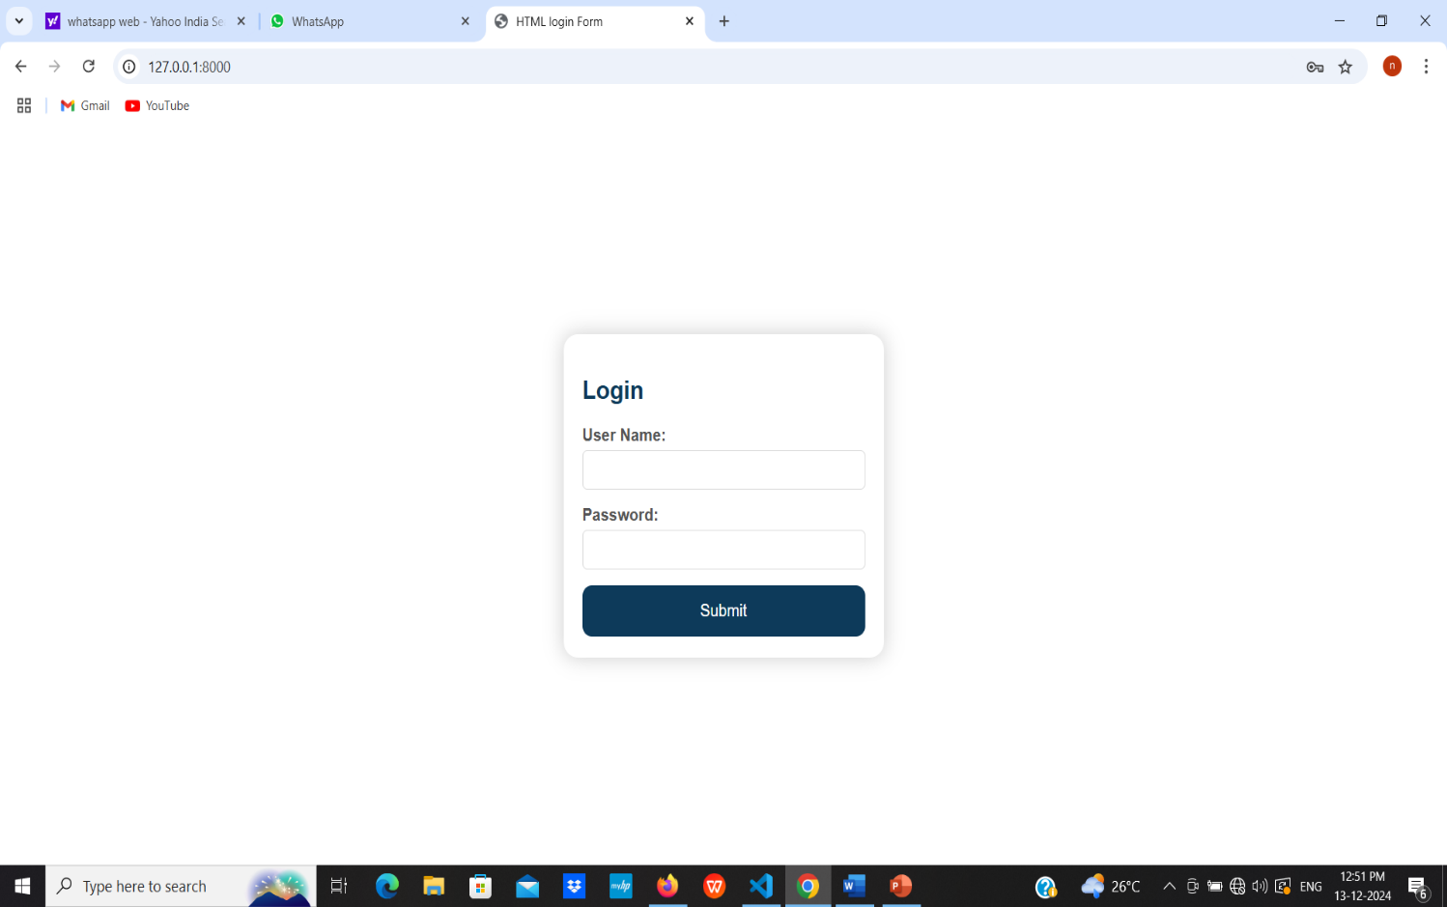

Add customer

* Name
* Address
* Contact number
* WhatsApp Number
* Reffered By

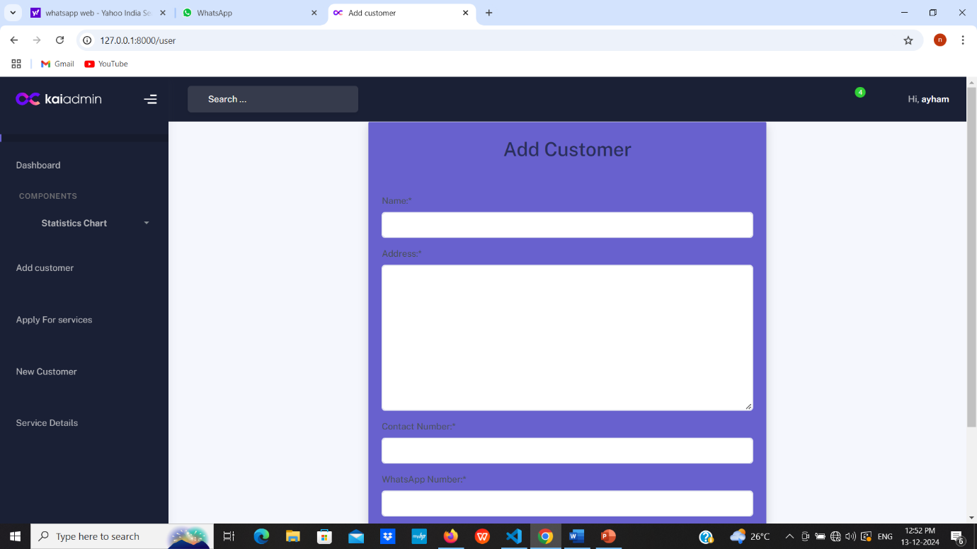

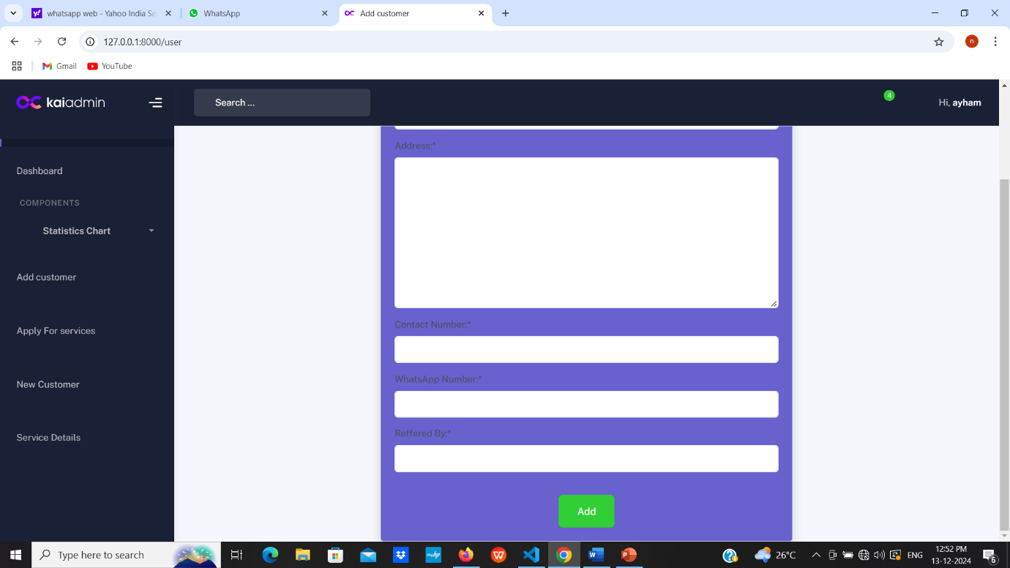

View Customer

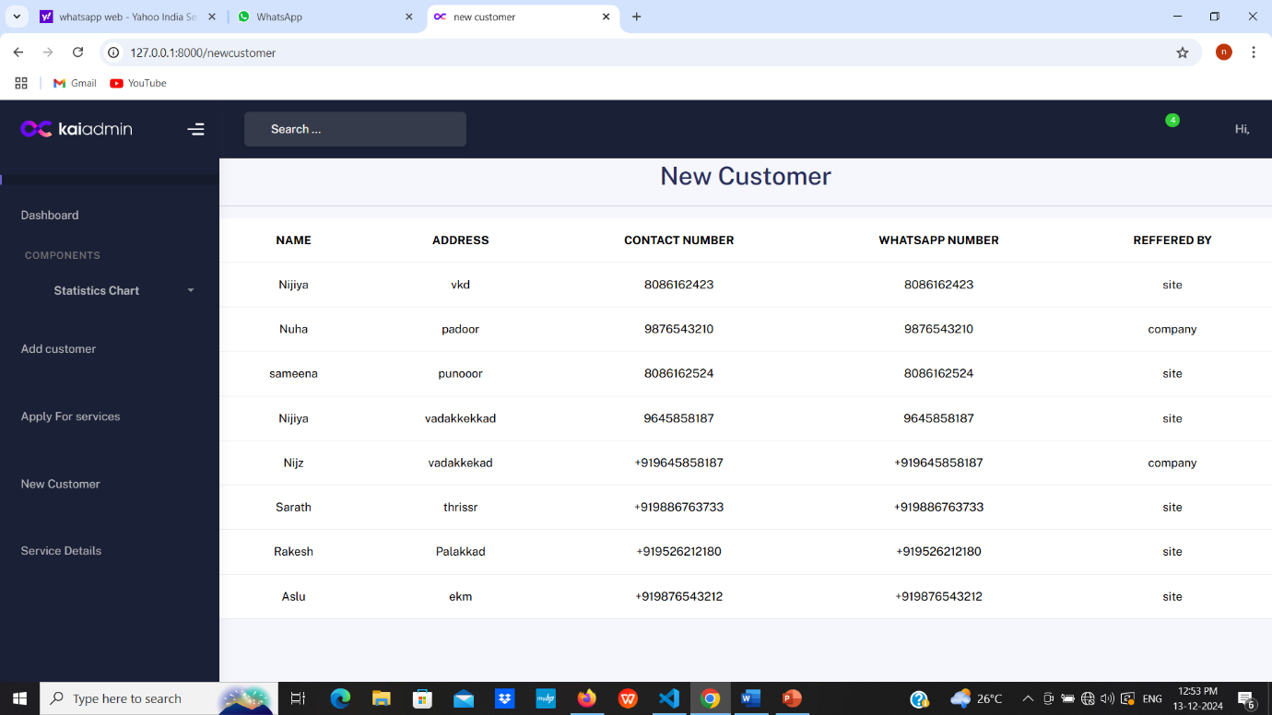

Apply For Service

* Contact number
* Name
* Address
* Contact Number
* WhatsApp Number
* Reffered By
* Service By
* Work Type
* Item Name
* Issue
* Photo of item
* Estimted Document
* Estimated Price
* Estimated Date
* Any comments

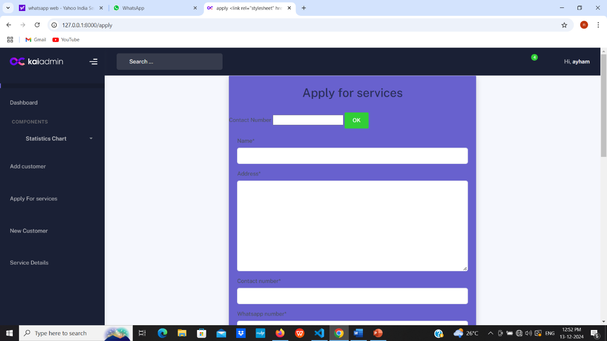

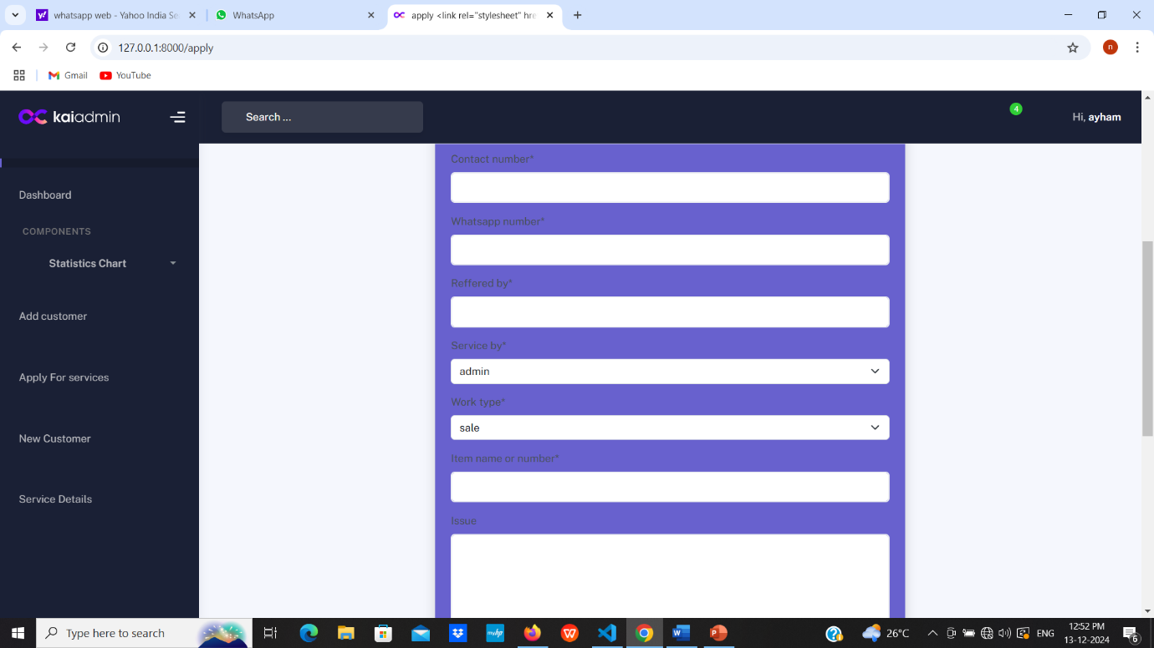

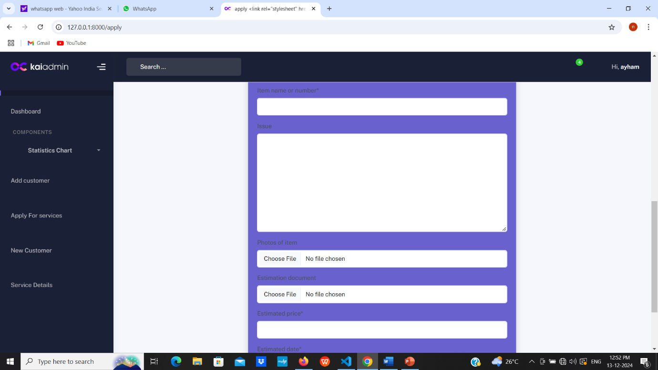

Service Details

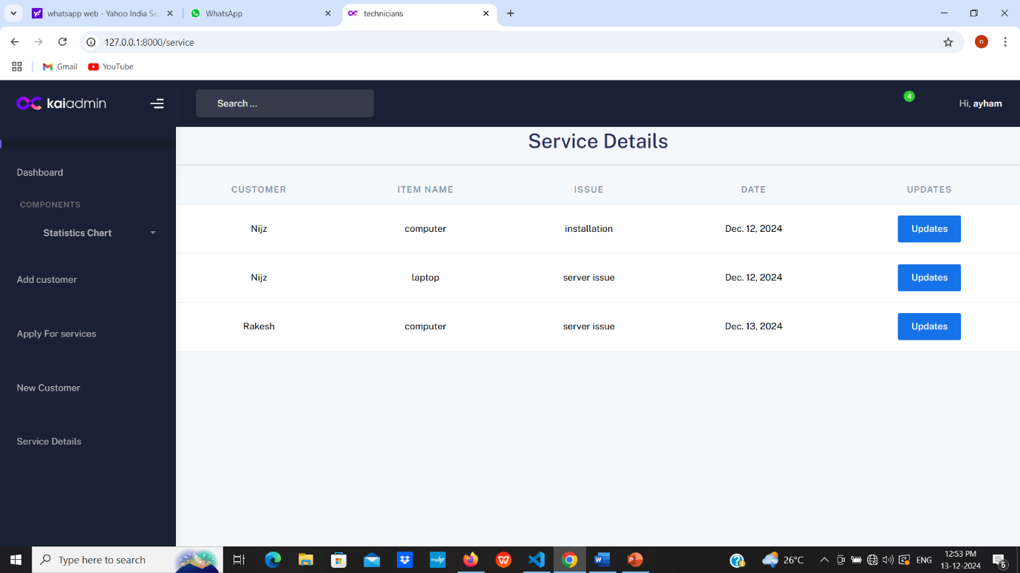

Fuel Charge

* Technician name
* Date
* Purpose
* Kilometer

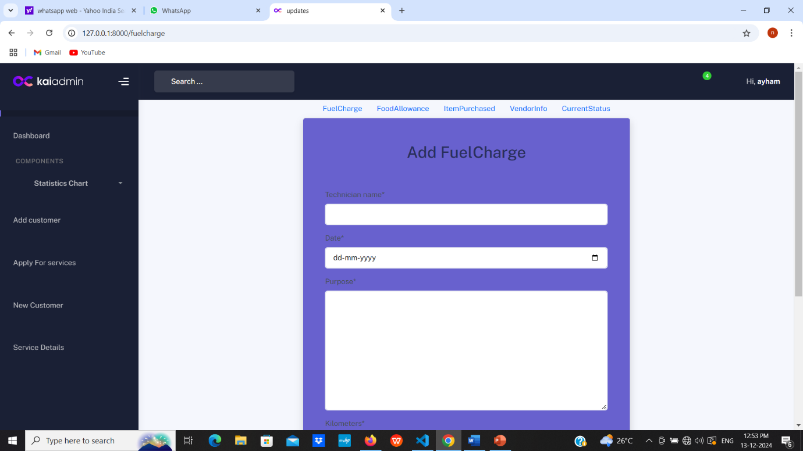

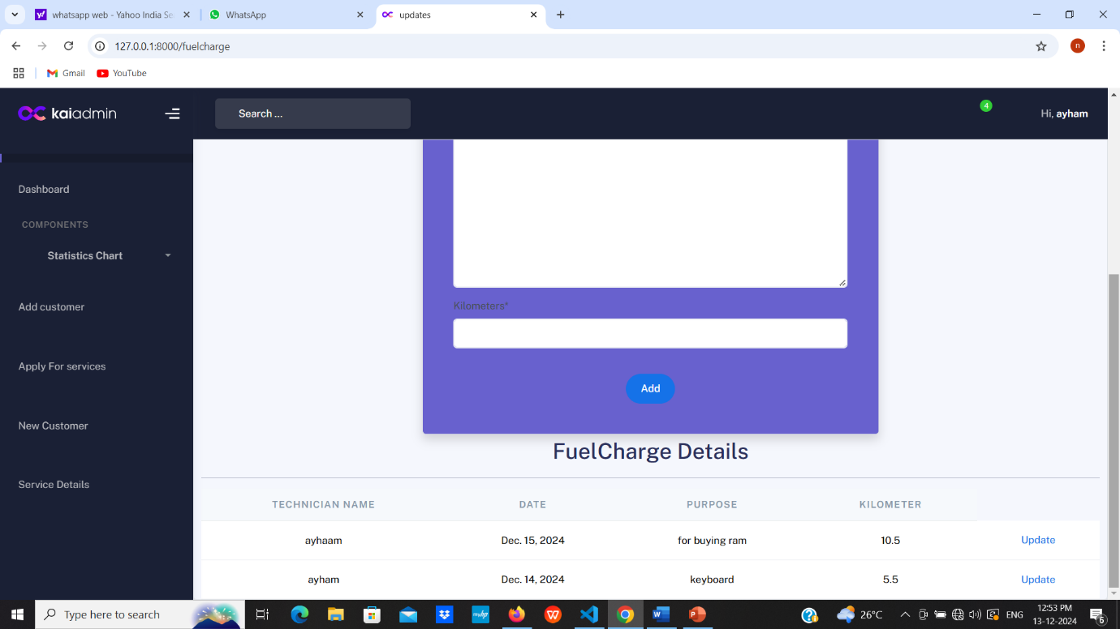

Update Fuel Charge

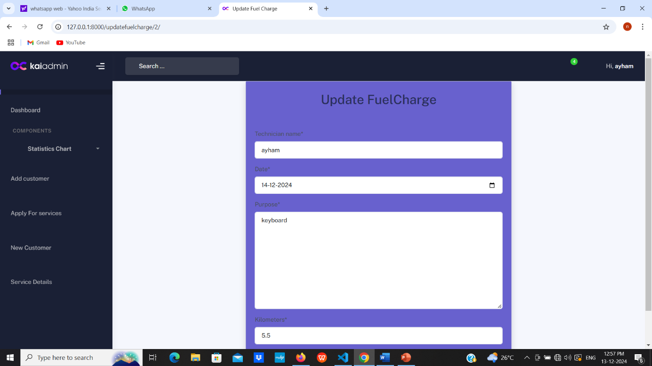

Food Allowance

* Technician Name
* Date
* Purpose
* cost

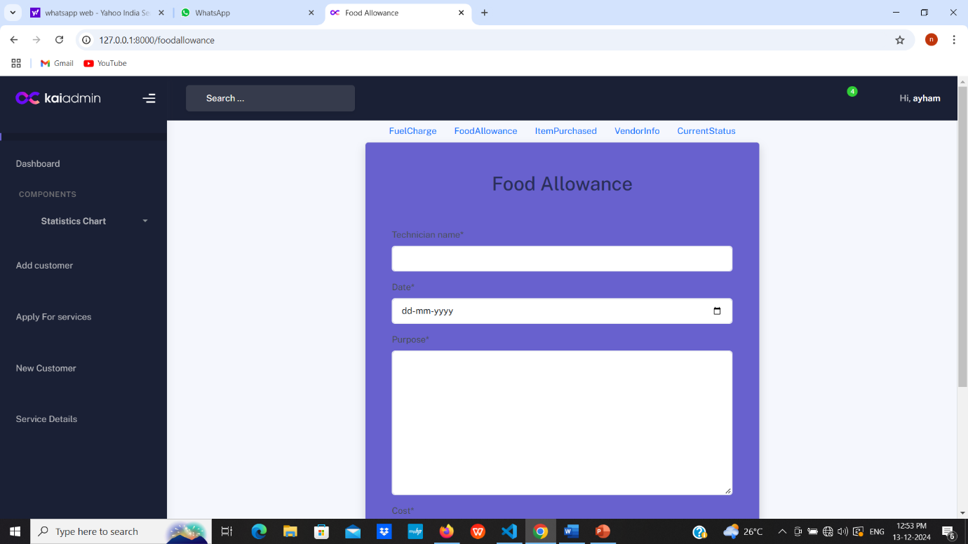

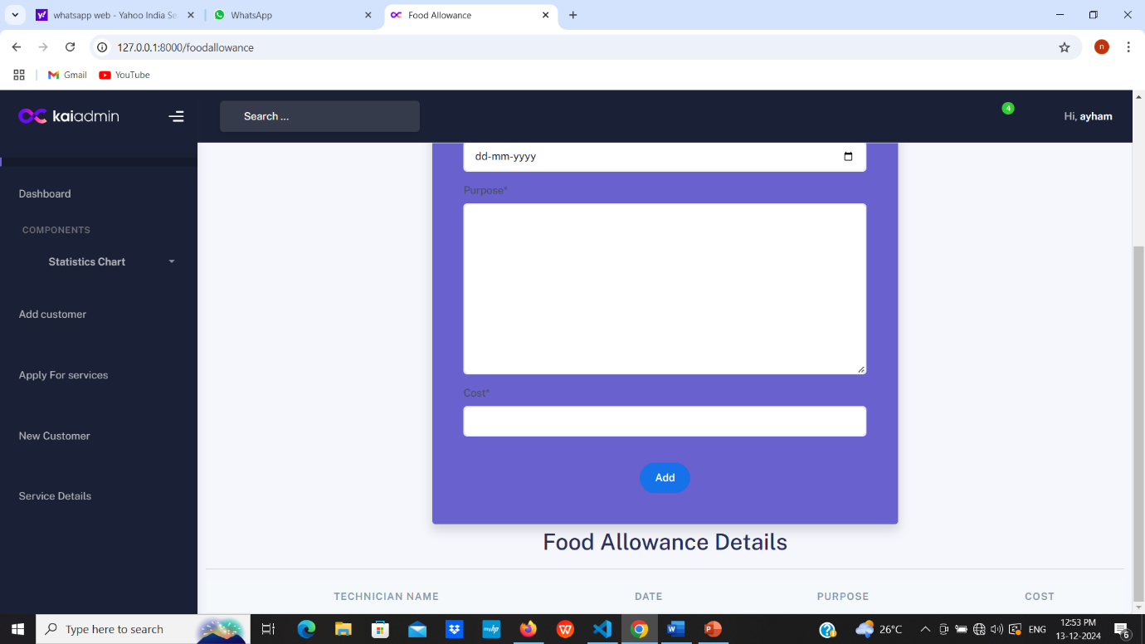

Update food allowance

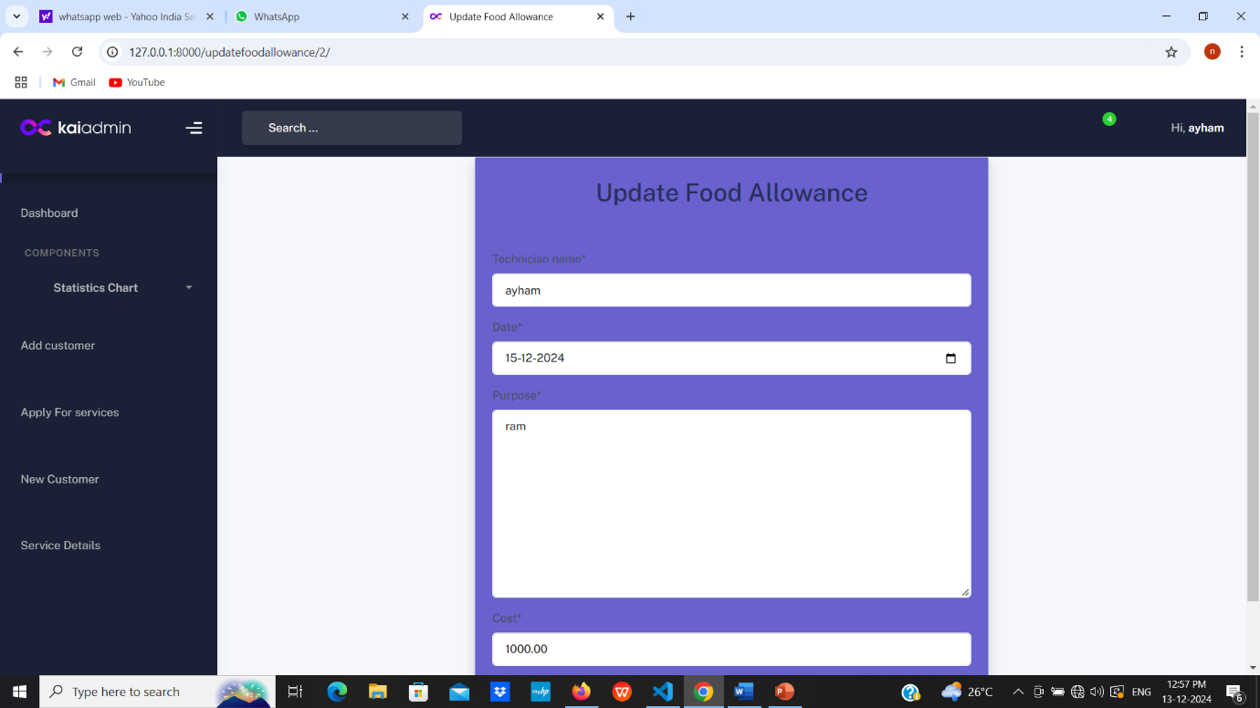

Item Purchased

* Date
* Item name
* Bill photo
* Price

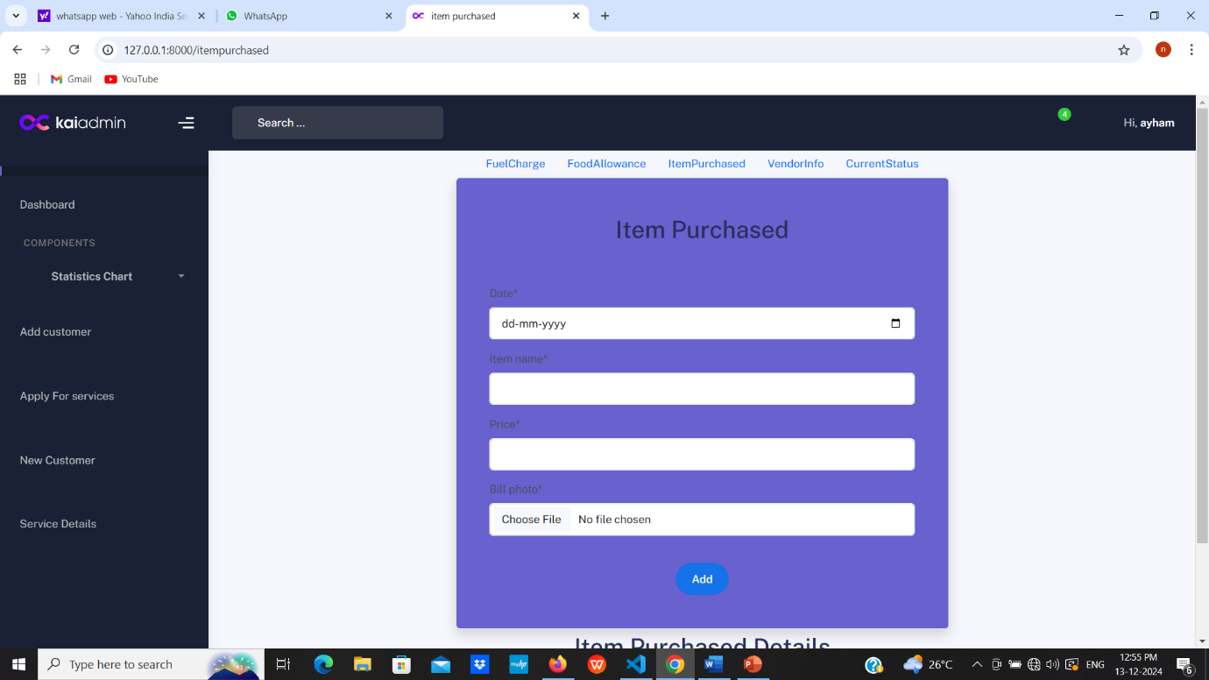

Update item Purchased

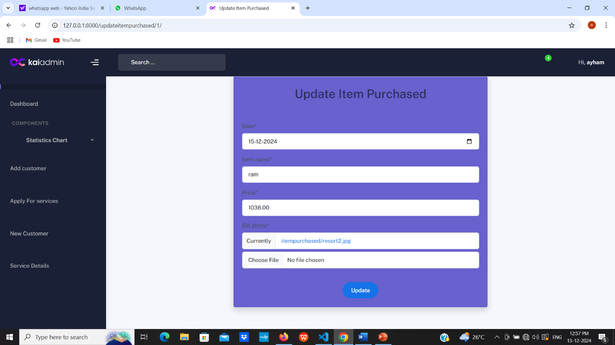

Vendor info

* Date
* Vendor name
* Vendor Bill photo
* Vendor ETA
* Vendor cost

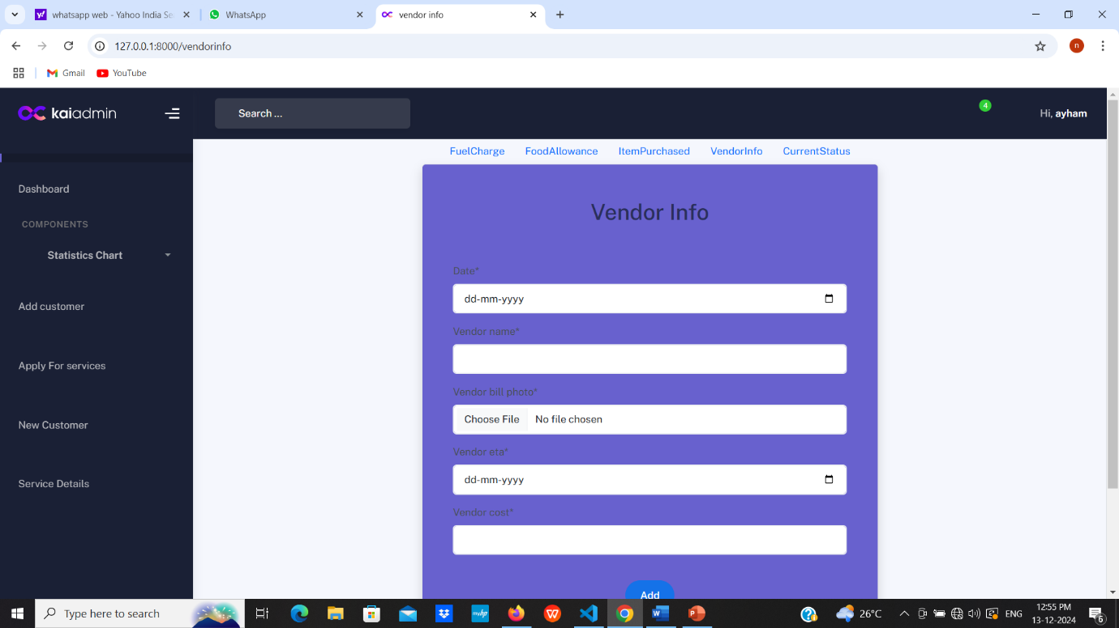

Update Vendor Info

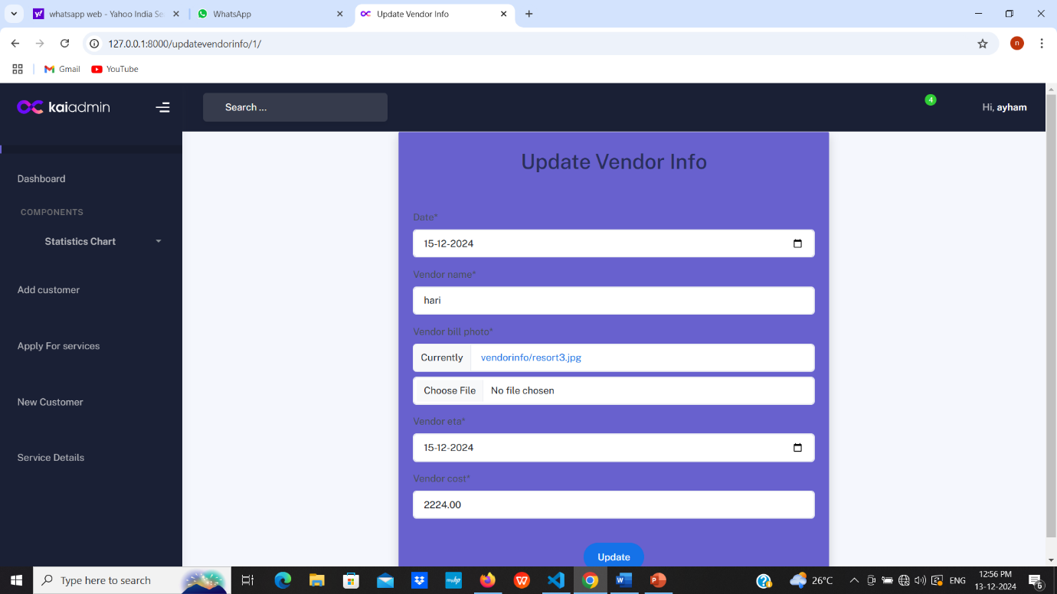

Current Status

* Date
* Update By
* Status

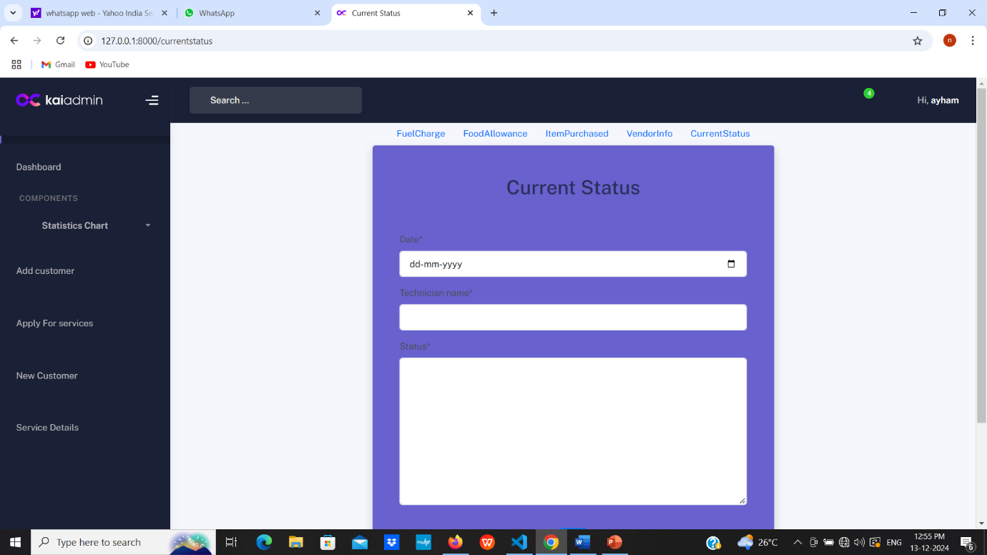

Update Current status

