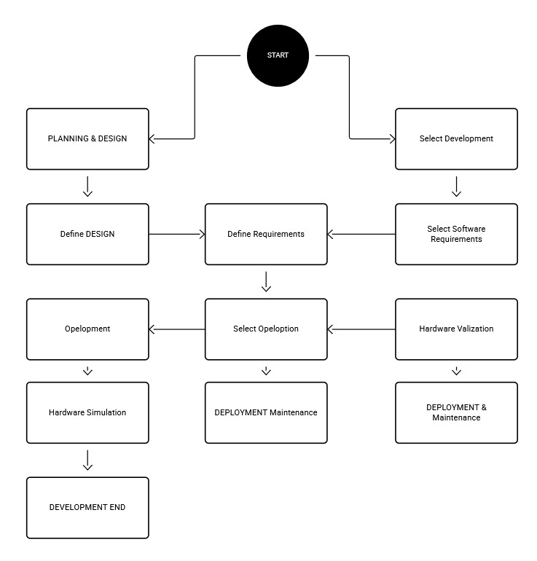

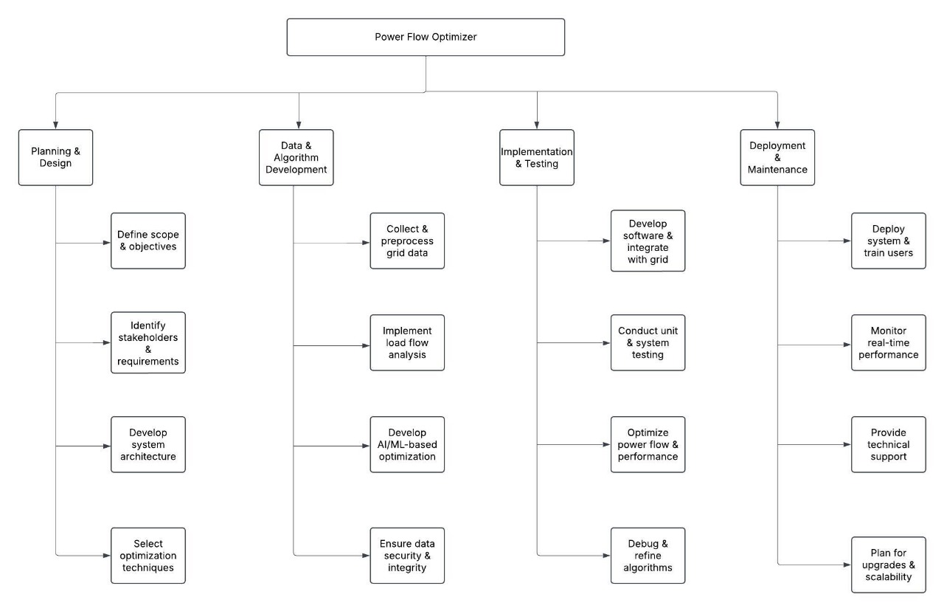

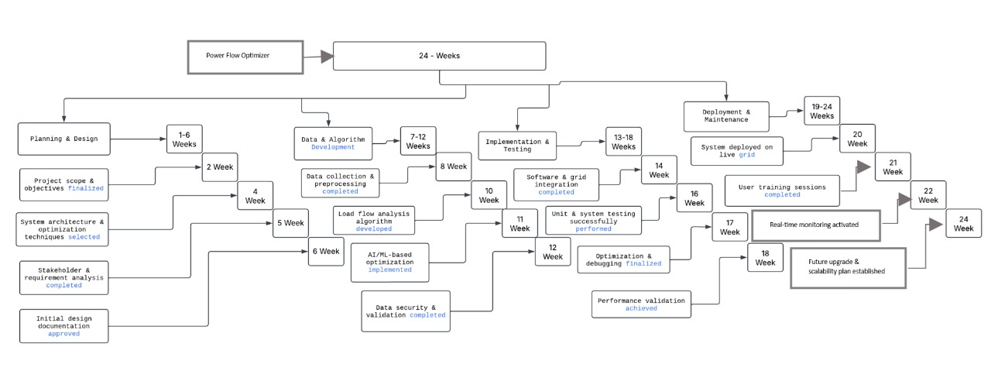

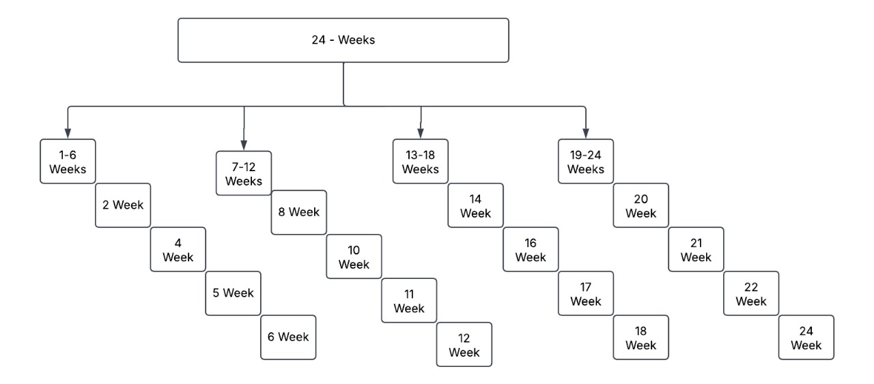

**WBS**

Start

│

├── 1. Project Initiation

│ ├── Define objectives and scope

│ ├── Identify stakeholders

│ ├── Conduct feasibility study

│ └── Develop project plan & timeline

│

├── 2. Requirement Analysis

│ ├── Gather functional & non-functional requirements

│ ├── Define system constraints & optimization goals

│ ├── Identify compliance and regulatory requirements

│ └── Document technical specifications

│

├── 3. System Design & Architecture

│ ├── Develop system architecture

│ ├── Define communication protocols (IoT, SCADA, Cloud)

│ ├── Design user interface & visualization tools

│ └── Select software & hardware components

│

├── 4. Algorithm Development

│ ├── Implement power flow analysis (Newton-Raphson, Gauss-Seidel)

│ ├── Develop optimization techniques (Genetic Algorithm, PSO, LP)

│ ├── Integrate renewable energy sources

│ └── Model predictive control for real-time adjustments

│

├── 5. Software Development

│ ├── Backend development (Python, Matlab, C++)

│ ├── Frontend development (GUI, visualization)

│ ├── Database management for real-time data storage

│ └── API development for system integration

│

├── 6. Testing & Validation

│ ├── Unit testing of modules

│ ├── System integration testing

│ ├── Load & stress testing under different grid conditions

│ └── Performance validation with real-world case studies

│

├── 7. Deployment & Maintenance

│ ├── Install & configure optimizer in test environment

│ ├── Conduct pilot testing on a real power grid

│ ├── Train operators and stakeholders

│ └── Regular system updates, bug fixing & performance monitoring

│

End

**Milestone**

Project Timeline (52 Weeks)

1. Project Initiation (Weeks 1-4)

Week 1: Define objectives and scope

Week 2: Identify stakeholders

Week 3: Conduct feasibility study

Week 4: Develop project plan & timeline

2. Requirement Analysis (Weeks 5-8)

Week 5-6: Gather functional & non-functional requirements

Week 7: Define system constraints & optimization goals

Week 8: Identify compliance and regulatory requirements, document specifications

3. System Design & Architecture (Weeks 9-14)

Week 9-10: Develop system architecture

Week 11: Define communication protocols (IoT, SCADA, Cloud)

Week 12-13: Design user interface & visualization tools

Week 14: Select software & hardware components

4. Algorithm Development (Weeks 15-22)

Week 15-16: Implement power flow analysis (Newton-Raphson, Gauss-Seidel)

Week 17-18: Develop optimization techniques (Genetic Algorithm, PSO, LP)

Week 19-20: Integrate renewable energy sources

Week 21-22: Model predictive control for real-time adjustments

5. Software Development (Weeks 23-30)

Week 23-25: Backend development (Python, Matlab, C++)

Week 26-27: Frontend development (GUI, visualization)

Week 28: Database management for real-time data storage

Week 29-30: API development for system integration

6. Testing & Validation (Weeks 31-38)

Week 31-32: Unit testing of modules

Week 33-34: System integration testing

Week 35-36: Load & stress testing under different grid conditions

Week 37-38: Performance validation with real-world case studies

7. Deployment & Maintenance (Weeks 39-52)

Week 39-40: Install & configure optimizer in test environment

Week 41-42: Conduct pilot testing on a real power grid

Week 43-44: Train operators and stakeholders

Week 45-48: Regular system updates, bug fixing & performance monitoring

Week 49-52: Final optimization, documentation & future recommendation