

Zenkraft
LINK Integration Guide (SFRA)
Version 20.1.0


Table of Contents
1. Summary 4
2. Component Overview 4
2.1 Functional Overview 4
2.2 Use Cases 4
Estimated Delivery Dates 4
Return Labels For Customers 5
Drop Off Shipments (In Progress) 5
Shipment Tracking for Customers 5
Shipment Tracking Notifications 6
2.3 Limitations/Constraints 7
2.4 Compatibility 7
2.5 Privacy, Payment 7
3. Implementation Guide 7
3.1 Setup 7
Cartridges 7
3.2 Configuration 8
Assign Cartridges 8
Import Metadata 8
Custom Preference Configuration 8
Zenkraft Group Preferences 8
Zenkraft Rates Group Preferences 9
Zenkraft Advanced Configuration 10
Zenkraft Shipment Notifications Preferences 11
Zenkraft Tracking Page Settings 11
Zenkraft Returns Settings 12
Shipping Method Configuration 13
Estimated Delivery Dates 13
Drop Off Shipments (In Progress) 13
3.3 Custom Code 14
3.3.1 Estimated Delivery Dates 14
There is no custom code necessary to enable the Estimated Delivery Dates feature. To enable it, you simply need to configure the shipping methods with Zenkraft IDs as mentioned in the ‘Shipping Method Configuration’ section of this document, then enable the site preference named ‘Enable Zenkraft Estimated Delivery Dates’. 14
3.3.2 Return Labels for Customers 14
Templates 14
account/order/orderHistoryCard.isml 14
Client-side Javascript 14
3.3.3 Drop Off Shipping Locations (In Progress) 15
Templates 15
3.3.4 Shipment Tracking 15
Shipment Tracking URL 15
3.4 External Interfaces 15
3.5 Testing 15
4. Operations, Maintenance 16
4.1 Data Storage 16
4.2 Availability 16
4.3 Support 16
5. User Guide 16
5.1 Roles/Responsibilities 16
5.2 Business Manager 16
5.3 Storefront Functionality 16
Shipment Tracking Page 16
Print Return Labels 16
Zenkraft Shipping Rates 17
Drop Off Shipments 17
6. Known Issues 17
7. Release History 17

1. Summary
Zenkraft provides 100% Native shipping applications for All Salesforce Clouds including a cartridge for Cloud Commerce (formerly Demandware). We provide Rating, Label, Tracking and Pickup technology for 45+ carriers including FedEx, UPS, USPS, DHL and 40+ others. In additional to parcel carriers, we also provide access to some Freight providers.

Zenkraft are a cloud-first business and also make available a core logistics API for integration into your own business application.

Zenkraft has nearly 1,000 customers including over 10% of Fortune 500 businesses. As well has having over 200 5 star reviews on the Salesforce AppExchange.

Zenkraft have been a Salesforce partner since 2009.

This cartridge was created and tested against SFRA version 4.4.1.

The int_zenkraft_sfra cartridge works against all locales in Salesforce Commerce Cloud.

2. Component Overview

2.1 Functional Overview
Zenkraft provides shipping integration with Salesforce Commerce Cloud. This includes the ability to:

- Calculate ratings during the checkout process.
- Book shipments from Business Manager for 45+ carriers.
- Transmit order data to your 3PLs and back.
- Provide real-time tracking within the user order page.
- Generate return shipping labels from within the user order page
- Provide users with a link to a public tracking page that will allow them to see the current status of their shipment, as well as provide the opportunity to show content or related products
- Give users the option to subscribe to shipment update notifications through several channels

2.2 Use Cases

Estimated Delivery Dates
When a user is given their shipping method options in the checkout area of the storefront, currently they are just given a static range of days that it will take for the item(s) to be delivered via that method (ex. 7-10 Business Days). With the Zenkraft Estimated Delivery Dates feature, users are instead given an exact estimated date of arrival based on their entered address (ex. Tuesday, October 29th). If an estimated date isn’t available for the method, the default static range is automatically displayed.

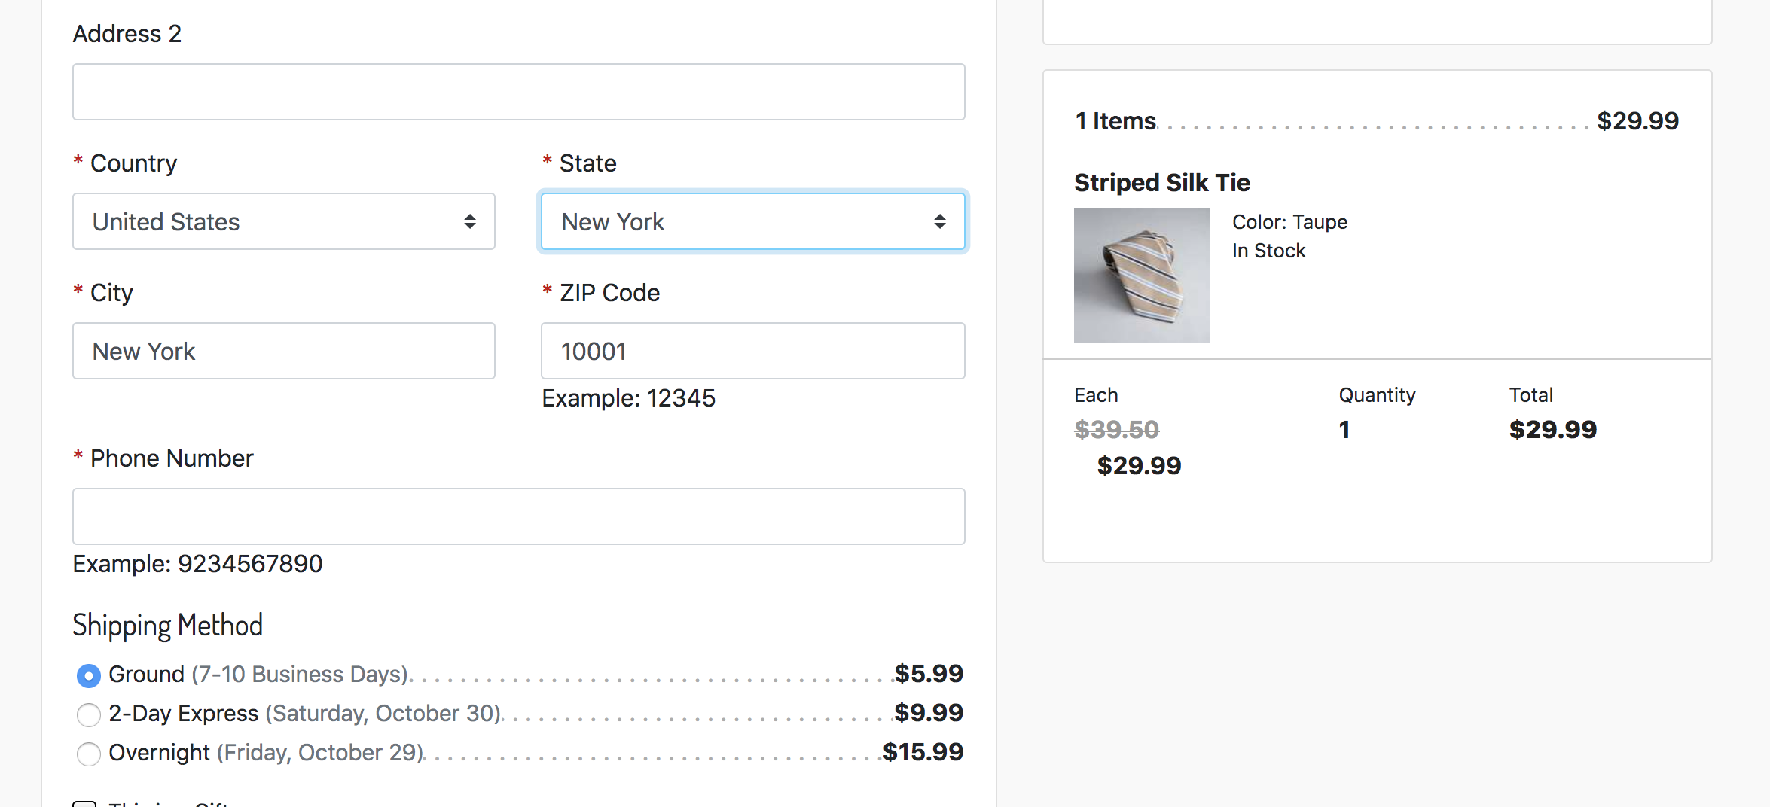

Return Labels For Customers
Users are given the option to print shipping labels for product returns or email them to themselves for later use. This includes a separate UI for users to select specific items and quantities from their order to return. This is accessed through the Track Order area or in Order History for logged-in users.

Drop Off Shipments (In Progress)
This feature allows storefront customers to select non-residential locations as their shipping address. When a user selects a Drop-off-enabled shipping method, they are presented with a search box so that they can search for drop-off locations by postal code. Once they search, nearby drop off locations, and a map, are presented to the user so that they can select a location to ship their order.

In order to enable this feature, you’ll need to set a shipping method as drop-off-enabled, add the zenkraft.js client code, include the drop-offs template, and obtain/set a Google Maps API key. Instructions for each of these are included in this document.

Shipment Tracking for Customers
The Public Shipment Tracking page is a publicly available link that you can provide a customer that will allow them to quickly see the current tracking status of their order, as well as the history of all of the tracking checkpoints of that shipment. Additionally, since this page lives on your SFCC site, you can give targeted branding and communication to the customer, as well as give them personalized promotions. As an added bonus, if you are using Einstein recommendations, a content slot is provided on the template so that you can recommend products to the customer as they are looking at their tracking information. Note that this area does not contain any personal identifiable information, so it’s safe to provide publicly.

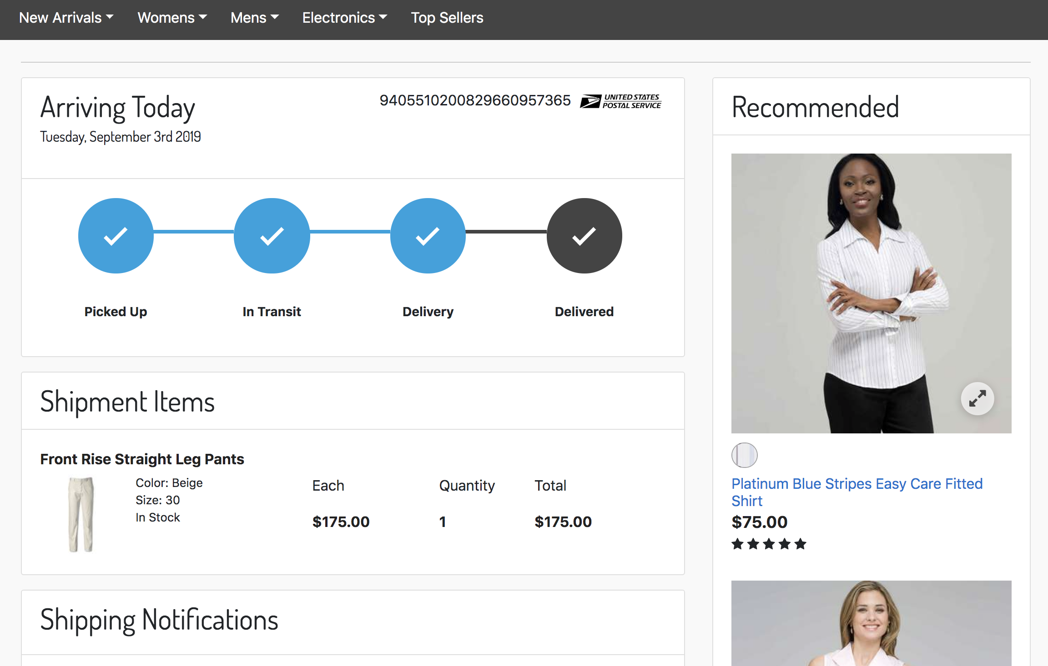

Shipment Tracking Notifications
The public Shipment Tracking page also allows for users to subscribe to notifications (see screenshot above). The Zenkraft cartridge provides a framework for sending notifications to users when their shipment’s status changes, via any channel with which you want to integrate. Included with the cartridge is an integration with Twilio for SMS, WhatsApp, and Facebook Messenger notifications.
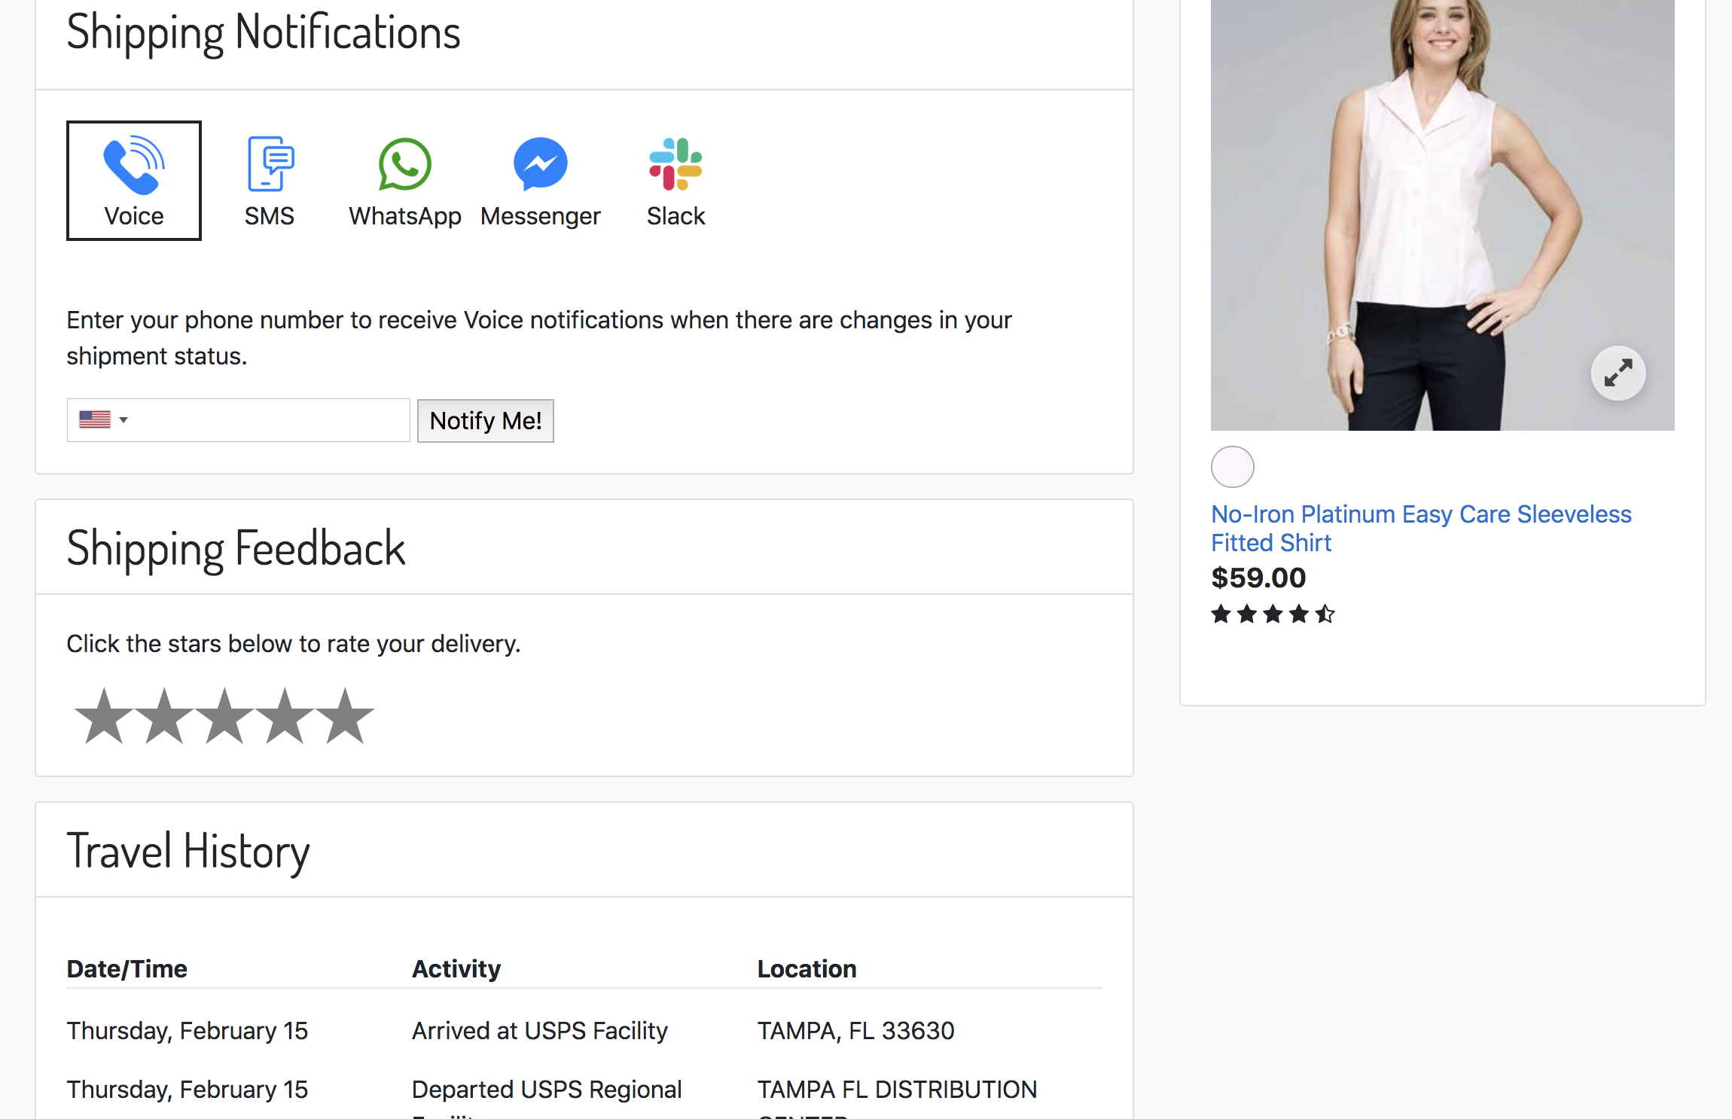

2.3 Limitations/Constraints
We currently do not support multiple tracking numbers and return labels on a shipment. Everything is handled at the shipment level, not the line item level.

Also, the Zenkraft API is carrier-specific, meaning that if you need to retrieve Estimated Delivery Dates for multiple carriers, multiple calls to the API would be required.

2.4 Compatibility
The Zenkraft LINK Cartridge is available since Salesforce Commerce Cloud version 19.10.

This cartridge is available to be implemented on storefronts that support the Storefront Reference Architecture (SFRA).

2.5 Privacy, Payment
No payment or credit card data is passed between Salesforce Commerce Cloud and the Zenkraft API.

3. Implementation Guide

3.1 Setup
The Zenkraft LINK Integration contains two cartridges: one for the storefront integration and one for the optional Business Manager extension. They will need to be added to your codebase, associated with an SFCC server connection and uploaded to an SFCC environment.

Cartridges
int_zenkraft_sfra – This cartridge contains all of the controllers, forms, templates, and scripts for integration with the Zenkraft API:

Controllers:
- Zenkraft.js
- CheckoutShippingServices.js
- Checkout.js
Form Definitions:
- zenkraft.xml
Scripts:
- Zenkraft.js
- Notifications.js
- serviceInit.js
Models
- shipping/shippingMethod.js
Helpers
- ZenkraftHelpers.js
- ServiceHelper.js
Static Files
- zenkraft.js
- tracking.js
- zenkraft.css
Templates:
- account/orderhistory/printlabel
- account/tracking/tracking
- mail/printlabelemail
- checkout/shipping/dropoffshipments
- checkout/shipping/dropoffresults
Resources:
- checkout.properties
- forms.properties
- order.properties

3.2 Configuration

Assign Cartridges
In order to use the int_zenkraft_sfra cartridge, it needs to be assigned to your site through Administration -> Sites -> Manage Sites -> Your Site -> Settings tab. Add the cartridge to the left of your base cartridge because there are several methods and models that are extending via the Zenkraft cartridge.

Import Metadata
In order to function correctly, you’ll need to import the metadata for services, jobs and custom system objects. Import this into Business Manager via Administration -> Site Development -> Site Import & Export.

zenkraft-meta-import.zip – This is the import file located in the metadata folder of the root link_zenkraft. There are two folders inside. Be sure to use the import under sfra.

Custom Preference Configuration
There are several custom site preferences that can be set. Some are essential to connecting to the Zenkraft API and some allow you to enable/disable/customize certain pieces of functionality. All of the following preferences are in the Zenkraft and Zenkraft Returns preference groups. Available values for some of the preferences can be found in the Zenkraft API documentation here: https://api.zenkraft.com.

Zenkraft Group Preferences

Site Preference | Description
Zenkraft Master API Key | You will need to get this from Zenkraft. The API key is required for all API calls.
Zenkraft Production Mode | Allows you to toggle between production mode and development mode.
Enable Zenkraft Shipping Methods | Allows you to toggle the Real-Time Shipping Rates for Shipping Methods
Enable Zenkraft Shipping Rates | Allows you to toggle the Real-Time Shipping Rates for Shipping Methods
Enable Zenkraft Estimated Delivery Dates | Enables estimated delivery dates to be shown in checkout. These will replace the static Estimated Arrival that can be set on the shipping method in Business Manager.
Carrier ID | Carrier ID to use for Shipments to the customer.
Packaging Type | Packaging type to use for shipments to the customer. Values can be found in Zenkraft API documentation.
Shipping Account ID | ID Number for the Carrier account for shipments to the customer.
Currency Code | Currency Code to use with the Zenkraft API. Default value is USD and available values can be found in the Zenkraft API documentation.
Dimension Units | Units to be used for dimensions.
Weight Units | Units to be used for weight.
Default Product Weight | This is the default weight to be used for products when determining shipping rates. If the weight is not defined on the product, this is what is used.
Sender Street Address | This is the address used as the FROM address for shipments to the customer.
Sender Address City | This is the city used as the FROM city for shipments to the customer.
Sender Address State Code | This is the state code used as the FROM state code for shipments to the customer. This is optional as not all countries have states.
Sender Address Postal Code | This is the postal code used as the FROM postal code for shipments to the customer.
Sender Address Country Code | This is the country code used as the FROM country code for shipments to the customer.
Sender Company | This is the Company Name used as the FROM company name for shipments to the customer.
Sender Name | This is the name used as the FROM name for shipments to the customer.
Sender Phone Number | This is the phone number used as the FROM phone number for shipments to the customer.
Sender Email Address | This is the email address used as the FROM email address for shipments to the customer.

Zenkraft Rates Group Preferences

Site Preference | Description
Carrier ID | Carrier ID to use for Return Labels
Packaging Type | Packaging type to use for Return Labels. Values can be found in Zenkraft API documentation.
Shipping Account ID | ID Number for the Carrier account for return shipments.
Recipient Street Address | This is the address used as the TO address for returns.
Recipient Address City | This is the city used as the TO city returns.
Recipient Address State Code | This is the state code used as the TO state code for returns. This is optional as not all countries have states.
Recipient Address Postal Code | This is the postal code used as the TO postal code for returns.
Recipient Address Country Code | This is the country code used as the TO country code for returns.
Recipient Company | This is the Company Name used as the TO company name for returns.
Recipient Name | This is the name used as the TO name for returns.
Shipping Service | This is the shipping service that is used for returns. Available values for your carrier can be found in the Zenkraft API documentation.
Recipient Phone Number | This is the phone number used as the TO phone number for returns.
Recipient Email Address | This is the email address used as the TO email address for returns.
Shipping Label File Type | The file type to be used for shipping labels. Check the Zenkraft API documentation to see the available values for each carrier.

Zenkraft Advanced Configuration

Site Preference | Description
Enable Advanced JSON Configuration | If this is enabled, the other carrier and address settings in the Zenkraft site preference groups will be overridden by the JSON provided in the next site preference in this group..
Zenkraft Advanced JSON Object | This is the object used for the advanced configuration. Out of the box, the json specifies ship preferences and return preferences, and allows for different configurations per country. This JSON could be changed (along with a code change in ZenkraftHelper.js) to allow for other configurations, such as separate settings for carriers instead of country.  JSON Example:  {  "SHIP": {  "US": {  "ACCOUNT_ID": "1234567890",  "CARRIER_ID": "fedex",  "PACKAGING": "your_packaging",  "CURRENCYCODE": "USD",  "DIM_UNITS": "IN",  "WEIGHT_UNITS": "LB",  "FILETYPE": "",  "ADDRESS": {  "STREET": "20 W 34th St JSON",  "CITY": "New York",  "STATECODE": "NY",  "POSTALCODE": "10001",  "COUNTRYCODE": "US",  "COMPANY": "Zenkraft",  "NAME": "Zenkraft",  "PHONE": "1231231233",  "EMAIL": "api@zenkraft.com"  }  }  },  "RETURN": {  "US": {  "ACCOUNT_ID": "0987654321",  "CARRIER_ID": "fedex",  "SHIPPING_SERVICE": "fedex_ground",  "PACKAGING": "your_packaging",  "CURRENCYCODE": "US",  "DIM_UNITS": "IN",  "WEIGHT_UNITS": "LB",  "FILETYPE": "PDF",  "ADDRESS": {  "STREET": "10062 Treena Street",  "CITY": "San Diego",  "STATECODE": "CA",  "POSTALCODE": "92131",  "COUNTRYCODE": "US",  "COMPANY": "Zenkraft Default",  "NAME": "Zenkraft Default",  "PHONE": "1231231233",  "EMAIL": "api@zenkraft.com"  }  }  }  }

Zenkraft Shipment Notifications Preferences

Site Preference | Description
Enable Shipping Notifications | Enables the shipping notifications section on the public tracking page.
Twilio Base URL | Base URL for the Twilio Service
Twilio Account SID | Twilio Account Identifier
Twilio Auth Token | Token used for Basic Authentication with the Twilio API. Get this from Twilio.

Zenkraft Tracking Page Settings
Site Preference | Description
Enable Zenkraft Tracking Page | Enables the tracking page via the Zenkraft-Track route.
Zenkraft Tracking Settings JSON | JSON configuration for shipping account settings on the Tracking Page. This allows for multiple carriers and different shipping accounts per carrier.  Example JSON value:  {  "fedex": {  "DEBUG": "false",  "SHIPPING_ACCOUNT": "1234567891234567"  },  "ups": {  "DEBUG": "true",  "SHIPPING_ACCOUNT": "000011112222333"  }  }

Zenkraft Returns Settings

Site Preference | Description
Returns Shipping Account ID | Number representing the Returns Shipping Account ID (ex: 394893489238983)
Returns Carrier ID | This is the carrier ID (ex: fedex, dhl) used when getting shipping information for returns. It must match a valid carrier ID in Zenkraft. The API documentation here: https://api.zenkraft.com/#objects has a list of carriers under the Service Types section.
Shipping Service | Must match the ID that is in Zenkraft, ex. fedex_ground.
Returns Packaging Type | packaging_type from the Zenkraft API Docs for Returns.
Recipient Address Street | Street address representing where items will ship to.
Recipient Address City | City representing where items will ship to.
Recipient Address State Code | State Code representing where items will ship to.
Recipient Address Postal Code | Postal Code representing where items will ship to.
Recipient Address Country Code | Country Code representing where items will ship to.
Recipient Company | Representing the company name where items will ship to.
Recipient Name
Recipient Phone Number
Recipient Email Address
Shipping Label File Type For Returns | Representing the file type of the label ex: PDF, GIF, JPG, etc.
Return Reasons Configuration | JSON object representing reasons for returns and sub-reasons.  {  "reasons": [  {  "id": "wrong-size",  "name": "Wrong Size",  "values": [  "Too Small",  "Too Large",  "Was not what I expected"  ]  },  {  "id": "damaged",  "name": "Damaged",  "values": [  "Damaged during shipment",  "Product was defective"  ]  },  {  "id": "incorrect",  "name": "Incorrect Product",  "values": [  "I ordered the wrong product",  "I was sent the wrong product",  "This is not what I wanted"  ]  }  ]  }
Returns Require Approval | Enables all returns to require approval before processing it.
Dimension Units | Units to be used for dimensions. IN = Inches, CM = Centimeters.
Weight Units | Weight Units to be used with Zenkraft.
Sync Return with Zenkraft | Enable Zenkraft Sync Return service, synchronizing the returns with Zenkraft API.
Catalog categories requiring return approval. | List of comma separated no white space catalog categories requiring return approval.
Customer groups requiring returns approval. | List of comma separated with no white space customer groups requiring return approval.

Shipping Method Configuration

Estimated Delivery Dates
In order to use the Zenkraft LINK Cartridge functionality, you’ll need to configure your SFCC Shipping Methods to map to shipping services in Zenkraft. To facilitate this, there is a new custom attribute on the Shipping Method.

To configure the methods, go to the Shipping Method in the Merchant Tools -> Ordering -> Shipping Methods and select your method.

Add your Zenkraft shipping service ID to the Zenkraft section to map it to the method. You can find the method IDs in the Zenkraft API Documentation.
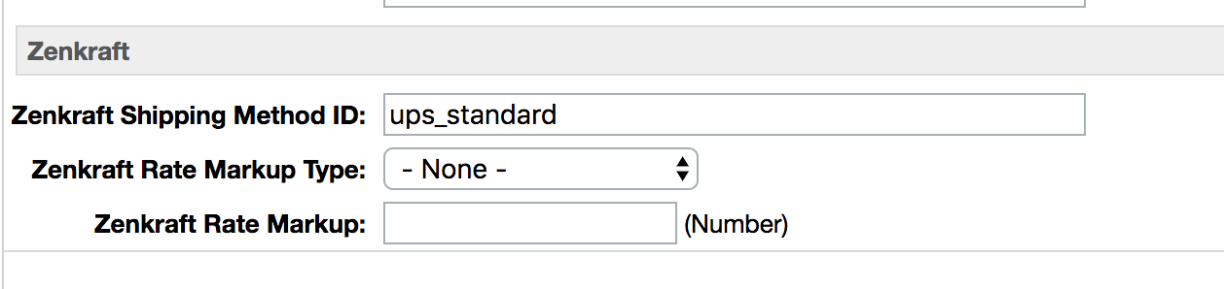

Drop Off Shipments (In Progress)
To enable the Drop Off Shipments feature, you’ll need to designate a shipping method or methods to use for the Drop Offs. To set one up, simply create a shipping method as you normally would. Then, check the box in the Zenkraft section that sets the method as Drop-off, as seen in the following screenshot:
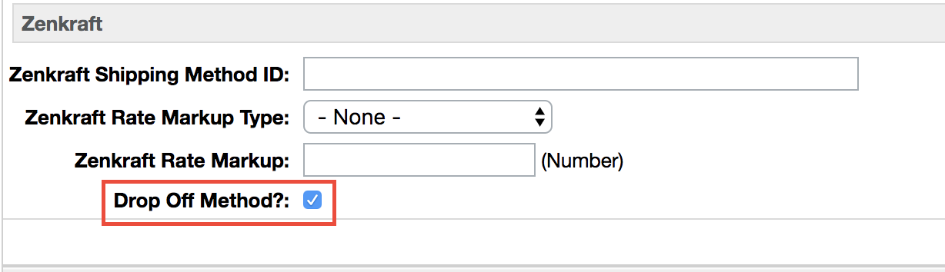

3.3 Custom Code

In order to implement some of the features of the Zenkraft LINK Integration cartridge, some custom code changes need to be done. Below are the changes that need to be made, separated by available feature.

3.3.1 Estimated Delivery Dates

There is no custom code necessary to enable the Estimated Delivery Dates feature. To enable it, you simply need to configure the shipping methods with Zenkraft IDs as mentioned in the ‘Shipping Method Configuration’ section of this document, then enable the site preference named ‘Enable Zenkraft Estimated Delivery Dates’.

3.3.2 Return Labels for Customers

Templates

account/order/orderHistoryCard.isml
This template override is provided in the Zenkraft SFRA cartridge as an example of how to implement the Print Label page. The Print Label page will already exist, but for it to work you’ll need to POST to it and pass the necessary parameters. To display a link in the order details so that a user can print a return label if the order has a shipping status of shipped, add the following code. You can customize the UI in any way you want so that it’s a link, button, etc. You just need to make sure that the zenkraft form definition is used and that the action is the Zenkraft-PrintLabel route.

<form action="${URLUtils.https('Zenkraft-PrintLabel')}" method="post" id="zenkraft-print-label-form">
<input type="hidden" id="orderno" name="orderno" value="${order.orderNumber}"/>
<iscomment>
<input type="hidden" id="shipmentno" name="shipmentno" value="${order.getDefaultShipment().ID}"/>
</iscomment>
<button type="submit" class="button-text" name="zenkraft-printlabel" value="Print Label">Print Return Label</button>
</form>

Client-side Javascript
int_zenkraft_sfra/cartridge/static/default/js/zenkraft.js
This file contains all of the out-of-the-box SFRA client side interactions for the Print Label page. It is included as an asset in the account/orderhistory/printlabel.isml template. You can choose to use this client side javascript as-is, or implement the logic into your own js.

3.3.3 Drop Off Shipping Locations (In Progress)

Templates

3.3.4 Shipment Tracking
One of the best things about the shipment tracking page is that once you have the Zenkraft cartridge set up, there’s no custom code needed in order to get it up and running. It is available at the Zenkraft-Track endpoint of your existing site.

To enable, just set the site preference to true and include your shipping account settings JSON. For more information, see the Site Preferences section below.

Shipment Tracking URL
In order to send your customers to the shipment tracking page, you’ll need to construct the URL in the correct format. As mentioned earlier, the Zenkraft-Track route is where you’ll send them. The URL requires two query string parameters: tracknumber and carrier, with an optional order parameter
- tracknumber: the tracking number associated with this shipment
- carrier: the carrier associated with this shipment
- order: the SFCC order number
You can also set up seo-friendly URLs so that your resulting URL will look something like: https://www.yourbrandedsite.com/trackshipment?tracknumber=123456789&order=N1231231

3.4 External Interfaces
The Zenkraft LINK cartridge integrates with the Zenkraft API through the Salesforce Commerce Cloud Service Framework. In order to get access to the API, you’ll need to contact a representative at Zenkraft and obtain an API key.

3.5 Testing
You can test all of the integrations by setting up your own test account through Zenkraft. Reach out to a representative for assistance with setting up your account.

Once you get your test account, all you need to do is fill in the necessary custom site preferences and the Zenkraft Production Mode preference in the Zenkraft group to ‘NO’. This will enable test mode for all APIs.

Estimated Delivery Dates
Once this is set up, you can test the shipping rates simply by going to the shipping page and entering an address. The estimated delivery dates should display with the shipping methods. You can enable Communication logging for the zenkraft.http.rate service in the SFCC Service Framework to verify that API responses are successful.

Return Labels
To test the return labels, place an order and set the Shipping Status on the order to Shipped via Business Manager. Then open the order on the storefront via the Track Order page or the customer Order History. The Print Return Label link will show on the individual shipment for the order.

4. Operations, Maintenance

4.1 Data Storage
Zenkraft’s core API is hosted on Google Cloud. Zenkraft inherit hardware encryption support in hard drives and SSDs. Before a decommissioned encrypted storage device can physically leave, it is cleaned using a multi-step process that includes two independent verifications. Devices that do not pass this wiping procedure are physically destroyed (e.g. shredded) on-premises.

Once a Zenkraft account is deleted. The data associated with that account is deleted within 12 months.

4.2 Availability
Zenkraft guarantee an uptime of 99.9% however in reality we achieve uptime closer to 99.999%. Zenkraft uptime guarantees exclude the service availability provided by your shipping carrier. Please contact your carrier directly to discuss their SLA.

4.3 Support
Zenkraft provide support from 9am GMT to 5pm EST. Monday to Friday. Our support SLA is outlined in our Master Subscription Agreement, which can be obtained by emailing support@zenkraft.com

5. User Guide

5.1 Roles/Responsibilities
There are no Business Manager roles necessary to implement the Zenkraft SFRA cartridge.

5.2 Business Manager
All Business Manager configurations can be found in the Configuration area of this guide as well as Roles/Responsibilities.

5.3 Storefront Functionality

Shipment Tracking Page
The shipment tracking page is available from the Zenkraft cartridge through the Zenkraft-Track route. The controller expects query string parameters in order to show the proper tracking and order information to the customer. The parameters include ‘tracknumber’, which is the tracking number, ‘carrier’ for the carrier, and ‘order’ for the order ID. ‘order’ is an optional parameter. If it exists then the user is shown the line items on their order. If it does not exist, then the section is not displayed.

The shipment tracking page also allows users to subscribe to shipment notifications when their shipment status has changed. For example, they could be notified when their shipment is out for delivery. Currently, our cartridge supports SMS, WhatsApp and Facebook Messenger notifications through Twilio. But this could easily be swapped out with another notifications service through the NotificationsModel.js.

Print Return Labels
You can add the ability to print return labels through the order history or track order areas by adding the custom code to the templates as described above and setting the necessary custom preferences.

Zenkraft Shipping Rates
You can display real-time shipping rates along with your shipping methods by setting the necessary custom site preferences mentioned in the configuration section of this document and adding the necessary custom code.

Drop Off Shipments
In order to enable this feature, you’ll need to set a shipping method as drop-off-enabled, add the zenkraft.js client code, include the drop-offs template, and obtain/set a Google Maps API key. Instructions for each of these are included in this document.

6. Known Issues
There are no known issues at this time.

7. Release History

Version | Changes
18.1.0 | LINK Cartridge release

