Zenkraft SFRA Test Cases

Purpose Of This Document

These test cases walk through the full flow of each feature in the cartridge, including how to functionally execute.

Estimated Delivery Dates

Test Data

Shipping Methods (Merchant Tools -> Ordering -> Shipping Methods)
- For 3 available shipping methods, add one of the following to the ‘Zenkraft Shipping Method ID’ field. This will map your SFCC methods to UPS methods in Zenkraft.
  - ups_three_day_select
  - ups_second_day_air_am
  - ups_second_day_air
Custom Site Preferences
- Zenkraft Group
  - Zenkraft Master API Key: 3yp7n9oRVvJjrIPVLy6hl2jbjaJZIPgW7vwFCp9Kb3OVdAYuSO
  - Carrier ID: ups
  - Sender Address Street: 20 W 34th St
  - Sender Adrress City: New York
  - Sender Address State: NY
  - Sender Address Postal Code: 10001
  - Sender Address Country Code: US
  - Shipping Account ID: 474557840
  - Enable Zenkraft Estimated Delivery Dates: YES

Functional Steps

1. Set up your configuration based on the Estimated-Delivery-Dates document in the int_zenkraft_sfra cartridge documentation folder

2. Add an item to your cart and proceed to checkout
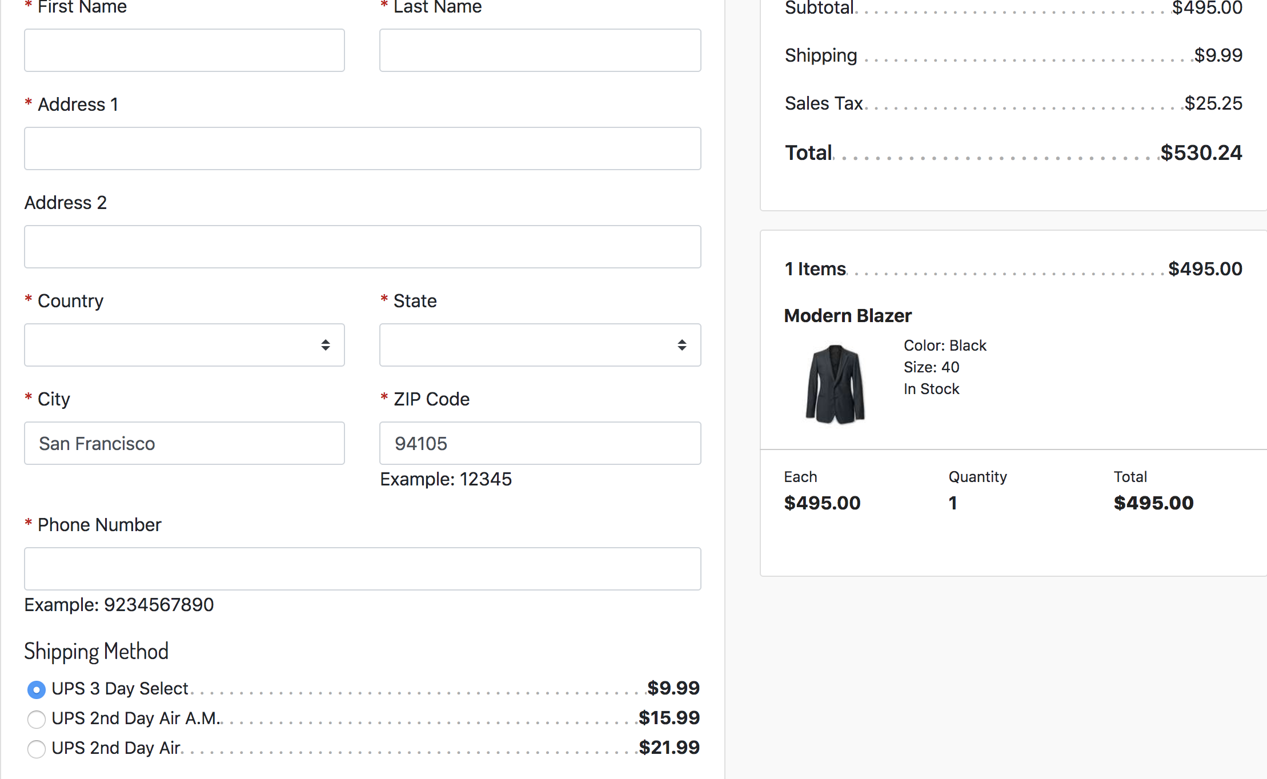

3. Notice that the shipping methods to not have a Delivery Day next to them.
4. Enter the following test address:
a. Address !: 1 Market Street
b. Country: United States
c. City: San Francisco
d. Zip Code: 94105
e. State: California (choose state last as this triggers the refresh in the default RefArch site.
5. Notice that the methods now have days next to them:

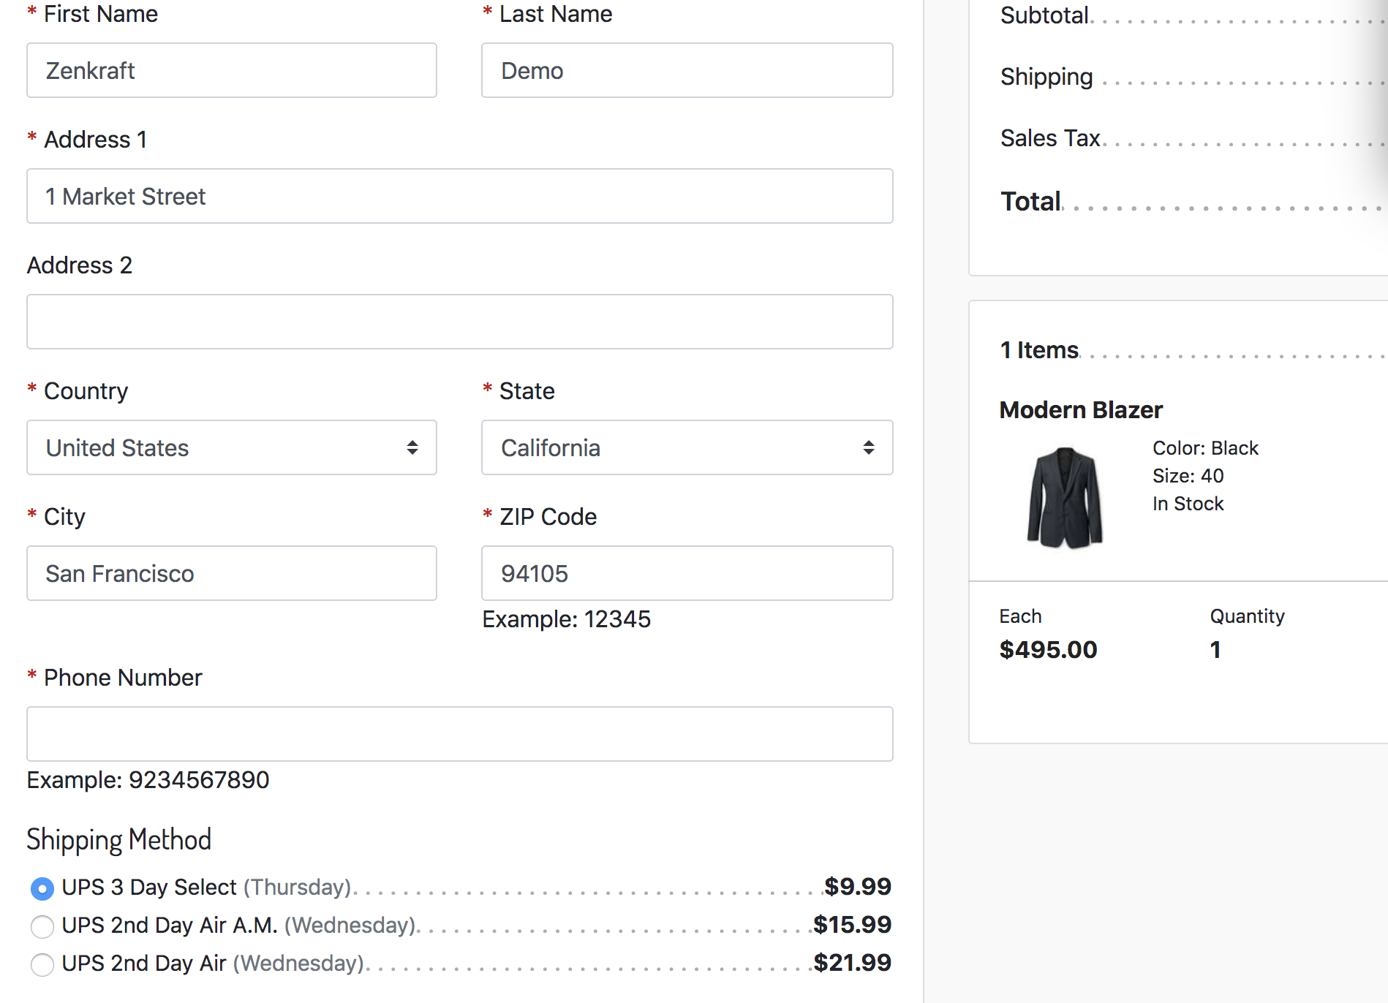

Return Labels

Test Data
Custom Site Preferences
- Zenkraft Group
  - Zenkraft Master API Key: 3yp7n9oRVvJjrIPVLy6hl2jbjaJZIPgW7vwFCp9Kb3OVdAYuSO
  - Carrier ID: ups
  - Sender Address Street: 20 W 34th St
  - Sender Adrress City: New York
  - Sender Address State: NY
  - Sender Address Postal Code: 10001
  - Sender Address Country Code: US
  - Shipping Account ID: 474557840
  - Enable Zenkraft Estimated Delivery Dates: YES
- Zenkraft Returns Group
  - Returns Shipping Account ID: 5648633076645888
  - Returns Carrier ID: ups
  - Shipping Service: ups_ground
  - Recipient Address Street: 10062 Treena Street
  - Recipient Adrress City: San Diego
  - Recipient Address State: CA
  - Recipient Address Postal Code: 92131
  - Recipient Address Country Code: US
  - Shipping Label File Type For Returns: PDF

Functional Steps

1. You’ll need to add an item to your cart and place an order. Then, have the shipment status changed to ‘SHIPPED’ in order to see the Print Return Label button

2. Proceed to ‘Check Order’ in the site footer
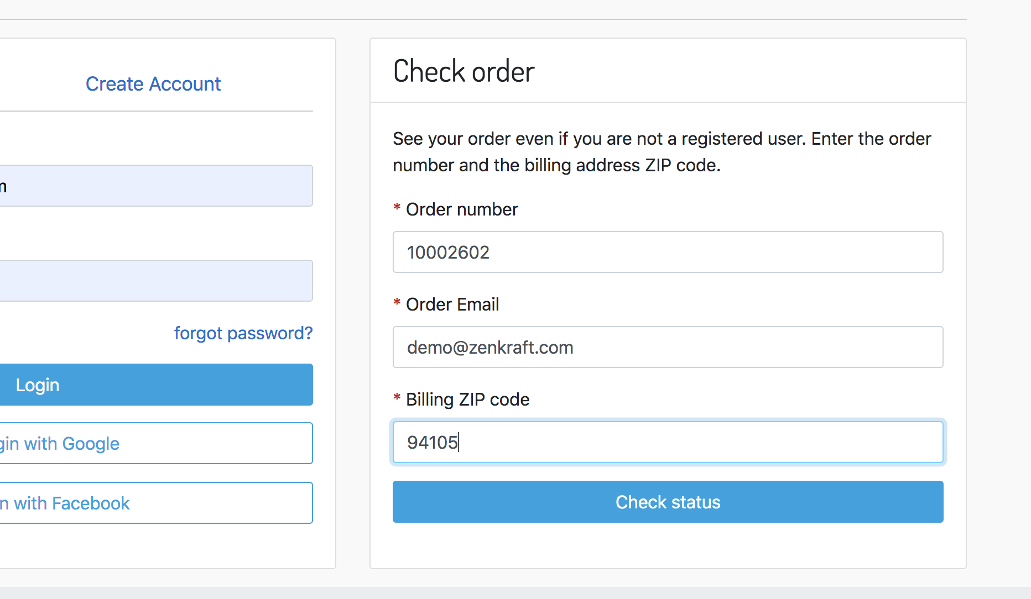
3. Enter your order details and click ‘Check Status’

4. Click the Print Return Label button.
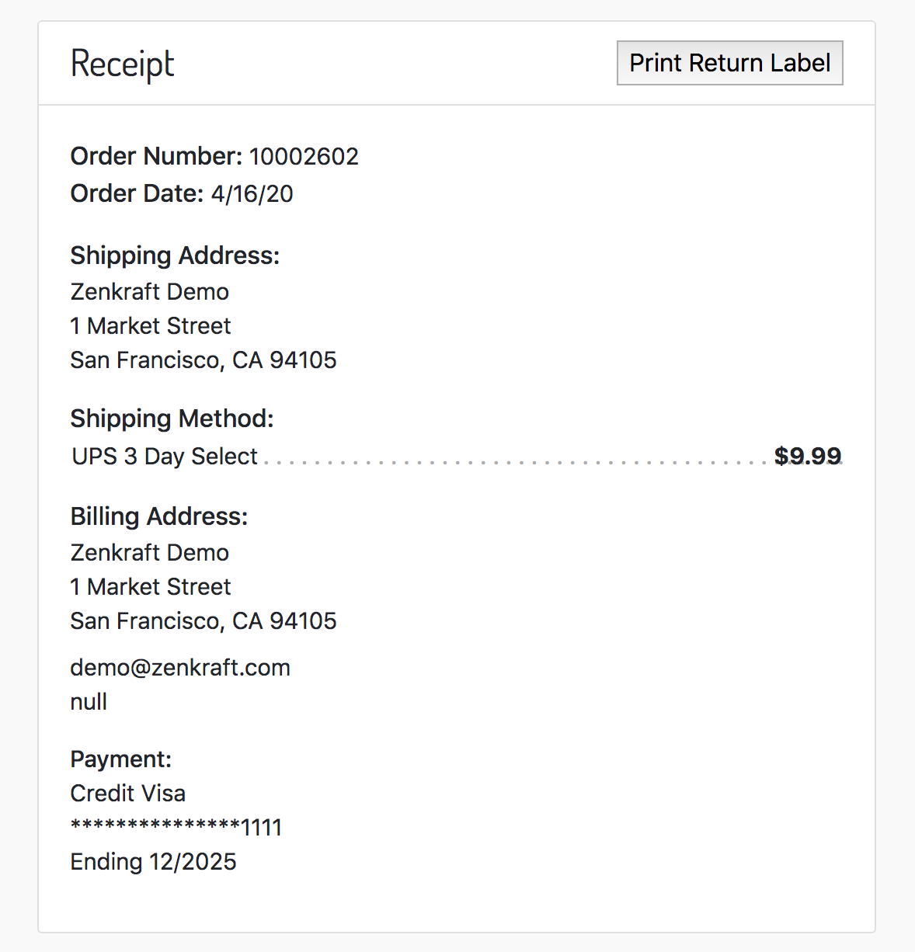

5. Select an item for the return and click ‘Print Label’
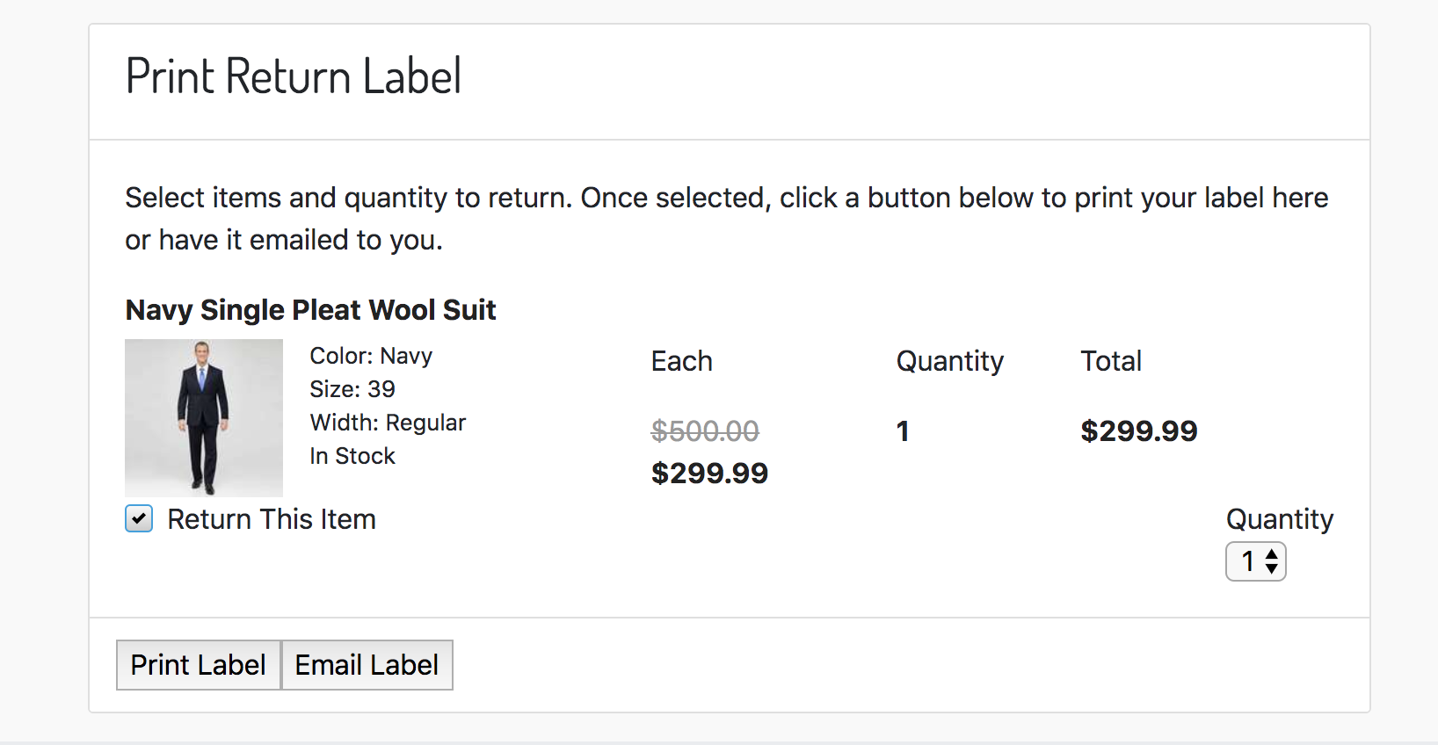

6. Observe that the label opens in a new tab/window.

7. Click the ‘Email Label’ button, fill out and submit the form.

8. Check you email and observe that you have received a link to the return label:
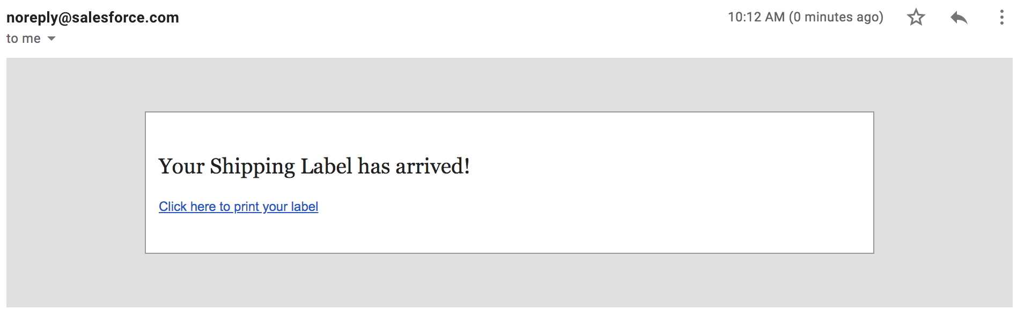

Shipment Tracking Page

Test Data
Custom Site Preferences
- Zenkraft Tracking Page Settings Group
  - Enable Zenkraft Tracking page: YES
  - Zenkraft Tracking Settings JSON:
{
"fedex": {
"DEBUG": "true",
"SHIPPING_ACCOUNT": "5954269987129640120"
},
"ups": {
"DEBUG": "true",
"SHIPPING_ACCOUNT": "5648633076645888"
},
"dhl": {
"DEBUG": "true",
"SHIPPING_ACCOUNT": "285153973"
}
}

Functional Steps

1. Open up a link in your environment that goes to the Zenkraft-Track route, for example:
https://zenkraftlimited01-tech-prtnr-eu04-dw.demandware.net/on/demandware.store/Sites-RefArchUPS-Site/en_US/Zenkraft-Track?tracknumber=1Z447943A447456176&carrier=ups

2. In the above URL, replace the realm and site with your own. The test tracking number and carrier included will work with the settings provide above.

3. Open the page and observe the following:
