Steps to Create Database and Tables for TalentLync Daily Attendance Website/App

1. Install Xampp
2. After Setup open the Xampp control panel and click the start buttons at Apache and MySQL – those 2 turn green indicating servers started and displays port numbers. Now go to your browser and type in the URL http://localhost/phpmyadmin
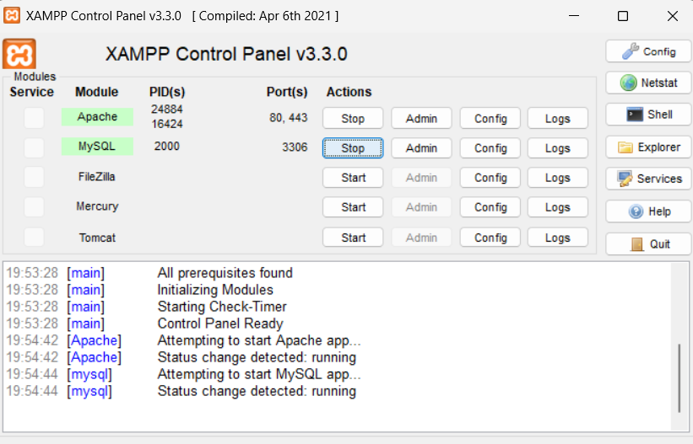
3. Go to database and create a database by giving a name – talentlyncattendanceportal
4. Create tables by giving Table name and no. of columns required
5. For each column specify name of the column data type any special constraint like PRIMARY or not NULL under NULL section
6. If required specify the length
7. For Id kind of columns use auto_increment when needed ( tick the A.I box )
8. For any default values specification we can choose As_defined and enter the required default value to be displayed
9. After filling all the column details click on save to save the table
10. And continue the same process for creating all the tables

NOTE :
- For login_dateTime use time stamp and under default select current_timestamp() and choose "on update current_timestamp()"
- Ensure to click the save button after every change you make to the table structure
- To add columns or edit already added columns go to structure section and
- Add : at Add enter no. of columns to add and choose to add after the specific column and click Go.
- Edit existing : select the columns to modify and then add/modify respectively.
Table 1 : admin_tbl
admin_id INT 11 PRIMARY (Auto Increment)
username VARCHAR 20
secure_key VARCHAR 200
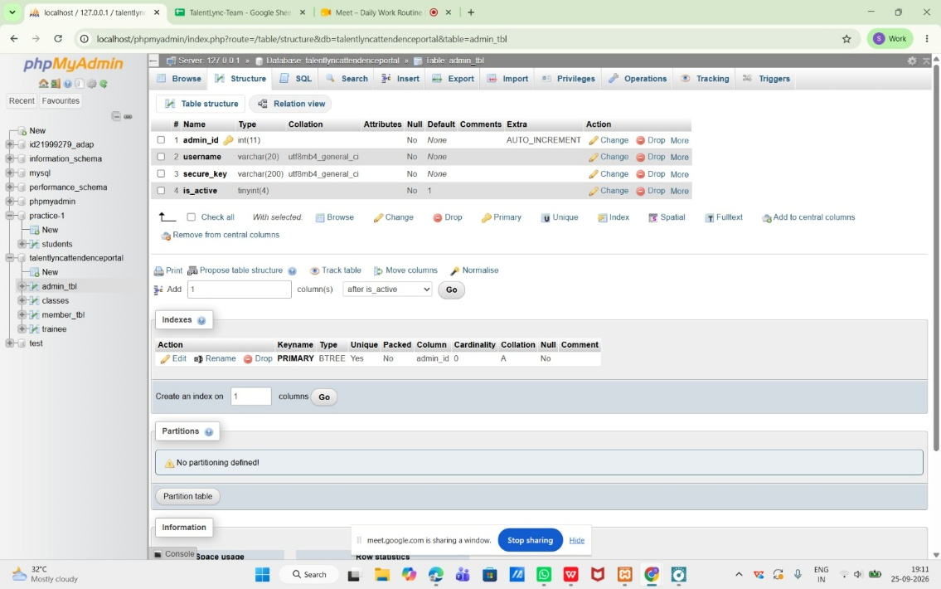
is_active TINYINT(4) default 1
Table 2 : member_tbl:
member_id INT 70 PRIMARY (Auto Increment)
username VARCHAR 40
email VARCHAR 60
roll_number VARCHAR 40
GitHub TEXT 250
LinkedinProfile TEXT 250
Batch INT 4
Mobile VARCHAR 10
Branch VARCHAR 100
JoinedDate DATE
CreatedOn DATE
UpdatedOn DATE
skills TEXT
password VARCHAR 100
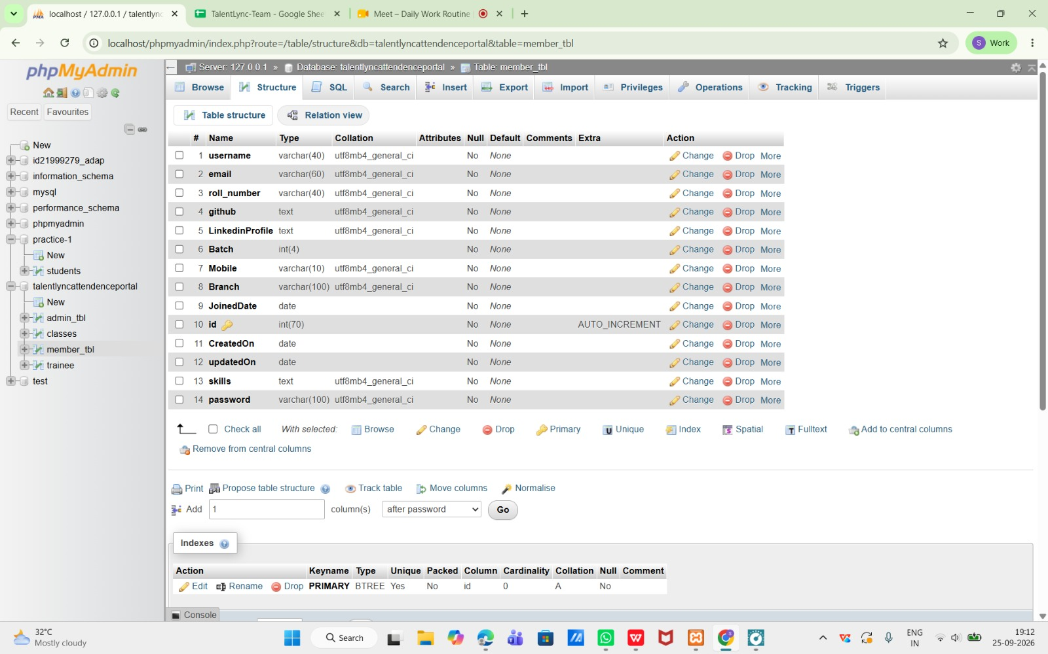
Table 3: trainee
trainee_id INT 11 PRIMARY (Auto Increment)
username VARCHAR 70
email VARCHAR 60
Mobile VARCHAR 10
skills TEXT
password VARCHAR 100
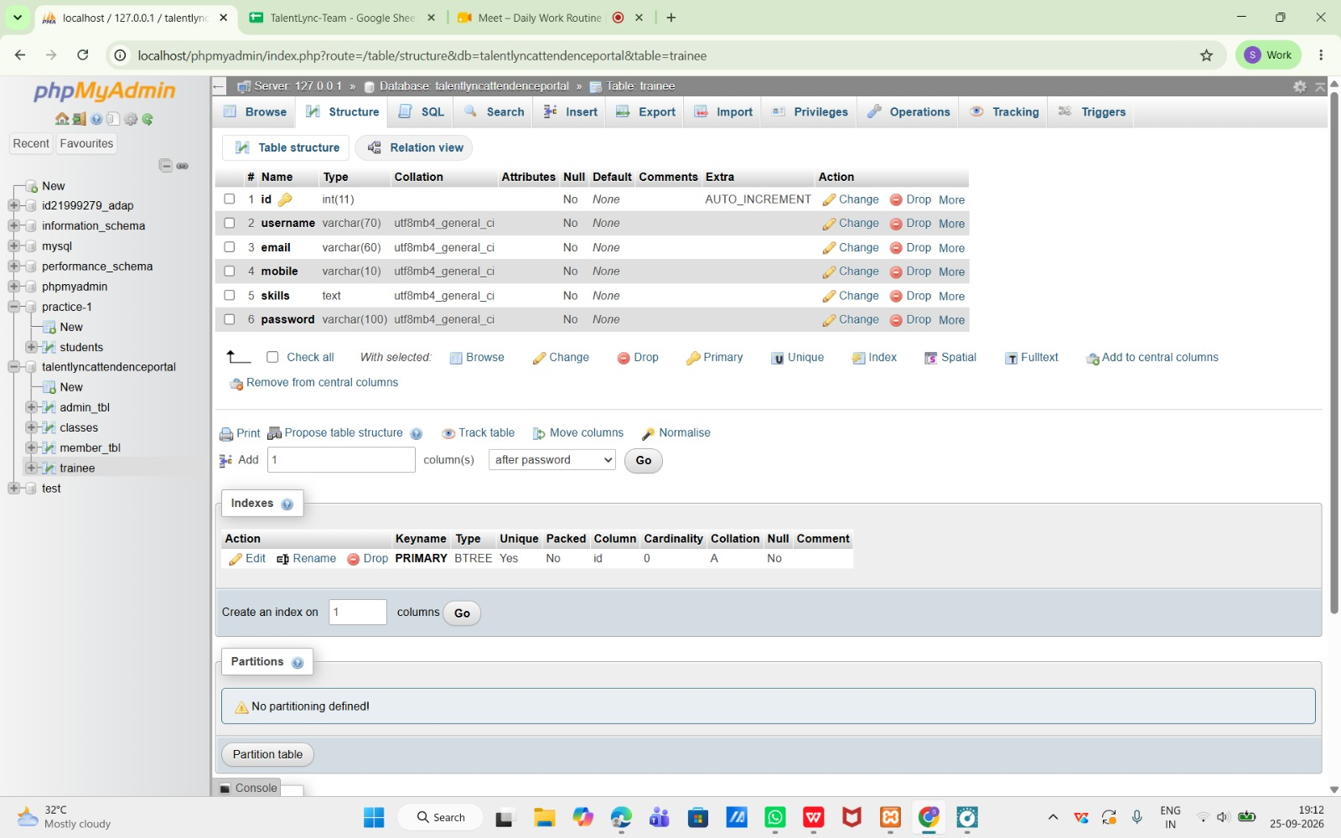

Table 4: classes
class_id INT 11 PRIMARY (Auto Increment)
className VARCHAR 100
Timings TEXT
description TEXT
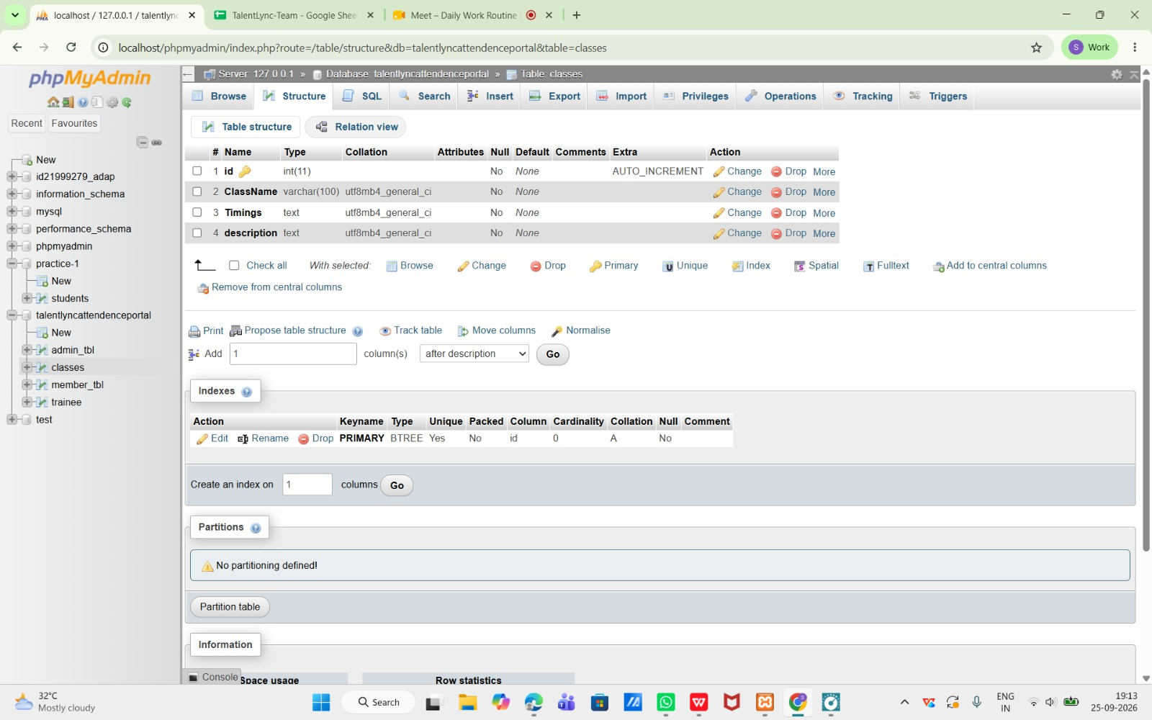

Table 5: attendance
attendance_id INT 11 PRIMARY (Auto Increment)
class_id INT 11
member_id INT 70
trainee_id INT 11
login_dateTime timestamp current_timestamp Extra : ON UPDATE CURRENT_TIMESTAMP()
createdON DATE
Location TEXT
trainee_approve TINYINT 4
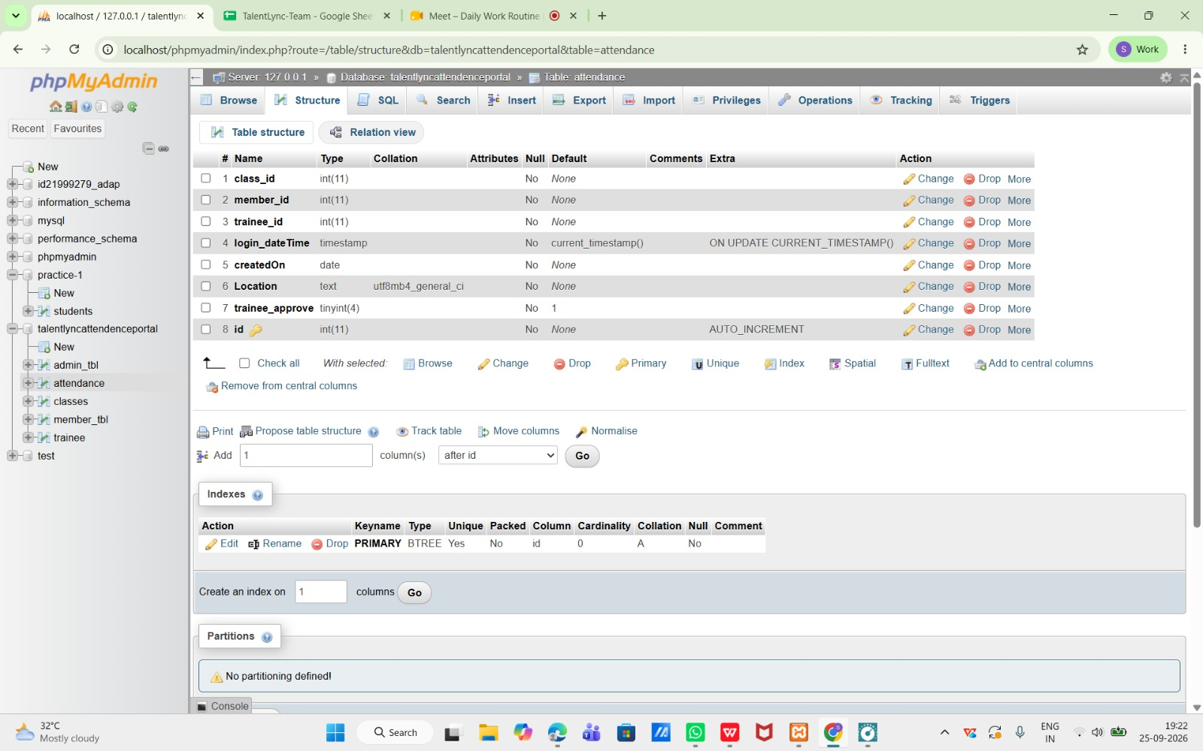
Schema after creating all tables – Designer Section
