training data – from 2012 to 2017 i.e., 5 years of data

testing data – from 2018 to 2019 i.e., 2 years of data

**Method - 1 - #NEAT-Neuro Evolution of augmenting topologies**

* artificial neural networks with genetic algorithms
* crossover of different topologies, incrementally growing from minimal structure, by protecting structural innovation

Each **genome** includes – Node genes and connection genes

Connection gene specifies

* in-node
* out-node
* weight of the connection
* whether there is a connection or not
* innovation number (allows to find the corresponding genes during crossover)

R^2 value - 0.6454438572917882

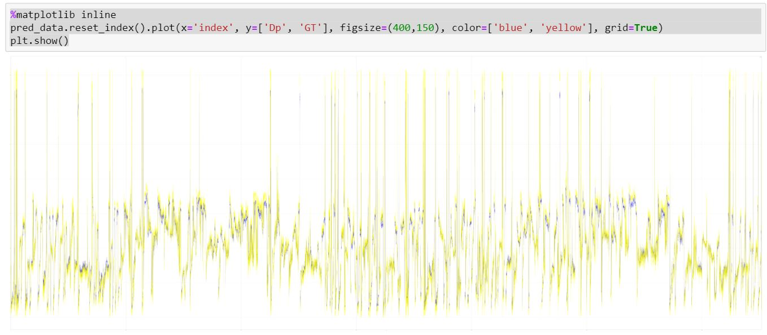

Figure 1 - neat, ground truth vs prediction

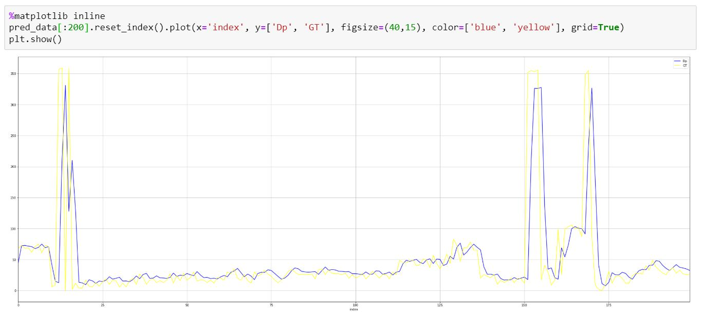

Figure 2- neat, ground truth vs prediction for 200 observations

Method 2 – Gradient Boosting Regressor model

R^2 value – 0.6985648776018133

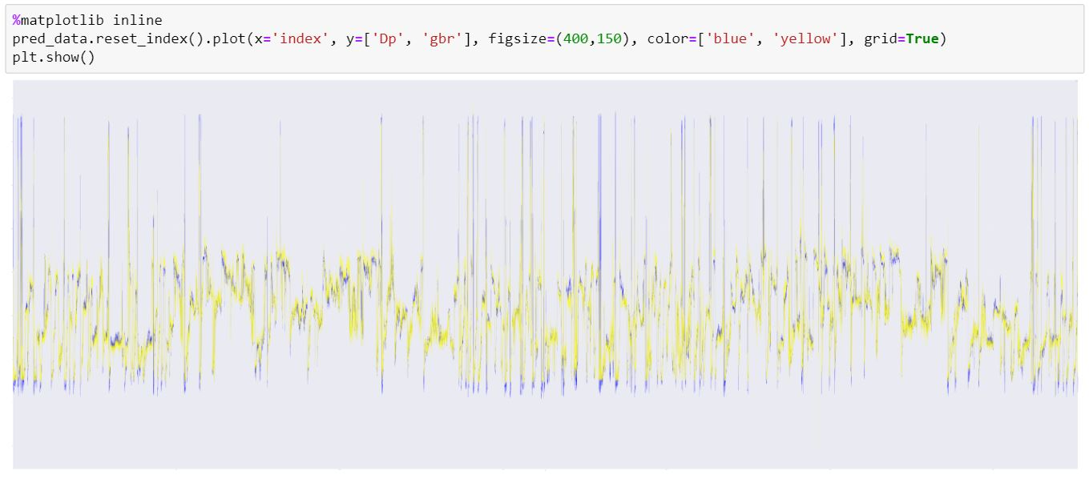

Figure 3 - GBR, ground truth vs prediction

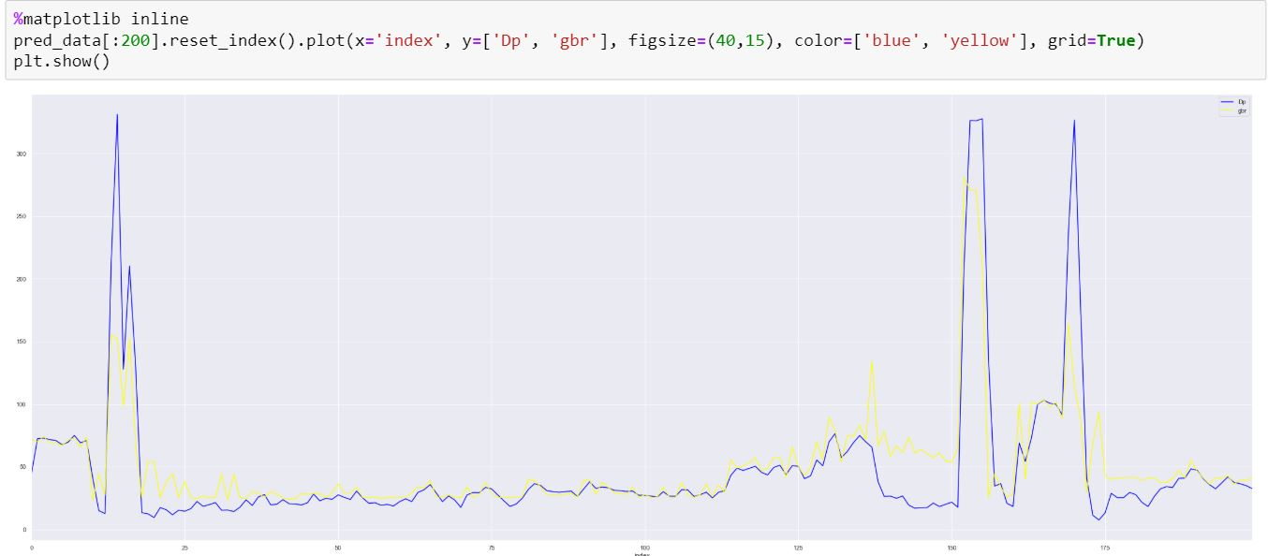

Figure 4 - GBR, ground truth vs prediction for 200 observations

Method 3 – Random Forest Regressor

R^2 value – 0.6130752585918393

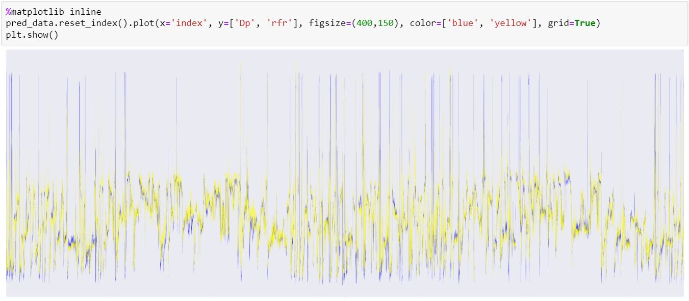

Figure 5 - RFR, ground truth vs prediction

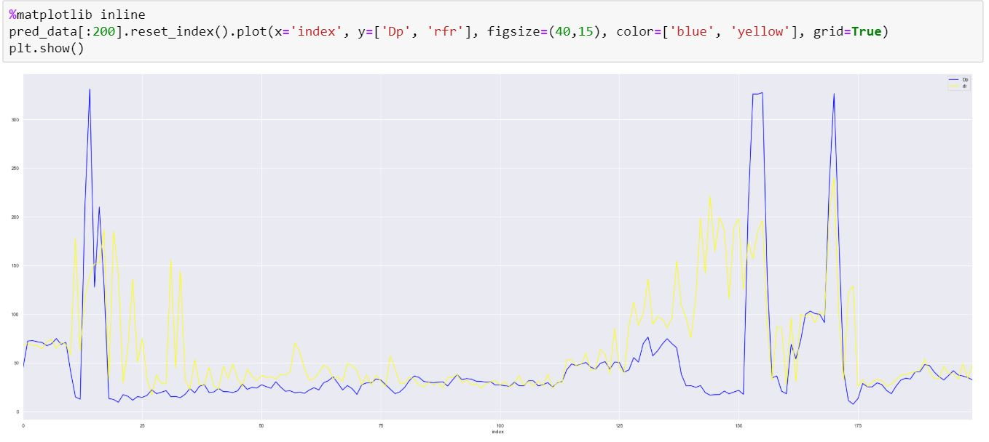

Figure 6 - RFR, ground truth vs prediction for 200 observations