**#NEAT-Neuro Evolution of augmenting topologies**

* artificial neural networks with genetic algorithms
* crossover of different topologies, incrementally growing from minimal structure, by protecting structural innovation

Each **genome** includes – Node genes and connection genes

Connection gene specifies

* in-node
* out-node
* weight of the connection
* whether there is a connection or not
* innovation number (allows to find the corresponding genes during crossover)

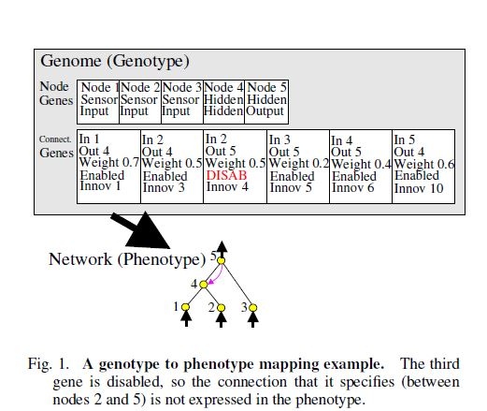

**Add connection** mutation - a single new connection gene is added connecting two previously unconnected nodes

**Add node** mutation – an existing connection is split, and a new node is added

When a new gene appears, a global innovation number is incremented and assigned to that gene.

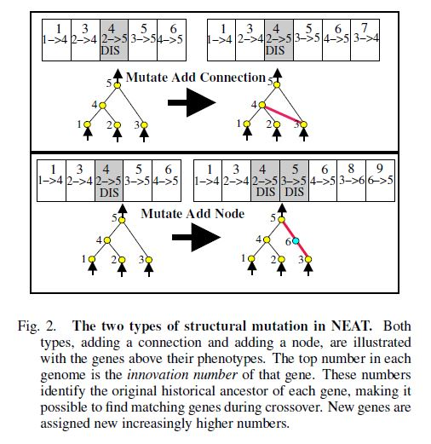

Genes that do not match are either disjoint or excess, offspring

* inherits from the more fit parent
* if equally fit, randomly inherited from the parents

