AI-DEFECT-ANALYSIS-SYSTEM
RAG-Powered Multi-Agent Software Defect Analysis Platform

Technical Project Documentation
Technology:
- Python
- Google Gemini 2.5 Flash
- RAG
- ChromaDB
- Sentence Transformers
- Multi-Agent AI
- Streamlit
Knowledge Base:
- Eclipse
- Mozilla Historical Defect Repositories
- Apache
-----------------------------------------------------------------------------------------------------
1. ABSTRACT
Software defect management is an essential part of modern software development, but conventional bug-tracking systems largely depend on manual analysis. Developers and testers must examine defect descriptions, search historical issues, inspect logs, identify possible duplicates, determine severity, locate root causes, and design appropriate remediation strategies. This process can be time-consuming, inconsistent, and difficult to scale when large historical defect repositories are involved.
The AI-Powered Software Defect Analysis System addresses this challenge by combining Retrieval-Augmented Generation (RAG) with a specialized multi-agent AI architecture.
The system accepts a software defect description along with optional stack traces, error logs, and supporting files. Historical software defect repositories from Apache, Eclipse, and Mozilla are processed, standardized, chunked, transformed into semantic embeddings, and indexed using ChromaDB. During analysis, the system retrieves semantically relevant historical defects and provides this evidence to specialized AI agents.
The analysis pipeline consists of five specialized agents:
- Triage Agent for defect classification, severity, priority, scope, and reproducibility.
- Duplicate Detection Agent for identifying related or potentially duplicate historical defects.
- Log Analysis Agent for interpreting stack traces and technical error evidence.
- Root Cause Agent for correlating direct technical evidence with historical evidence.
- Remediation Agent for generating corrective actions, testing strategies, and regression-prevention recommendations.
Google Gemini 2.5 Flash acts as the reasoning engine, while the RAG layer provides historical software engineering context. The resulting system demonstrates how AI can move beyond simple bug classification toward evidence-driven defect investigation and engineering decision support.
---------------------------------------------------------------------------------------------------------
2. KEYWORDS
Artificial Intelligence, Software Defect Analysis, Bug Triage, Retrieval-Augmented Generation, RAG, Multi-Agent AI, Large Language Models, Gemini 2.5 Flash, ChromaDB, Semantic Search, Root Cause Analysis, Duplicate Detection, Software Testing, Automated Remediation
---------------------------------------------------------------------------------------------------------
3. INTRODUCTION
Software systems continuously evolve through new features, configuration changes, integrations, and maintenance activities. As software complexity increases, the number and diversity of defects also increase.
Traditional defect management generally follows a workflow where a tester or developer:
- Reports the defect.
- Reads the defect description.
- Searches previous issues.
- Examines logs and stack traces.
- Determines severity and priority.
- Investigates the root cause.
- Suggests a fix.
- Performs regression testing.
Although this process is effective, it places significant cognitive and time requirements on engineering teams.
A major source of useful information already exists within historical defect repositories. Previous defects contain valuable information about recurring failures, affected components, authentication problems, crashes, exceptions, configuration issues, and previously applied resolutions.
However, manually searching hundreds of thousands of historical defect reports is impractical.
The proposed system therefore combines:
Semantic Retrieval + Historical Evidence + Specialized AI Agents + LLM Reasoning
to create an intelligent defect analysis pipeline.
---------------------------------------------------------------------------------------------------------
4. PROBLEM STATEMENT
Modern software defect reports often contain incomplete or unstructured information. A single defect may require engineers to correlate:
- User-reported symptoms
- Application behavior
- Error messages
- Stack traces
- Server logs
- Historical defects
- Component information
- Severity and priority
- Previous resolutions
Existing bug-tracking systems primarily store and organize defects but do not provide a complete autonomous reasoning workflow for investigating them.
Therefore, there is a need for an intelligent system that can:
Understand a new software defect, retrieve relevant historical evidence, analyze technical logs, correlate multiple sources of evidence, identify the likely root cause, and generate an actionable remediation strategy.
---------------------------------------------------------------------------------------------------------
5. PROJECT OBJECTIVES
The primary objectives of the project are:
Objective 1: Intelligent Defect Triage
Automatically determine:
- Defect category
- Severity
- Priority
- Affected area
- Reproducibility
- User/business impact
Objective 2: Historical Defect Retrieval
Build a semantic knowledge base from historical Apache, Eclipse, and Mozilla defects and retrieve the most relevant historical evidence for a new defect.
Objective 3: Multi-Agent Defect Investigation
Use specialized AI agents to divide the defect investigation process into focused analytical tasks.
Objective 4: Technical Evidence Analysis
Analyze stack traces, application logs, server logs, and error messages to identify concrete technical failure points.
Objective 5: Root Cause Identification
Correlate direct technical evidence with historical defect evidence to distinguish confirmed causes from hypotheses.
Objective 6: Actionable Remediation
Generate practical corrective actions, testing strategies, and regression-prevention recommendations.
---------------------------------------------------------------------------------------------------------
6. PROPOSED SOLUTION
The proposed solution is an RAG-powered multi-agent defect analysis platform.
The system follows the pipeline:
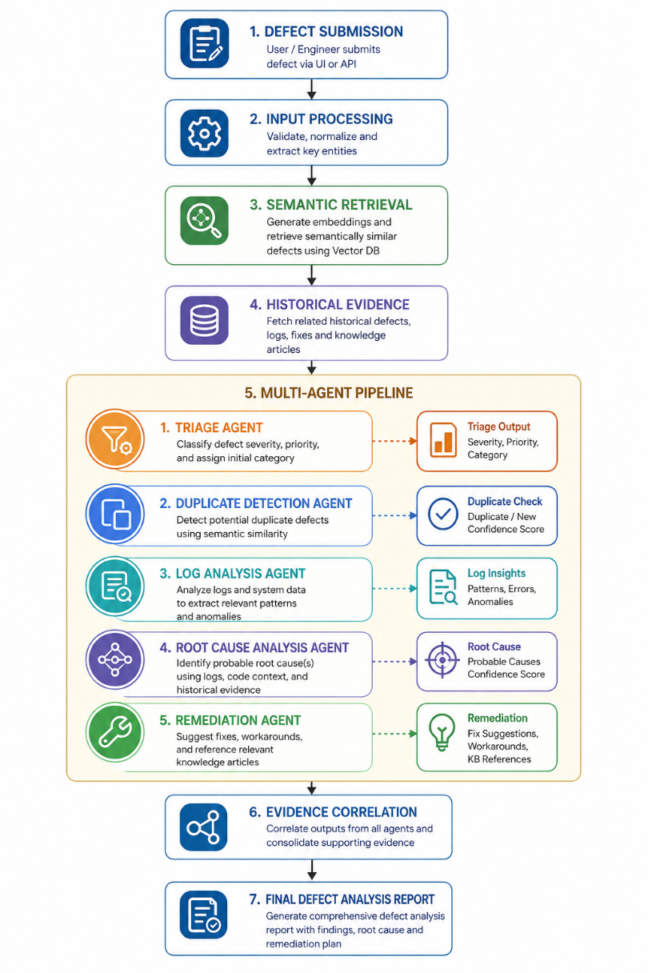
The important design principle is that the system does not rely exclusively on the language model's internal knowledge.
Instead:
Historical defects provide evidence, while the AI agents provide reasoning.
---------------------------------------------------------------------------------------------------------
7. SYSTEM ARCHITECTURE
7.1 Architecture Overview
The system consists of six major layers:
- User Interface Layer
- Defect Processing Layer
- RAG Knowledge Layer
- Multi-Agent Analysis Layer
- LLM Reasoning Layer
- Final Reporting Layer

Architecture Diagram
Figure 1: Overall System Architecture
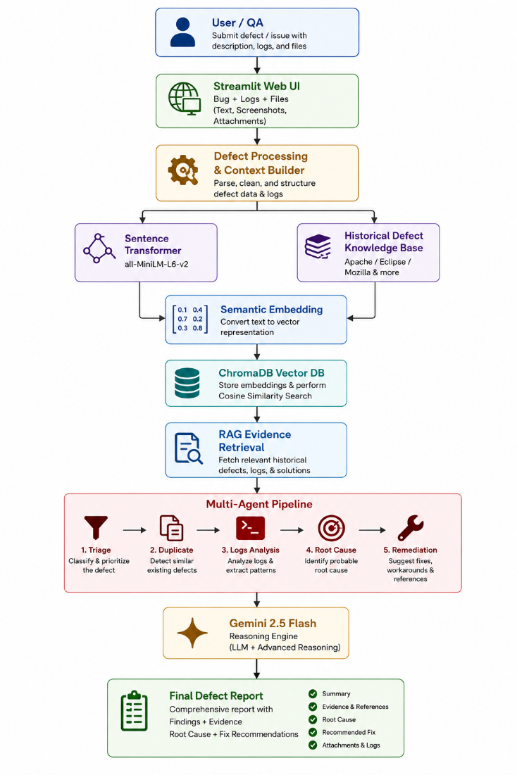
---------------------------------------------------------------------------------------------------------
8. TECHNOLOGY STACK
Layer | Technology
Programming Language | Python
User Interface | Streamlit
LLM | Google Gemini 2.5 Flash
Embedding Model | all-MiniLM-L6-v2
Embedding Dimension | 384
Vector Database | ChromaDB
Similarity Metric | Cosine Similarity
AI Architecture | Multi-Agent System
Retrieval Architecture | RAG
Data Format | CSV / JSON / JSONL
Environment | Python Virtual Environment
Configuration | Environment Variables
Testing | Python Test Scripts
---------------------------------------------------------------------------------------------------------
9. HISTORICAL DEFECT KNOWLEDGE BASE
A strong RAG system requires a reliable knowledge base.
This project uses historical defect information from three major open-source software ecosystems:
Apache
The Apache historical dataset contains a large collection of historical defect reports covering projects such as Tomcat, Log4j, Xerces, Ant, and FOP.
Eclipse
The Eclipse dataset provides a significantly larger defect repository containing hundreds of thousands of historical reports.
Mozilla
Mozilla defect information provides additional historical software defect evidence from the Firefox/Mozilla ecosystem.
The combination of these sources provides diversity across:
- Authentication defects
- Application crashes
- Null pointer exceptions
- Configuration failures
- Build problems
- Network issues
- UI failures
- Performance issues
- Browser failures
- Server-side failures
---------------------------------------------------------------------------------------------------------
10. DATA PREPROCESSING PIPELINE
The historical data was not directly inserted into the vector database.
A structured preprocessing pipeline was implemented.
Raw Dataset
↓
Data Inspection
↓
Missing Value Analysis
↓
Column Standardization
↓
Unified Schema
↓
Balanced Dataset
↓
Text Chunking
↓
Embedding Generation
↓
Vector Database
---------------------------------------------------------------------------------------------------------
11. DATA STANDARDIZATION
Different defect repositories use different field names.
For example:
short_desc
bug_severity
bug_status

were standardized into a common representation such as:
title
severity
status

The final standardized schema contains:
bug_id
source
title
description
product
component
severity
priority
status
resolution
duplicate_info
root_id
disc_id
search_text
Additional source-specific fields were retained where required during preprocessing.
---------------------------------------------------------------------------------------------------------
12. DATASET RESULTS
The standardized datasets produced the following results:
Source | Final Records
Apache | 43,991
Eclipse | 503,097
Mozilla | 99
Total | 547,187
The unified dataset therefore contains:
547,187 historical defect records
No duplicate records or empty-title records were removed during the final unification stage.
---------------------------------------------------------------------------------------------------------
13. BALANCED DATASET
Because the source datasets have significantly different sizes, a balanced evaluation dataset was created.
The balanced dataset contains:
Source | Bug Reports
Apache | 2,000
Eclipse | 2,000
Mozilla | 99
Total | 4,099
This provides a more controlled test environment for evaluating retrieval across multiple defect sources.
---------------------------------------------------------------------------------------------------------
14. TEXT CHUNKING
Historical defect reports were converted into searchable textual representations.
The chunking configuration used:
Maximum Characters = 2000
Overlap = 300 characters
The purpose of overlap is to reduce information loss when a defect report exceeds the maximum chunk size.
The balanced dataset produced:
4,125 chunks from 4,099 bug reports
Distribution:
Number of Chunks | Bug Reports
1 | 4,084
2 | 11
3 | 2
6 | 1
7 | 1
---------------------------------------------------------------------------------------------------------
15. EMBEDDING GENERATION
Each chunk was converted into a numerical semantic representation using the:
all-MiniLM-L6-v2
embedding model.
Each embedding contains:
384 dimensions
The balanced knowledge base generated:
4,125 embeddings
These embeddings allow the system to compare a new defect against historical defects based on semantic meaning rather than exact keyword matching.
---------------------------------------------------------------------------------------------------------
16. VECTOR DATABASE
The generated embeddings were stored in ChromaDB.
Configuration
Collection:
historical_defects_balanced

Vectors:
4,125

Distance Metric:
Cosine

Embedding Dimension:
384
Validation confirmed:
Expected vectors: 4,125
Stored vectors: 4,125

Validation: PASSED
The vector database enables fast semantic retrieval of historical defects relevant to a newly submitted defect.
---------------------------------------------------------------------------------------------------------
17. RETRIEVAL-AUGMENTED GENERATION
Retrieval-Augmented Generation is the central intelligence layer of the system.
Instead of asking Gemini to analyze a defect without context, the system first retrieves relevant historical defects.
New Defect
↓
Embedding
↓
Vector Search
↓
Top Historical Defects
↓
RAG Context
↓
Gemini
↓
Evidence-Based Analysis
The RAG context contains:
- Historical bug ID
- Source
- Title
- Product
- Component
- Severity
- Priority
- Status
- Resolution
- Similarity score
- Relevant text
This context is then passed to the AI agents.
---------------------------------------------------------------------------------------------------------
18. SEMANTIC RETRIEVAL VALIDATION
Several retrieval test cases were used to validate the semantic search system.
Test Case 1: Login Failure
Query:
"Application crashes during login after entering valid credentials"
Top retrieved defects included authentication-related Apache defects such as:
- JDBC Realm authentication crash
- Wrong user/password authentication error
- Login page authentication flow failure
- JDBC Realm session failure
This demonstrated that the system could retrieve defects from the same functional domain even when the wording differed.
---------------------------------------------------------------------------------------------------------
Test Case 2: Null Pointer Exception
Query:
"Null pointer exception causes application crash"
The system retrieved historical defects containing:
- NullPointerException
- Null pointer bugs
- MemoryRealm exceptions
- Parsing-related NullPointerException
The highest similarity score was approximately:
0.5243
---------------------------------------------------------------------------------------------------------
Test Case 3: Build Failure
Query:
"Software build fails unexpectedly after changing configuration"
The retrieval system returned Eclipse defects related to:
- Build configurations
- Environment variables
- Build variants
- Launch/build configuration
- Release engineering builds
This indicates that semantic retrieval is able to capture contextual relationships between software defects.
---------------------------------------------------------------------------------------------------------
19. MULTI-AGENT ARCHITECTURE
The system divides defect investigation into five specialized agents.
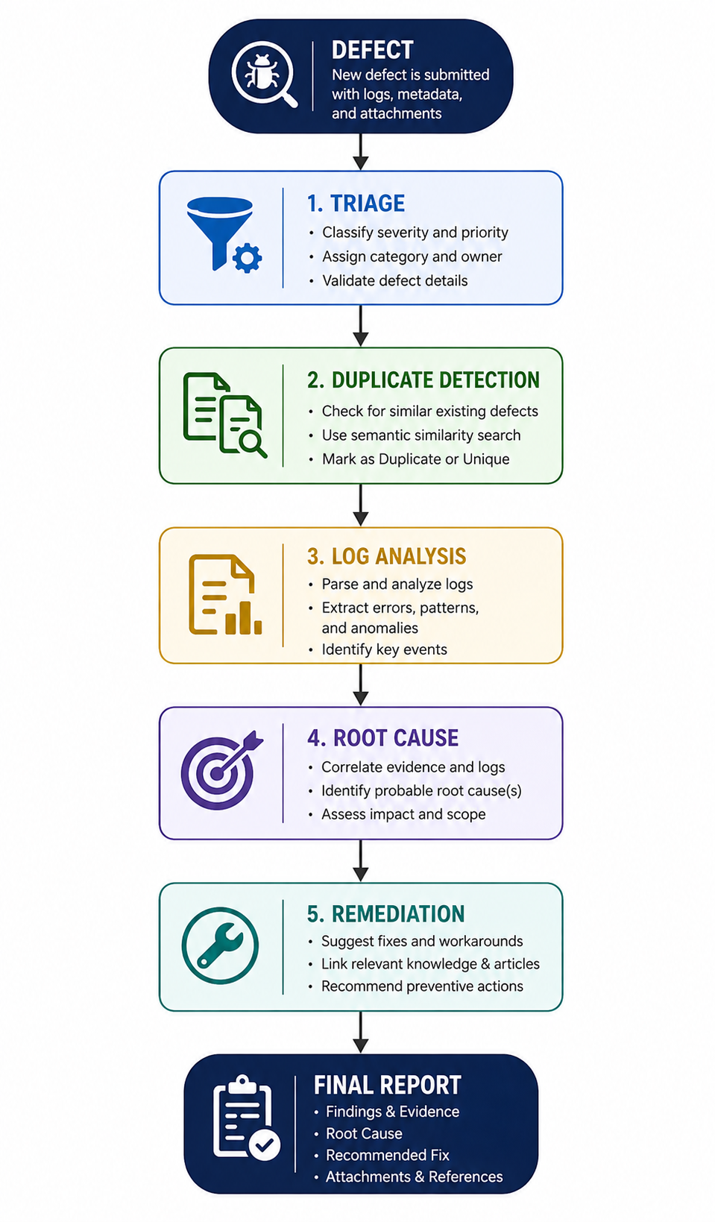
20. TRIAGE AGENT
The Triage Agent performs the initial classification of the defect.
It evaluates:
- Defect category
- Severity
- Priority
- Affected area
- Business impact
- Reproducibility
- Investigation confidence
Example
For a defect where the application consistently crashes during login, the agent identified:
Category:
Application Crash / Functional Defect

Affected Area:
Authentication / Login Flow

Severity:
HIGH

Priority:
P2

Reproducibility:
Consistent
The agent also identifies missing information required for stronger analysis.
---------------------------------------------------------------------------------------------------------
21. DUPLICATE DETECTION AGENT
The Duplicate Detection Agent compares the current defect with historically retrieved defects.
Importantly, the system does not classify a defect as a duplicate merely because it has a high semantic similarity score.
The agent evaluates:
- Symptom similarity
- Failure behavior
- Product
- Component
- Authentication context
- Technical evidence
- Historical metadata
For the login crash test, Apache Bug 24901 was identified as a related historical defect.
However, the agent correctly classified it as:
RELATED DEFECT
rather than an exact duplicate because the historical defect involved an HTTP 500 response while the current defect involved application termination.
This evidence-based distinction is an important feature of the system.
---------------------------------------------------------------------------------------------------------
22. LOG ANALYSIS AGENT
The Log Analysis Agent processes technical evidence such as:
- Stack traces
- Error messages
- Application logs
- Server logs
- Console output
Two scenarios were tested.
Scenario A: No Technical Logs
When no technical evidence is provided:
Exception:
Not identified

Failure Location:
Unknown

Evidence Quality:
NONE

Confidence:
LOW
The system explicitly identifies the missing evidence rather than inventing a root cause.

Scenario B: Stack Trace Provided
The test stack trace contained:
java.lang.NullPointerException
with the message:
Cannot invoke "UserSession.setToken(String)"
because "session" is null

The agent identified:
AuthenticationService.createSession
AuthenticationService.java:142
and reconstructed the call sequence:
LoginController.login:54
↓
LoginController.authenticate:87
↓
AuthenticationService.createSession:142
Evidence Quality:
HIGH
Confidence:
HIGH
---------------------------------------------------------------------------------------------------------
23. ROOT CAUSE AGENT
The Root Cause Agent combines evidence from:
- Triage
- Duplicate Detection
- Log Analysis
- RAG historical evidence
The agent follows an evidence hierarchy where direct technical evidence receives greater weight than semantic similarity.
For the tested login defect, the root cause was confirmed as:
A UserSession object was null when session.setToken() was invoked inside AuthenticationService.createSession().
The confirmed failure location was:
AuthenticationService.java:142

The agent correctly distinguished:
Confirmed
The session object is null.
Not yet confirmed
Why the session object became null.
Possible underlying causes include:
- Session factory returning null
- Missing initialization
- Conditional path bypassing assignment
- Dependency injection/configuration problem
This distinction prevents the system from presenting unsupported assumptions as facts.
---------------------------------------------------------------------------------------------------------
24. REMEDIATION AGENT
The Remediation Agent converts the root cause into an actionable engineering plan.
For the confirmed NullPointerException, recommendations included:
Immediate Fix
Add validation before:
session.setToken(...)
Graceful Error Handling
Instead of allowing application termination:
Null session
↓
SessionCreationException
↓
Structured error handling
↓
User-friendly login failure
Code Investigation
Inspect:
- Session factory
- Dependency injection
- Session initialization
- Authentication lifecycle
Testing
Recommended:
- Unit testing
- Integration testing
- Regression testing
Prevention
Recommended controls include:
- Non-null contracts
- Static analysis
- Defensive programming
- Code review checks
- Authentication monitoring
--------------------------------------------------------------------------------------------------------
25. EVIDENCE-DRIVEN REASONING
A major design principle of this system is:
Similarity is evidence, not proof.
For example, a historical defect may have a high semantic similarity score but still represent a different technical failure.
Therefore, the agents distinguish between:
Historical Similarity
≠
Confirmed Root Cause
Direct stack traces, logs, and concrete technical evidence receive higher analytical priority.
This improves the reliability of the generated defect report.
---------------------------------------------------------------------------------------------------------
26. GEMINI 2.5 FLASH INTEGRATION
Google Gemini 2.5 Flash serves as the reasoning engine of the system.
The model receives structured prompts containing:
- Current defect
- Technical evidence
- Retrieved historical defects
- Previous agent findings
- Evidence confidence
- Required output structure
The LLM is therefore used primarily for:
- Reasoning
- Evidence correlation
- Classification
- Explanation
- Recommendation generation
The API key is maintained through an environment configuration rather than being hard-coded into the application source.
---------------------------------------------------------------------------------------------------------
27. USER INTERFACE
The system provides a Streamlit-based web interface.
Main Interface Components
The interface provides:
- System architecture overview
- RAG knowledge base information
- Model information
- Defect submission
- Technical evidence input
- File upload
- Sample bug presets
- Multi-agent execution
- Final defect report
UI Architecture Information
The interface displays:
5,000 Indexed Defect Corpus
5 Specialized AI Agents
384D Semantic Vector Space
Gemini 2.5 Reasoning Core
The system also identifies the knowledge sources:
Apache
Eclipse
Mozilla
---------------------------------------------------------------------------------------------------------
28. DEFECT SUBMISSION WORKFLOW
The user can provide:
Bug Description
A description of:
- What happened
- Expected behavior
- Steps to reproduce
- User impact
Technical Evidence
Optional:
- Stack trace
- Error logs
- Console output
- Server logs
Attachments
Supported formats include:
TXT
LOG
JSON
CSV
After submission, the user executes:
Multi-Agent Defect Analysis Pipeline
---------------------------------------------------------------------------------------------------------
29. COMPLETE EXECUTION WORKFLOW
The complete system operates as follows:
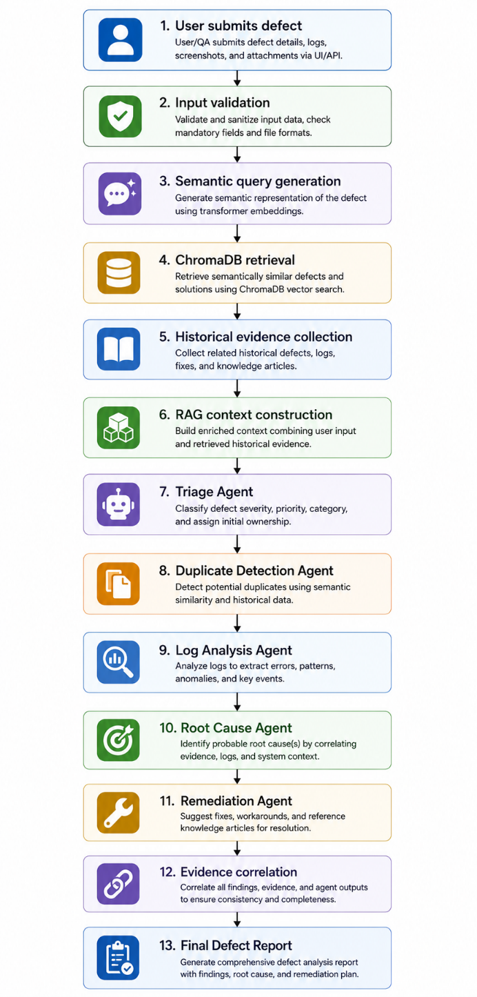
---------------------------------------------------------------------------------------------------------
30. SAMPLE END-TO-END ANALYSIS
Input Defect
"The application crashes immediately after a user enters valid credentials and clicks the Login button. The login request reaches the server, but the application terminates before the dashboard is displayed."
Technical Evidence
java.lang.NullPointerException

Cannot invoke
"UserSession.setToken(String)"
because "session" is null

Failure Location
AuthenticationService.createSession
AuthenticationService.java:142
Agent Findings
Triage
→ High severity
→ P2 priority

Duplicate Detection
→ Related defect
→ Not confirmed duplicate

Log Analysis
→ NullPointerException
→ HIGH evidence

Root Cause
→ UserSession is null

Remediation
→ Null validation
→ Session lifecycle investigation
→ Unit + integration + regression tests
---------------------------------------------------------------------------------------------------------
31. TESTING AND VALIDATION
The project contains dedicated tests for the major system components.
tests/
├── test_agent_orchestrator.py
├── test_triage_agent.py
├── test_duplicate_detection.py
├── test_log_analysis_no_logs.py
├── test_log_analysis_stacktrace.py
├── test_root_cause_agent.py
├── test_remediation_agent.py
├── test_rag_retrieval.py
└── test_defect_analyzer.py
Testing covers:
- RAG retrieval
- Semantic search
- Agent execution
- Log analysis
- Root cause analysis
- Remediation
- End-to-end orchestration
-----------------------------------------------------------------------------------------------------
32. VALIDATION RESULTS
Knowledge Base
Unified historical records:
547,187

Balanced test bug reports:
4,099

Balanced chunks:
4,125

Embeddings:
4,125

Embedding dimensions:
384

Vector database records:
4,125
Multi-Agent System
Specialized agents:
5

LLM:
Gemini 2.5 Flash

RAG:
Enabled

Vector similarity:
Cosine
The major pipeline components successfully completed validation.
---------------------------------------------------------------------------------------------------------
33. PROJECT STRUCTURE
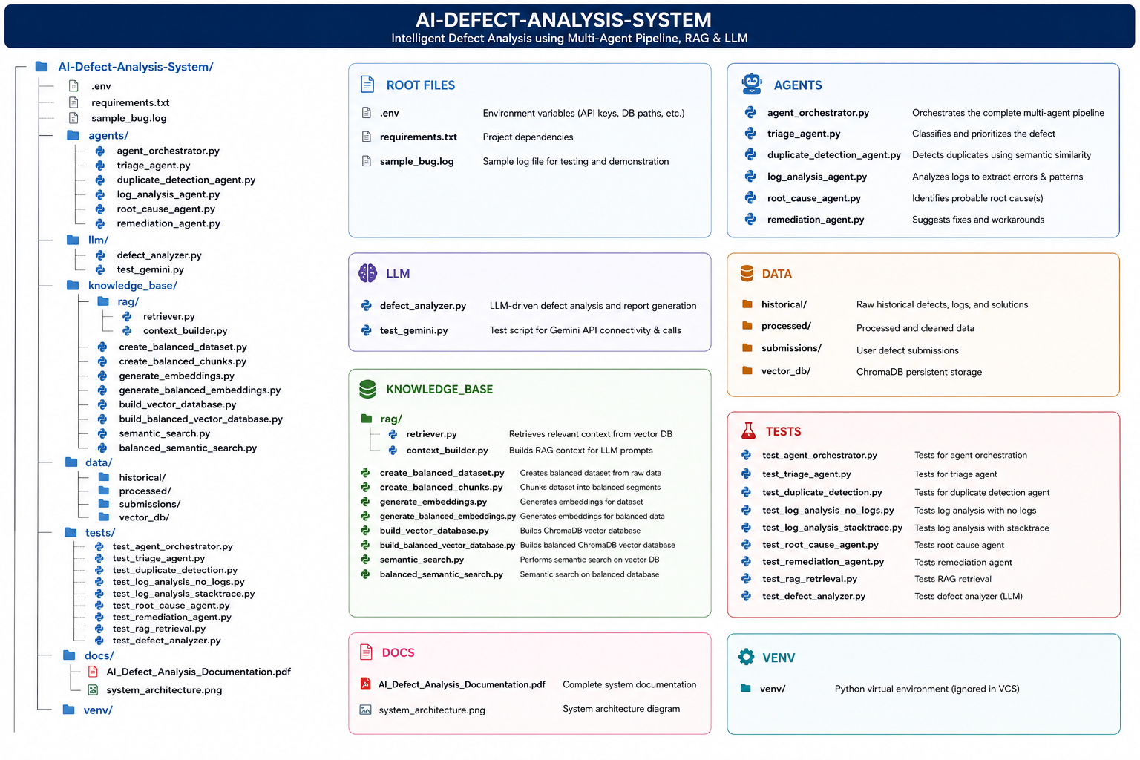
---------------------------------------------------------------------------------------------------------
34. SECURITY AND CONFIGURATION
The Gemini API credential is managed through environment variables.
Example configuration:
GEMINI_API_KEY=your_api_key
The API key should never be committed to GitHub.
A safe repository should contain:
.env
in .gitignore, while providing:
.env.example
for configuration guidance.
This prevents accidental exposure of sensitive credentials.
---------------------------------------------------------------------------------------------------------
35. LIMITATIONS
Although the system provides an automated defect investigation workflow, several limitations remain.
1. Retrieval Quality
Semantic retrieval depends on the quality and coverage of the historical knowledge base.
2. Historical Data Bias
The available historical repositories may contain more defects from some software projects than others.
3. Missing Technical Evidence
Without stack traces or logs, the system cannot reliably identify the exact technical failure location.
4. LLM Dependency
Generated reasoning and recommendations depend on the quality of the provided context and model response.
5. Root Cause Verification
A root cause should be considered confirmed only when supported by direct technical evidence such as logs, stack traces, or source-code inspection.
---------------------------------------------------------------------------------------------------------
36. FUTURE ENHANCEMENTS
The system can be extended significantly.
Advanced Code-Level Root Cause Analysis
Integrate source-code repositories to allow agents to inspect the actual code surrounding a failure.
Automated Patch Generation
Generate candidate patches after confirming the root cause.
CI/CD Integration
Integrate the system with:
- GitHub Actions
- Jenkins
- GitLab CI/CD
so defects can automatically trigger analysis.
Real-Time Monitoring
Connect application monitoring systems to automatically analyze production exceptions.
Larger Knowledge Base
Expand the RAG corpus with additional open-source projects and organizational defect repositories.
Feedback Learning
Allow developers to approve or reject AI recommendations and use that feedback to improve future analysis.
Explainable AI Dashboard
Provide evidence graphs showing exactly which historical defects and technical logs influenced each conclusion.
---------------------------------------------------------------------------------------------------------
37. EXPECTED INDUSTRIAL IMPACT
The proposed system can support software engineering teams by reducing the manual effort required for initial defect investigation.
Potential benefits include:
- Faster bug triage
- Improved defect prioritization
- Faster discovery of related historical defects
- Reduced duplicate investigation
- Faster stack-trace analysis
- Structured root-cause investigation
- Consistent remediation recommendations
- Better regression planning
- Improved knowledge reuse
The system is therefore positioned as an AI-assisted engineering decision-support platform, rather than simply an automated chatbot.
---------------------------------------------------------------------------------------------------------
38. CONCLUSION
The AI-Powered Software Defect Analysis System demonstrates a practical application of Generative AI, Retrieval-Augmented Generation, semantic search, and multi-agent reasoning to software engineering.
The system successfully establishes a complete pipeline from:
Defect Submission → Historical Retrieval → Multi-Agent Investigation → Evidence Correlation → Root Cause → Remediation
The use of Apache, Eclipse, and Mozilla historical defect repositories provides a diverse engineering knowledge base, while semantic embeddings and ChromaDB enable efficient retrieval of relevant historical evidence.
The five-agent architecture further decomposes the complex defect investigation process into specialized analytical responsibilities. Most importantly, the system prioritizes direct technical evidence over unsupported assumptions. For example, when a stack trace explicitly identified a NullPointerException at AuthenticationService.java:142, the Root Cause Agent used that direct evidence to confirm the immediate failure mechanism rather than relying solely on historical similarity.
This architecture demonstrates how AI can be integrated into software engineering workflows in a structured, explainable, and evidence-driven manner.
The final outcome is not merely an AI-generated answer to a bug report, but a RAG-powered intelligent defect investigation pipeline capable of assisting engineers from initial triage through root cause analysis and remediation planning.
---------------------------------------------------------------------------------------------------------
39. REFERENCES
Datasets
- Apache Historical Defect Dataset
- Eclipse Historical Defect Dataset
- Mozilla CORE Issue Report Dataset
Technologies
- Google Gemini API
- ChromaDB Vector Database
- Sentence Transformers
- Streamlit
- Python
Repository Resources
The project maintains the preprocessing, embedding, retrieval, agent, and testing components within the project repository.
---------------------------------------------------------------------------------------------------------
40. PROJECT HIGHLIGHTS
For the final documentation's last page, I recommend a visually strong summary like this:
🚀 AI-DEFECT-ANALYSIS-SYSTEM
Evidence-Driven AI for Software Engineering
Capability | Implementation
🧠 AI Reasoning | Gemini 2.5 Flash
🔎 Semantic Retrieval | RAG + ChromaDB
📚 Knowledge Base | Apache + Eclipse + Mozilla
📐 Embeddings | all-MiniLM-L6-v2
🔢 Vector Dimension | 384
🤖 Specialized Agents | 5
🐛 Defect Analysis | Automated
🔍 Duplicate Detection | Evidence-based
📋 Log Analysis | Stack-trace aware
🎯 Root Cause | Multi-evidence correlation
🛠️ Remediation | Action + Testing Strategy
🖥️ Interface | Streamlit
Final Pipeline
SUBMIT → RETRIEVE → TRIAGE → COMPARE → ANALYZE → CORRELATE → RECOMMEND

