

REQUIREMENT ANALYSIS
PROJECT TITLE
HOSTEL OCCUPANCY AND VACANCY REPORT SYSTEM

Submitted By
1. Member 1: Rakesh CP USN: 01FE24ICA001
2. Member 2: Abhishek G USN: 01FE24ICA007
3. Member 3: Siddu Badiger USN: 01FE24ICA039
4. Member 4: Arpit Shirol USN: 01FE24ICA047


Submitted To
Faculty Name: Pavan V
Faculty Name: Prajna B

Department of Computer Applications
KLE TECHNOLOGICAL UNIVERSITY
Academic Year: 2026–2027

Document Purpose and Basis
This System Requirements Analysis (SRA) is prepared for the project titled “Hostel Occupancy and Vacancy Report System”. It follows the uploaded BCA Mini Project handbook and Gate Assessment Sheets, particularly Theme 4: Reporting and MIS System. The handbook expects a single runnable system, three independently testable engines, integration of five foundational course areas, measurable requirements, report aggregation queries, documented cleaning rules, and traceability from displayed numbers to the queries that produce them.
Project-specific capacities, response-time targets, data fields, and sample thresholds below are proposed baseline values for the student team to confirm with the hostel warden or college administration at Gate 0 and Gate 1. They are not claims about an existing hostel policy.

1. Project Overview

1.1 Problem Statement
Hostel occupancy and vacancy figures may be maintained in paper registers, spreadsheets, or separate records. When room allocation, student check-in, room transfer, or check-out information is updated late, different staff members may calculate different vacancy totals from the same underlying records. This can lead to incorrect vacancy information, double allocation of a bed, delayed reporting, and poor decisions about hostel capacity.
The system will maintain structured hostel and allocation data, define how each occupancy figure is calculated, validate records, and generate management reports from documented database queries. Every important number displayed on a dashboard or report must be reproducible from its source query, with its reporting date and counting definition clearly stated.

1.2 Governing Reporting Definition
For a selected hostel and reporting time, occupied beds are the number of beds with a valid active allocation at that time; vacant beds are approved, usable beds minus occupied beds; occupancy percentage is occupied beds divided by approved, usable beds, multiplied by 100. Beds marked out of service are excluded from usable capacity and must be reported separately.
This definition is the initial governing rule. The hostel authority must confirm whether capacity is counted by bed, room, or both, and how temporary leave, reserved beds, maintenance closures, and future-dated allocations are treated. The chosen definitions must be recorded before implementation.

1.3 Stakeholders and Needs
Stakeholder | Need / concern | System response
Hostel warden / administrator | Know current capacity, occupied beds, vacancies and room status. | Dashboard, allocation management, hostel-wise reports.
Hostel office staff | Find rooms and beds, register check-in/check-out, correct records safely. | Validated forms, search, allocation history and clear error messages.
College management | Compare hostels and review occupancy over time. | Summary reports, date filters, KPIs and exports.
Student (optional read-only role) | View own allocation details or approved vacancy information. | Restricted read-only page if approved for scope.
System administrator | Manage accounts and access permissions. | Role-based login, account management and audit trail.
Project team / tester | Verify calculations and demonstrate system quality. | Documented queries, test cases, KPI results and version-control evidence.

1.4 Objectives
- Maintain a single structured source for hostel, block, room, bed, student and allocation records.
- Calculate capacity, occupied beds, vacant beds and occupancy percentage using documented definitions.
- Prevent invalid allocations, duplicate active allocations, and occupancy beyond usable capacity.
- Generate hostel-wise, room-wise, date-wise and status-wise MIS reports.
- Record and explain data-cleaning actions, including the number of rows affected.
- Verify headline report figures using an independent calculation or reconciliation query.
- Provide secure role-based access and preserve allocation history for audit and reporting.
- Demonstrate the five course areas and the three-engine architecture required by the BCA framework.

2. Scope, Exclusions, Feasibility and Risks

2.1 In Scope
- Create and update hostel, block, floor, room and bed master records.
- Maintain student identity and hostel allocation records.
- Record allocation, transfer, cancellation and check-out events with timestamps and responsible users.
- Search available rooms or beds using hostel, block, floor, room type and status filters.
- Calculate and display total approved usable capacity, occupied beds, vacant beds and occupancy rate.
- Generate current snapshot and historical/date-range reports.
- Show report definitions, reporting time, applied filters, and the source query identifier.
- Export selected reports to CSV and/or PDF if included in the implementation.
- Manage user roles and record important changes in an audit log.

2.2 Out of Scope for the First Version
- Online hostel fee payment, accounting, refunds or fee arrears management.
- Biometric attendance, face recognition, smart locks or IoT sensors.
- Automatic room allocation without staff review or approval.
- Parent portals, messaging gateways or integration with external university systems.
- Full hostel maintenance work-order management.
- Public vacancy publication without approval from hostel administration.

2.3 Feasibility
Type | Assessment
Technical | Feasible as a small web application using HTML/CSS/JavaScript or React, a backend such as Flask/FastAPI or Node/Express, and MySQL. The team should select one backend and document it.
Operational | The workflow resembles existing hostel office work. Staff training and agreement on definitions are needed.
Economic | Can be developed with commonly available student tools and open-source software. Hosting cost, if any, depends on deployment choice.
Schedule | Can be completed through the handbook's S0 to S7 stages if the team limits the first version to occupancy, vacancy and reporting.
Data feasibility | Accurate reports depend on complete room capacity, usable-bed status, active allocations and valid timestamps.

2.4 Main Risks and Mitigation
Risk | Impact | Mitigation / evidence
Late or incomplete source records | Incorrect vacancy figures. | Required-field validation, data-quality report and named data owner.
Two staff allocate the same bed simultaneously | Double allocation. | Database transaction and unique/overlap constraint; concurrent test.
Ambiguous capacity definition | Different staff produce different totals. | Definition Register approved at Gate 1; display denominator and exclusions.
Out-of-service beds included in capacity | Vacancy percentage appears too low or too high. | Separate bed status and reconciliation test.
Historical report uses current status only | Past occupancy becomes inaccurate. | Store allocation start/end times and query status as of selected time.
Unauthorized access to student records | Privacy breach. | Role checks on server, least privilege, password hashing and access tests.
Exports do not match dashboard | Management receives conflicting values. | Shared aggregation service and report-query traceability.

3. AS-IS and TO-BE Workflows

3.1 AS-IS: Current Manual / Spreadsheet Workflow
- Staff receive student allocation, transfer and check-out information.
- Details are written in registers or separate spreadsheets.
- Staff manually count occupied beds and subtract from room capacity.
- Different staff may include different room statuses or use different reporting dates.
- Reports are copied into a summary sheet and sent to management.
- Errors are discovered when a student is assigned to an unavailable bed or totals do not agree.

AS-IS Workflow Diagram
Figure 1. Current manual workflow and points where inconsistent records or totals can occur.
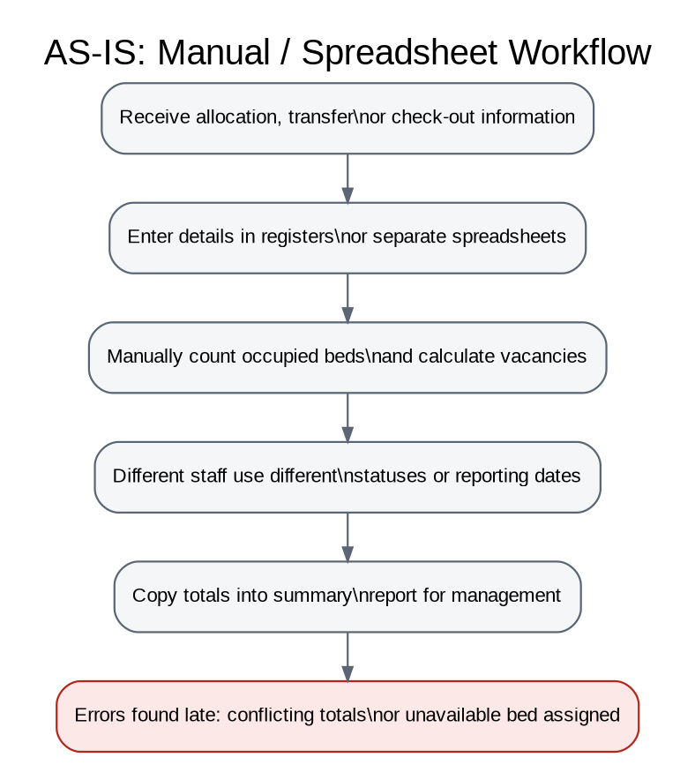

3.2 TO-BE: Proposed System Workflow
- Authorized staff sign in and select the required hostel or reporting period.
- Staff enter or update master data and allocation events through validated forms.
- The backend validates the request, and the database enforces key integrity and allocation constraints.
- The reporting engine applies documented cleaning and inclusion rules.
- The aggregation engine executes the documented query for each KPI and report.
- The dashboard displays results with filters, definitions, reporting timestamp and query identifier.
- The user exports or prints a report; the system records important report and data-change events where implemented.
- The team verifies headline numbers independently and records test evidence.

TO-BE Workflow Diagram
Figure 2. Proposed system workflow from authenticated data entry through report verification.
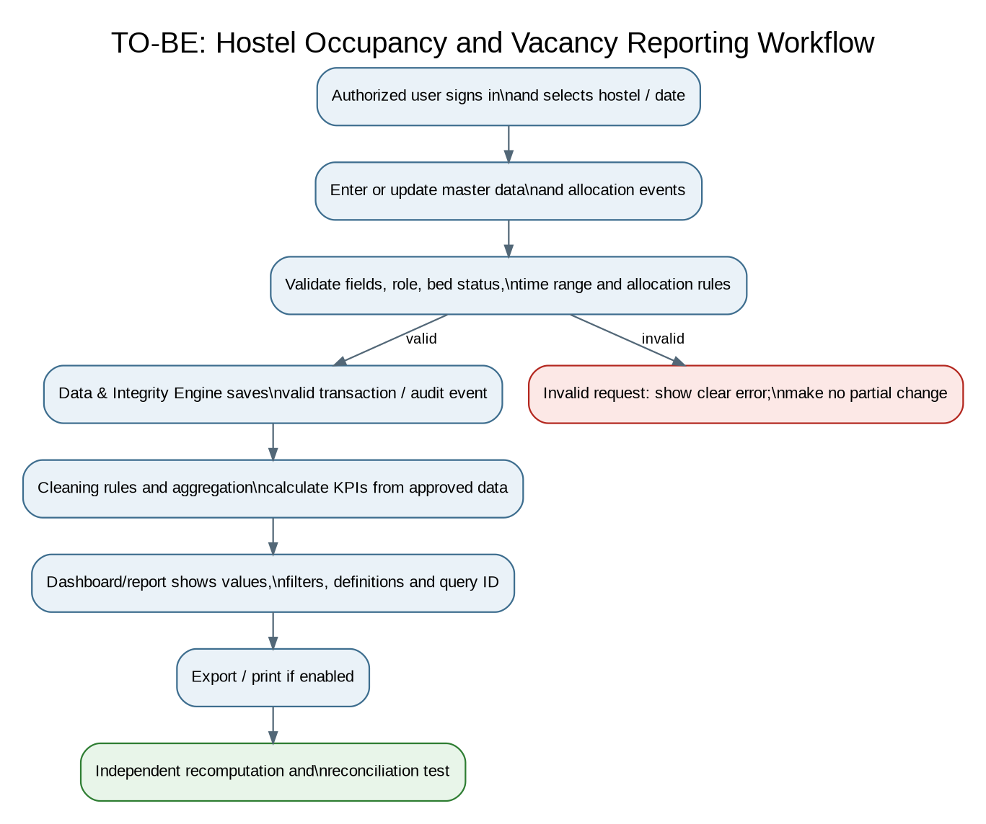

3.3 Allocation, Transfer and Check-out Workflow
Figure 3. Validation and transaction flow for new allocations, transfers and check-outs.
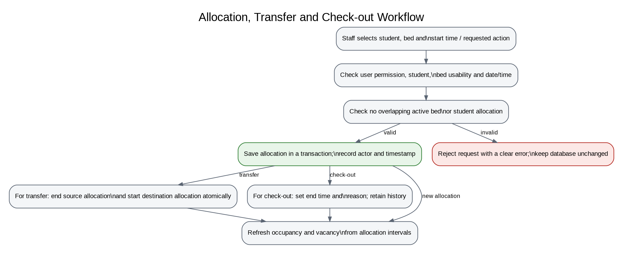

4. Functional Requirements
Priority meanings: P1 = essential for the first working version; P2 = useful supporting feature. Acceptance criteria are observable tests, not general statements.
ID | Requirement | Detailed statement | Priority | Acceptance criterion
FR-01 | User authentication | The system shall allow registered users to sign in using valid credentials. | P1 | Given valid active credentials, the user reaches the authorized dashboard; invalid credentials show a generic error and create no session.
FR-02 | Role-based access | The system shall assign permissions by role: Administrator, Hostel Staff, and Management Viewer. | P1 | A Viewer cannot create or edit allocations through either the interface or a direct API request; the server returns 403 or equivalent.
FR-03 | Hostel master | The administrator shall create, view, update and deactivate hostel records. | P1 | A hostel cannot be saved without a unique code and required name; duplicate hostel codes are rejected.
FR-04 | Room and bed master | The system shall store block, floor, room, approved capacity and bed status. | P1 | A room's bed count cannot exceed its configured capacity; invalid capacity values are rejected with a field-level message.
FR-05 | Student records | Authorized staff shall register and update the minimum student information needed for allocation. | P1 | A duplicate institutional student identifier is rejected; required fields are validated on the server.
FR-06 | Allocate a bed | Staff shall allocate a student to an available bed with a start date/time. | P1 | A valid allocation succeeds once; an occupied, inactive or out-of-service bed is rejected and no duplicate active allocation is created.
FR-07 | Check-out / end allocation | Staff shall close an allocation using an end date/time and reason where required. | P1 | After a valid check-out, the bed is available for later allocation; the previous allocation remains in history.
FR-08 | Room transfer | Staff shall transfer a student from one bed to another while preserving history. | P1 | Transfer is recorded atomically; the source allocation ends and the destination allocation begins without overlapping active allocations.
FR-09 | Vacancy search | Users with permission shall filter available beds by hostel, block, floor, room and bed status. | P1 | For a test dataset, results include only beds meeting all selected filters and exclude occupied or unusable beds.
FR-10 | Occupancy summary | The system shall calculate usable capacity, occupied beds, vacant beds and occupancy percentage. | P1 | For a controlled dataset, the figures match the documented query and independent recomputation exactly.
FR-11 | Hostel-wise report | The system shall generate one summary row per selected hostel for the chosen reporting time. | P1 | Each row shows hostel, usable capacity, occupied beds, vacant beds and occupancy percentage; totals reconcile with detail records.
FR-12 | Room-wise report | The system shall generate room-level capacity and occupancy details. | P1 | Each room row identifies capacity, occupied beds, vacant beds and excluded/out-of-service beds where applicable.
FR-13 | Historical report | The system shall calculate occupancy for a selected date or time range using allocation start/end times. | P1 | A test allocation ending before the selected snapshot is not counted as occupied at that snapshot.
FR-14 | Date and filter validation | The system shall validate date ranges and report filters. | P1 | An end date before the start date is rejected; the message explains the valid date range.
FR-15 | Report definitions | Each report shall state its reporting time, denominator and inclusion/exclusion definition. | P1 | A user can identify the capacity denominator and exclusions on screen or in the exported report.
FR-16 | Data-quality summary | The system shall identify malformed, duplicate, missing or inconsistent records according to approved cleaning rules. | P1 | Each cleaning rule records its ID, action and row count affected; valid source data is not silently deleted.
FR-17 | Report export | Authorized users shall export the selected report to CSV or PDF if the format is implemented. | P2 | Exported rows and KPI values match the same filters and query result shown on screen.
FR-18 | Audit history | The system shall record important create, update, allocation, transfer and check-out events. | P1 | Each event records actor, action, entity identifier and timestamp; ordinary users cannot alter audit entries.
FR-19 | Search student allocation | Authorized staff shall search allocation history by student identifier or name. | P1 | Search results are restricted to permitted records and return the matching student's active and historical allocations.
FR-20 | Error reporting | The system shall return understandable validation and processing errors. | P1 | A failed request returns a non-sensitive error message and does not leave partial changes in the database.

5. Non-Functional Requirements
ID | Quality attribute | Measurable requirement | Acceptance test
NFR-01 Performance | With up to 10,000 student/allocation records and 100 rooms, common dashboard and filtered report requests shall complete within 3 seconds for 95% of 100 measured requests on the team's test machine. | Record response times for 100 requests; at least 95 must be <= 3 seconds.
NFR-02 Report generation | A hostel-wide report for the stated test dataset shall generate within 5 seconds. | Run the same report 10 times after warm-up; all runs should be <= 5 seconds or document the measured limitation.
NFR-03 Calculation accuracy | All displayed capacity, occupancy, vacancy and percentage figures shall match the documented calculation and independent recomputation. | 100% of the defined test cases must reconcile; percentage difference must be <= 0.01 percentage point due only to rounding.
NFR-04 Data integrity | No bed may have overlapping active allocations, and no allocation may reference a missing student or bed. | Database constraint and transaction tests pass, including direct database/API attempts.
NFR-05 Security | All protected operations shall be checked server-side; passwords shall be stored using a suitable password hash, not plain text. | Role-negative tests pass; database inspection confirms no plain-text password storage.
NFR-06 Availability for demo | The application shall complete a 2-hour demonstration session without an unhandled crash on the team's test environment. | Run a 2-hour scripted session and record errors and restarts.
NFR-07 Usability | A trained staff user shall be able to find a vacant bed and generate a hostel summary in no more than 5 user actions after login, excluding typing filter values. | Observe five trial tasks; at least four should complete within the action target.
NFR-08 Maintainability | Business logic, database access, report aggregation and interface code shall be separated into documented modules/engines. | Code review confirms each responsibility is in its designated module and modules have README notes.
NFR-09 Compatibility | The application shall support current stable versions of Chrome and Edge at a 1366 x 768 viewport. | Complete login, allocation, search and report tests in both browsers.
NFR-10 Backup and recovery | The team shall document a database backup procedure and demonstrate restoration of a sample backup. | Restore into a test database and compare record counts and selected KPI results.
NFR-11 Auditability | Every displayed headline KPI shall point to a documented query ID and definition. | 100% of dashboard headline numbers have query/definition references in the report catalogue.
NFR-12 Privacy | Only fields required for hostel operations shall be collected, and each role shall see only the information needed for its work. | Role-based data review and access tests show no unauthorized student details.

6. Reporting Definitions and MIS KPIs
Metric / KPI | Definition / formula | Denominator and exclusions
Approved usable capacity | Count of beds whose status is Approved/Usable at the selected time. | Exclude out-of-service, decommissioned and unapproved beds. Reserved beds must be treated according to an approved policy.
Occupied beds | Count of usable beds with an active allocation at the selected snapshot time. | An allocation is active when start_time <= snapshot and end_time is null or end_time > snapshot.
Vacant beds | Approved usable capacity - occupied beds. | The calculation must use the same hostel, time and status filters as occupied beds.
Occupancy percentage | Occupied beds / approved usable capacity * 100. | If usable capacity is zero, display N/A, not 0%.
Out-of-service beds | Count of beds marked out of service at the selected time. | Report separately; do not silently count them as vacancies.
Allocation turnover | Number of check-outs or ended allocations during a selected period. | Define whether transfers count as a checkout; initial version should report transfers separately.
Capacity reconciliation | Sum of room-level usable capacity compared with hostel-level usable capacity. | Difference must equal zero after applying identical filters.
Data cleaning impact | Number of rows affected by each approved cleaning rule. | Retain raw source data or an audit copy; document whether rows were corrected, excluded or flagged.

Example only: a hostel has 120 approved usable beds, 96 occupied beds and 4 out-of-service beds excluded from the usable capacity. If the 120 already represents usable capacity, vacancies are 24 and occupancy is 80%. The system must not subtract the 4 out-of-service beds again. This illustrates why the denominator must be explicitly defined.

8. Rule Register: Hard Rules and Soft Warnings
Hard rules block a transaction or prevent a report from being certified. Soft rules warn the user but allow the action when policy permits. Rule thresholds and policy choices should be stored in a configuration/rule table with valid_from and valid_to dates where practical, rather than scattered as constants in code.
Rule ID | Condition | Enforcement location | Failure message
R-01 | A bed must belong to an existing room and hostel. | Database foreign keys; backend validation. | Bed cannot be saved because its parent room does not exist.
R-02 | A bed cannot have overlapping active allocations. | Logic engine plus transaction/locking and database support where feasible. | Allocation blocked: this bed is already allocated for the selected period.
R-03 | A student cannot have more than one active hostel-bed allocation at the same time, unless the college explicitly permits it. | Logic engine and database-supported integrity strategy. | Allocation blocked: the student already has an active allocation.
R-04 | An allocation start time must precede its end time. | Form, backend and database CHECK where supported. | End time must be later than start time.
R-05 | Only usable beds may be allocated. | Form, logic engine and database-supported constraint. | Allocation blocked: the selected bed is not currently usable.
R-06 | Vacant beds cannot be negative; occupied beds cannot exceed usable capacity. | Aggregation validation and database constraints for stored values. | Report validation failed: occupied count exceeds usable capacity.
R-07 | When usable capacity is zero, occupancy percentage is N/A. | Reporting logic. | Occupancy percentage is not applicable because usable capacity is zero.
R-08 | Optional contact details are incomplete. | Form / data-quality engine. | Warning: contact details are incomplete. Continue only if permitted by policy.
R-09 | Room capacity and bed master counts disagree. | Data-quality engine; report certification check. | Warning or report hold: room capacity requires reconciliation.
R-10 | Historical records are changed after a report has been generated. | Audit layer; preserve report parameters and query version. | The source data has changed since this report was generated; regenerate to obtain current results.

9. User Stories and Use Cases
Role | User story | Expected result
Administrator | As an administrator, I want to configure hostels, rooms, beds and user roles so the system reflects approved capacity. | Master records are validated and permissions are applied.
Hostel staff | As hostel staff, I want to allocate a student to a vacant bed so the allocation is recorded correctly. | System validates student, bed, time and active-allocation rules.
Hostel staff | As hostel staff, I want to record check-out or transfer while preserving history. | Old allocation is closed and history remains available.
Management viewer | As management, I want a hostel-wise report for a selected date so I can compare occupancy. | Report shows definitions, denominator, filters and reconciled totals.
Management viewer | As management, I want to export a report so I can include it in a review. | Export matches the on-screen report.
System administrator | As system administrator, I want to review audit records so I can investigate a disputed change. | Actor, action, entity and timestamp are visible to authorized users.
Project tester | As a tester, I want to trace every KPI to its query and recompute it independently. | Query catalogue and test evidence prove the result.

10. Requirements Traceability Matrix
Stakeholder need | Requirement IDs | Evidence / acceptance
N-01: Current reliable vacancy information | FR-04, FR-06, FR-07, FR-09, FR-10 | Occupied/vacant boundary tests and allocation validation.
N-02: Consistent management reporting | FR-10, FR-11, FR-12, FR-13, FR-15 | Query catalogue, denominator definitions and report reconciliation.
N-03: Reduce duplicate and invalid records | FR-03, FR-05, FR-06, FR-08, FR-18, FR-20 | Unique key, FK, transaction and error-path tests.
N-04: Find vacancies quickly | FR-09, FR-19 | Filter correctness and performance measurements.
N-05: Protect student information | FR-01, FR-02, FR-18 | Authentication, role-negative and audit access tests.
N-06: Explain data quality | FR-16, FR-20 | Cleaning rule register with row counts and messages.
N-07: Share reports | FR-11, FR-12, FR-15, FR-17 | Export-to-screen reconciliation.
N-08: Maintain past occupancy evidence | FR-07, FR-08, FR-13, FR-18 | Historical snapshot tests and audit trail.

11. Three-Engine Architecture
The uploaded BCA framework requires three engines with clear boundaries, individual ownership and tests. Software Engineering and SDLC run across all three engines rather than forming a fourth engine.
Engine | Responsibilities | Inputs and outputs | Primary owner / course connection
Engine 1: Data & Integrity Engine | Database schema, master records, allocation history, constraints, transactions, indexes, data-quality staging and audit records. | Input: validated commands/data. Output: stored records, transaction result, data-quality findings and row counts. | Member 1; DBMS: normalization, keys, constraints, transactions and indexes.
Engine 2: Logic, Aggregation & Verification Engine | Allocation rule checks, occupancy calculations, report aggregation, cleaning rule execution, independent KPI recomputation and reconciliation. | Input: selected hostel/time/filters and data access interface. Output: metrics, detail rows, warnings, query ID and verification status. | Member 2; Programming, OOP, data structures and algorithms.
Engine 3: Interface, Reporting & Access Engine | Login and role checks, forms, vacancy search, dashboard, filters, report rendering and export. | Input: user requests. Output: pages, structured responses, validation messages and reports. | Member 3; Web Technologies and client-server principles.

11.1 Interface Contract Between Engines
Operation | Request fields | Response fields / errors
Create allocation | student_id, bed_id, start_time, created_by | allocation_id, status, message; errors: STUDENT_NOT_FOUND, BED_UNAVAILABLE, ACTIVE_ALLOCATION_EXISTS, INVALID_TIME.
End allocation | allocation_id, end_time, reason, actor_id | updated status and timestamp; errors: ALLOCATION_NOT_FOUND, INVALID_END_TIME, FORBIDDEN.
Get occupancy summary | hostel_id optional, snapshot_time, filters | capacity, occupied, vacant, occupancy_pct or null, excluded_beds, definition_id, query_id; errors: INVALID_FILTER, ZERO_CAPACITY.
Get room report | hostel_id, snapshot_time, block/floor optional | Rows with room_id, usable_capacity, occupied, vacant, excluded count; plus reconciliation status.
Get data-quality report | period, rule IDs optional | Rule ID, affected row count, action, severity, sample record identifiers subject to permissions.
Export report | report_id, filters, format, actor_id | file/stream metadata and audit event; errors: UNSUPPORTED_FORMAT, FORBIDDEN, REPORT_FAILED.

11.2 Integration Map v1 and v2
Course area | Where it appears | Evidence/file pointer to add during implementation
Programming & OOP | AllocationService, ReportService, rule classes, validation and error handling. | src/services/allocation_service.*; src/services/report_service.*
Data Structures & Algorithms | Grouping/aggregation, indexed lookup, independent verification or reconciliation algorithm. | src/logic/occupancy_aggregator.*; tests/test_aggregation.*
DBMS | Normalized tables, primary/foreign keys, uniqueness, transactions, indexes and SQL report queries. | database/schema.sql; database/report_queries.sql
Software Engineering & SDLC | SRA, architecture, test plan, Git commits, RCA, regression report and final technical report. | docs/requirements_analysis.docx; docs/test_plan.md; docs/rca.md
Web Technologies | Client-server endpoints, forms, server-side validation and role-based screens. | frontend/; backend/routes/; docs/api_contract.md

12. Data Model and Database Requirements
Table | Important fields | Keys / constraints
users | user_id, username, password_hash, role, is_active, created_at | PK user_id; unique username; role restricted to approved values.
hostels | hostel_id, hostel_code, hostel_name, address, is_active | PK hostel_id; unique hostel_code.
blocks | block_id, hostel_id, block_name | PK block_id; FK hostel_id; unique (hostel_id, block_name) if policy requires.
rooms | room_id, block_id, room_number, floor_no, room_type, declared_capacity, is_active | PK room_id; FK block_id; unique (block_id, room_number); capacity non-negative.
beds | bed_id, room_id, bed_code, status, valid_from, valid_to | PK bed_id; FK room_id; unique bed_code within room; status constrained.
students | student_id, institutional_id, full_name, course, semester, contact_optional, is_active | PK student_id; unique institutional_id.
allocations | allocation_id, student_id, bed_id, start_time, end_time, allocation_status, created_by, ended_by, reason | PK allocation_id; FKs student_id, bed_id and user IDs; start before end; overlap prevention in logic/transaction.
rule_parameters | rule_id, parameter_name, parameter_value, valid_from, valid_to, severity, description | PK rule_id or composite key; valid period; value type validated.
audit_log | audit_id, actor_id, action, entity_type, entity_id, event_time, summary | PK audit_id; actor FK where retention policy allows; append-only access policy.
report_catalog | query_id, report_name, definition, SQL_version, created_at, owner | PK query_id; stores the documented meaning and version of report queries.
cleaning_log | cleaning_id, rule_id, run_time, rows_examined, rows_affected, action_taken, run_by | PK cleaning_id; FK rule_id and actor.

13. Aggregation Queries and Meaning of One Output Row
Theme 4 requires an aggregation query designed for each report and a sentence explaining what one output row means. The following are query designs; adapt syntax to the selected MySQL version and final schema.
Query ID | Report and row meaning | Core calculation / SQL design
Q-01 | Hostel summary: one row represents one hostel for one selected snapshot time. | Group usable beds and active allocations by hostel_id. Compute usable_capacity, occupied_beds, vacant_beds = usable_capacity - occupied_beds, and occupancy_pct = 100 * occupied_beds / usable_capacity; return NULL when capacity is zero.
Q-02 | Room detail: one row represents one room at the selected snapshot time. | Group beds by room_id; count usable beds and usable beds with an active allocation; calculate vacant beds and excluded beds.
Q-03 | Vacancy list: one row represents one available bed that matches the filters. | Select usable beds for which no allocation interval covers the selected snapshot time; apply hostel/block/floor/room filters.
Q-04 | Allocation activity: one row represents one allocation event in the selected date range. | Filter allocation start/end/transfer events by period and group by event type, date or hostel as required.
Q-05 | Data-quality report: one row represents one cleaning rule executed in one run. | Group cleaning_log by run_id and rule_id; return rows_examined, rows_affected, action_taken and severity.
Q-06 | Capacity reconciliation: one row represents one hostel and reports the difference between room-level and hostel-level totals. | Compute totals independently from beds and rooms, compare them, and show difference = room_total - hostel_total.

13.2 MIS Report Generation and Verification Workflow
Figure 5. Report generation validates filters, applies the approved definition, runs the documented query, independently reconciles results and then displays or exports the report.
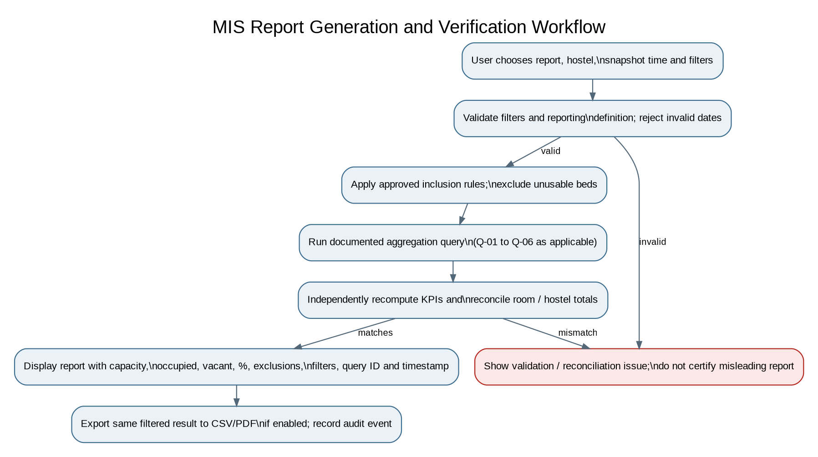

14. Acceptance Test Plan and Boundary Tests
Test ID | Input / scenario | Expected result | Pass condition
AT-01 | Capacity 10; 0 active allocations | Occupied 0, vacant 10, occupancy 0%. | Pass if all values reconcile.
AT-02 | Capacity 10; 10 active allocations | Occupied 10, vacant 0, occupancy 100%. | Pass if no negative vacancy appears.
AT-03 | Capacity 10; 11 allocation attempts | The extra allocation is blocked; stored occupied count remains <= 10. | Pass if only valid allocations persist.
AT-04 | Usable capacity 0 | Occupancy percentage displays N/A/null, not 0%. | Pass if divide-by-zero is prevented.
AT-05 | One bed out of service, no allocation | Bed is excluded from usable capacity and reported separately. | Pass if denominator follows the definition.
AT-06 | Allocation starts after snapshot time | It is not counted as occupied at the earlier snapshot. | Pass if historical snapshot is correct.
AT-07 | Allocation ends exactly at snapshot time | It is not active if the agreed interval rule uses end_time > snapshot_time. | Pass if boundary behavior is consistent.
AT-08 | Two concurrent requests allocate the same bed | At most one succeeds. | Pass if no overlapping active allocation is stored.
AT-09 | Room-level capacity sum differs from hostel total | Reconciliation report identifies the difference. | Pass if discrepancy is not hidden.
AT-10 | Invalid date range | Request is rejected with a useful message. | Pass if no misleading report is returned.
AT-11 | Viewer calls allocation API directly | Server denies the request. | Pass if UI bypass does not bypass access control.
AT-12 | Export report with selected filters | Export matches displayed values and row count. | Pass if every headline figure reconciles.
AT-13 | Duplicate student institutional ID | Second record is rejected. | Pass if unique constraint is enforced.
AT-14 | Cleaning rule flags 3 malformed rows in test fixture | Cleaning log shows rows_affected = 3 and action taken. | Pass if count and rule ID are recorded.
AT-15 | Change a configured warning threshold in rule data | Behavior changes according to the new valid rule without code edits. | Pass if change is documented and effective for its validity period.

15. Key Performance Indicators (KPIs) for Gate Assessment
KPI | Measurement | Target proposed for Gate 1 | Evidence
Report verification agreement | Headline figures that match independent recomputation / total headline figures * 100 | 100% | Test report with both calculation results.
Query traceability | Displayed headline figures linked to a query ID and definition / all headline figures * 100 | 100% | Dashboard/report review checklist.
Cleaning traceability | Cleaning rules with recorded row counts / cleaning rules executed * 100 | 100% | Cleaning log and test fixture.
Capacity reconciliation | Hostels with zero unexplained capacity difference / hostels tested * 100 | 100% | Q-06 output and reconciliation tests.
Invalid allocation prevention | Invalid allocation attempts correctly blocked / invalid attempts tested * 100 | 100% | Negative and concurrent tests.
Role enforcement | Unauthorized protected actions blocked / unauthorized actions tested * 100 | 100% | Role-based access test results.
Dashboard performance | 95th percentile response time for 100 requests | <= 3 seconds | Timestamped performance test results.
Report generation time | Elapsed time for full hostel report on fixed test dataset | <= 5 seconds | Ten measured runs and environment notes.

Targets are proposed measurable targets. Confirm them at Gate 1 and do not change them retrospectively to make results look successful. If a target is missed, report the measured result, investigate the cause and document the decision.

17. Failure Modes, Root Cause Analysis and Regression
Symptom | Possible root cause | Investigation / fix | Regression test
Vacancy differs between dashboard and export | Different query definitions or filters. | Compare query IDs, filters and denominator; use one aggregation service. | Export and dashboard produce identical figures for same filters.
Occupancy exceeds 100% | Duplicate/overlapping allocation or wrong denominator. | Inspect active intervals and capacity exclusions; enforce transaction and integrity checks. | Attempt overlapping and over-capacity allocations.
Past report changes unexpectedly | Report uses current status instead of selected snapshot time. | Use allocation intervals and snapshot parameter consistently. | Test allocations before, during and after the snapshot.
Out-of-service bed counted as vacant | Bed status filter missing from capacity query. | Fix usable-capacity predicate and document exclusions. | Compare KPI before and after status change.
Concurrent allocation duplicates | Race condition between availability check and insert. | Use transaction/locking and database-supported uniqueness strategy. | Run simultaneous requests for one bed.
Cleaning count differs from expected | Rule applied after filtering or rows counted twice. | Document stage order and define whether counts are per row or per event. | Run cleaning on a fixed fixture with known expected counts.

18. Constraints and Assumptions
- The system depends on hostel staff entering allocation and check-out events promptly and accurately.
- Every bed must have a stable identifier and a defined status.
- The project team must choose and document one backend framework and one database implementation.
- Historical reporting is reliable only from the point at which sufficiently complete dated allocation data exists.
- Policies about temporary leave, reservations, guest beds, room sharing and maintenance closure require stakeholder approval.
- PDF/CSV export is a planned feature only if time and implementation permit; the selected deliverable must be fixed at Gate 1.
- Performance targets apply to the documented test dataset and environment, not an unspecified production deployment.

20. Conclusion
The Hostel Occupancy and Vacancy Report System is framed as a Theme 4 Reporting and MIS System mini project. Its main deliverable is not merely a collection of screens: it is a single integrated application whose occupancy and vacancy figures have explicit definitions, documented aggregation queries, recorded data-cleaning effects, independent verification and traceability from each displayed number to its source. The three-engine architecture connects DBMS integrity, programming and aggregation logic, and role-based web interfaces. The S0 to S7 gate plan gives the team measurable evidence for requirements, design, implementation, validation and release.

