

SOFTWARE REQUIREMENTS SPECIFICATION (SRS)
PROJECT TITLE
HOSTEL OCCUPANCY AND VACANCY REPORT SYSTEM

Submitted By
1. Member 1: Rakesh CP USN: 01FE24ICA001
2. Member 2: Abhishek G USN: 01FE24ICA007
3. Member 3: Siddu Badiger USN: 01FE24ICA039
4. Member 4: Arpit Shirol USN: 01FE24ICA047


Submitted To
Faculty Name: Pavan V
Faculty Name: Prajna B

Department of Computer Applications
KLE TECHNOLOGICAL UNIVERSITY
Academic Year: 2026–2027

Contents
1. Introduction
• 1.1 Purpose
• 1.2 Scope
• 1.3 Objectives
• 1.4 Intended Audience
• 1.5 Definitions, Acronyms and Abbreviations
• 1.6 Document Overview
• 1.7 Foundational Concepts Used
• 1.8 Product Perspective
• 1.9 User Classes and Characteristics
• 1.10 Assumptions and Dependencies
2. Specific Requirements
• 2.1 System Architecture and Data Views
• 2.1.1 Entity Relationship Diagram (ERD)
• 2.2 Data Flow Diagrams (DFD)
• 2.2.1 DFD Level 0 (Context Diagram)
• 2.2.2 DFD Level 1
• 2.2.3 DFD Level 2
• 2.3 Use Cases
• 2.3.1 Use Case Description: Process Room Allotment
• 2.4 Functional Requirements
• 2.5 Non-Functional Requirements
• 2.6 Business Rules
• 2.7 Design Constraints
• 2.8 External Interface Requirements
• 2.9 Error Handling and Edge Cases
• 2.10 Open Policy Decisions and Proposed Defaults
• 2.11 Requirements Traceability Matrix
• 2.12 UML Diagrams
• 2.12.1 Class Diagram
• 2.12.2 Sequence Diagram
• 2.12.3 Activity Diagram
3. Hardware and Software Requirements
• 3.1 Hardware Requirements
• 3.2 Software Requirements
4. References
5. Future Enhancements
6. Conclusion

1. Introduction

1.1 Purpose
This Software Requirements Specification (SRS) defines the functional and non-functional requirements of the Hostel Occupancy and Vacancy Report System. It describes the system services, user roles, data requirements, room-allotment rules and reporting functions. This document provides a common reference for design, development, testing and project evaluation.

1.2 Scope
The system is intended to maintain centralized hostel, room, student and allotment records and to provide accurate information about occupied and vacant beds. It supports the hostel administration in managing room capacity, allotments, check-in and check-out records, and management reports.
- Maintain hostel, block, floor and room details, including approved room capacity.
- Maintain student details required for hostel admission and room allotment.
- Record allotment requests and confirmed room or bed allotments.
- Validate room availability and prevent allotment beyond approved capacity.
- Record student check-in, check-out, cancellation and room transfer.
- Update occupancy and vacancy information when an allotment status changes.
- Search and filter records by hostel, block, room, student and allotment status.
- Generate occupancy, vacancy and summary MIS reports for authorized users.
- Maintain a record of important changes for accountability.
Out of scope for the initial release: online fee payment, mess billing, biometric attendance, visitor management, automatic student selection, predictive analytics and integration with external university systems.

1.3 Objectives
- OBJ-1: Maintain centralized and organized hostel, room and student information.
- OBJ-2: Make room allotment accurate and prevent over-capacity allocation.
- OBJ-3: Display updated occupancy and vacancy information.
- OBJ-4: Reduce manual effort in preparing hostel occupancy and vacancy reports.
- OBJ-5: Restrict information and operations according to user roles.
- OBJ-6: Maintain traceable records of allotments and important changes.

1.4 Intended Audience
- Faculty members, project guides and evaluators.
- Project team members and software developers.
- Hostel administrators and wardens.
- Authorized clerical or data-entry staff.
- Institutional management and system testers.

1.5 Definitions, Acronyms and Abbreviations
Term | Definition
SRS | Software Requirements Specification
MIS | Management Information System
Admin | User with overall authority to configure and manage the system
Warden | Hostel staff member responsible for assigned hostel operations
Allotment | Assignment of a hostel room or bed to a student
Occupancy | Number of beds currently occupied by active confirmed allotments
Vacancy | Number of approved beds not occupied by active confirmed allotments
Approved capacity | Maximum number of students permitted for a room or hostel
Audit log | Record of important actions and changes made in the system
RBAC | Role-Based Access Control

1.6 Document Overview
Section 1 introduces the system and its context. Section 2 describes the system architecture, ER diagram, data flow diagrams, use cases, functional and non-functional requirements, business rules, constraints, interfaces, error handling, policy decisions, traceability and UML diagrams. Section 3 lists hardware and software requirements. Section 4 provides references, Section 5 lists future enhancements and Section 6 presents the conclusion.

1.7 Foundational Concepts Used
Concept | Meaning in this system
Role-based access | Users can perform only the operations permitted for their assigned role.
Room capacity | Approved maximum number of occupants for a room.
Active allotment | A confirmed allotment that has not been cancelled or checked out.
Vacancy calculation | Approved capacity minus active occupied beds.
Validation | Checking data and business rules before saving an operation.
Audit trail | Recording who performed an important action and when.

1.8 Product Perspective
The system is a centralized web-based application consisting of a user interface, application logic and a relational database. Authorized users access it through a web browser. The application validates user actions, stores hostel and student records, processes room allotments, calculates occupancy and vacancy, and prepares reports from the stored information. The system is intended to operate as a standalone application for the institution.

1.9 User Classes and Characteristics
User class | Typical responsibilities | Access scope
Admin | Create users, assign roles, configure hostels and rooms, view all records and reports. | System-wide
Warden | Manage student records, room allotments, check-in/check-out and reports for assigned hostel(s). | Assigned hostel(s)
Data-entry staff | Enter and update permitted student and allotment details under authorization. | Assigned tasks / records
Management | View summary occupancy and vacancy reports for decision-making. | Read-only reports

1.10 Assumptions and Dependencies
- The institution provides accurate hostel, block, room and approved-capacity information.
- Each student is identified by a unique student or institutional registration number.
- Only authorized staff members can confirm, cancel or modify allotments.
- Users have access to a supported web browser and a working network connection.
- Hostel administration confirms local rules for room capacity, eligibility and allotment approval.
- System date and time are configured correctly for recording transactions.

2. Specific Requirements
Requirements use the word “shall” to indicate mandatory system behaviour. Priority is identified as Must (M), Should (S) or Could (C). Acceptance criteria describe how each requirement can be checked.

2.1 System Architecture and Data Views
The system follows a three-layer structure: presentation layer for user interaction, application layer for validation and business operations, and database layer for persistent records.
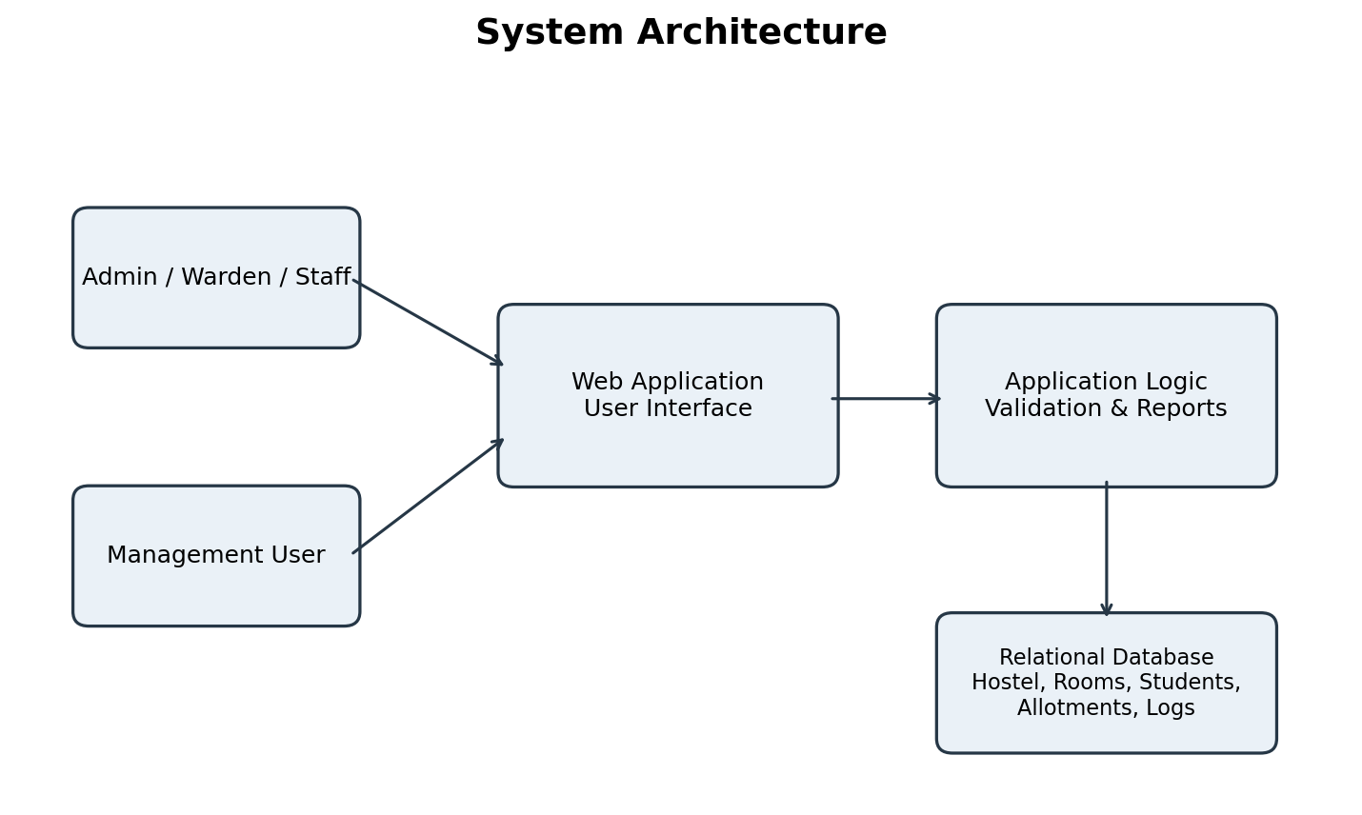
Main data entities include User, Hostel, Block, Room, Student, Allotment and Audit Log. A room belongs to a block; a block belongs to a hostel; an allotment connects a student with an assigned room for a defined period.

2.1.1 Entity Relationship Diagram (ERD)
The simplified ER diagram contains four main entities: Hostel, Room, Student and Allotment. It shows the primary keys (PK), foreign keys (FK), and one-to-many relationships. A hostel contains rooms; students and rooms are linked through allotment records.
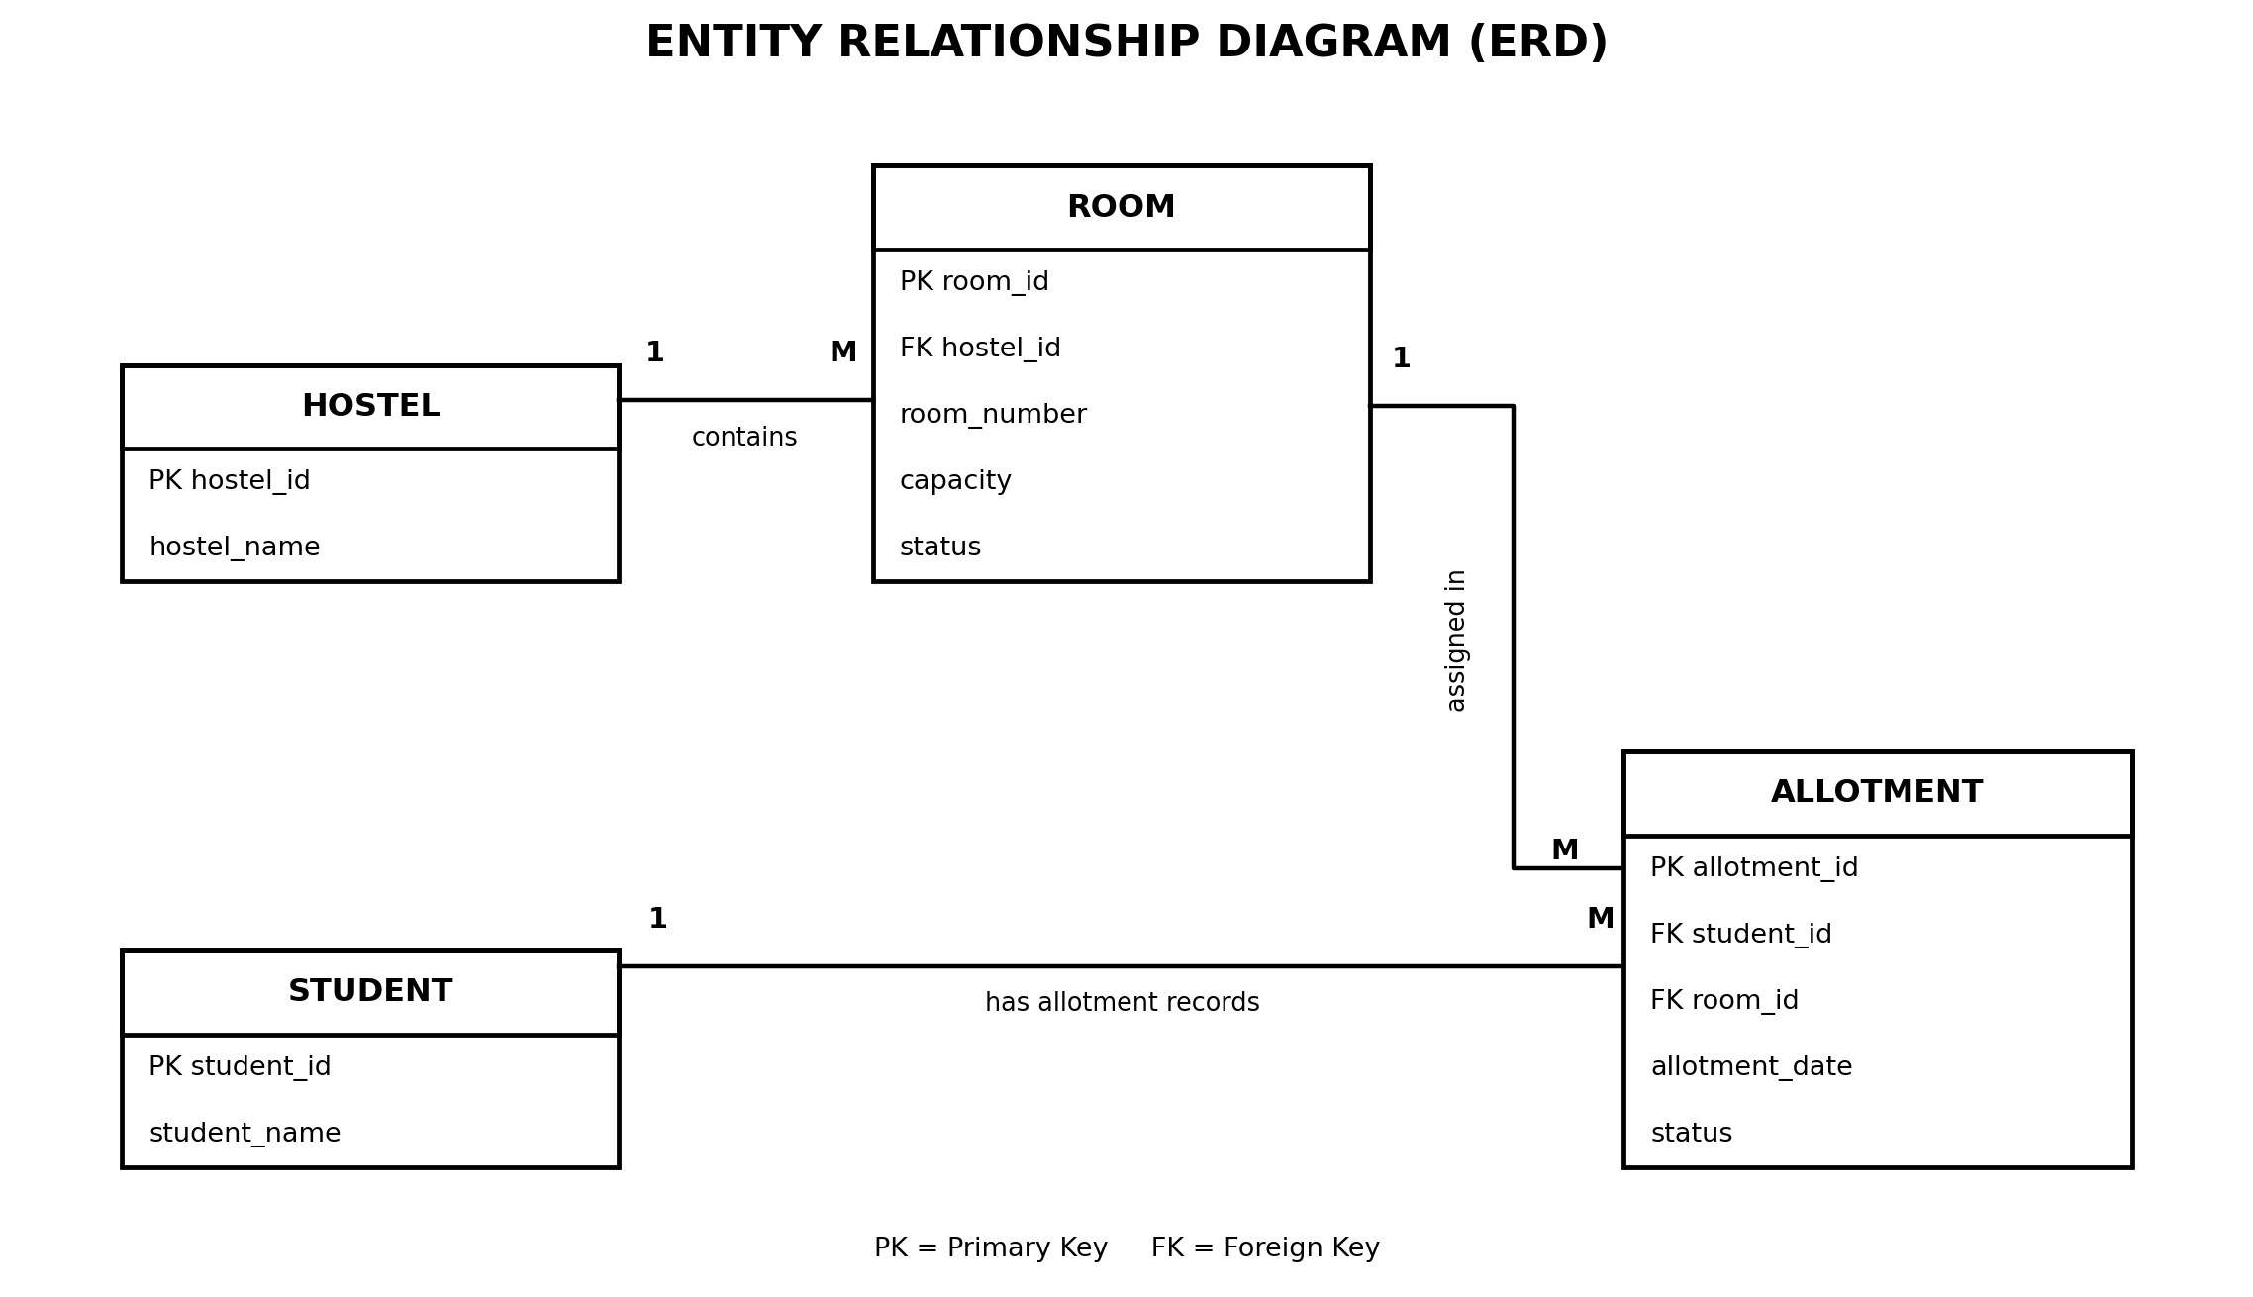

2.2 Data Flow Diagrams (DFD)

2.2.1 DFD Level 0 (Context Diagram)
The Level 0 DFD shows the system as a single process and its interaction with Admin, Warden/Staff and Management. Users provide hostel, room, student, allotment and report requests; the system returns status information and reports.
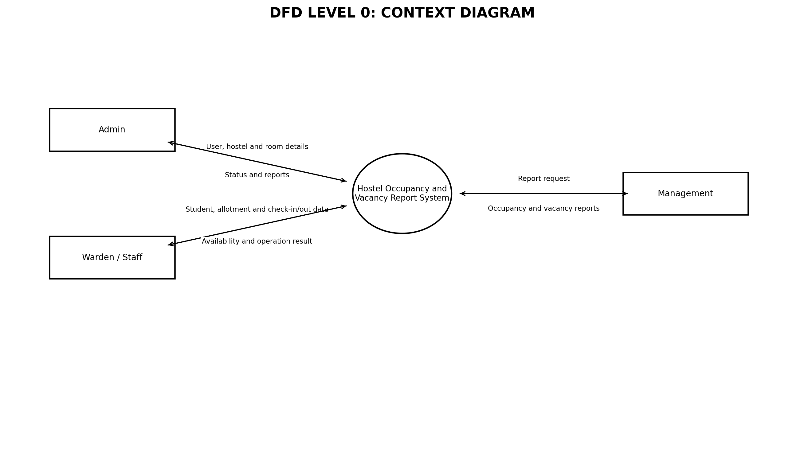

2.2.2 DFD Level 1
The Level 1 DFD divides the system into user and hostel/room management, student record management, allotment and occupancy processing, and MIS report generation. It also shows the main data stores used by these processes.
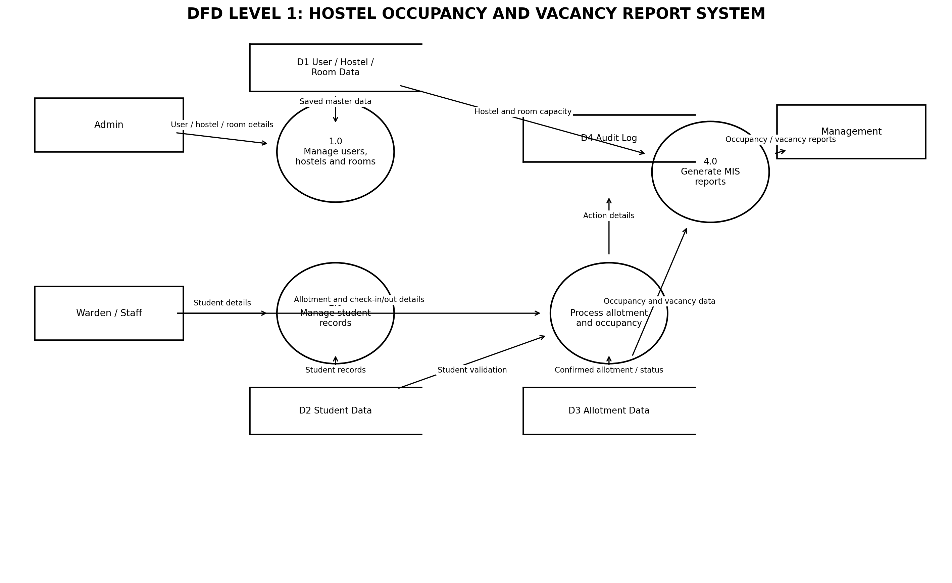

2.2.3 DFD Level 2
The Level 2 DFD expands Process 3.0 into receiving allotment details, validating the student, checking room status and capacity, saving the allotment, updating occupancy and vacancy, and recording the audit activity.
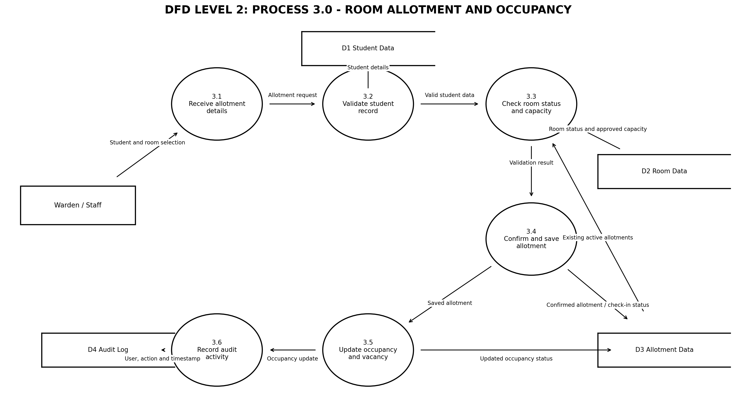

2.3 Use Cases
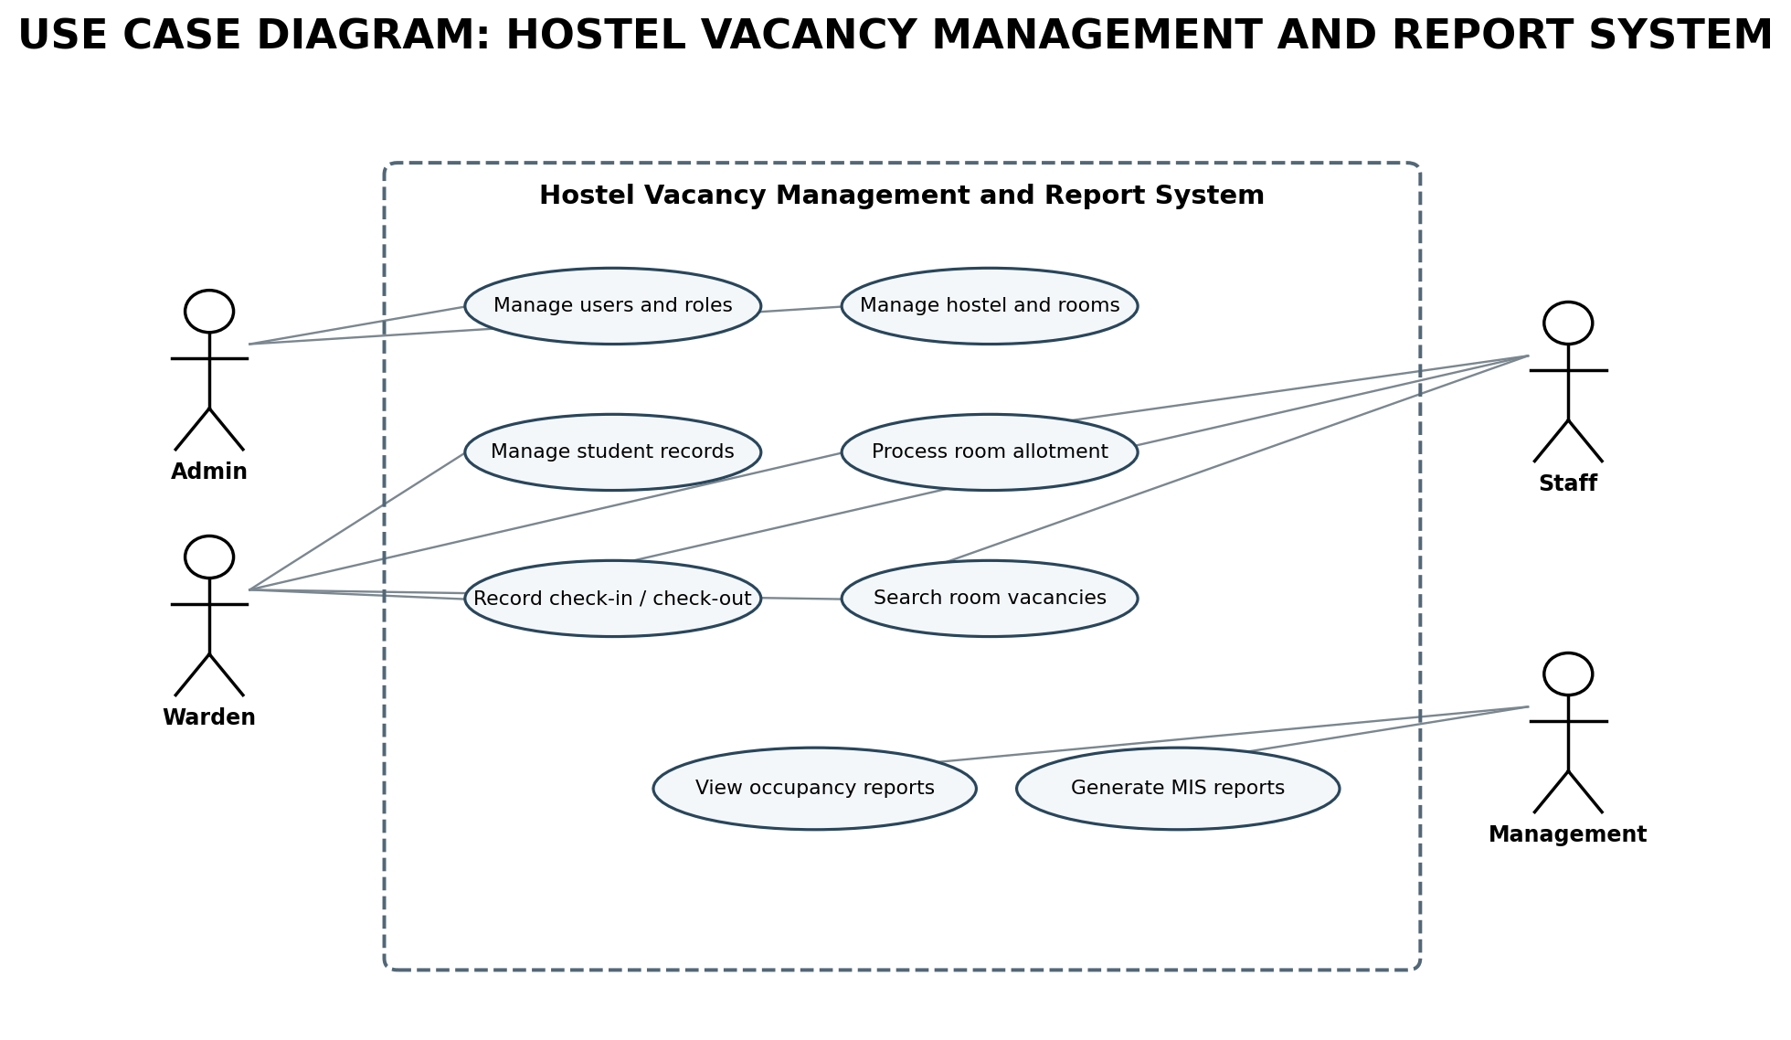
ID | Use case | Actor(s) | Expected result
UC-01 | Log in and log out | All users | Authorized user session is created or closed.
UC-02 | Manage users and roles | Admin | User accounts and permissions are maintained.
UC-03 | Manage hostel, block and room details | Admin, Warden | Hostel structure and room capacity are maintained.
UC-04 | Manage student records | Admin, Warden, Staff | Student information is created or updated.
UC-05 | Process room allotment | Warden, Staff | Allotment is validated and recorded.
UC-06 | Record check-in and check-out | Warden, Staff | Occupancy status is updated.
UC-07 | View vacancy and occupancy | Admin, Warden, Management | Current availability is displayed.
UC-08 | Generate MIS reports | Admin, Warden, Management | Reports are generated from saved records.

2.3.1 Use Case Description: Process Room Allotment
Field | Description
Use case | Process Room Allotment
Primary actor | Warden or authorized staff
Precondition | User is logged in; student and room records exist.
Main flow | Select student; select hostel/block/room; system checks capacity and active allotments; authorized user confirms; system saves allotment and updates availability.
Alternative flow | If capacity is full or a conflicting active allotment exists, the system rejects the operation and displays the reason.
Postcondition | A valid allotment is stored and the occupancy/vacancy summary is updated.

2.4 Functional Requirements
ID | Area | Requirement | Pri. | Acceptance criterion
FR-01 | Authentication | The system shall allow registered users to log in using valid credentials and log out securely. | M | Valid credentials permit access; invalid credentials are rejected.
FR-02 | Role management | The system shall provide role-based permissions for Admin, Warden, Staff and Management. | M | Users cannot access functions outside their assigned role.
FR-03 | Hostel management | Admin shall add, view, update and deactivate hostel records. | M | Saved hostel details are available to authorized users.
FR-04 | Block and floor management | The system shall maintain blocks and floors associated with a hostel. | M | Each block/floor is linked to its parent hostel.
FR-05 | Room management | The system shall maintain room number, type, approved capacity and room status. | M | Room details are saved and capacity is a positive value.
FR-06 | Student management | Authorized users shall add, view and update student records required for allotment. | M | Student identifier is unique and mandatory fields are validated.
FR-07 | Allotment processing | The system shall record allotment requests and confirmed room/bed allotments. | M | A confirmed allotment is linked to a valid student and room.
FR-08 | Capacity validation | The system shall prevent a room from being allotted beyond its approved capacity. | M | An allotment that exceeds available capacity is rejected.
FR-09 | Duplicate allotment validation | The system shall prevent conflicting active allotments for the same student. | M | A student cannot hold conflicting active allotments.
FR-10 | Check-in and check-out | Authorized users shall record student check-in and check-out dates. | M | Status and occupancy are updated after a valid transaction.
FR-11 | Cancellation and transfer | The system shall record allotment cancellation and room transfer with the reason and date. | S | Old allotment history is retained and new availability is recalculated.
FR-12 | Room status | The system shall allow authorized users to mark rooms available, occupied, unavailable or under maintenance as applicable. | S | Unavailable rooms are excluded from available capacity.
FR-13 | Vacancy calculation | The system shall calculate vacancies using approved capacity and active occupied beds. | M | Displayed vacancy equals eligible capacity minus occupied beds.
FR-14 | Occupancy summary | The system shall display occupancy by room, block and hostel. | M | Totals match the underlying active allotment records.
FR-15 | Search and filter | The system shall allow authorized users to search and filter student, room and allotment records. | S | Results match the selected search and filter criteria.
FR-16 | MIS reports | The system shall generate date-wise and summary occupancy and vacancy reports. | M | Reports show hostel, capacity, occupied beds and vacancies.
FR-17 | Report export/print | The system should allow authorized users to print or export reports where supported. | S | Generated output matches the displayed report.
FR-18 | Audit log | The system shall record important create, update, allotment, cancellation and status-change actions. | M | Log records identify action, user and timestamp.
FR-19 | Data validation | The system shall validate mandatory fields, formats and relationships before saving. | M | Invalid or incomplete data is not saved.
FR-20 | Backup and recovery | The system shall support regular database backup and restoration by an authorized administrator. | S | A backup can be restored using the documented procedure.

2.5 Non-Functional Requirements
ID | Category | Requirement | Measure / target
NFR-01 | Performance | Common screens and reports should load within an acceptable time under normal project workload. | Target: 95% of normal requests within 3 seconds.
NFR-02 | Security | The system shall require authentication for protected functions and enforce role permissions. | Unauthorized requests are denied.
NFR-03 | Data integrity | The system shall preserve valid relationships between hostels, rooms, students and allotments. | Invalid references and duplicate identifiers are rejected.
NFR-04 | Usability | Forms and reports shall use clear labels, messages and consistent navigation. | A user can complete common tasks with limited training.
NFR-05 | Availability | The system should be available during the institution's normal administrative working hours. | Planned maintenance is communicated.
NFR-06 | Reliability | The system shall update allotment and vacancy records consistently. | A failed transaction shall not leave partial updates.
NFR-07 | Maintainability | The application shall use organized modules and documented database structures. | Changes can be made without unnecessary impact on unrelated modules.
NFR-08 | Backup | The database should be backed up at a defined interval. | Backup and restore procedure is documented and tested.
NFR-09 | Compatibility | The web interface should work on current versions of commonly used browsers. | Core screens are checked in supported browsers.
NFR-10 | Privacy | Student information shall be visible only to authorized users and used for hostel administration. | Role and access tests confirm restricted visibility.

2.6 Business Rules
ID | Rule | Description
BR-01 | Unique student record | Each student shall have a unique institutional student identifier.
BR-02 | Room capacity | Active confirmed allotments shall not exceed the approved capacity of a room.
BR-03 | Vacancy calculation | Vacancy = approved usable capacity - occupied beds.
BR-04 | Active occupancy | Only confirmed allotments with active occupancy status are counted as occupied.
BR-05 | Unavailable rooms | Rooms marked unavailable or under maintenance shall not be offered for new allotment.
BR-06 | Student allotment | A student shall not have more than one conflicting active room allotment.
BR-07 | Check-out | A valid check-out shall close the active occupancy period and release the bed.
BR-08 | Cancellation | Cancelled allotments shall not be counted as occupied.
BR-09 | Room transfer | A transfer shall close the previous allotment and create a new allotment while preserving history.
BR-10 | Access control | Only users with appropriate permission may approve or modify allotments.

2.7 Design Constraints
- The system shall use a centralized database to maintain consistent hostel records.
- Every room shall be associated with a valid block and hostel.
- Every allotment shall be associated with a valid student and room.
- Only approved capacity values shall be used for vacancy calculation.
- Access to student and hostel records shall be controlled by user role.
- Technology selection shall remain consistent with the project environment and available resources.

2.8 External Interface Requirements
Interface | Requirement
User interface | A web-based interface shall provide login, dashboards, data-entry forms, search and reports.
Hardware interface | The system shall run on standard computers or laptops with network access; no specialized hardware is required.
Software interface | The application shall use a relational database and a supported web server/application environment.
Communication interface | Client and server communication shall use standard web protocols; HTTPS is recommended for deployment.

2.9 Error Handling and Edge Cases
Situation | Required behaviour
Invalid login details | Display a clear error and do not create a user session.
Room capacity already full | Reject the allotment and show that no vacancy is available.
Duplicate active allotment | Reject the conflicting allotment and identify the existing active record where permitted.
Missing mandatory information | Highlight the required fields and prevent saving.
Room marked under maintenance | Do not include the room in available vacancy results.
Check-out entered twice | Prevent duplicate closure and show the current allotment status.
Database or network failure | Display a safe error message and avoid showing an unconfirmed successful update.
Unauthorized access | Deny the operation and do not expose restricted student information.

2.10 Open Policy Decisions and Proposed Defaults
The following values are proposed for initial design and testing. The hostel administration should confirm them before implementation.
Topic | Proposed default | Responsible authority | Status
Student identifier | Use the institution's unique student registration number. | Institution / Admin | To be confirmed
Room capacity | Use the capacity approved by hostel administration for each room. | Hostel Admin | To be confirmed
Allotment approval | Warden or designated authorized staff confirms allotments. | Hostel Admin | To be confirmed
Unavailable room | Exclude rooms under maintenance or blocked from vacancy totals. | Hostel Admin | To be confirmed
Vacancy report period | Provide current summary and date-wise report filters. | Project / Hostel Admin | To be confirmed

2.11 Requirements Traceability Matrix
Objective | Related requirements | Verification
OBJ-1 Centralized records | FR-03, FR-04, FR-05, FR-06, FR-18 | CRUD and data-integrity tests.
OBJ-2 Accurate allotment | FR-07, FR-08, FR-09, FR-11; BR-02, BR-06 | Capacity, duplicate and transfer tests.
OBJ-3 Updated vacancy | FR-10, FR-12, FR-13, FR-14; BR-03 to BR-08 | Check-in/check-out and vacancy calculation tests.
OBJ-4 Reduced report effort | FR-14, FR-15, FR-16, FR-17 | Search, filter and report validation.
OBJ-5 Controlled access | FR-01, FR-02; NFR-02, NFR-10 | Role-based access and security tests.
OBJ-6 Traceable changes | FR-18, FR-20; NFR-03, NFR-08 | Audit-log review and backup/restore test.

2.12 UML Diagrams

2.12.1 Class Diagram
The class diagram shows the main data classes and their relationships. A hostel contains blocks; blocks contain rooms; students receive room allotments; user accounts perform authorized operations.
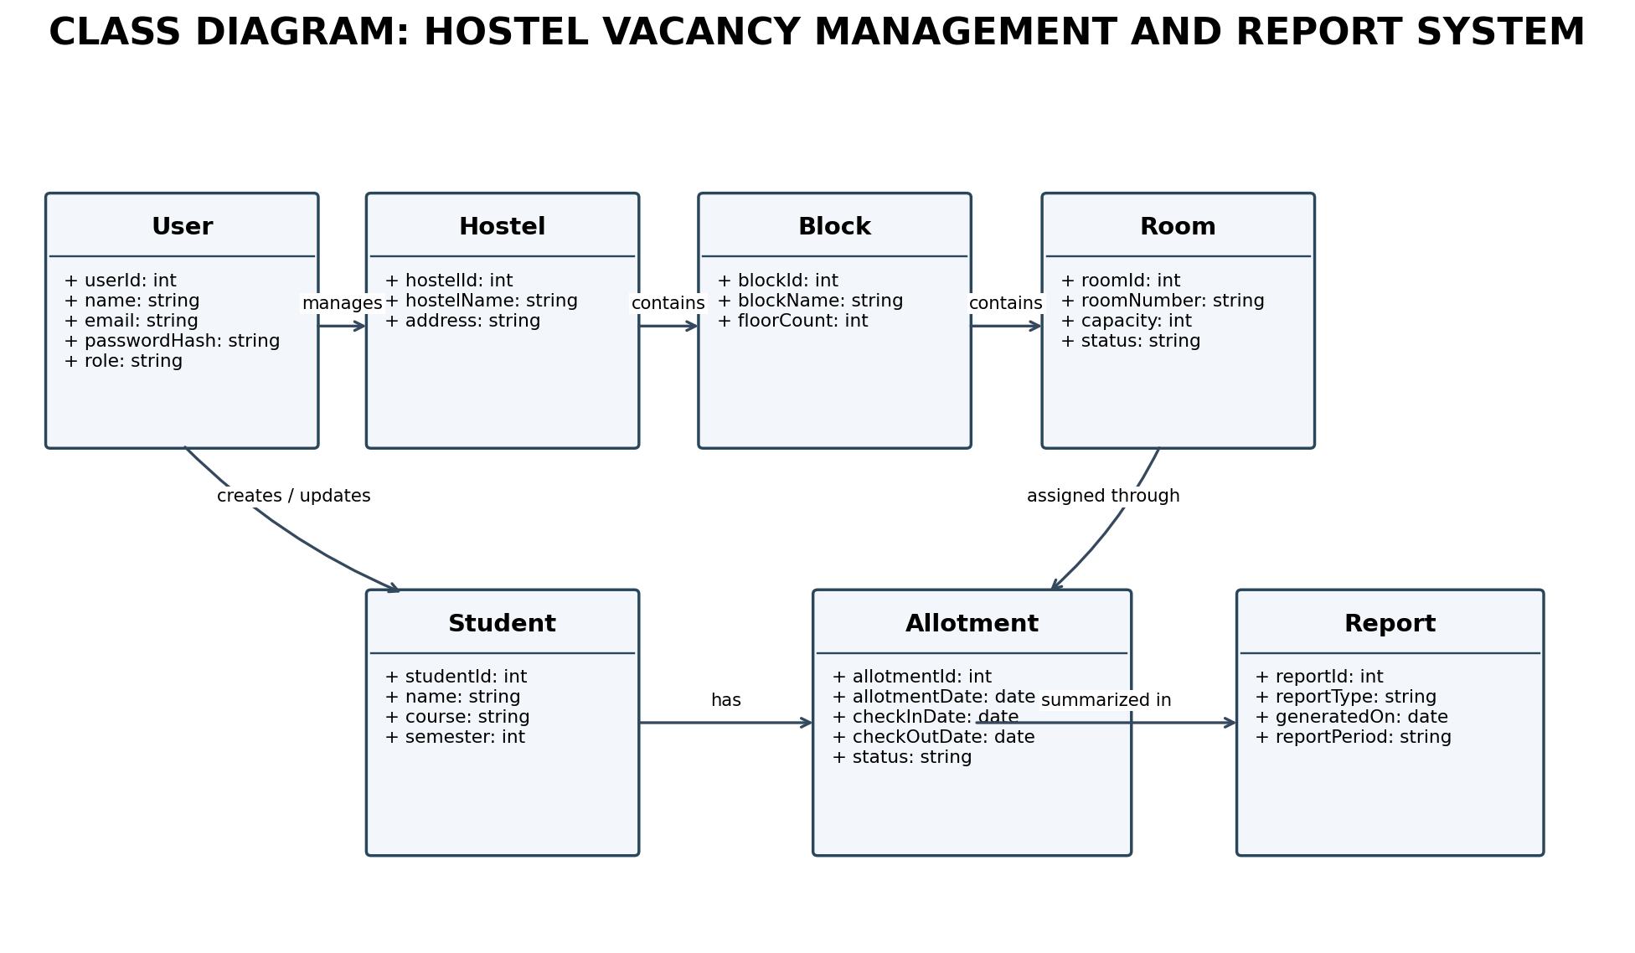

2.12.2 Sequence Diagram
The sequence diagram illustrates how an authorized staff member submits an allotment, how the system validates capacity and student records, and how the database and report module are updated.
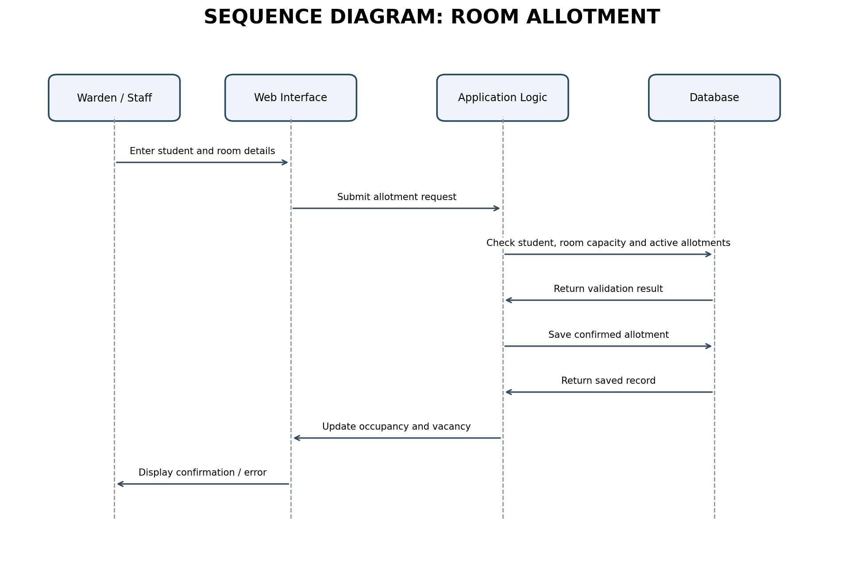

2.12.3 Activity Diagram
The activity diagram represents the main allotment process from staff login to validation, saving the allotment and recalculating occupancy and vacancy.
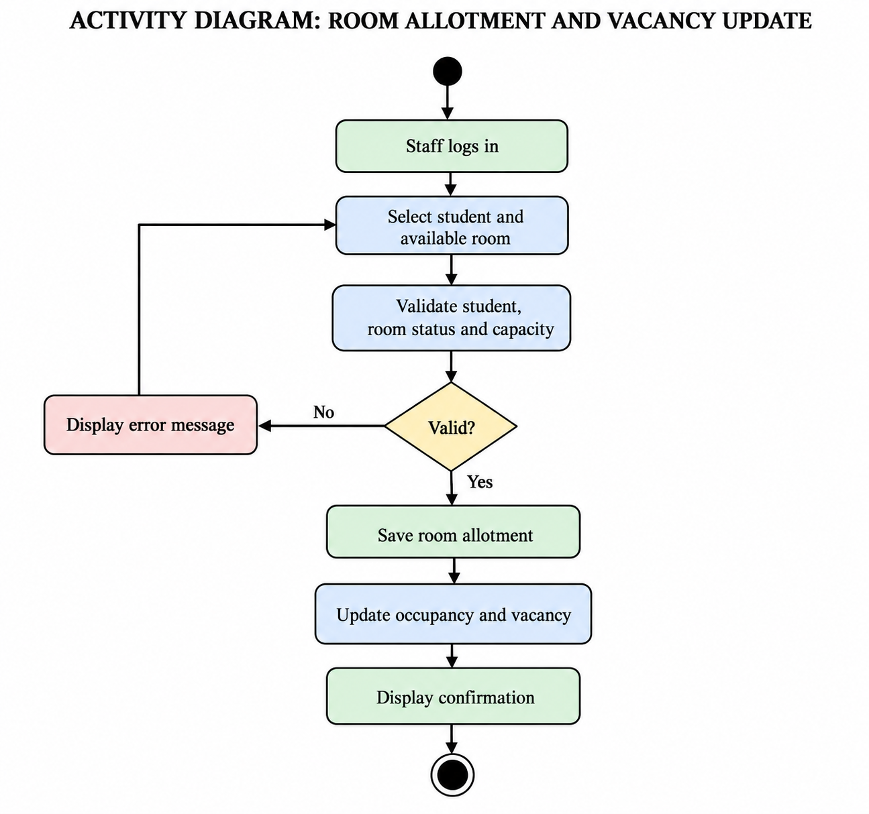

3. Hardware and Software Requirements

3.1 Hardware Requirements
Component | Minimum / suggested requirement
Development computer | Dual-core processor or higher, 4 GB RAM minimum (8 GB recommended), and sufficient free storage for source code and database.
Application host | A computer or server capable of running the web application and database for the expected project workload.
User device | Desktop computer or laptop with a keyboard, display and network connection.
Network | Stable local network or internet connection for browser access.

3.2 Software Requirements
Component | Software / requirement
Operating system | Windows 10/11 or a supported Linux distribution.
Client | Current version of Chrome, Edge or Firefox.
Frontend | HTML, CSS and JavaScript or another framework selected by the project team.
Backend | A server-side programming language and web framework selected for implementation.
Database | MySQL or another suitable relational database.
Development tools | Visual Studio Code or equivalent code editor; database management tool.
Documentation and diagrams | MS Word or compatible document editor; UML diagramming tool.

4. References
- IEEE Std 830-1998, Recommended Practice for Software Requirements Specifications.
- ISO/IEC/IEEE 29148:2018, Systems and software engineering: Life cycle processes: Requirements engineering.
- Institutional hostel admission, room-allocation and occupancy policies, to be confirmed by the institution.
- Official documentation for the selected programming language, web framework and relational database.
- Project-specific requirements and guidance provided by the faculty and project guide.

5. Future Enhancements
- Provide additional report filters by academic year, course, room type and hostel block.
- Add downloadable PDF and spreadsheet reports if required by the institution.
- Provide notifications for allotment approval, cancellation and room-transfer updates.
- Add student self-service access to view allotment status, subject to institutional approval.
- Provide dashboard summaries and comparison of occupancy across hostels.
- Support integration with institutional student records after approval and availability of an authorized interface.

6. Conclusion
This SRS defines the requirements of the Hostel Occupancy and Vacancy Report System. It covers user access, hostel and room details, student records, room allotment, check-in and check-out, capacity validation, occupancy and vacancy calculation, and MIS reporting. The requirements and diagrams provide a common reference for implementation and testing. By maintaining centralized and validated records, the proposed system is expected to reduce manual work, improve the accuracy of vacancy information and support hostel administration in making informed room-allocation decisions.

