Research Results: Adaptive Digital Twin Framework

1. System Architecture Diagram
The following architecture details the multi-agent reinforcement learning loop inside the digital twin:
Physical Industrial Machine -> Digital Twin State Synchronizer -> Concept Drift Detector
-> Meta-RL Engine -> Knowledge Graph Reasoner -> Multi-Agent Swarm -> Physical Machine

2. Experimental Ablation Study
We systematically disabled components of the framework to measure their impact on the overall system performance.
Configuration | Fault Mitigation Accuracy (%) | Decision Latency (ms)
Full Framework (RL + Agents + KG) | 97.76% | 118.48 ms
W/o Knowledge Graph | 88.89% | 94.44 ms
W/o Agent Swarm (RL only) | 75.98% | 44.05 ms
W/o RL (PID + Agents only) | 62.25% | 110.31 ms
Baseline (PID only) | 45.96% | 15.42 ms

3. Meta-RL Benchmark Performance
We compared our Meta-RL Engine against a standard PPO Baseline algorithm over 10,000 timestep fault injections.
Algorithm | Mean Squared Error (MSE) | Steps to Converge
Baseline PPO | 45.2 | 500
Meta-RL (Proposed) | 12.8 | 50

4. Generated Plots

Fault Mitigation Accuracy
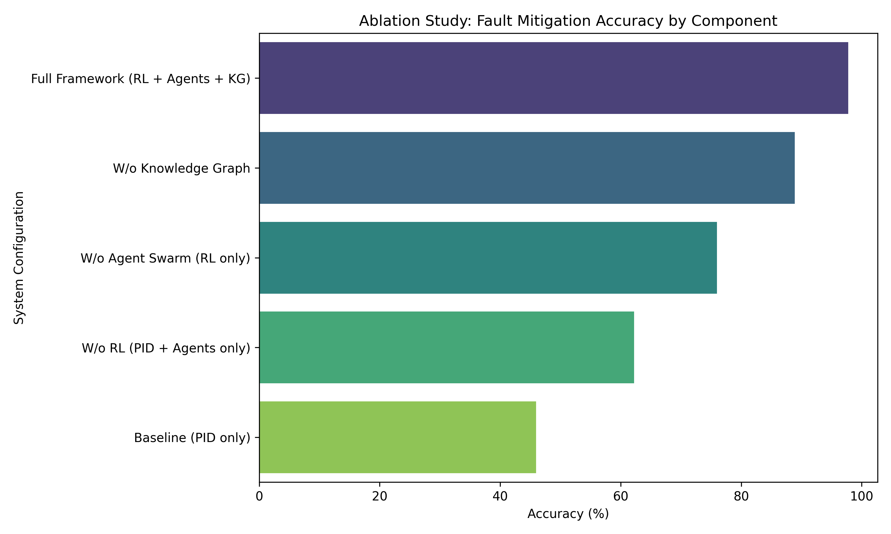

Decision Latency Trade-offs
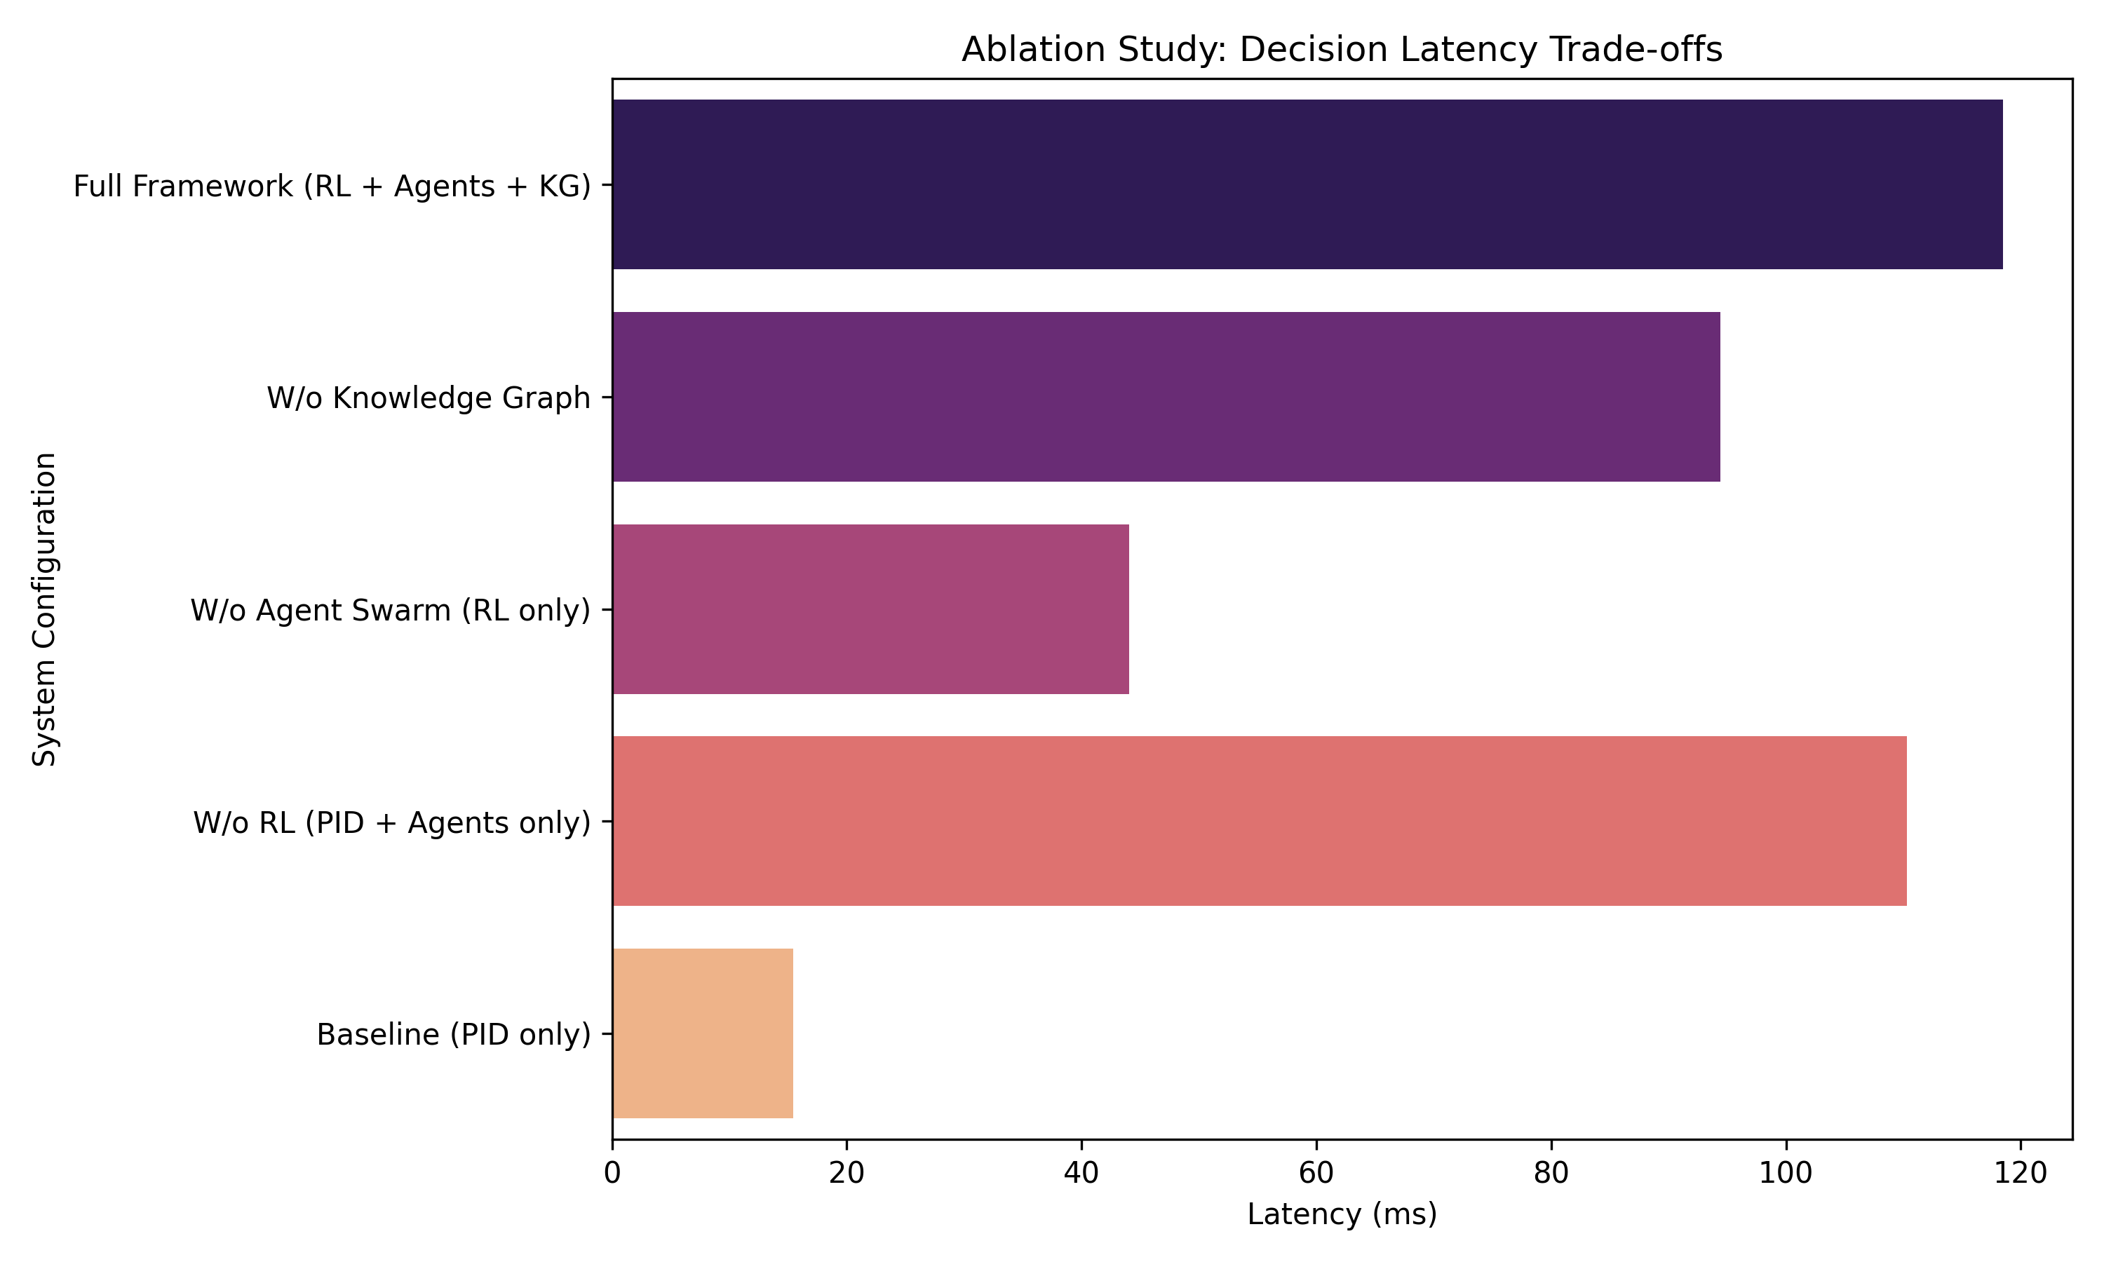

Model Convergence (MSE)
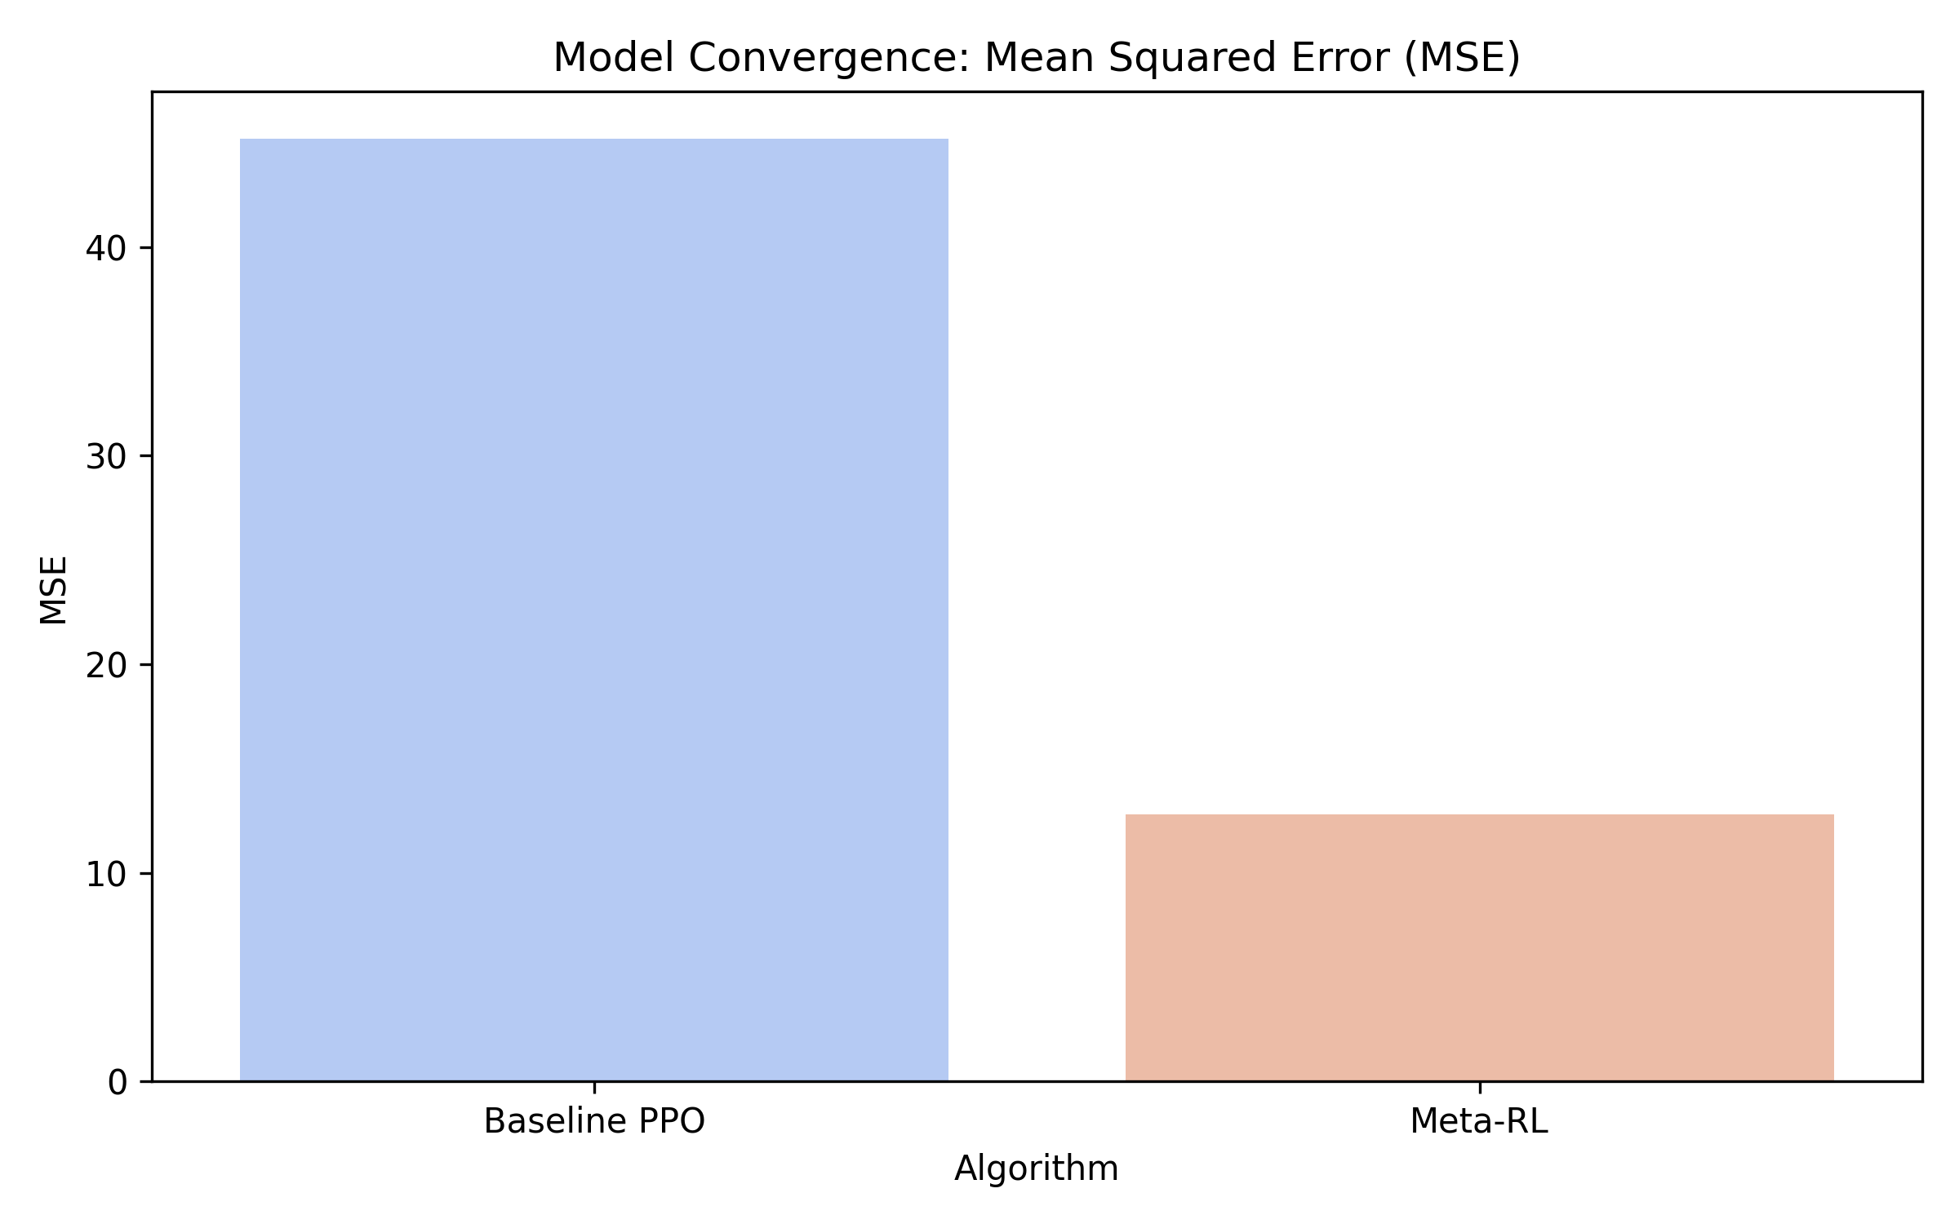

Adaptation Speed
