**DevOps Lab 2.1: Docker**

These instructions will guide you through the process of using Docker.

Open the Cloud Platform Console at [https://console.cloud.google.com](https://console.cloud.google.com/).

Click on the three horizontal bars at the left most side of the blue bar near the top of the browser window. *Select Compute Engine*.

Select *VM Instances*. You should see the virtual machine you created earlier.

Click on the checkbox to the left of the VM name and then select *START*. It will take a few moments to start.

Click on *SSH* to start a terminal window.

**Change the host name to student:** Find the icon that looks like a gear in the upper right-hand corner of this terminal browser window and select *Change Linux User Name*. Enter *student* and *click Change*. Now, notice the prompt that says "student@lab:~$"

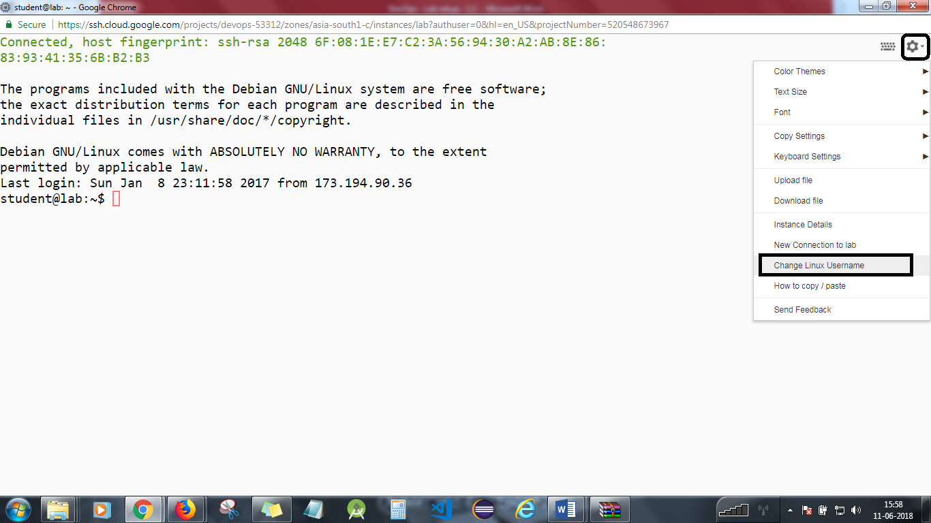

Test that Docker has been installed correctly on your computer.

The GCE image you used to create this computer already has Docker installed. Check to see the version of Docker.

*docker --version*

Pull a pre-built Docker image with a very light-weight operating system installed by pulling the latest version of the Alpine Linux distribution container.

*docker pull alpine*

Notice the size of this image.

*docker images*

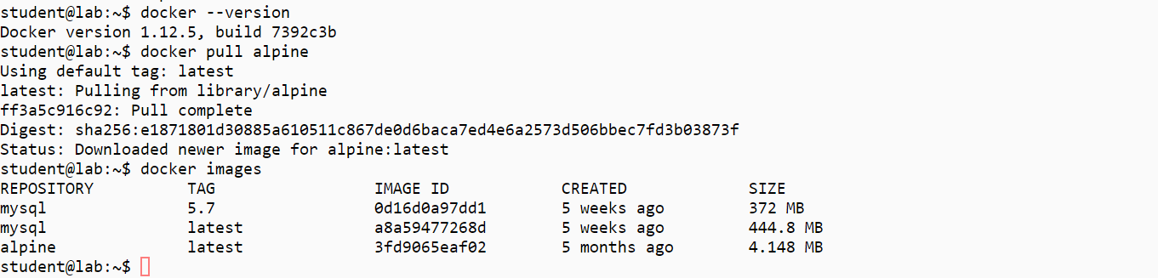

Run a container based on this image. Give the container the name "client," and activate the command shell processor.

*docker run -it --name client alpine /bin/sh*

Explore the Alpine Linux distribution by executing various Linux commands.

*date  
pwd  
whoami*

Do any additional exploration you may want to do.

Change to the root user's directory

*cd*

Touch a file to create it in the root directory.

*touch testfile*

Exit the container.[Please refer to the screenshot]

*exit*

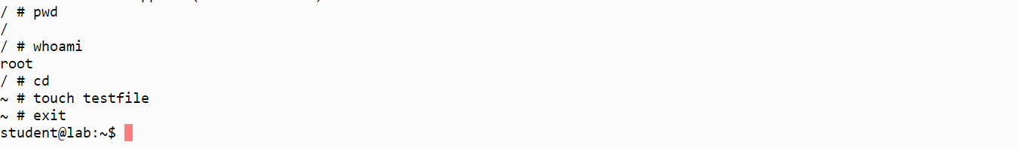

View the running containers (you should see none as you exited the last container).

*docker ps*

View all containers.  
You will see a non-running but still available container named "client."

*docker ps -a*

Restart the container.

*docker restart client*

Connect your terminal to the running container.

*docker attach client*

Verify that the file you placed in the root directory is still there.

*ls –la*

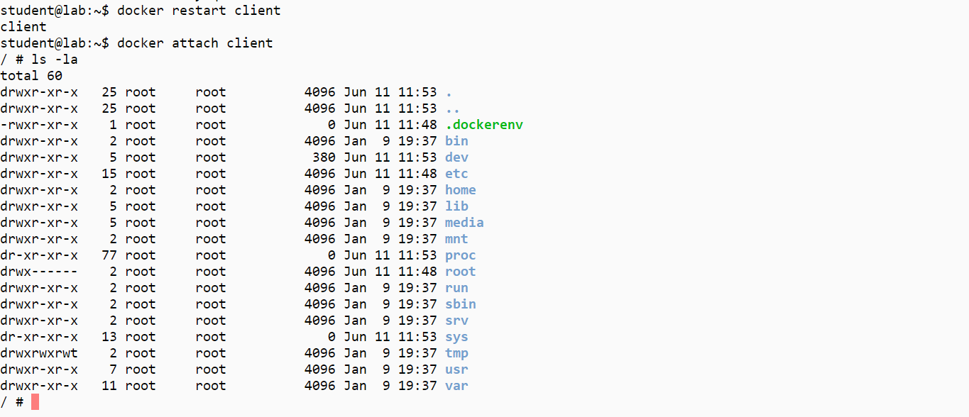

Pull a pre-built Docker image with a heavier weight operating system.Pull the latest version of the Debian Linux distribution container.

*docker pull debian*

Notice the size of this image, and compare it with Alpine.

*docker images*

Run a container based on this image, and activate the command shell processor.

*docker run --rm -ti debian /bin/bash*

Explore the Debian Linux distribution by executing various Linux commands.[Please refer the screenshot]

*date*

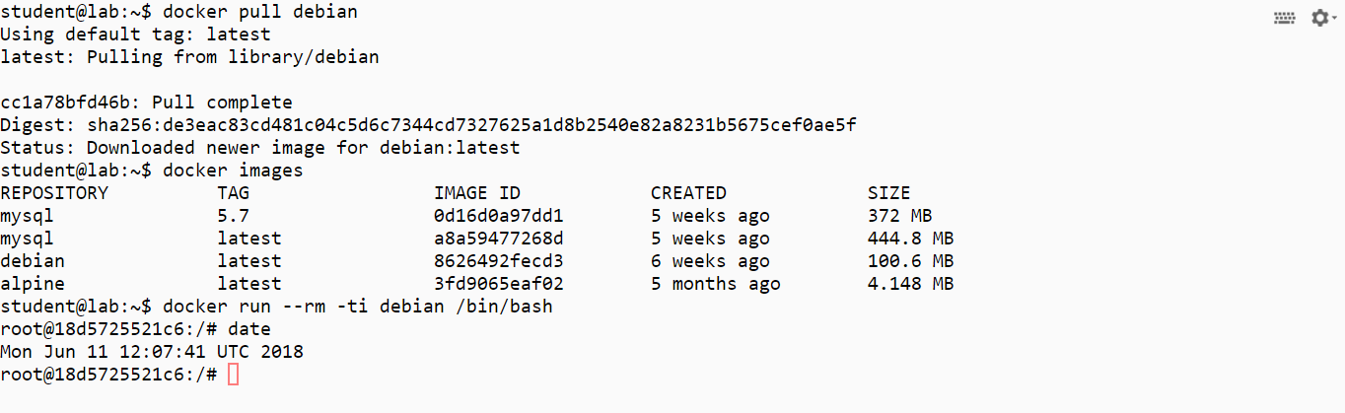

Exit the container.

*exit*

Run a container with a program already installed.Pull the hello-world image.

*docker pull hello-world*

Run the hello-world container and program.

*docker run hello-world*

Clean up after the lab.

*docker rm -f $(docker ps -aq)  
docker rmi $(docker images -q)*

You will need to stop the lab computer at the end of each day to prevent it from accumulating costs during the evening and night.

From the Web UI, you can navigate to the Compute Engine section and select your lab computer. When it is selected, click on the icon representing the "Stop" operation as shown below:

