**DevOps lab 2.3: Docker Registry**

Working with a Docker registry

Open the Cloud Platform Console at [https://console.cloud.google.com](https://console.cloud.google.com/).

Click on the three horizontal bars at the left most side of the blue bar near the top of the browser window. *Select Compute Engine*.

Select *VM Instances*. You should see the virtual machine you created earlier.

Click on the checkbox to the left of the VM name and then select *START*. It will take a few moments to start.

Click on *SSH* to start a terminal window.

**Change the host name to student:** Find the icon that looks like a gear in the upper right-hand corner of this terminal browser window and select *Change Linux User Name*. Enter *student* and *click Change*. Now, notice the prompt that says "student@lab:~$"

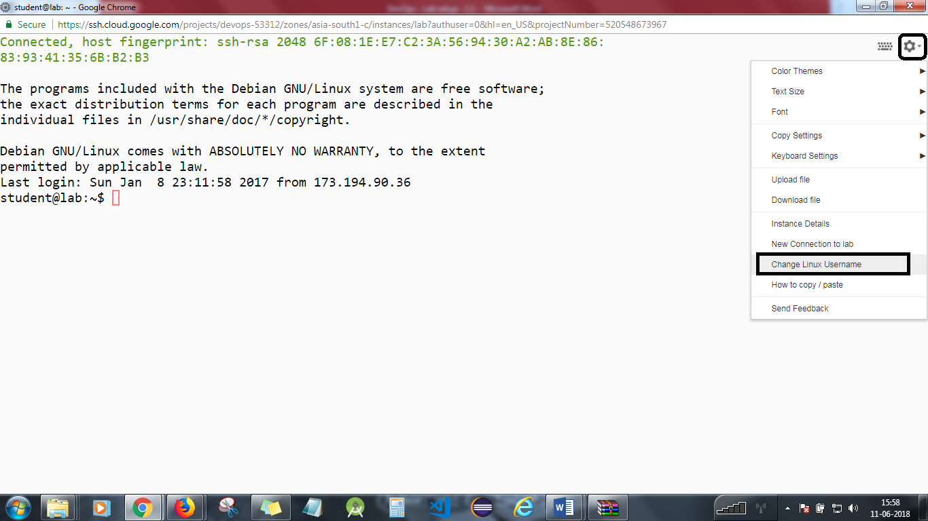

Run a Docker registry from an official registry image

Pull a recent version of the Centos Linux container.  
docker pull registry:2

Run the registry in a new Docker container. Expose port 5000.  
docker run -d -p 5000:5000 --restart=always --name registry registry:2

Pull another image and store it in the local registry.

Pull a new image from Docker hub.  
docker pull ubuntu

Tag the image for the local registry.  
docker tag ubuntu localhost:5000/ubuntu

Push the image to the local registry.  
docker push localhost:5000/ubuntu

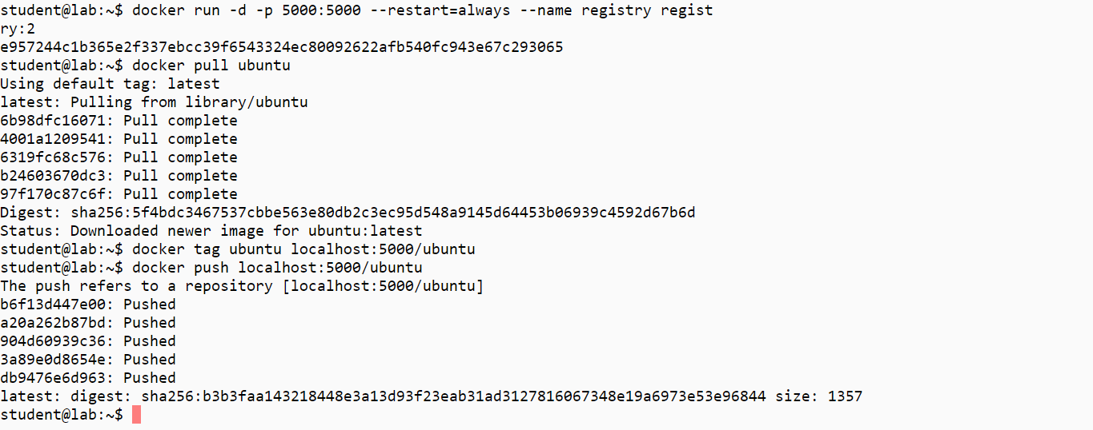

Remove the image from the local cache.  
docker rmi ubuntu

Confirm it has been removed.  
docker images

Pull the image from the local registry.  
docker pull localhost:5000/ubuntu

Confirm it is in the local cache.  
docker images

Run the new image.  
docker run -it --rm localhost:5000/ubuntu /bin/bash

Exit the container.  
exit

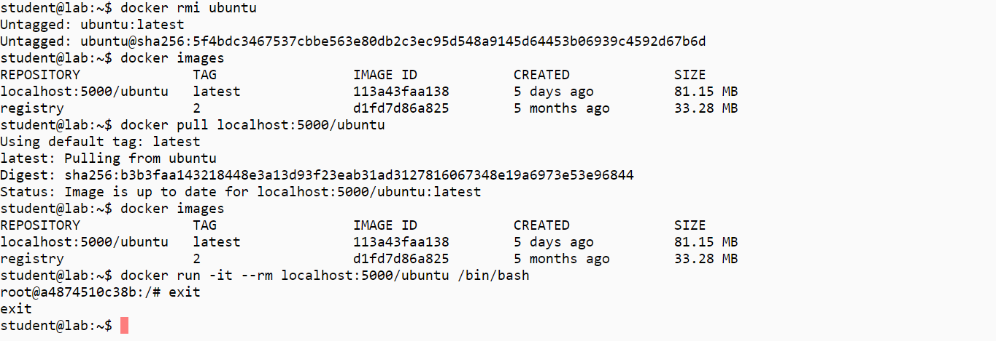

Clean up artifacts from the lab.  
docker rm -f $(docker ps -aq)  
docker rmi $(docker images -q)

You will need to stop the lab computer at the end of each day to prevent it from accumulating costs during the evening and night.

From the Web UI, you can navigate to the Compute Engine section and select your lab computer. When it is selected, click on the icon representing the "Stop" operation as shown below:

