**DevOps Lab 2.4: Docker Volumes**

Working with Docker volumes

Open the Cloud Platform Console at [https://console.cloud.google.com](https://console.cloud.google.com/).

Click on the three horizontal bars at the left most side of the blue bar near the top of the browser window. *Select Compute Engine*.

Select *VM Instances*. You should see the virtual machine you created earlier.

Click on the checkbox to the left of the VM name and then select *START*. It will take a few moments to start.

Click on *SSH* to start a terminal window.

**Change the host name to student:** Find the icon that looks like a gear in the upper right-hand corner of this terminal browser window and select *Change Linux User Name*. Enter *student* and *click Change*. Now, notice the prompt that says "student@lab:~$"

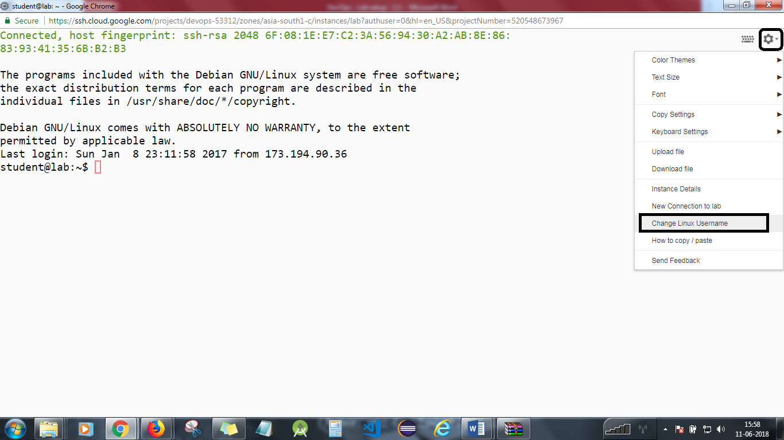

Create a Docker volume to which you will add persistent data.

docker volume create --name mydata

Create a Docker container, attach the data volume, and add persistent data.

Pull a light-weight Alpine distribution image.

docker pull alpine

Create a container from Alpine, and mount the volume mydata to /mnt.

docker run -ti --name client -v mydata:/mnt alpine /bin/sh

Go to the /mnt directory, touch (create) two files, and verify the exist.

cd /mnt  
touch foo.txt  
touch bar.txt  
ls

Exit the container.

exit

Verfiy that the container exists and is stopped.

docker ps -a

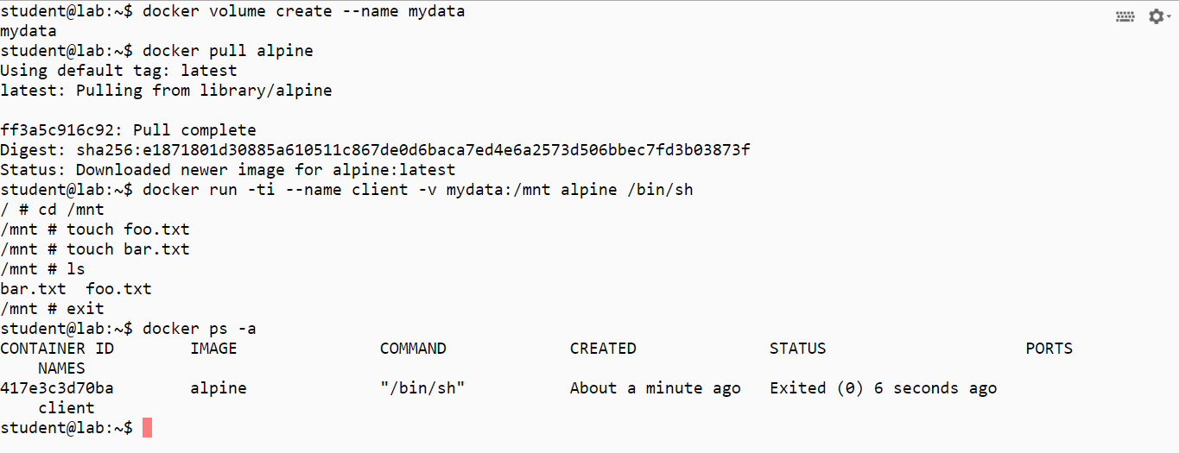

Delete the container and then verify it is gone.

docker rm client  
docker ps -a

Run a new container, and mount the volume mydata to /mnt again.

docker run --rm -ti -v mydata:/mnt alpine /bin/sh

Go to the /mnt directory, and observe if the files still exist.

cd /mnt  
ls

Exit the container.

exit

Verify that the volume still exists.

docker volume ls

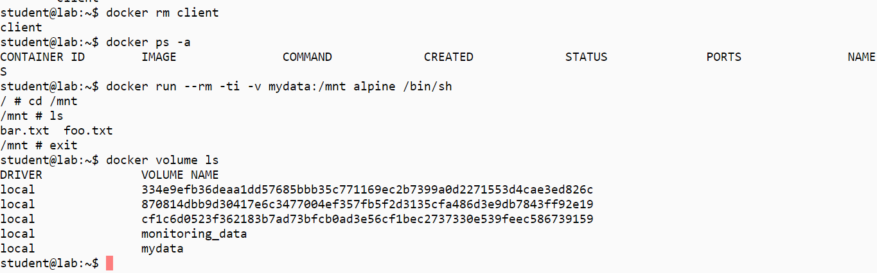

Clean up artifacts.

docker rm -f $(docker ps -aq) .  
docker rmi $(docker images -q)  
docker volume rm $(docker volume ls -q)

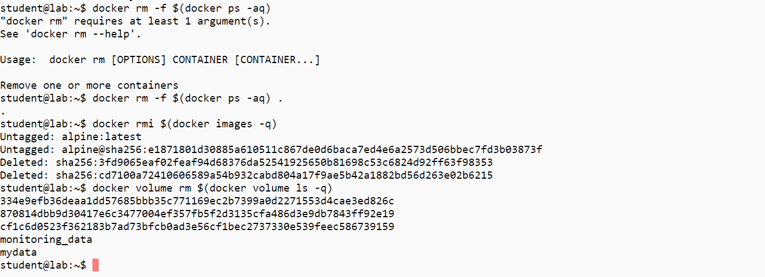

You will need to stop the lab computer at the end of each day to prevent it from accumulating costs during the evening and night.

From the Web UI, you can navigate to the Compute Engine section and select your lab computer. When it is selected, click on the icon representing the "Stop" operation as shown below:

