**Exercise 2.5: Docker Networking**

We will use Docker networking, and see how it is configured in a container.

Open the Cloud Platform Console at [https://console.cloud.google.com](https://console.cloud.google.com/).

Click on the three horizontal bars at the left most side of the blue bar near the top of the browser window. *Select Compute Engine*.

Select *VM Instances*. You should see the virtual machine you created earlier.

Click on the checkbox to the left of the VM name and then select *START*. It will take a few moments to start.

Click on *SSH* to start a terminal window.

**Change the host name to student:** Find the icon that looks like a gear in the upper right-hand corner of this terminal browser window and select *Change Linux User Name*. Enter *student* and *click Change*. Now, notice the prompt that says "student@lab:~$"

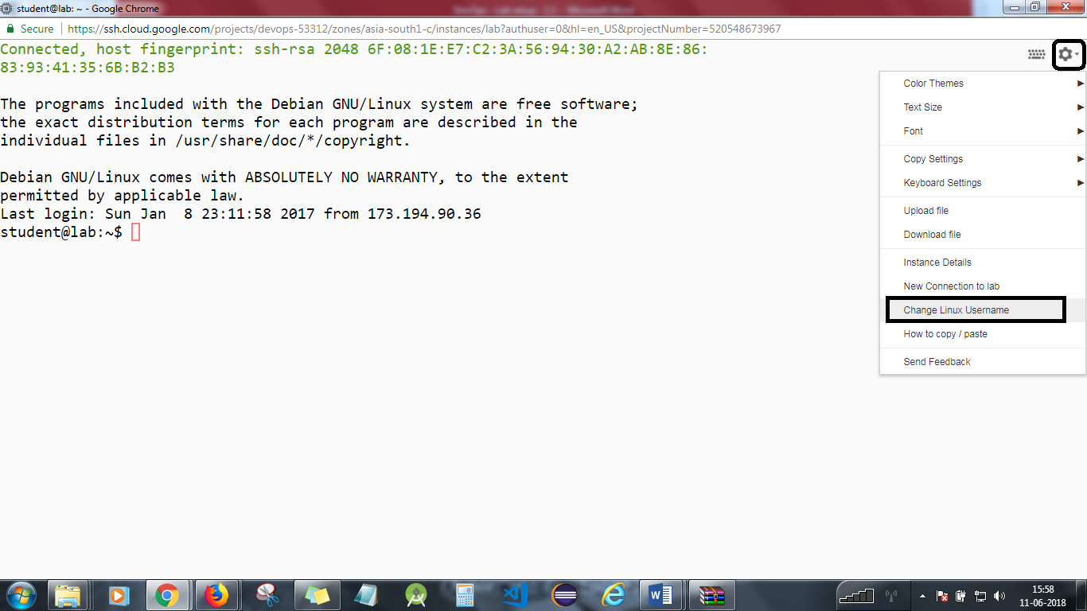

**Step 1**

You will need two SSH sessions for this exercise. Clone the files from GITHUB

*cd  
git clone https://github.com/simplilearn-devops/devops-lesson-2*

**Step 2**

Change to the exercise directory.

*cd  
cd devops-lesson-2/lab-2.5*

Create a Centos Docker container and install net tools.

*docker run -it --name centos centos /bin/bash  
yum install -y net-tools*

Check the IP address and hostname.

*ifconfig  
cat /etc/hosts  
hostname*

Exit the container using control-D.

Commit the container to an image. [Please refer the screenshot]

*docker commit centos centos-net  
docker images  
docker rm centos*

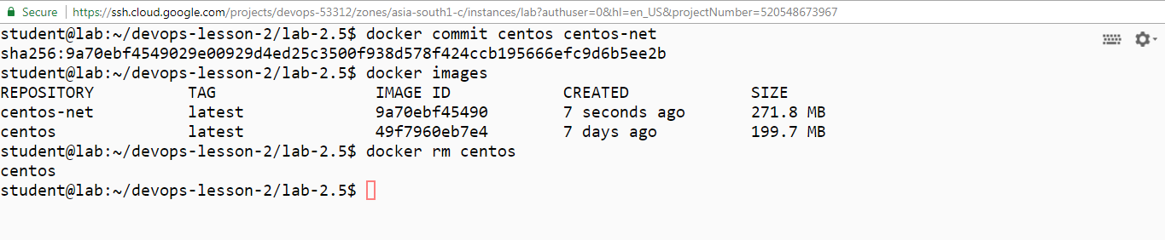

**Step 3**

Create a bridge network and find its IP range.

*docker network create exnet  
docker network ls  
docker network inspect exnet*

Run the centos container with the new network.

*docker run -it --rm --network exnet centos-net /bin/bash*

Check the IP address and hostname.

*ifconfig  
cat /etc/hosts  
hostname*

Exit the container with control-D.

**Step 4**

Start a new container using the default network.

*docker run -it --rm --name centos centos-net /bin/bash*

Check the IP address and hostname.

*ifconfig  
cat /etc/hosts  
hostname*

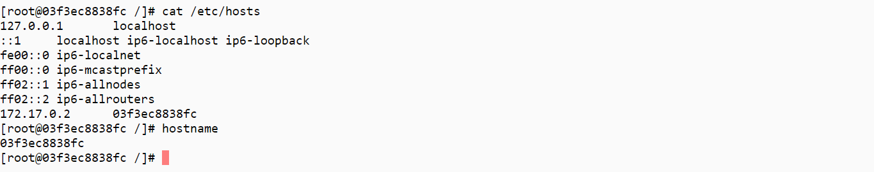

Exit the container with control-D.

**Step 4**

Start a new container using the default network.

*docker run -it --rm --name centos centos-net /bin/bash*

Check the IP address and hostname.

*ifconfig  
cat /etc/hosts  
hostname*

From the second SSH window, connect the network to the container.

*docker network connect exnet centos*

Go back to the running container, and see that it now has two IP addresses. [Please refer the screenshot]

*ifconfig  
cat /etc/hosts  
hostname*

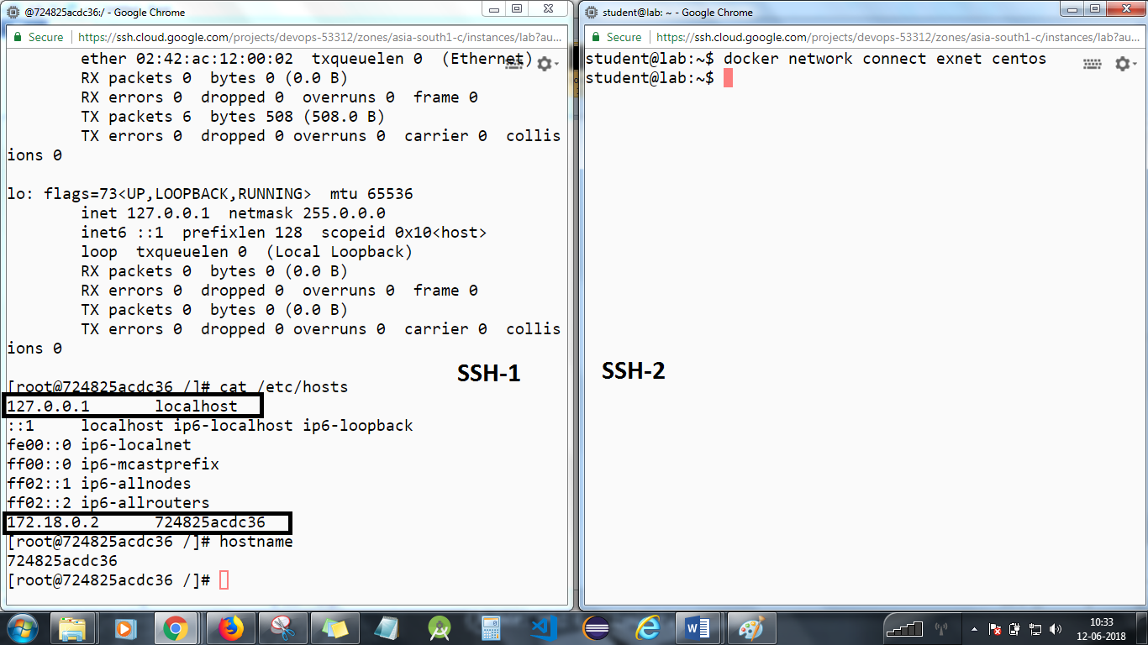

Go to the second SSH window and disconnect the network.

docker network disconnect exnet centos

Go back to the running container, and see that it now has one IP address.

*ifconfig  
cat /etc/hosts  
hostname*

Exit the container with control-D.

You will need to stop the lab computer at the end of each day to prevent it from accumulating costs during the evening and night.

From the Web UI, you can navigate to the Compute Engine section and select your lab computer. When it is selected, click on the icon representing the "Stop" operation as shown below:

