**Exercise 2.6: Docker Compose**

Use Docker Compose to manage a container.

Open the Cloud Platform Console at [https://console.cloud.google.com](https://console.cloud.google.com/).

Click on the three horizontal bars at the left most side of the blue bar near the top of the browser window. *Select Compute Engine*.

Select *VM Instances*. You should see the virtual machine you created earlier.

Click on the checkbox to the left of the VM name and then select *START*. It will take a few moments to start.

Click on *SSH* to start a terminal window.

**Change the host name to student:** Find the icon that looks like a gear in the upper right-hand corner of this terminal browser window and select *Change Linux User Name*. Enter *student* and *click Change*. Now, notice the prompt that says "student@lab:~$"

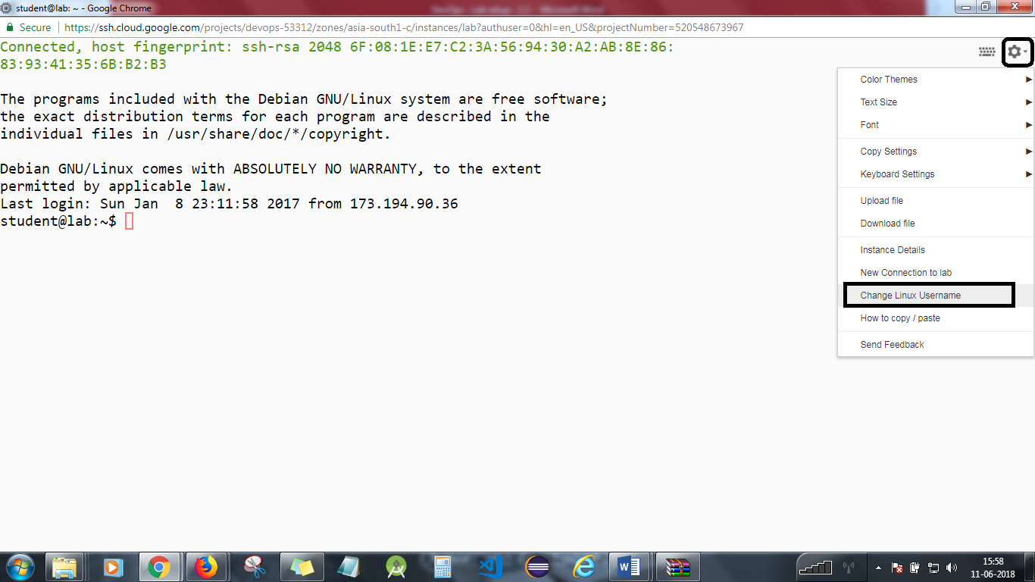

Use Docker Compose to manage a container.

**Step 1**

Start and connect to your Google Compute Engine virtual machine.

Download the docker-compose executable.  
cd  
mkdir bin  
curl -L "https://github.com/docker/compose/releases/download/1.9.0/docker-compose-$(uname -s)-$(uname -m)" -o bin/docker-compose  
chmod +x bin/docker-compose

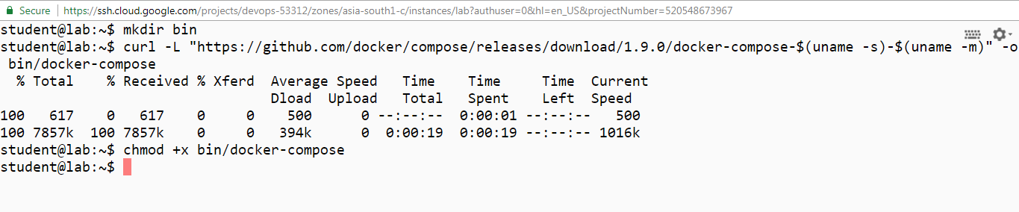

**Step 2**

Change to the exercise directory.  
cd devops-lesson-2/lab-2.6

Look at the Dockerfile.  
cat Dockerfile

Build the Docker image.  
docker build -t centos-sshd .

After executing the above, you should get the build result successful as shown below.

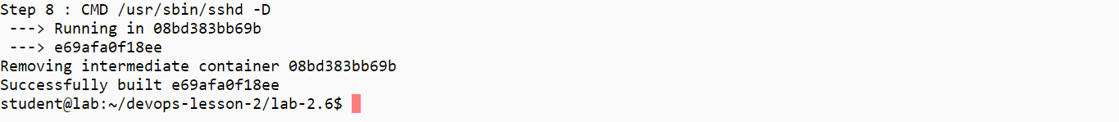

**Step 3**

Run the image.  
docker run -d --name sshd -p 2222:22 centos-sshd  
docker ps

Connect to the ssh server.  
ssh -p 2222 student@localhost  
Answer yes to accept the RSA key.

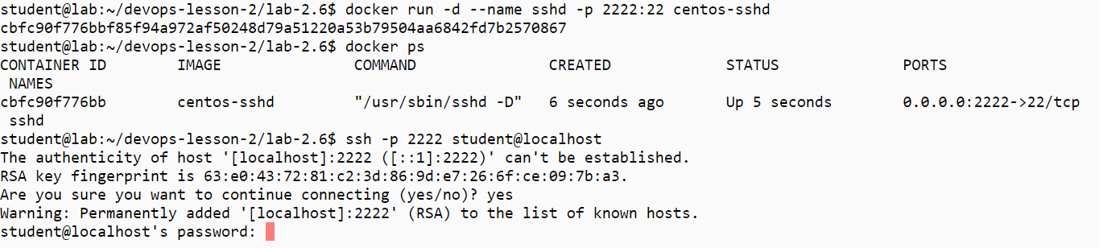

Give the password student.  
Verify that you are logged into the server.  
Log out with control-D.

Stop the server.  
docker rm -f sshd

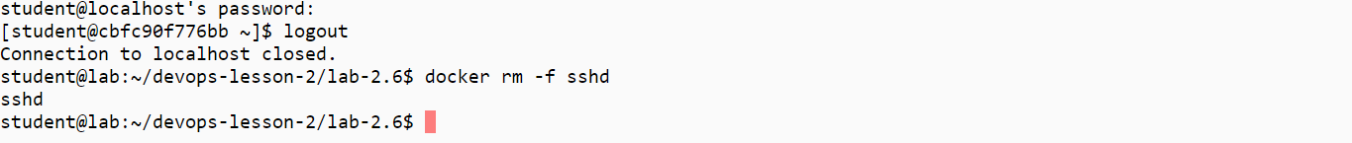

**Step 4**

Look at the Docker Compose YAML file.  
cat docker-compose.yml

The directory sshd is a build directory containing a copy of the Dockerfile.  
Start the server.  
~/bin/docker-compose up -d  
~/bin/docker-compose ps

Connect to the ssh server.  
ssh -p 2222 student@localhost  
Give the password student.  
Verify that you are logged into the server.  
Log out with control-D.

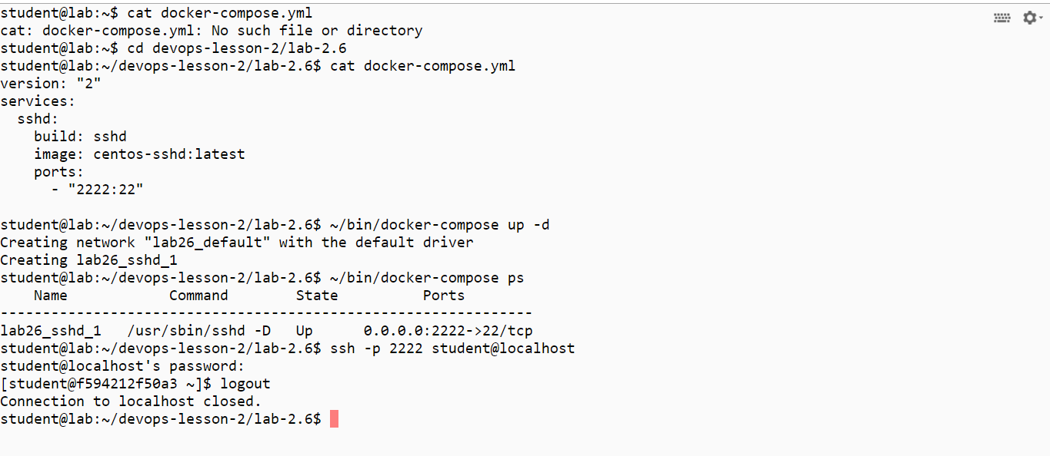

Stop the server.  
~/bin/docker-compose down  
~/bin/docker-compose ps

You will need to stop the lab computer at the end of each day to prevent it from accumulating costs during the evening and night.

From the Web UI, you can navigate to the Compute Engine section and select your lab computer. When it is selected, click on the icon representing the "Stop" operation as shown below:

