**Exercise 3.1: Ticketing**

You are going to install the open source ticketing system JTrac into a Docker container and use it.

Open the Cloud Platform Console at [https://console.cloud.google.com](https://console.cloud.google.com/).

Click on the three horizontal bars at the left most side of the blue bar near the top of the browser window. *Select Compute Engine*.

Select *VM Instances*. You should see the virtual machine you created earlier.

Click on the checkbox to the left of the VM name and then select *START*. It will take a few moments to start.

Click on *SSH* to start a terminal window.

**Change the host name to student:** Find the icon that looks like a gear in the upper right-hand corner of this terminal browser window and select *Change Linux User Name*. Enter *student* and *click Change*. Now, notice the prompt that says "student@lab:~$"

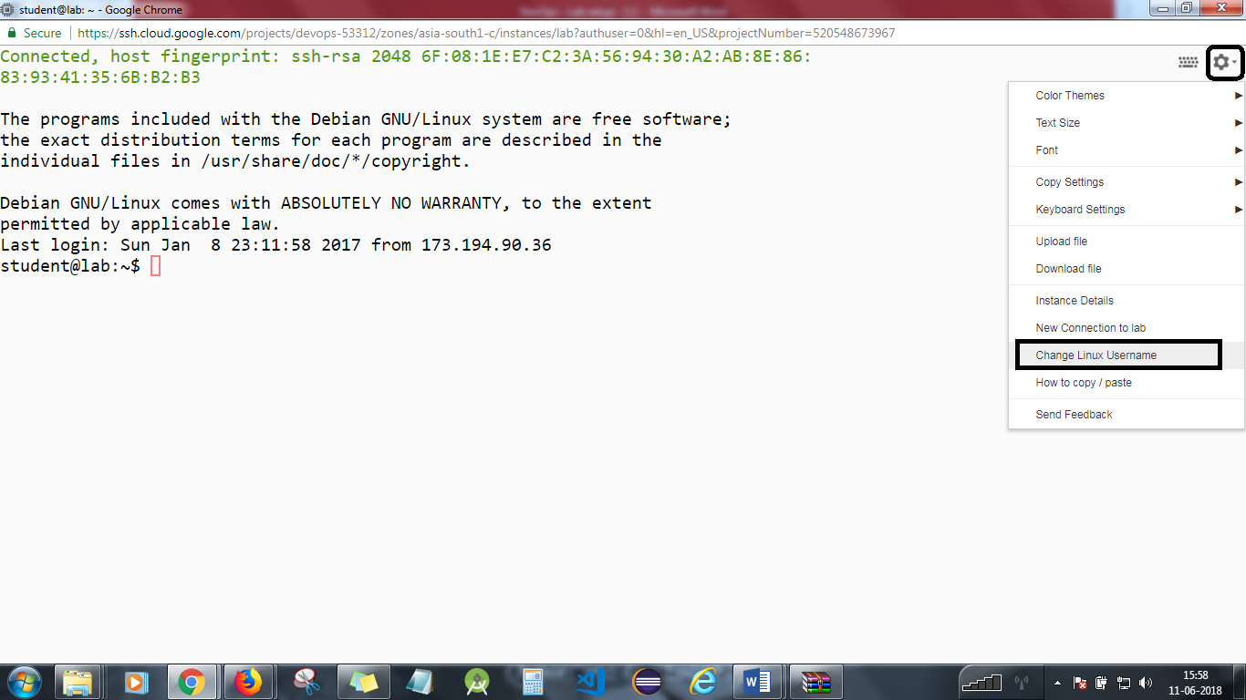

You are going to install the open source ticketing system JTrac into a Docker container and use it.

**Step 1**

Connect to the Google Compute Engine virtual machine.

You need to enable port 8080 in the Firewall.  
Go to the triple bar icon at the top left and select Networking. Then select Firewall Rules.

Select Create Firewall Rule. Fill in the form: Name: default-allow-http-8080 Source IP: 0.0.0.0/0 Allow protocols and ports: tcp:8080 Hit Create

**Step 2**

Clone out the GitHub repository for this lesson.  
cd  
git clone https://github.com/simplilearn-devops/devops-lesson-3

**Step 3**

Change to the lab directory.  
cd devops-lesson-3/lab-3.1

Check out the Dockerfile.  
cat Dockerfile

Build the Docker image.  
docker build -t jtrac .

You should be able to see that the build is successful as shown below:

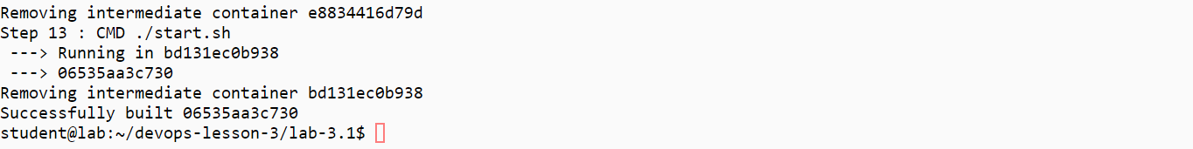

Now check if jtrac is available in the docker with

docker images

**Step 4**

Run the container.  
docker run -d --name jtrac -p 8080:80 jtrac  
docker ps

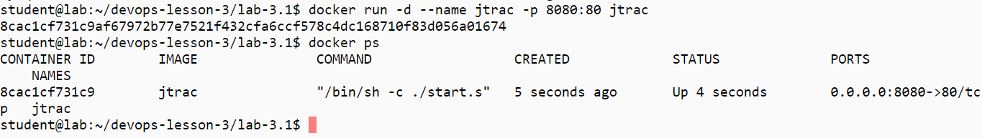

Find the external IP address of your VM.

In a browser on your local machine, enter the URL x.x.x.x:8080/jtrac replacing x.x.x.x with your external IP address as shown in the below example. You should see the Jtrac home page.

(Kindly do not copy the IP address available in the screenshot. It will not work)

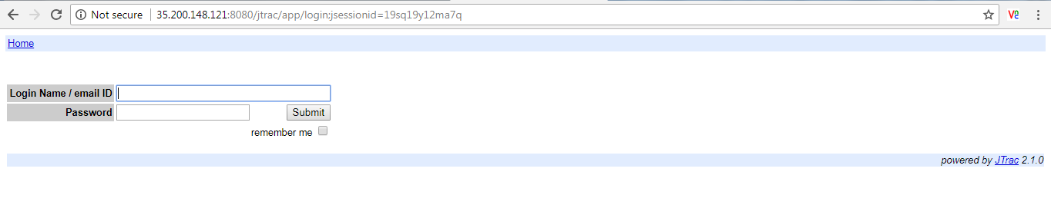

Log in as **admin** with passord **admin**.

**Step 5**

Select Options.  
Select Manage Spaces.  
Select Create new space.  
Give the space a Display Name, Space Key (The Space Key must be only upper case letters) and Description and hit Next as shown below:

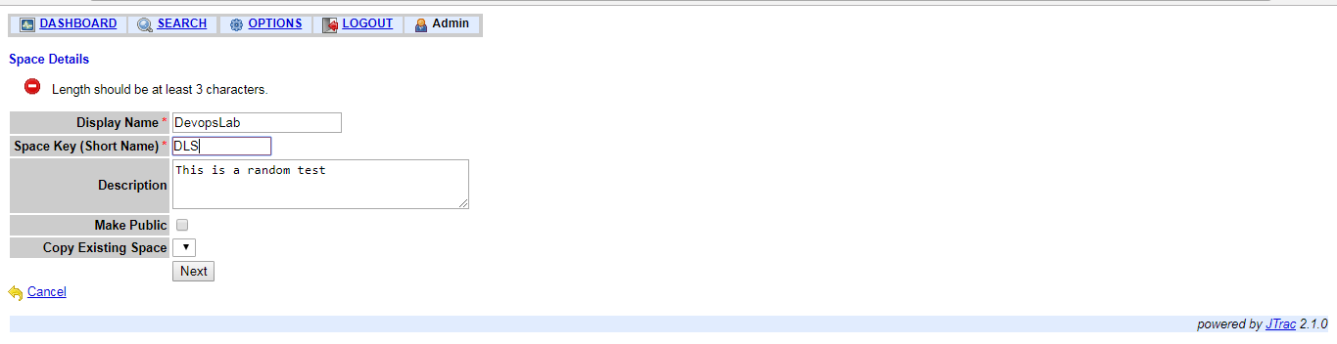

Hit Allocate to add the admin user to the space.  
Create a new user and allocate it to the space.

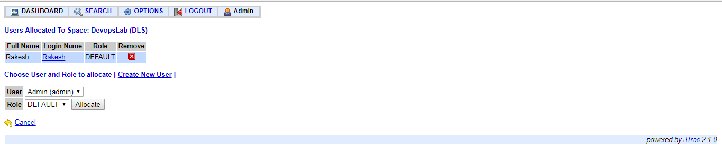

Use docker stop jtrac to stop the execution from the lab.

Create a few issues. Try out features on the application. It should be fairly intuitive. Check out this Web page for more information. http://jtrac.info/doc/html/features.html#features-dashboard

You will need to stop the lab computer at the end of each day to prevent it from accumulating costs during the evening and night.

From the Web UI, you can navigate to the Compute Engine section and select your lab computer. When it is selected, click on the icon representing the "Stop" operation as shown below:

