**Exercise 3.2: Subversion**

In this exercise, you will install Subversion into a Docker image and use the image as both a client and a server.

**Step-1**

Open the Cloud Platform Console at [https://console.cloud.google.com](https://console.cloud.google.com/).

Click on the three horizontal bars at the left most side of the blue bar near the top of the browser window. *Select Compute Engine*.

Select *VM Instances*. You should see the virtual machine you created earlier.

Click on the checkbox to the left of the VM name and then select *START*. It will take a few moments to start.

Click on *SSH* to start a terminal window.

**Change the host name to student:** Find the icon that looks like a gear in the upper right-hand corner of this terminal browser window and select *Change Linux User Name*. Enter *student* and *click Change*. Now, notice the prompt that says "student@lab:~$"

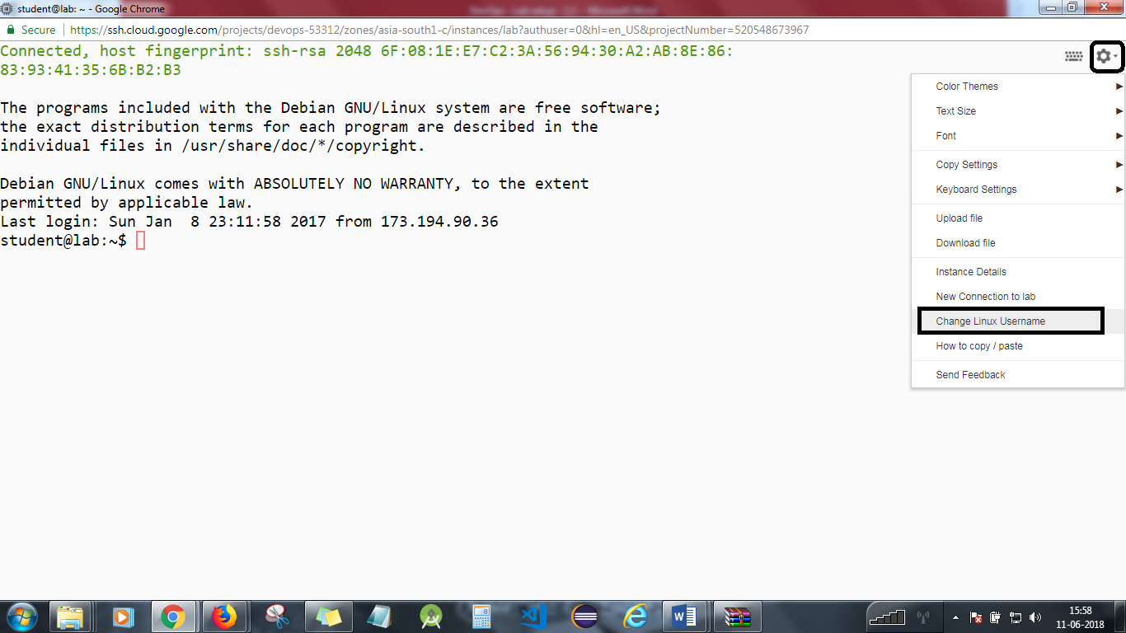

**Step-2:**

Change to the directory for this exercise.

*cd*

*Chmod +u *  
cd devops-lesson-3/lab-3.2*

Check out the Dockerfile.

*cat Dockerfile*

Build the image.

*docker build -t svn*

You should be able to see that the build is successful as shown below:



Check if the image is available with *docker images*

**Step 3**

Create two directories to work with.

*mkdir SVN Work*

Start a client container.

*docker run -it --rm -v $PWD/SVN:/opt/SVN svn /bin/bash*

Create a repository. It is basically a database, configuration, and scripts.

mkdir /opt/SVN/monitoring

ls -l /opt/SVN/monitoring

Edit the server configuration file, and give anonymous users write access by adding the line *anon-access = write* to the [general] section. You save and quit vi by typing :wq.

*vi /opt/SVN/monitoring/conf/svnserve.conf*

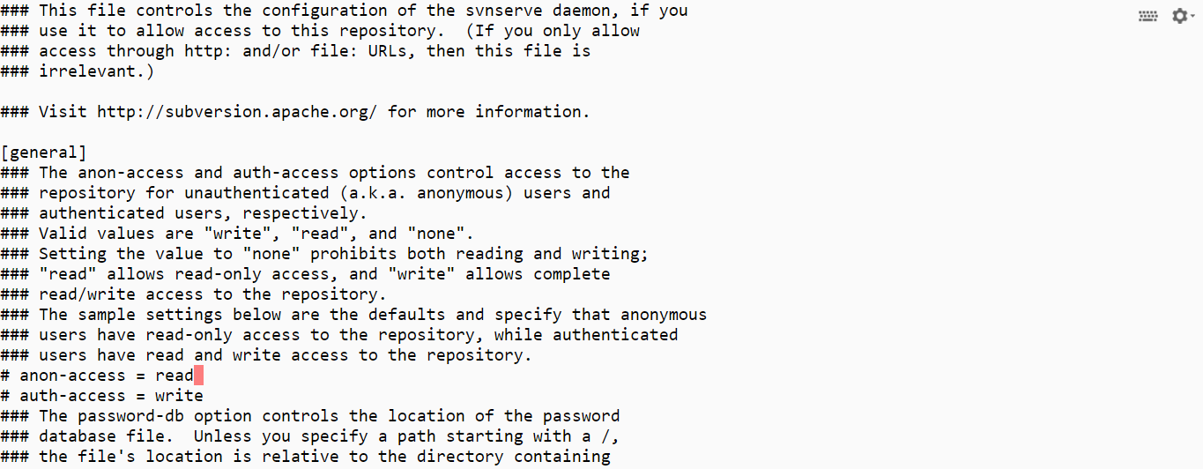

(Change **read** to **write**)

Edit the password file in the repository, and add the entry root = rootpw to the end of the file.

*vi /opt/SVN/monitoring/conf/passwd*

Exit the container with control-D.

**Step 4**

Run the server, and find its IP address.

*docker run -d --name svn -v $PWD/SVN:/opt/SVN -p 3690:3690 svn  
docker ps  
docker inspect svn*

**Step 5**

Run the client.

*docker run -it --rm -v $PWD/Work:/opt/Work svn /bin/bash*

Check out the repository.

*cd /opt/Work  
svn co svn://172.17.0.2/monitoring*



*ls -la  
cd monitoring*

**Step 6**

Try out some Subversion commands.

*echo "Message 1 " > message1.txt  
svn status  
svn add message1.txt  
svn status  
ls -la  
svn log message1.txt*

Try other commands and adding other files.

**Step 7**

Exit the container with control-D.

Delete the server container.

*docker rm -f svn*

You will need to stop the lab computer at the end of each day to prevent it from accumulating costs during the evening and night.

From the Web UI, you can navigate to the Compute Engine section and select your lab computer. When it is selected, click on the icon representing the "Stop" operation as shown below:

