**Exercise 3.3: Using Git**

In this exercise, you will install a Git server in a Docker container and use Git commands.

Open the Cloud Platform Console at [https://console.cloud.google.com](https://console.cloud.google.com/).

Click on the three horizontal bars at the left most side of the blue bar near the top of the browser window. *Select Compute Engine*.

Select *VM Instances*. You should see the virtual machine you created earlier.

Click on the checkbox to the left of the VM name and then select *START*. It will take a few moments to start.

Click on *SSH* to start a terminal window.

**Change the host name to student:** Find the icon that looks like a gear in the upper right-hand corner of this terminal browser window and select *Change Linux User Name*. Enter *student* and *click Change*. Now, notice the prompt that says "student@lab:~$"

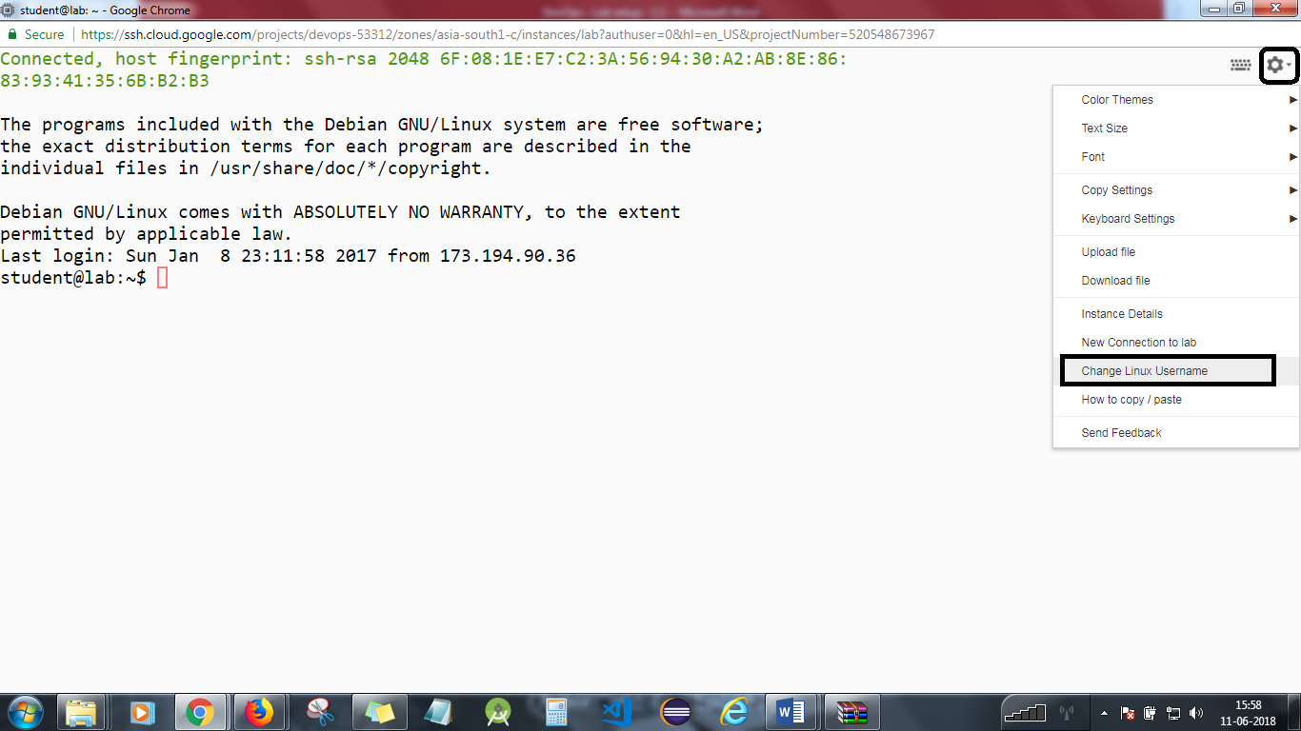

In this exercise, you will install a Git server in a Docker container and use Git commands.

**Step 2**

Change to the exercise directory, and ensure it is up to date.  
cd  
cd devops-lesson-3  
git pull  
cd lab-3.3

Copy the SSH keys, and clean the known hosts file.  
cp ~/.ssh/id_rsa.pub authorized_keys  
rm -f ~/.ssh/known_hosts

Check out the Dockerfile.  
cat Dockerfile

Build the Alpine Linux image.  
docker build -t git .  
docker images

**Step 3**

Run the container.  
docker run -d -p 2022:22 --name git git  
docker ps

See that docker has created a volume for the data.  
docker volume ls  
docker inspect git

**Step 4**

Clone the git repo. Ignore the warning about the repo being empty. It is  
git clone ssh://git@localhost:2022/home/git/project.git  
cd project  
ls -la

Add a new file. See how the status changes.  
echo "message 1" > message1.txt  
git status  
git add *  
git status  
git commit -m "added message"  
git status  
git push  
git log message1.txt

Try some other Git commands.

**Step 5**

Tidy up by deleting the container and image and other files which can cause problems later.  
docker rm -f git  
docker rmi git  
rm -rf project ~/.ssh/known_hosts

You will need to stop the lab computer at the end of each day to prevent it from accumulating costs during the evening and night.

From the Web UI, you can navigate to the Compute Engine section and select your lab computer. When it is selected, click on the icon representing the "Stop" operation as shown below:

