**Capstone - Exercise 2: Case Study DAO**

In this exercise, MySQL and Hibernate are used to create a DAO. Hibernate is an ORM which greatly simplifies the persistence of objects. The DAO is tested using JUnit integration tests.

Maven is not used for this project as sometimes it gets dependencies wrong. The necessary jars are part of the project.

Open the Cloud Platform Console at [https://console.cloud.google.com](https://console.cloud.google.com/).

Click on the three horizontal bars at the left most side of the blue bar near the top of the browser window. *Select Compute Engine*.

Select *VM Instances*. You should see the virtual machine you created earlier.

Click on the checkbox to the left of the VM name and then select *START*. It will take a few moments to start.

Click on *SSH* to start a terminal window.

**Change the host name to student:** Find the icon that looks like a gear in the upper right-hand corner of this terminal browser window and select *Change Linux User Name*. Enter *student* and *click Change*. Now, notice the prompt that says "student@lab:~$"

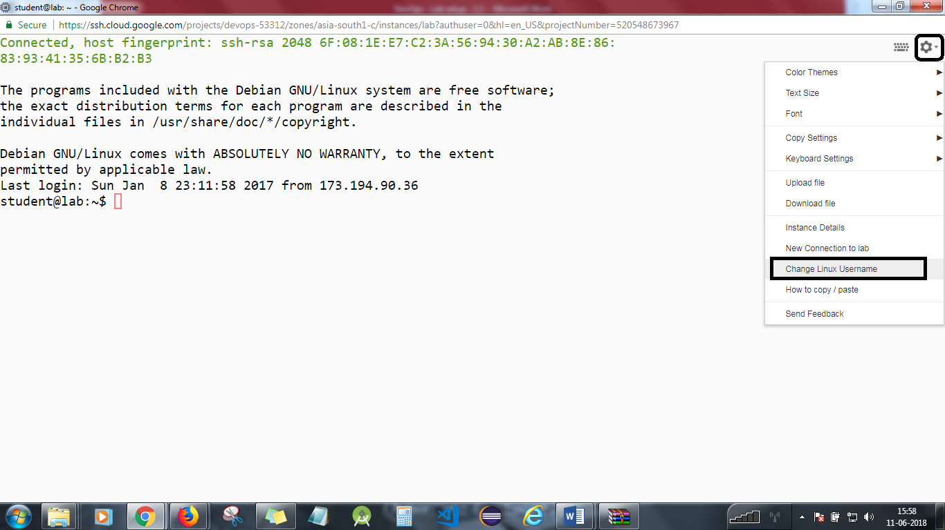

In this exercise, MySQL and Hibernate are used to create a DAO. Hibernate is an ORM which greatly simplifies the persistence of objects. The DAO is tested using JUnit integration tests.

Maven is not used for this project as sometimes it gets dependencies wrong. The necessary jars are part of the project.

**Step 1**

Start your Google Compute Engine virtual machine, and connect to it using SSH.

Start the MySQL server we created earlier.  
cd devops-capstone/lab-2  
chmod u+x ./runserver

./runserver

Start the vncserver.  
vncserver

**Step 2**

Now, you may have to set up a firewall rule in your Google cloud account to allow access to the IP addresses. Please follow the below steps:

1. Go to VPC Network under NETWORKING -> Firewall rules and click on CREATE FIREWALL RULE.

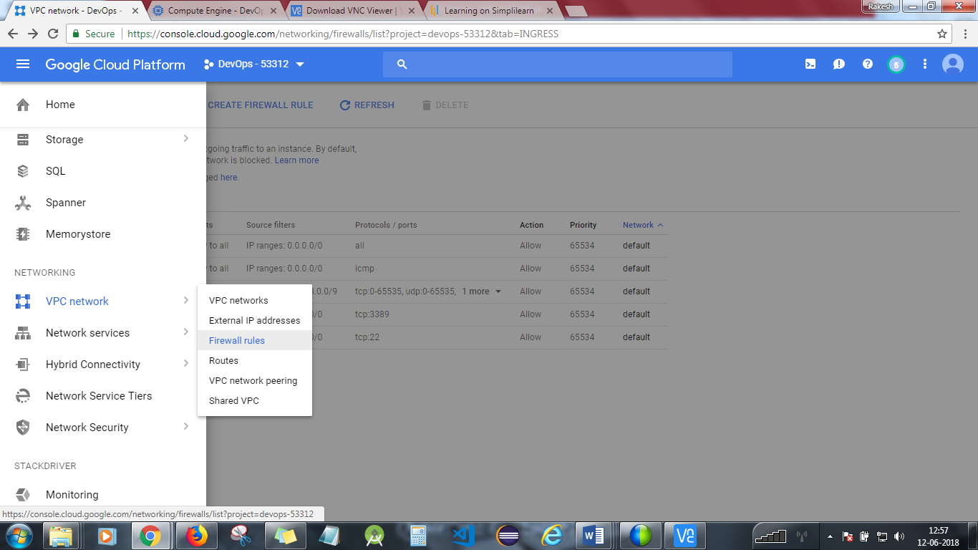

1. Add the below details and set up the rule as shown below :

Name : Anyname

Priority: Choose the highest number. ( Most cases : 65534)

Source filters : 0.0.0.0/0

Protocols and ports : All

Enforcement : Enabled.

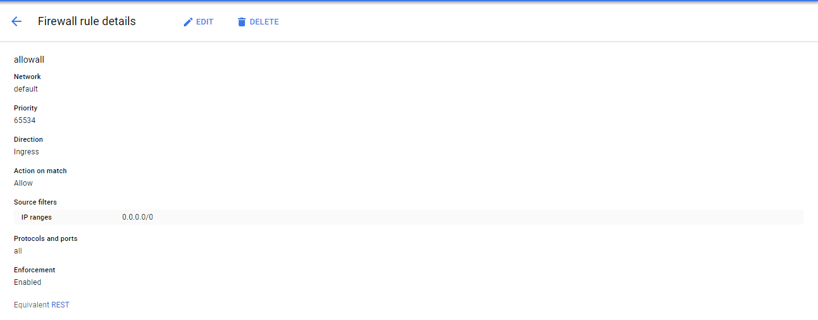

Start the VNC client on your local machine using x.x.x.x:5901. Where x.x.x.x is the external IP address of the virtual machine. The password is “simplilearn.”

**Step 3**

Start Eclipse which is available in the directory mentioned below:

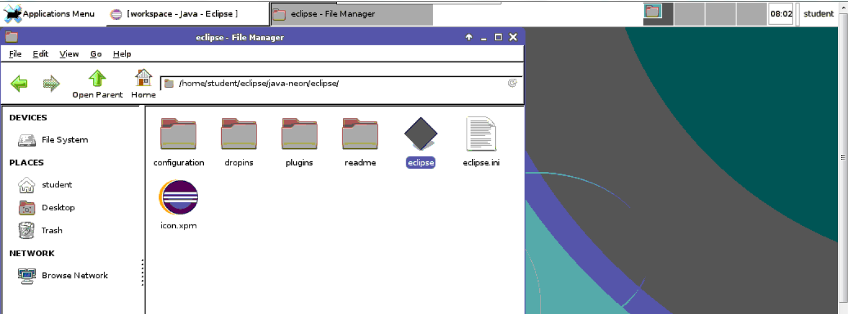

Now, start a new Java Project as shown below.

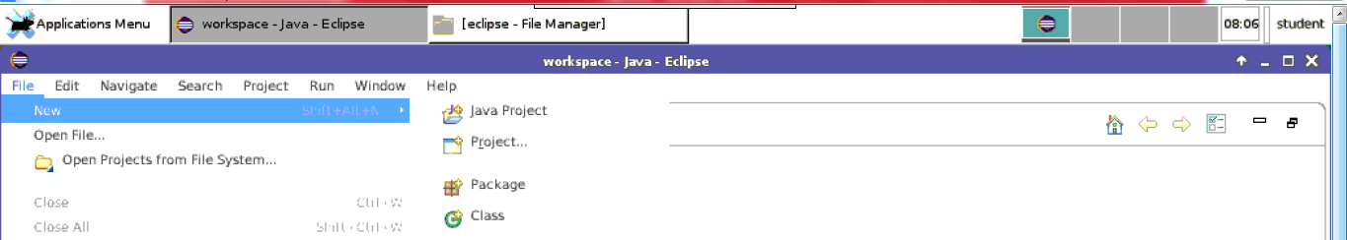

Do not select the Default directory instead click on **BROWSE** button and select **Home->Devops-Capstone-> Devops**

The code won't compile initially. Right click on the DevOps project, select *Preferences,* and then select *Java Build Path*.  
Go to the Libraries tab and do the following:

* Select *Add Library*, and add the JUnit 4 library.
* Select *Add Class Folder,* and add the resources folder.
* Select *Add Jars,* open the DevOps folder, and if there is a lib folder, open that and add all jars from all the folders under lib. Eclipse may have done this step for you.
* Select OK and everything should compile.

**Step 4**

Open up the src, test, and resources folders in the *Package Explorer*.  
Open up the files Docker.java, DockerDAO.java, DockerDAOImpl.java, DockerDAOTest.java, and hibernate.cfg.xml.  
Check that hibernate.cfg.xml has the right MySQL connection information.

Right click on DockerDAOTests.java, and select *Run as* *JUnit Test*.  
The unit tests should run successfully.  
Check out the console logs, and see what output Hibernate produced.

You will need to stop the lab computer at the end of each day to prevent it from accumulating costs during the evening and night.

From the Web UI, you can navigate to the Compute Engine section and select your lab computer. When it is selected, click on the icon representing the "Stop" operation as shown below:

