**DevOps lab 4.1 Test Driven Development (TDD)**

Set up a TDD environment.

**Step -1:**

Open the Cloud Platform Console at [https://console.cloud.google.com](https://console.cloud.google.com/).

Click on the three horizontal bars at the left most side of the blue bar near the top of the browser window. *Select Compute Engine*.

Select *VM Instances*. You should see the virtual machine you created earlier.

Click on the checkbox to the left of the VM name and then select *START*. It will take a few moments to start.

Click on *SSH* to start a terminal window.

**Change the host name to student:** Find the icon that looks like a gear in the upper right-hand corner of this terminal browser window and select *Change Linux User Name*. Enter *student* and *click Change*. Now, notice the prompt that says "student@lab:~$"

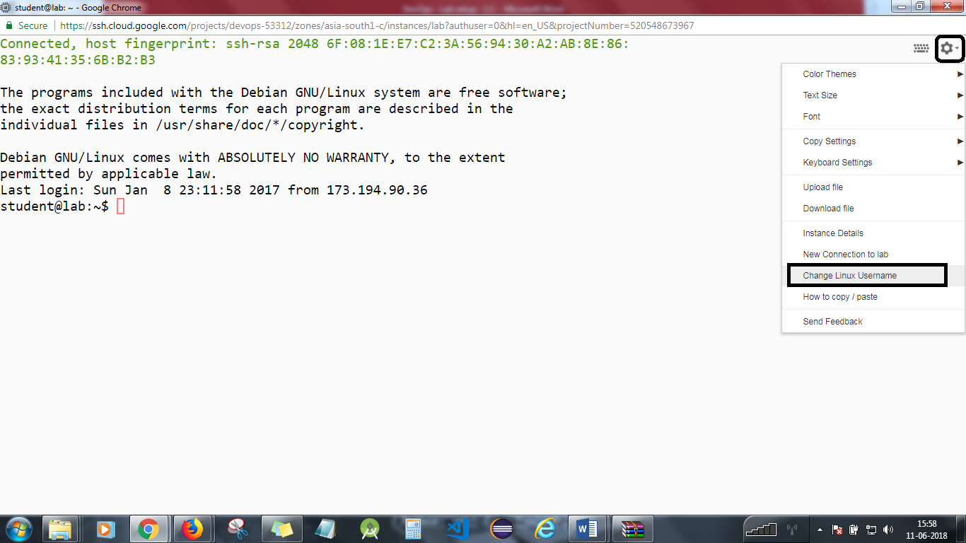

*git clone https://github.com/simplilearn-devops/devops-lesson-4  
cd devops-lesson-4/lab-4.1*

**Step 2**

Start the vncserver.

*vncserver*

Start the VNC client. You will need the external IP address of your virtual machine. Enter the following into the VNC client, replacing x.x.x.x with your IP address.

x.x.x.x:5901

If you are using a Mac, enter the following into Safari, replacing x.x.x.x with your IP address.

vnc://x.x.x.x:5901

Dismiss any warnings about insecure connections.

The password is *simplilearn*.

You will be connected to the graphical desktop of the virtual machine.

**Step 3**

Start and use Eclipse.

In your VNC window, start the *File System* from the desktop icon.  
Select *Student* in the left column.  
Open the *eclipse* folder.  
Open the java-neon_ folder.  
Open the *eclipse* folder.  
Start eclipse from the diamond shaped icon.  
Accept the default workspace location.

Select File->New->Java Project.  
Uncheck *Use default location*.  
Hit the *Browse* button and select *Home*.  
Open the devops-lesson-4 folder.  
Open the lab-4.1 folder.  
Select the FizzBuzz folder and click *OK* at the bottom of the dialog.  
Hit the *Finish* button at the bottom of the dialog.

You should see the FizzBuzz project on the left. The test folder is marked in red as there is a missing dependency.

Right click on the FizzBuzz project. A menu will appear. Select *Properties* at the bottom.

Select *Java Build Path*.  
Select the *Libraries* tab.  
Hit the *Add Library* button.  
Select *JUnit* and then hit *Next*.  
Make sure that *JUnit 4* is selected and then hit *Finish*. The project errors should disappear.

Open up the source and test folders and the DevOps packages. Double click on FizzBuzz.java and FizzBuzzTest.java. Editor windows will open.

**Step 4**

Right click on FizzBuzzTests.java

Select *Run as* the *JUnit Test*.

The unit tests should run successfully.

Implement the numberThreeReturnsFizz() test and run it. It should fail.

Implement the code and run it. Make changes until the tests pass.

If you have time, implement more tests.

**Step 5**

Exit eclipse by selecting *File*->*Exit*.

Close the VNC viewer.

You will need to stop the lab computer at the end of each day to prevent it from accumulating costs during the evening and night.

From the Web UI, you can navigate to the Compute Engine section and select your lab computer. When it is selected, click on the icon representing the "Stop" operation as shown below:

