**DevOps lab 4.2 Mocking**

Setup a Mocking framework environment.

**Step-1:**

Open the Cloud Platform Console at [https://console.cloud.google.com](https://console.cloud.google.com/).

Click on the three horizontal bars at the left most side of the blue bar near the top of the browser window. *Select Compute Engine*.

Select *VM Instances*. You should see the virtual machine you created earlier.

Click on the checkbox to the left of the VM name and then select *START*. It will take a few moments to start.

Click on *SSH* to start a terminal window.

**Change the host name to student:** Find the icon that looks like a gear in the upper right-hand corner of this terminal browser window and select *Change Linux User Name*. Enter *student* and *click Change*. Now, notice the prompt that says "student@lab:~$"

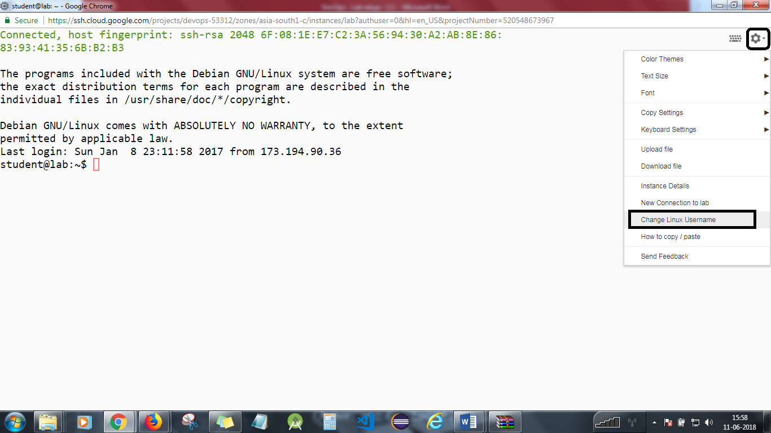

*cd devops-lesson-4/lab-4.2*

**Step 2**

Start the vncserver.

*vncserver*

**Step 3**

Start the VNC client on your local machine. You will need the external IP address of your virtual machine. Enter the following into the VNC client, replacing x.x.x.x with your IP address. Note that the external IP address can change every time you start the virtual machine.

x.x.x.x:5901

If you are using a Mac, enter the following into Safari, replacing x.x.x.x with your IP address.

vnc://x.x.x.x:5901

Dismiss any warnings about insecure connections.

The password is simplilearn.

You will be connected to the graphical desktop of the virtual machine.

**Step 4**

Start and use Eclipse.

In your VNC window, start the *File System* from the desktop icon.  
Select *Student* in the left column.  
Open the *eclipse* folder.  
Open the java-neon_ folder.  
Open the *eclipse* folder.  
Start eclipse from the diamond shaped icon.  
Accept the default workspace location.

Select File->New->Java Project.  
Uncheck *Use default location*.  
Hit the *Browse* button. Select *Home*.  
Open the devops-lesson-4 folder.  
Open the lab-4.2 folder.  
Select the Mocking folder and hit *OK* at the bottom of the dialog.  
Hit the *Finish* button at the bottom of the dialog.

You should see the Mocking project on the left. The test folder is marked in red as there is a missing dependency.

Right click on the Mocking project. A menu will appear. Select *Properties* at the bottom.

Select *Java Build Path*.  
Select the *Libraries* tab.  
Hit the *Add Library* button.  
Select *JUnit* and then hit *Next*.  
Make sure that *JUnit 4* is selected and then hit *Finish*.

Select *Add Jars*.  
Open the *Mocking* folder and then open the *lib* folder.  
You should see 4 jar files. Select them all and hit *OK*. If the lib folder isn’t visible, it means that Eclipse has automatically loaded the jar files and nothing needs to be done.

Hit *OK.* The project errors should disappear.

Open up the source and test folders and the DevOps packages. Double click on LoginController.java and LoginControlerTests.java. Editor windows will open.

**Step 5**

Right click on LoginControllerTests.java.

Select *Run as* and then select *JUnit Test*.

The unit tests should fail.

Implement the code and run it. Make changes until the tests pass.

If you have time, implement more tests.

**Step 6**

Exit eclipse by selecting *File*->*Exit*.

Close the VNC viewer.

You will need to stop the lab computer at the end of each day to prevent it from accumulating costs during the evening and night.

From the Web UI, you can navigate to the Compute Engine section and select your lab computer. When it is selected, click on the icon representing the "Stop" operation as shown below:

