**DevOps lab 5.1: Jenkins to Set Up Projects and Create Pipeline**

**Step-1:**

Open the Cloud Platform Console at [https://console.cloud.google.com](https://console.cloud.google.com/).

Click on the three horizontal bars at the left most side of the blue bar near the top of the browser window. *Select Compute Engine*.

Select *VM Instances*. You should see the virtual machine you created earlier.

Click on the checkbox to the left of the VM name and then select *START*. It will take a few moments to start.

Click on *SSH* to start a terminal window.

**Change the host name to student:** Find the icon that looks like a gear in the upper right-hand corner of this terminal browser window and select *Change Linux User Name*. Enter *student* and *click Change*. Now, notice the prompt that says "student@lab:~$"

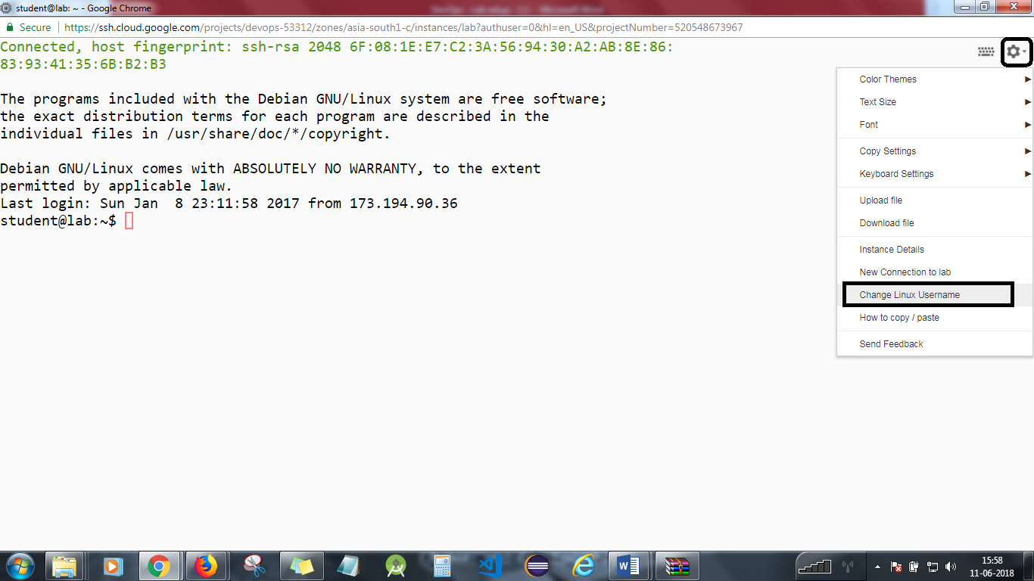

**Step 2:**

Start a browser on your local machine and enter the URL x.x.x.x:8080, replacing x.x.x.x with the external IP address of your virtual machine.

You will see *Jenkins Login* screen. Enter user ID and password and hit *Continue*.

Select *create new jobs*.  
Enter the name *HelloWorld*.  
Select *Freestyle project*.  
Hit *OK*.

Now, you should install jdk and maven in Jenkins.

You should have an oracle account in order to download jdk within Jenkins as shown below.

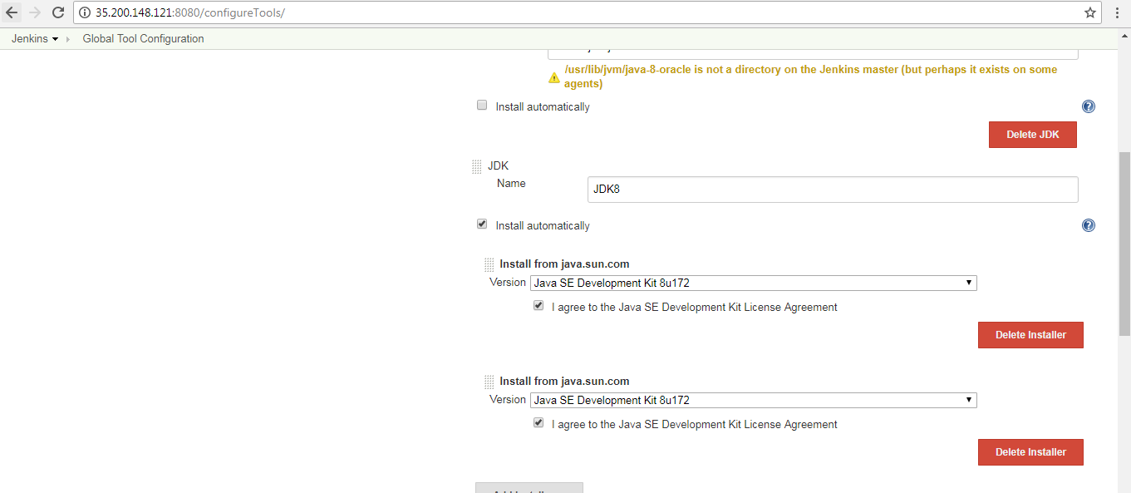

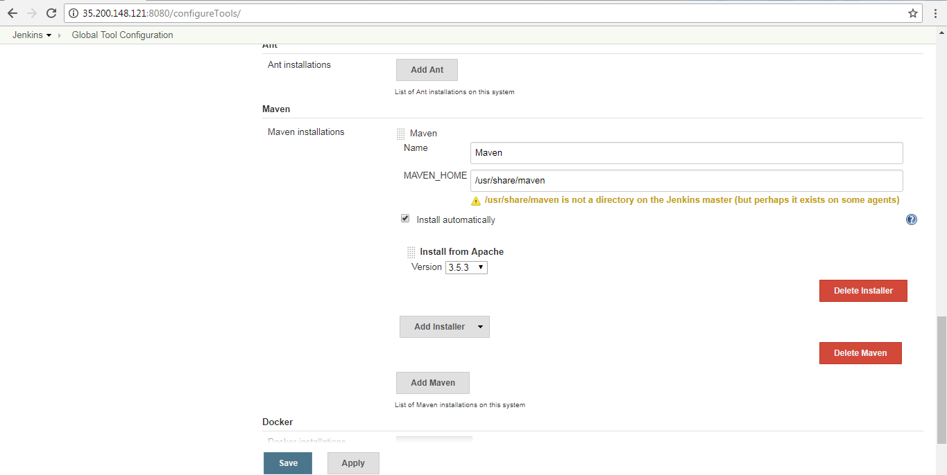

Now add your github repo where the below mentioned code is written and commit as shown below:

public class Hello {

public static void main(String args[]){

for(int i=1;i<=20;i++){

System.out.println(“Hello world from Devops”);

}

}

}

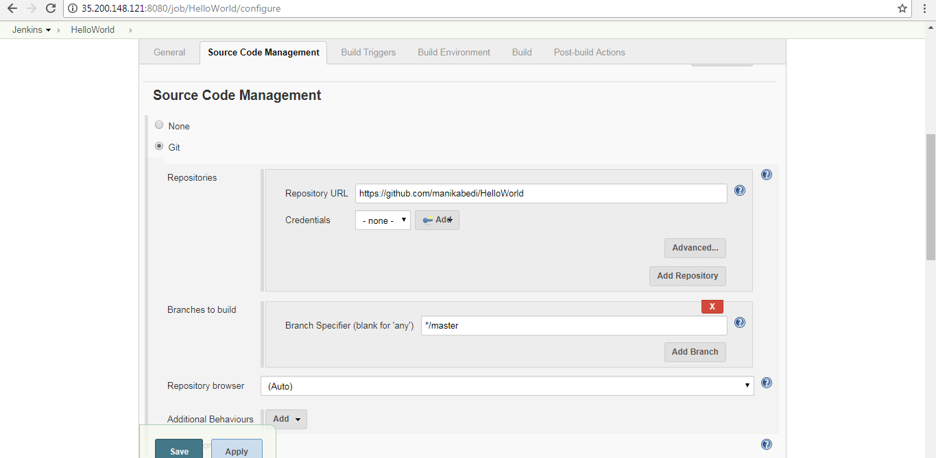

Add the below script exactly mentioned in the screenshot:

#!/bin/bash/

javac Hello.java

java Hello

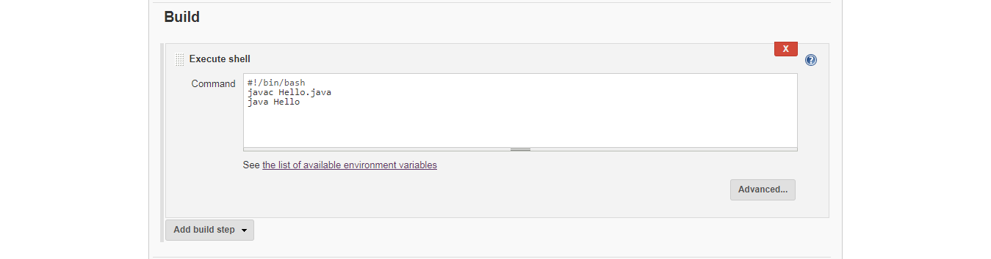

**Step 3**

Click on build the project. You should be able to see the below output.

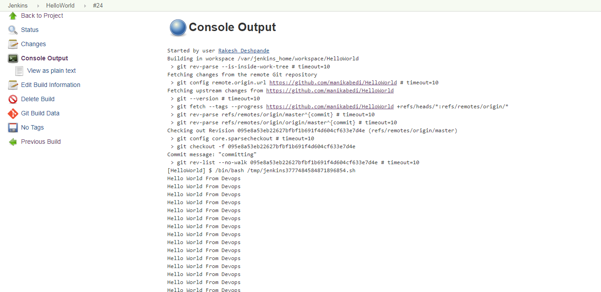

Repeat the process with different project name and changing the repository path and the codes.

You will need to stop the lab computer at the end of each day to prevent it from accumulating costs during the evening and night.

From the Web UI, you can navigate to the Compute Engine section and select your lab computer. When it is selected, click on the icon representing the "Stop" operation as shown below:

