**Capstone - Exercise 6 Monitoring back end.**

Use Apache Camel to get Docker events.

**Step-1:**

Open the Cloud Platform Console at [https://console.cloud.google.com](https://console.cloud.google.com/).

Click on the three horizontal bars at the left most side of the blue bar near the top of the browser window. *Select Compute Engine*.

Select *VM Instances*. You should see the virtual machine you created earlier.

Click on the checkbox to the left of the VM name and then select *START*. It will take a few moments to start.

Click on *SSH* to start a terminal window.

**Change the host name to student:** Find the icon that looks like a gear in the upper right-hand corner of this terminal browser window and select *Change Linux User Name*. Enter *student* and *click Change*. Now, notice the prompt that says "student@lab:~$"

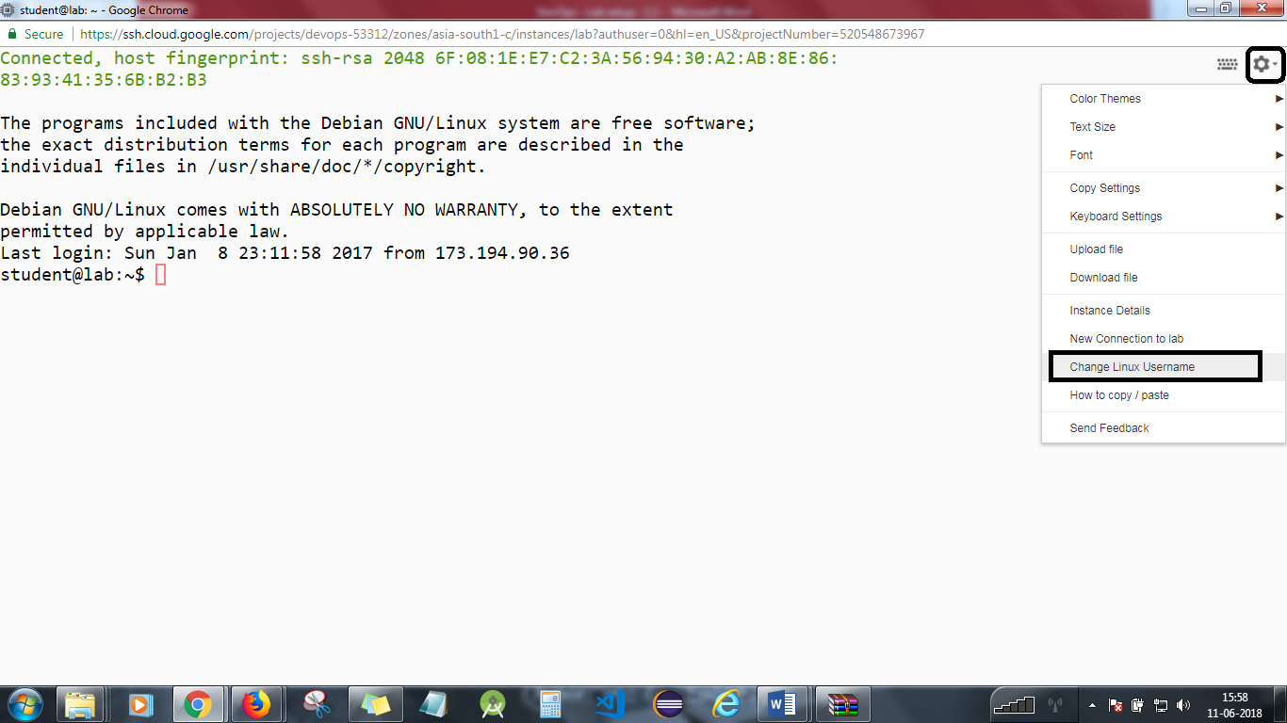

Change to the exercise directory.

*cd  
cd devops-capstone/lab-6*

*Chmod u+x runserver*

*Chmod 777 runclient*

Start the MySQL server.

*./runserver*

**Step 2**

Start the VNC server.

*vncserver*

Start the VNC client on your local machine and enter x.x.x.x.:5901, replacing x.x.x.x with the external IP address of your virtual machine.

Start Eclipse.

Open up the DevOps project and the src and test folders. Open the files DockerRouting.java, DockerProcessor.java, and MonitoringServer.java. These files complete a standalone application to read Docker events and store them in the database.

Run MonitoringServer.java as a Java application. It will run for 2 minutes.

Go to your SSH window and generate events.

*docker run -it --rm centos /bin/bash*

Exit with control-D.

**Step 3**

Go back to the SSH terminal.  
Run the MySQL client.

*./runclient*

Run the MySQL client.

*mysql -h 172.17.0.2 -u student -p monitoring*

See that data has been written to the database.

*select * from docker;*

Exit with control-D and control-D.

You will need to stop the lab computer at the end of each day to prevent it from accumulating costs during the evening and night.

From the Web UI, you can navigate to the Compute Engine section and select your lab computer. When it is selected, click on the icon representing the "Stop" operation as shown below:

