**Exercise 7.1: Continuous Deployment Using Jenkins**

You will now pull and run a puppet server and a puppet client in Docker containers.

Open the Cloud Platform Console at [https://console.cloud.google.com](https://console.cloud.google.com/).

Click on the three horizontal bars at the left most side of the blue bar near the top of the browser window. *Select Compute Engine*.

Select *VM Instances*. You should see the virtual machine you created earlier.

Click on the checkbox to the left of the VM name and then select *START*. It will take a few moments to start.

Click on *SSH* to start a terminal window.

**Change the host name to student:** Find the icon that looks like a gear in the upper right-hand corner of this terminal browser window and select *Change Linux User Name*. Enter *student* and *click Change*. Now, notice the prompt that says "student@lab:~$"

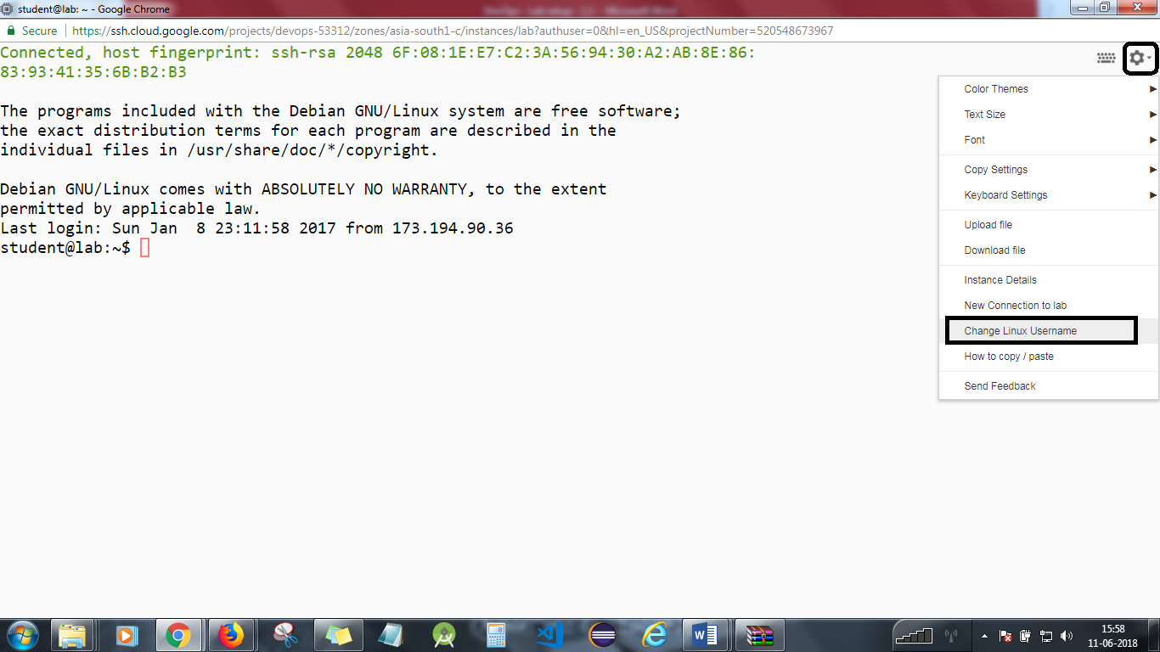

Install the Tomcat in your system. Follow the update steps and enter the commands:

sudo su

apt-get update

apt-get upgrade

cd /opt

go to the Apache tomcat server and copy the link address as shown below;

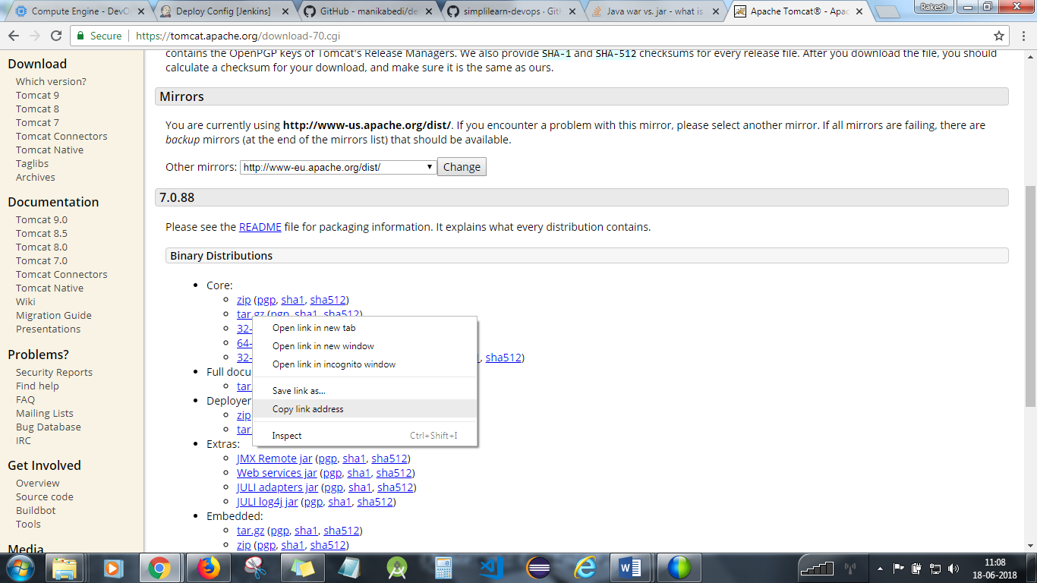

Now, type : wget <the link address> in the terminal.

Extract the file with: tar –xvzf <filename>

Type ls –l to confirm:



To confirm if you have installed the tomcat, do the following:

cd

cd /opt

cd apache*

cd bin

./startup.sh

Goto any browser and type: <External IP address of VM >:8080

Ctrl+D to exit from root.

You will now pull and run a puppet server and a puppet client in Docker containers.

Let’s take code from Github.

cd

git clone https://github.com/simplilearn-devops/devops-lesson-7

start Jenkins with:

docker run -d --name jenkins -p 8080:8080 -p 50000:50000 -v $PWD/jenkins:/var/jenkins_home/ jenkins

**Step 2**

Go to Manage Jenkins and under that, go to *Manage Plugins.* Under available plugins, search for *Deploy to Container* plugin and install it.

**Step 3**

Select *create new jobs*.  
Enter the name *Deploy*.  
Select *Freestyle project*.  
Hit *OK*.

**Step 4**

Under Build steps, select *execute shell script* and enter *date*

**Step 5**

Go to Post Build Actions, and select *Deploy war/ear file to your container*.

Under *war/ear file,s* enter **/*.war

In context path, enter the name of your war file.

**Step 6**

Under Containers, select Tomcat 7.x or whatever version of Tomcat you are using.

Enter Manager user name and password of your Tomcat.

Enter the URL of your Tomcat server.

Click Apply and Save.

**Step 7**

In order to know where your war file should be located for Jenkins deployment:

Go to Manage Jenkins under Configure Jenkins.

You will see Home Directory for Jenkins, and all the workspaces that are created for all Jenkins projects are under that.

Go to your terminal, and go to the Jenkins workspace folder.

Go to your workspace directory.

Put your war file in the workspace directory of *build* folder that is created for your Jenkins *build* project.

**Step 8**

Click on the Jenkins project Build, and click on Build Now.

Click on last build history, and click on Console Output.

You will need to stop the lab computer at the end of each day to prevent it from accumulating costs during the evening and night.

From the Web UI, you can navigate to the Compute Engine section and select your lab computer. When it is selected, click on the icon representing the "Stop" operation as shown below:

