**Exercise 8.1 Java Profiling**

Look at Java profiling.

**Step-1:**

Open the Cloud Platform Console at [https://console.cloud.google.com](https://console.cloud.google.com/).

Click on the three horizontal bars at the left most side of the blue bar near the top of the browser window. *Select Compute Engine*.

Select *VM Instances*. You should see the virtual machine you created earlier.

Click on the checkbox to the left of the VM name and then select *START*. It will take a few moments to start.

Click on *SSH* to start a terminal window.

**Change the host name to student:** Find the icon that looks like a gear in the upper right-hand corner of this terminal browser window and select *Change Linux User Name*. Enter *student* and *click Change*. Now, notice the prompt that says "student@lab:~$"

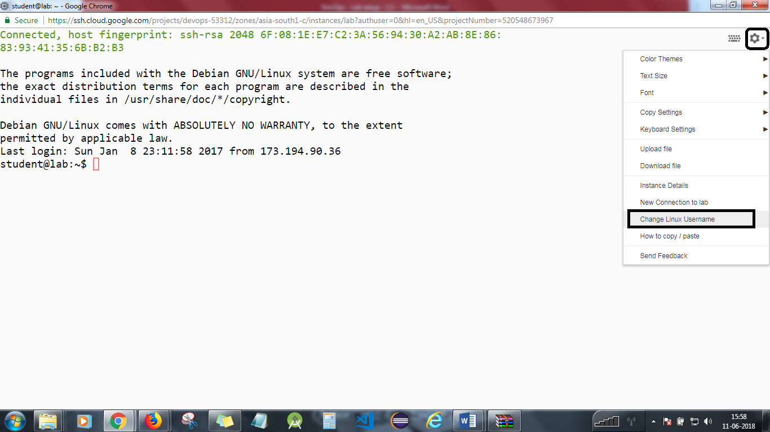

**Step 2**

*cd*

*git clone https://github.com/simplilearn-devops/devops-lesson-8*

Change to the code directory.

*cd devops-capstone/DevOps*

Look at the code.

*cat src/devops/threads/Counter.java  
cat src/devops/threads/CounterThread.java*

Manually compile the example code.

*ls bin  
javac -d bin src/devops/threads/*  
find bin*

Run the code. It will produce an unexpected result due to a thread conflict.

*java -cp bin devops.threads.CounterThread*

**Step 3**

Java has a profiler called hprof. See what options are available.

*java -agentlib:hprof=help*

Run the code again with the profiler enabled.

*java -agentlib:hprof -cp bin devops.threads.CounterThread*

Take a look at the output file. Use space for page forward, b for page backward, and q to quit.

*less java.hprof.txt*

**Step 4**

Tidy up.

*rm java.hprof.txt rm -rf bin/\**

You will need to stop the lab computer at the end of each day to prevent it from accumulating costs during the evening and night.

From the Web UI, you can navigate to the Compute Engine section and select your lab computer. When it is selected, click on the icon representing the "Stop" operation as shown below:

