**Capstone - Exercise 9: Nagios Monitoring**

Before beginning the work on Nagios, you need to install Nagios.

Open the Cloud Platform Console at [https://console.cloud.google.com](https://console.cloud.google.com/).

Click on the three horizontal bars at the left most side of the blue bar near the top of the browser window. *Select Compute Engine*.

Select *VM Instances*. You should see the virtual machine you created earlier.

Click on the checkbox to the left of the VM name and then select *START*. It will take a few moments to start.

Click on *SSH* to start a terminal window.

**Change the host name to student:** Find the icon that looks like a gear in the upper right-hand corner of this terminal browser window and select *Change Linux User Name*. Enter *student* and *click Change*. Now, notice the prompt that says "student@lab:~$"

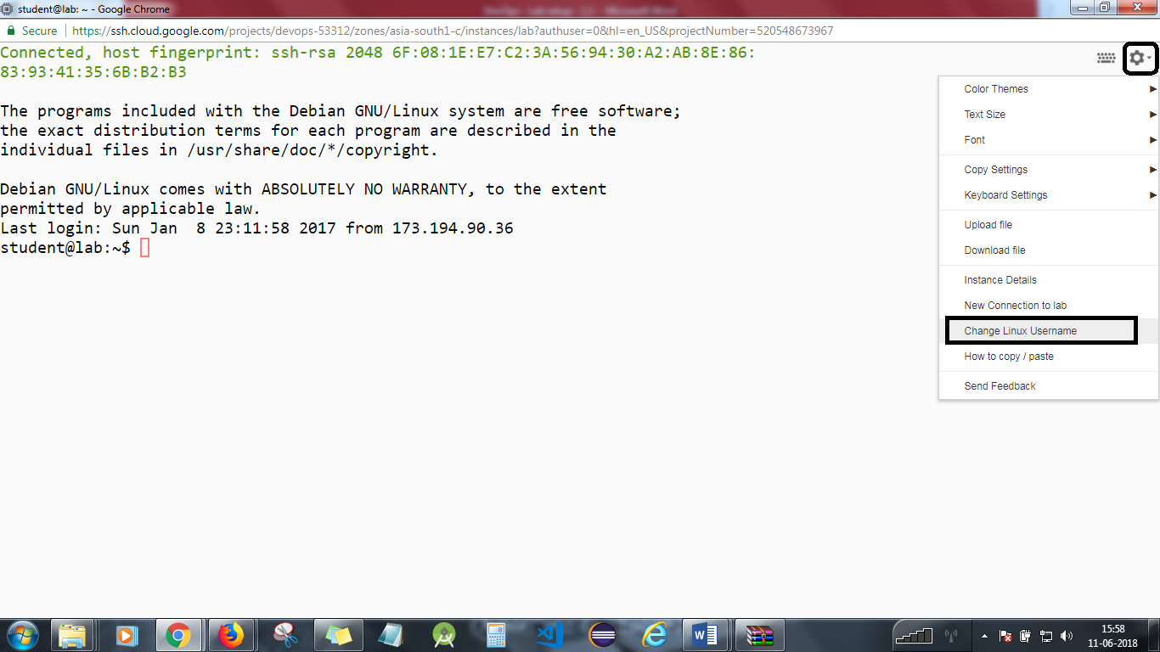

**Section 1 – Nagios Installation**

1. You must have superuser privileges on the Ubuntu 14.04 server that will run Nagios. Ideally, you will be using a non-root user with superuser privileges.
2. A LAMP stack is also required.
3. **Install Apache**

*sudo apt-get update*

*sudo apt-get install apache2*

You can do a spot check right away to verify that everything went as planned by visiting your server's public IP address in your web browser (see the note under the next heading to find out what your public IP address is if you do not have this information already):

http://your_server_IP_address

You will see the default Ubuntu 14.04 Apache web page.

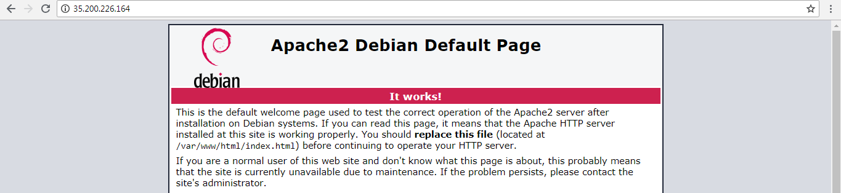

1. **Install MySQL**

*sudo apt-get install mysql-server php5-mysql*

*sudo mysql_install_db*

*sudo mysql_secure_installation*

You will be asked to enter the password you set for the MySQL root account.

1. **Install PHP**

*sudo apt-get install php5 libapache2-mod-php5 php5-mcrypt*

*sudo nano /etc/apache2/mods-enabled/dir.conf*

It will look like this:

<IfModule mod_dir.c>

DirectoryIndex index.html index.cgi index.pl index.php index.xhtml index.htm

</IfModule>

You must move the PHP index file highlighted above to the first position after the DirectoryIndex specification:

<IfModule mod_dir.c>

DirectoryIndex index.php index.html index.cgi index.pl index.xhtml index.htm

</IfModule>

After this, you need to restart the Apache web server so that your changes are recognized. You can do this by typing this:

*sudo service apache2 restart*

1. **Install PHP Modules**

*sudo apt-get install php5-cli*

1. **Install Nagios**

### Create Nagios User and Group

You must create a user and group that will run the Nagios process. Create a "nagios" user and "nagcmd" group and then add the user to the group with these commands:

*sudo useradd nagios*

*sudo groupadd nagcmd*

*sudo usermod -a -G nagcmd nagios*

### Install Build Dependencies

Because you are building Nagios Core from source, you must install a few development libraries that will allow you to complete the build. You must also install apache2-utils, which will be used to set up the Nagios web interface.

First, update your apt-get package lists:

*sudo apt-get update*

Then, install the required packages:

*sudo apt-get install build-essential libgd2-xpm-dev openssl libssl-dev xinetd apache2-utils unzip*

Let's install Nagios now.

### Install Nagios Core

Download the source code for the latest stable release of Nagios Core. Go to the [Nagios downloads page](http://www.nagios.org/download/core-stay-informed) and click the **Skip to download** link on the form. Copy the link address for the latest stable release so that you can download it to your Nagios server.

At the time of this writing, the latest stable release is Nagios 4.1.1. Download it to your home directory with curl:

*cd ~*

*curl -L -O https://assets.nagios.com/downloads/nagioscore/releases/nagios-4.1.1.tar.gz*

Extract the Nagios archive with this command:

* *tar xvf nagios-*.tar.gz*

Then change to the extracted directory:

* *cd nagios-\**

Before building Nagios, you must configure it. If you want to configure it to use postfix (which you can install with apt-get), add --with-mail=/usr/sbin/sendmail to the following command:

* *./configure --with-nagios-group=nagios --with-command-group=nagcmd*
* Now, compile Nagios with this command:
* *make all*

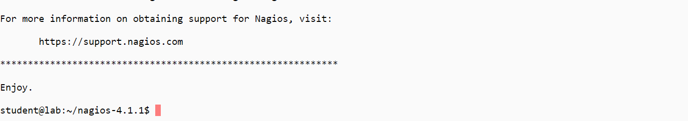

Now, you can run these make commands to install Nagios, init scripts, and sample configuration files:

* *sudo make install*
* *sudo make install-commandmode*
* *sudo make install-init*
* *sudo make install-config*
* *sudo /usr/bin/install -c -m 644 sample-config/httpd.conf /etc/apache2/sites-available/nagios.conf*

In order to issue external commands via the web interface to Nagios, you must add the web server user, www-data, to the nagcmd group:

* *sudo usermod -G nagcmd www-data*

### Install Nagios Plugins

Find the latest release of Nagios Plugins here: [Nagios Plugins Download](http://nagios-plugins.org/download/?C=M;O=D). Copy the link address for the latest version so you can download it to your Nagios server.

At the time of this writing, the latest version is Nagios Plugins 2.1.1. Download it to your home directory with curl:

*cd ~*

*curl -L -O http://nagios-plugins.org/download/nagios-plugins-2.1.1.tar.gz*

Extract Nagios Plugins archive with this command:

*tar xvf nagios-plugins-*.tar.gz*

Then, change to the extracted directory:

*cd nagios-plugins-\**

Before building Nagios Plugins, you must configure them. Use this command:

*./configure --with-nagios-user=nagios --with-nagios-group=nagios --with-openssl*

Now, compile Nagios Plugins using this command:

*make*

Then install them using this command:

*sudo make install*

### Install NRPE

Find the source code for the latest stable release of NRPE at the [NRPE downloads page](http://sourceforge.net/projects/nagios/files/nrpe-2.x/). Download the latest version to your Nagios server.

At the time of this writing, the latest release is 2.15. Download it to your home directory with curl:

*cd ~*

*curl -L -O http://downloads.sourceforge.net/project/nagios/nrpe-2.x/nrpe-2.15/nrpe-2.15.tar.gz*

Extract the NRPE archive with this command:

*tar xvf nrpe-*.tar.gz*

Then change to the extracted directory:

*cd nrpe-\**

Configure NRPE with these commands:

*./configure --enable-command-args --with-nagios-user=nagios --with-nagios-group=nagios --with-ssl=/usr/bin/openssl --with-ssl-lib=/usr/lib/x86_64-linux-gnu*

Now build and install NRPE and its xinetd startup script with these commands:

*make all*

*sudo make install*

*sudo make install-xinetd*

*sudo make install-daemon-config*

Open the xinetd startup script in an editor:

*sudo vi /etc/xinetd.d/nrpe*

Modify the only_from line by adding the private IP address of the your Nagios server to the end (substitute the actual IP address of your server):

only_from = 127.0.0.1 10.132.224.168

Save and exit. Only the Nagios server will be allowed to communicate with NRPE.

Restart the xinetd service to start NRPE:

*sudo service xinetd restart*

Now that Nagios 4 is installed, you need to configure it.

## **Configure Nagios**

Perform the initial Nagios configuration. You only need to perform this section once, on your Nagios server.

### Organize Nagios Configuration

Open the main Nagios configuration file in your favorite text editor. Use vi to edit the file:

*sudo vi /usr/local/nagios/etc/nagios.cfg*

Now, find and uncomment this line by deleting the #:

*#cfg_dir=/usr/local/nagios/etc/servers*

Save and exit.

Now, create the directory that will store the configuration file for each server that you will monitor:

*sudo mkdir /usr/local/nagios/etc/servers*

### Configure Nagios Contacts

Open the Nagios contacts configuration in your favorite text editor. Use vi to edit the file:

*sudo vi /usr/local/nagios/etc/objects/contacts.cfg*

Find the email directive and replace its value (the highlighted part) with your own email address:

email nagios@localhost ; <<***** CHANGE THIS TO YOUR EMAIL ADDRESS ******

Save and exit.

### Configure check_nrpe Command

Add a new command to your Nagios configuration:

*sudo vi /usr/local/nagios/etc/objects/commands.cfg*

Add the following to the end of the file:

define command{

command_name check_nrpe

command_line $USER1$/check_nrpe -H $HOSTADDRESS$ -c $ARG1$

}

Save and exit. This allows you to use the check_nrpe command in your Nagios service definitions.

### Configure Apache

Enable the Apache rewrite and cgi modules:

sudo a2enmod rewrite

sudo a2enmod cgi

Use htpasswd to create an admin user called "nagiosadmin" that can access the Nagios web interface:

*sudo htpasswd -c /usr/local/nagios/etc/htpasswd.users nagiosadmin*

Enter a password at the prompt. Remember this password as you will need it to access the Nagios web interface.

**Note:** If you create a user that is not named "nagiosadmin", you will need to edit /usr/local/nagios/etc/cgi.cfg and change all the "nagiosadmin" references to the user you created.

Now, create a symbolic link of nagios.conf to the sites-enabled directory:

*sudo ln -s /etc/apache2/sites-available/nagios.conf /etc/apache2/sites-enabled/*

Nagios is ready to be started. Restart Nagios and then restart Apache:

*sudo service nagios start*

*sudo service apache2 restart*

In case Nagios service does not start, follow these steps:

*sudo vi /etc/systemd/system/nagios.service*

and add the following:

[Unit]

Description=Nagios

BindTo=network.target

[Install]

WantedBy=multi-user.target

[Service]

User=nagios

Group=nagios

Type=simple

ExecStart=/usr/local/nagios/bin/nagios /usr/local/nagios/etc/nagios.cfg

Then the following:

sudo systemctl enable /etc/systemd/system/nagios.service

sudo systemctl start nagios

sudo systemctl restart nagios

## **Accessing the Nagios Web Interface**

Open your favorite web browser and go to your Nagios server (substitute the IP address or hostname for the highlighted part):

http://nagios_server_public_ip/nagios

As you configured Apache to use htpasswd, you must enter the login credentials that you created earlier. You used "nagiosadmin" as the username:

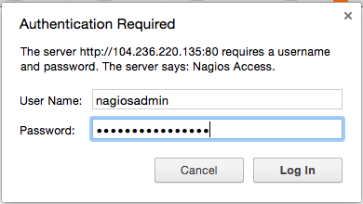

After authenticating, you will be able to see the default Nagios home page. Click on the **Hosts** link in the left navigation bar to see which hosts Nagios is monitoring:

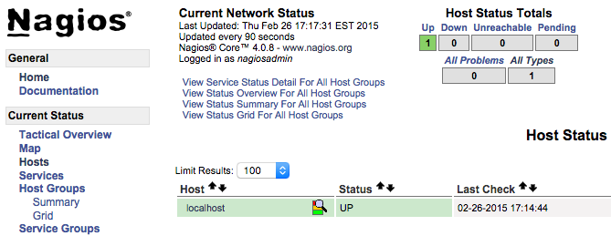

As you can see, Nagios is monitoring only "localhost" or itself.

Let's monitor another host with Nagios!

## **Monitor a Host with NRPE**

In this section, you’ll learn how to add a new host to Nagios so that it will be monitored. Repeat this section for each server you wish to monitor.

On a server that you want to monitor, update apt-get:

*sudo apt-get update*

Now, install Nagios Plugins and NRPE:

*sudo apt-get install nagios-plugins nagios-nrpe-server*

### Configure Allowed Hosts

Now, lupdate the NRPE configuration file. Open it in your favorite editor (we're using vi):

*sudo vi /etc/nagios/nrpe.cfg*

... and add Nagios Server IP *192.168.1.9* to the *server_address*.

*server_address=192.168.1.9*

Find the allowed_hosts directive, and add the private IP address of your Nagios server to the comma-delimited list (substitute it in place of the highlighted example):

allowed_hosts=127.0.0.1,10.132.224.168

Save and exit. This configures NRPE to accept requests from your Nagios server via its private IP address.

### Configure Allowed NRPE Commands

Look up the name of your root filesystem (because it is one of the items you want to monitor):

*df -h /*

Use the filesystem name in the NRPE configuration to monitor your disk usage (it is probably /dev/vda). Now open nrpe.cfg for editing:

*sudo vi /etc/nagios/nrpe.cfg*

The NRPE configuration file is very long and full of comments. There are a few lines that you will need to find and modify:

* **server_address**: Set to the private IP address of this host
* **allowed_hosts**: Set to the private IP address of your Nagios server
* **command[check_hda1]**: Change /dev/hda1 to whatever your root filesystem is called

The three aforementioned lines should look like this (substitute the appropriate values):

*server_address=client_private_IP*

*allowed_hosts=nagios_server_private_IP*

*command[check_hda1]=/usr/lib/nagios/plugins/check_disk -w 20% -c 10% -p /dev/vda*

Note that there are several other "commands" defined in this file that will run if the Nagios server is configured to use them. Also note that NRPE will be listening on port 5666 because server_port=5666 is set. If you have any firewalls blocking that port, be sure to open it to your Nagios server.

Save and quit.

### Restart NRPE

Restart NRPE to put the change into effect:

*sudo service nagios-nrpe-server restart*

Once you are done installing and configuring NRPE on the hosts that you want to monitor, you will have to add these hosts to your Nagios server configuration before it will start monitoring them.

### Add Host to Nagios Configuration

On your Nagios server, create a new configuration file for each of the remote hosts that you want to monitor in /usr/local/nagios/etc/servers/. Replace the highlighted word "yourhost" with the name of your host:

*sudo vi /usr/local/nagios/etc/servers/yourhost.cfg*

Add in the following host definition, replacing the host_name value with your remote hostname ("web-1" in the example), the alias value with a description of the host, and the address value with the private IP address of the remote host:

define host {

use linux-server

host_name yourhost

alias My first Apache server

address 10.132.234.52

max_check_attempts 5

check_period 24x7

notification_interval 30

notification_period 24x7

}

With the configuration file above, Nagios will only monitor if the host is up or down. If this is sufficient for you, save and exit and then restart Nagios. If you want to monitor particular services, read on.

Add any of these service blocks for services you want to monitor. Note that the value of check_command determines what will be monitored, including status threshold values. Here are some examples that you can add to your host's configuration file:

Ping:

define service {

use generic-service

host_name yourhost

service_description PING

check_command check_ping!100.0,20%!500.0,60%

}

SSH (notifications_enabled set to 0 disables notifications for a service):

define service {

use generic-service

host_name yourhost

service_description SSH

check_command check_ssh

notifications_enabled 0

}

If you're not sure what use generic-service means, it is simply inheriting the values of a service template called "generic-service" that is defined by default.

And now check the configuration:

*/usr/local/nagios/bin/nagios -v /usr/local/nagios/etc/nagios.cfg*

... to see if the configuration is correct.

[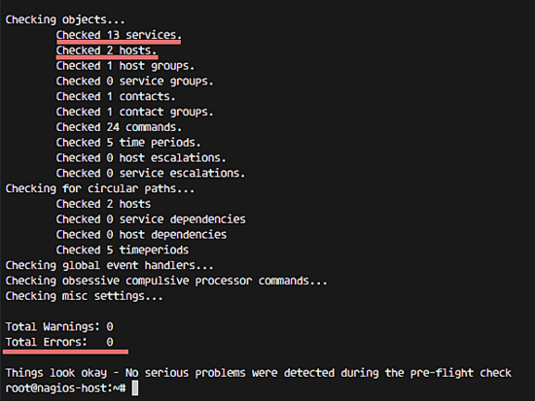](https://www.howtoforge.com/images/how_to_install_nagios_on_ubuntu_16_04/big/8.png)

Now save and quit. Reload your Nagios configuration to put any changes into effect:

Sudo service apache2 restart  
sudo service nagios restart

sudo service nagios reload

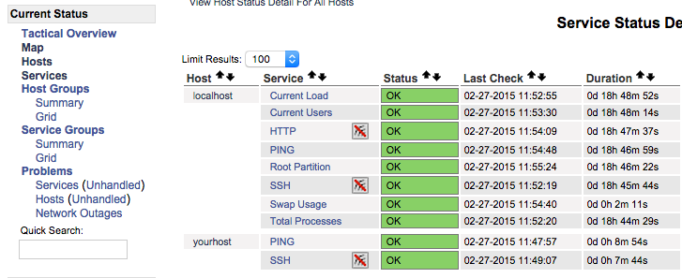Once you are done configuring Nagios to monitor all of your remote hosts, be sure to access your Nagios web interface and check out the **Services** page to see all of your monitored hosts and services:

**Section 2 – Capstone Exercise**

**Step 1**

Start your Google Compute Engine virtual machine and connect to it using SSH.

*sudo ls /usr/local/nagios/etc/servers*

*sudo nano /usr/local/nagios/etc/servers/devops-host.cfg*

**Step 2**

Add code

define service {

use generic-service

host_name devops-host

service_description CHECKJAVA

check_command check_java

notifications_enabled 0

}

define service {

use generic-service

host_name devops-host

service_description CHECKTOMCAT

check_command check_tomcat

notifications_enabled 0

}

define service {

use generic-service

host_name devops-host

service_description CHECKTOMCATAPP

check_command check_TomcatApplication -u admin -p admin -h http://localhost -P $

notifications_enabled 0

}

**Step 3**

Save the file and exit.

**Step 4**

*sudo service apache 2 restart*

*sudo service nagios restart*

**Step 5**

Go to your browser and open the Nagios page

http://nagios_server_public_ip/nagios

You will need to stop the lab computer at the end of each day to prevent it from accumulating costs during the evening and night.

From the Web UI, you can navigate to the Compute Engine section and select your lab computer. When it is selected, click on the icon representing the "Stop" operation as shown below:

