Open the Cloud Platform Console at [https://console.cloud.google.com](https://console.cloud.google.com/).

Click on the three horizontal bars at the left most side of the blue bar near the top of the browser window. *Select Compute Engine*.

Select *VM Instances*. You should see the virtual machine you created earlier.

Click on the checkbox to the left of the VM name and then select *START*. It will take a few moments to start.

Click on *SSH* to start a terminal window.

**Change the host name to student:** Find the icon that looks like a gear in the upper right-hand corner of this terminal browser window and select *Change Linux User Name*. Enter *student* and *click Change*. Now, notice the prompt that says "student@lab:~$"

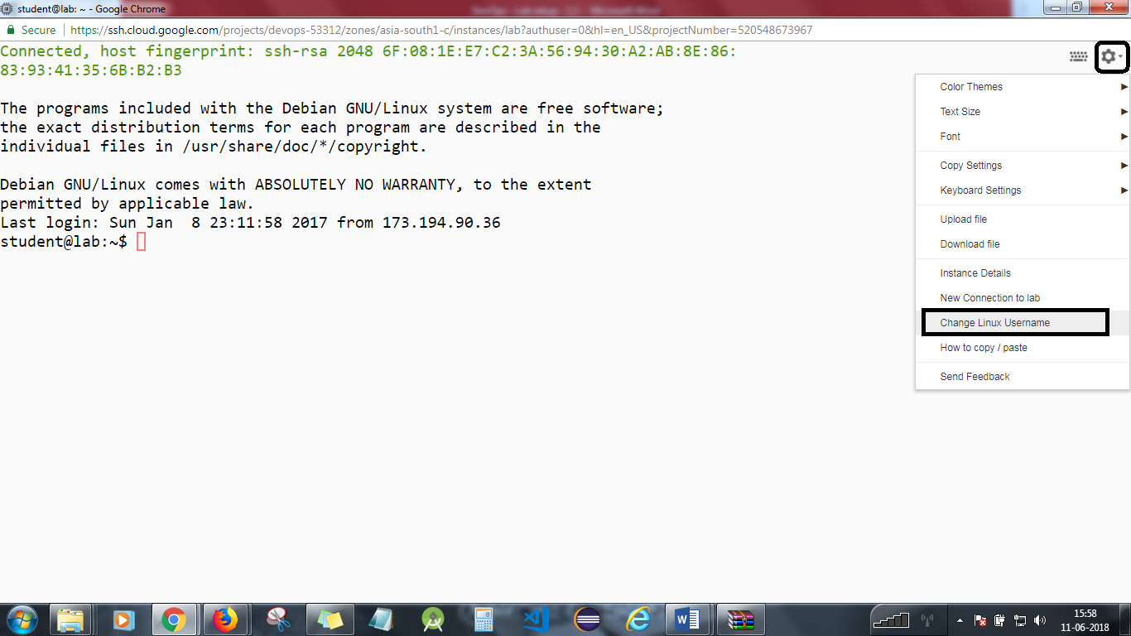

You will need to stop the lab computer at the end of each day to prevent it from accumulating costs during the evening and night.

From the Web UI, you can navigate to the Compute Engine section and select your lab computer. When it is selected, click on the icon representing the "Stop" operation as shown below:

