## Logic For Final Submission

**Task 5: Calculate the total number of different drivers for each customer.**

**select customer_id , count(distinct driver_id) from booking_data group by customer_id order by customer_id asc;**

This query will group the results by customer_id and then order the output by customer_id in ascending order.

Explaination of each part:

SELECT customer_id: This specifies the column customer_id that you want to retrieve in the results.

COUNT(DISTINCT driver_id) AS num_unique_drivers: This calculates the count of distinct driver_id values for each customer_id group. The alias num_unique_drivers gives a name to this computed value in the result set.

FROM booking_data: This specifies the table booking_data from which the data is being queried.

GROUP BY customer_id: This groups the rows of the booking_data table by customer_id.

ORDER BY customer_id ASC: This orders the result set by customer_id in ascending order (ASC).

screenshot:

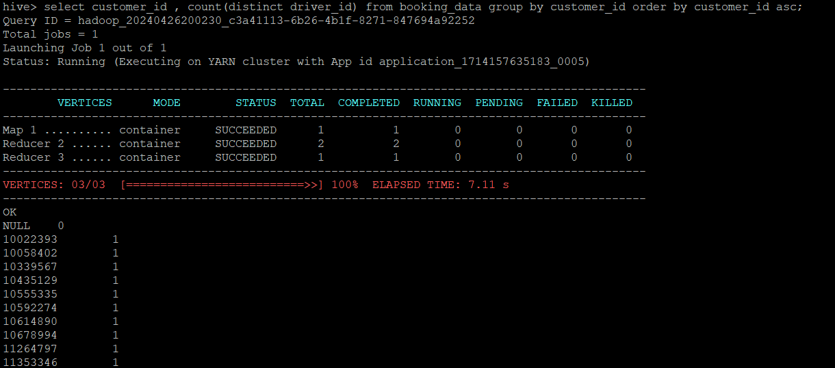

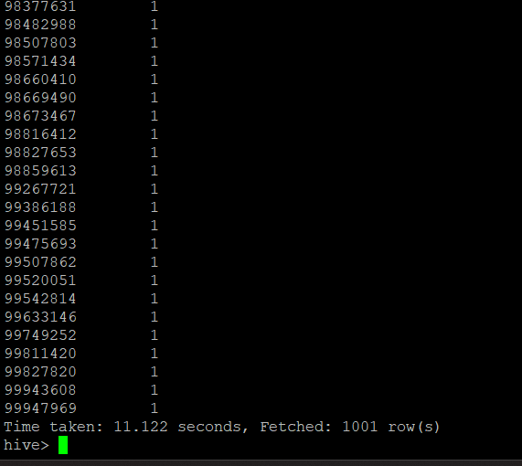

**Task 6: Calculate the total rides taken by each customer.**

**select customer_id ,count(distinct booking_id) from booking_data group by customer_id order by customer_id asc;**

This SQL query is structured to count the distinct booking_id values for each customer_id in the booking_data table, grouping the results by customer_id and then ordering them in ascending order based on customer_id.

Explanation of each part:

SELECT customer_id: This specifies the column customer_id that you want to include in the output.

COUNT(DISTINCT booking_id) AS num_unique_bookings: This calculates the count of distinct booking_id values for each customer_id group. The result of this count is given an alias num_unique_bookings in the output.

FROM booking_data: This indicates the source table from which data is being queried, which is booking_data in this case.

GROUP BY customer_id: This clause groups the data by customer_id, so the COUNT(DISTINCT booking_id) is calculated per customer_id.

ORDER BY customer_id ASC: This specifies that the result set should be ordered by customer_id in ascending (ASC) order.

screenshot:

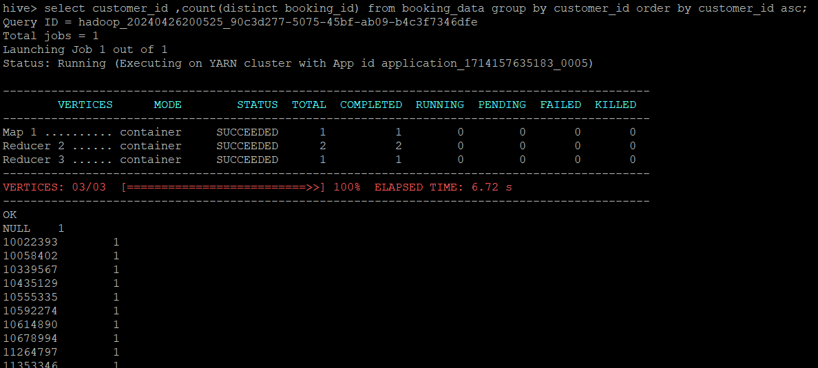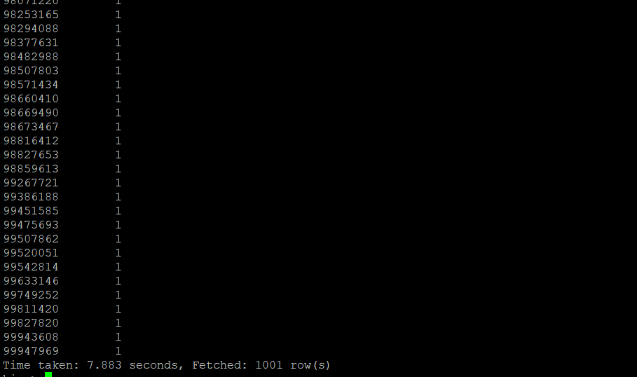

**Task 7: Find the total visits made by each customer on the booking page and the total ‘Book Now’ button presses. This can show the conversion ratio.**

**select (sum(case when button_id = "fcba68aa-1231-11eb-adc1-0242ac120002" and**

**is_button_click = 'Yes' then 1 end) / sum(case when page_id = "e7bc5fb2-1231-11eb-adc1-0242ac120002" and is_page_view = 'Yes' then 1 end)) as conversion_ratio from clickstream_data;**

This query will calculate the conversion ratio, which typically represents the ratio of button clicks (meeting specific criteria) to page views (meeting specific criteria) within your clickstream_data table. The result will be a single value representing this conversion ratio.

Explanation of each part:

SELECT: This indicates that we want to select and calculate a value based on the subsequent expression.

SUM(CASE WHEN button_id = 'fcba68aa-1231-11eb-adc1-0242ac120002' AND is_button_click = 'Yes' THEN 1 END): This part of the query calculates the total count of records where button_id matches 'fcba68aa-1231-11eb-adc1-0242ac120002' and is_button_click is 'Yes'. The CASE statement assigns a value of 1 for each matching record, and SUM adds these values together.

SUM(CASE WHEN page_id = 'e7bc5fb2-1231-11eb-adc1-0242ac120002' AND is_page_view = 'Yes' THEN 1 END): This part of the query calculates the total count of records where page_id matches 'e7bc5fb2-1231-11eb-adc1-0242ac120002' and is_page_view is 'Yes'. Similarly, the CASE statement assigns a value of 1 for each matching record, and SUM adds these values together.

The division (/) operator is used to divide the sum of button clicks (is_button_click = 'Yes') by the sum of page views (is_page_view = 'Yes') to compute the conversion ratio.

AS conversion_ratio: This assigns an alias conversion_ratio to the calculated value in the result set.

screenshot:

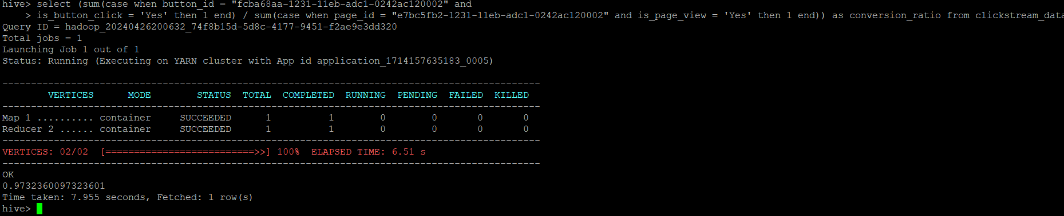

**Task 8: Calculate the count of all trips done on black cabs.**

**select cab_color ,count(distinct driver_id ) from booking_data where cab_color in ('black') group by cab_color ;**

This query will provide you with the count of distinct driver_id values for bookings associated with black-colored cabs (cab_color = 'black'), grouped by cab_color. The result will show the number of unique drivers for black-colored cab bookings.

Explanation of each part:

SELECT cab_color: This specifies the cab_color column that you want to include in the output.

COUNT(DISTINCT driver_id) AS num_unique_drivers: This calculates the count of distinct driver_id values for bookings where the cab_color is 'black'. The alias num_unique_drivers gives a name to this computed value in the result set.

FROM booking_data: This indicates the source table from which data is being queried, which is booking_data in this case.

WHERE cab_color = 'black': This filters the rows to only consider bookings where the cab_color is 'black'.

GROUP BY cab_color: This groups the data by cab_color, so the COUNT(DISTINCT driver_id) is calculated for each distinct cab_color group.

screenshot:

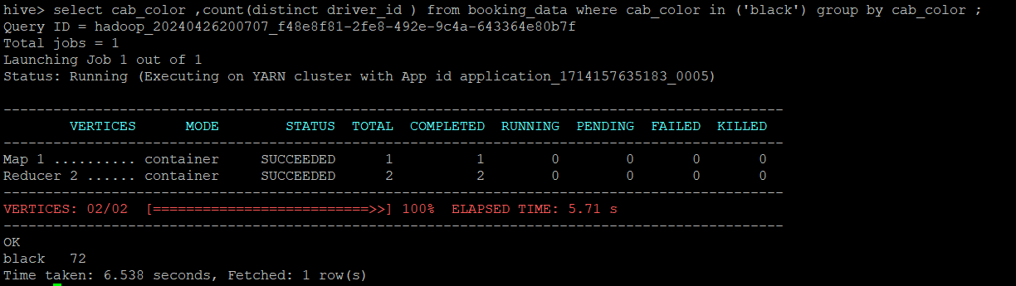

**Task 9: Calculate the total amount of tips given date wise to all drivers by customers.**

**select pickup_date, sum(tip_amount) from booking_data group by pickup_date order by pickup_date asc;**

This query will provide you with the total tip amount (total_tips) for each pickup_date, sorted in chronological order by pickup_date. Each row in the result set will show a pickup_date along with the corresponding sum of tip_amount for bookings on that date.

Explanation of each part:

SELECT pickup_date: This specifies the pickup_date column that you want to include in the output.

SUM(tip_amount) AS total_tips: This calculates the sum of tip_amount for each pickup_date group. The alias total_tips assigns a name to this aggregated value in the result set.

FROM booking_data: This indicates the source table from which data is being queried (booking_data in this case).

GROUP BY pickup_date: This groups the data by pickup_date, so the SUM(tip_amount) is calculated for each unique pickup_date.

ORDER BY pickup_date ASC: This orders the result set by pickup_date in ascending (ASC) order.

screenshot:



**Task 10: Calculate the total count of all the bookings with ratings lower than 2 as given by customers in a particular month.**

**select date_format(pickup_timestamp,'yyyy-MM') ,count( rating_by_customer) from booking_data where rating_by_customer < 2 group by date_format(pickup_timestamp,'yyyy-MM');**

This query will provide you with the count of ratings by customers that are less than 2 (rating_by_customer < 2) for each month (pickup_month), formatted as year and month (yyyy-MM). The result set will show each month along with the corresponding count of low ratings for that month**.**

Explanation of each part:

SELECT DATE_FORMAT(pickup_timestamp, 'yyyy-MM') AS formatted_date: This part of the query selects the pickup_timestamp column from the booking_data table and formats it using the DATE_FORMAT function to display the date in the format 'yyyy-MM', which represents the year and month (e.g., '2024-05'). The AS formatted_date clause assigns an alias formatted_date to this formatted result.

COUNT(rating_by_customer): This counts the number of rows where the rating_by_customer column has a value less than 2 (rating_by_customer < 2). The COUNT() function is used here without an alias, so the resulting count will be displayed in the output without a specific column name.

FROM booking_data: This specifies the source table booking_data from which data is being queried.

WHERE rating_by_customer < 2: This filters the rows of booking_data to include only those where the rating_by_customer value is less than 2.

GROUP BY DATE_FORMAT(pickup_timestamp, 'yyyy-MM'): This part of the query groups the results based on the formatted pickup_timestamp values ('yyyy-MM'). This means that rows with the same year and month will be grouped together.

screenshot:

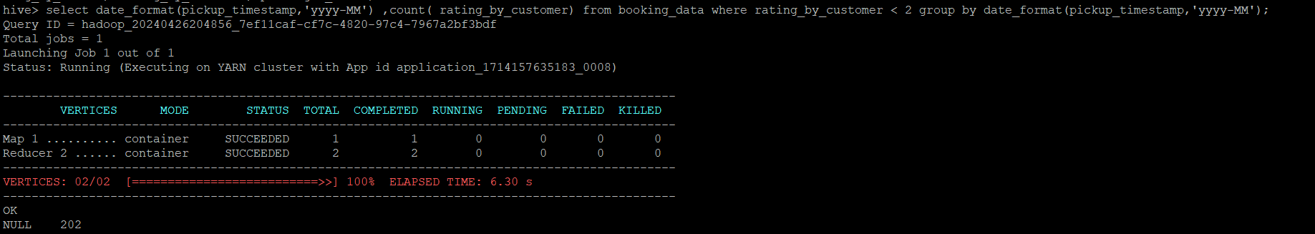

**Task 11: Calculate the count of total iOS users.**

**select os_version ,count(distinct customer_id) from clickstream_data where os_version in ('iOS') group by os_version;**

This query is useful for analyzing the distribution of unique customers across different versions of the iOS operating system recorded in your clickstream data.

Explanation of each part:

SELECT os_version, COUNT(DISTINCT customer_id): This part of the query selects the os_version column and counts the distinct customer_id values from the clickstream_data table.

os_version: This is the column name representing the operating system version.

COUNT(DISTINCT customer_id): This function calculates the number of unique customer_id values for each os_version.

FROM clickstream_data: This specifies the source table clickstream_data from which data is being queried.

WHERE os_version IN ('iOS'): This part of the query filters the rows to include only those where the os_version is 'iOS'. The IN ('iOS') condition checks if the os_version matches the specified value 'iOS'.

GROUP BY os_version: This groups the results by os_version, meaning that the counts will be aggregated and displayed for each unique os_version value ('iOS' in this case).

screenshot:

