## Queries

**<Hive Query for Task 5>**

select customer_id , count(distinct driver_id) from booking_data group by customer_id order by customer_id asc;

**<Screenshot after executing Query>**

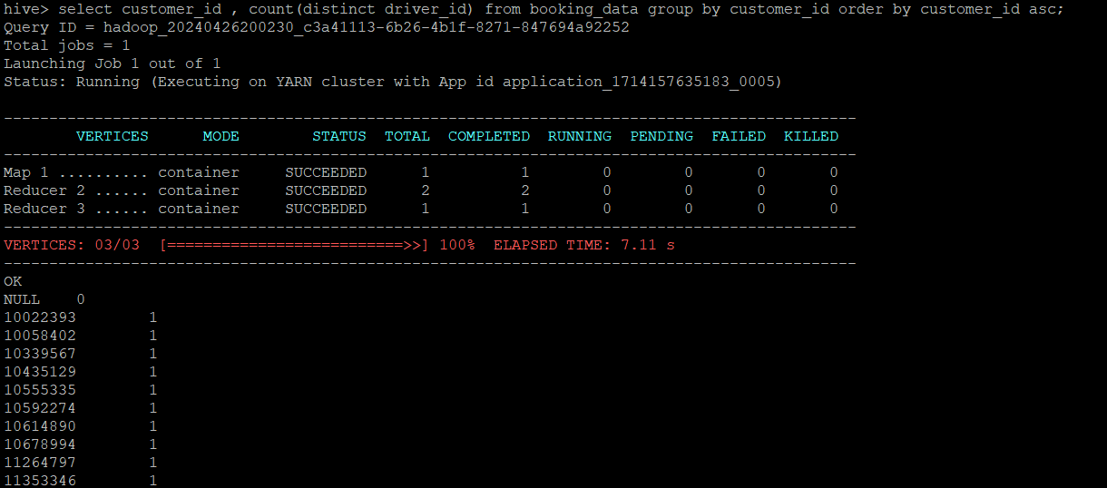

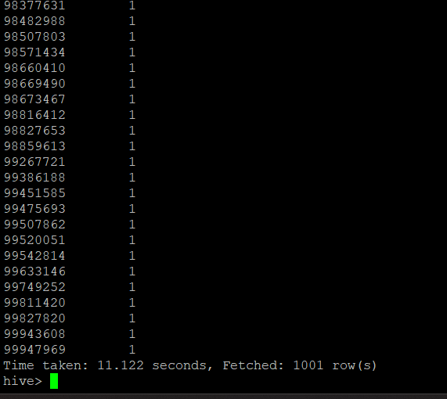

**<Hive Query for Task 6>**

select customer_id ,count(distinct booking_id) from booking_data group by customer_id order by customer_id asc;

**<Screenshot after executing Query>**

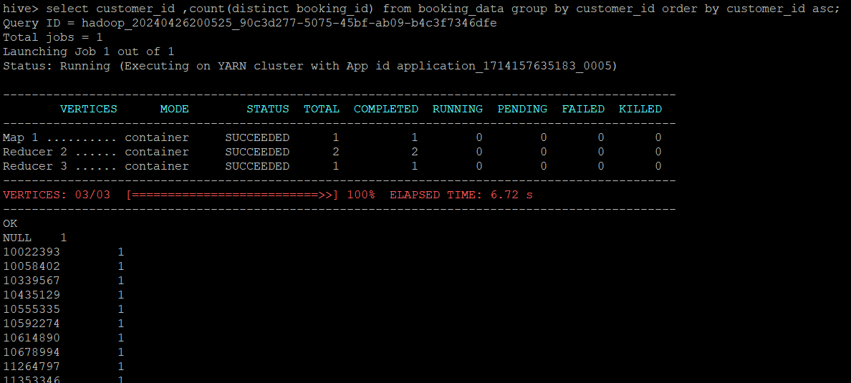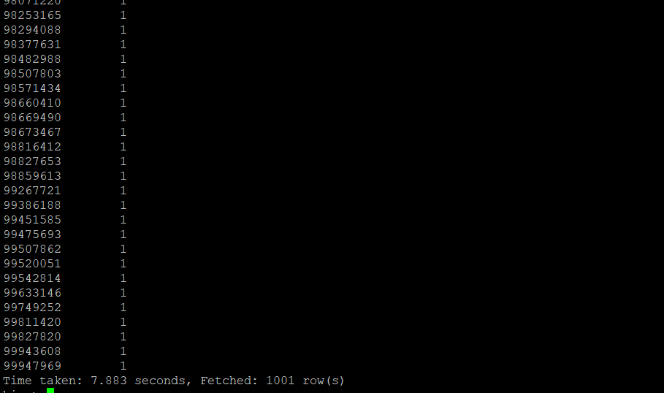

**<Hive Query for Task 7>**

select (sum(case when button_id = "fcba68aa-1231-11eb-adc1-0242ac120002" and

is_button_click = 'Yes' then 1 end) / sum(case when page_id = "e7bc5fb2-1231-11eb-adc1-0242ac120002" and is_page_view = 'Yes' then 1 end)) as conversion_ratio from clickstream_data;

**<Screenshot after executing Query>**

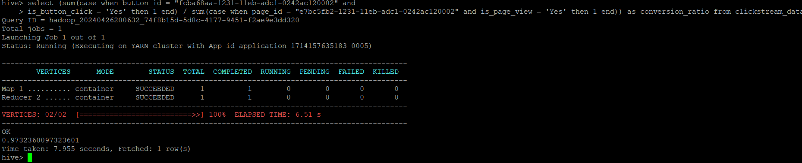

**<Hive Query for Task 8>**

select cab_color ,count(distinct driver_id ) from booking_data where cab_color in ('black') group by cab_color ;

**<Screenshot after executing Query>**

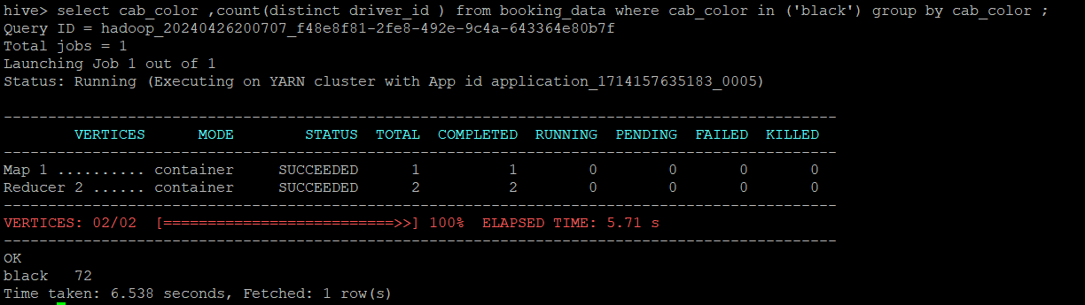

**<Hive Query for Task 9>**

select pickup_date, sum(tip_amount) from booking_data group by pickup_date order by pickup_date asc;

**<Screenshot after executing Query>**



**<Hive Query for Task 10>**

select date_format(pickup_timestamp,'yyyy-MM') ,count( rating_by_customer) from booking_data where rating_by_customer < 2 group by date_format(pickup_timestamp,'yyyy-MM');

**<Screenshot after executing Query>**

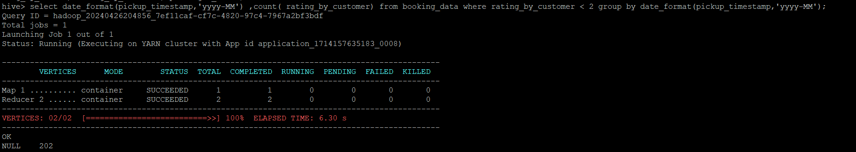

**<Hive Query for Task 11>**

select os_version ,count(distinct customer_id) from clickstream_data where os_version in ('iOS') group by os_version;

**<Screenshot after executing Query>**

