**REPORT ON**

**ELECTRONIC PEST REPELLER**

**Submitted by**

**RAVEENA. C 2015105557**

**RAKESH. K 2015105077**

**EC7713 – MINI PROJECT**

**SEMESTER VII**

**BACHELOR OF ENGINEERING**

**DEPARTMENT OF ELECTRONICS AND COMMUNICATION ENGINEERING**



**COLLEGE OF ENGINEERING GUINDY**

**ANNA UNIVERSITY – CHENNAI 6000025**

**BONAFIDE CERTIFICATE**

Certified that this report is the bonafide work done by **RAVEENA.C (2015105557), RAKESH.K (2015105077)** who carried out the Mini Project under my supervision.

**SIGNATURE SIGNATURE**

**Dr. S MUTTAN Dr. V. JEYALAKSHMI**

**HEAD OF THE DEPARTMENT GUIDE**

PROFESSOR, PROFESSOR,

ECE DEPARTMENT, ECE DEPARTMENT,

COLLEGE OF ENGINEERING, COLLEGE OF ENGINEERING,

GUINDY GUINDY

CHENNAI – 600 025. CHENNAI – 600 025.

**TABLE OF CONTENTS:**

* Abstract
* Introduction
* Circuit Diagram
* Components Used
* Design Approach
* Theory behind the circuit
* Operation
* Simulation
* Breadboard Connection
* PCB Design
* Real Time Applications
* Limitations
* References

**ABSTRACT:**

The purpose of the project is to design an ultrasonic pest repellent. Such a device can be very useful to counter the various problems caused by ants, insects, pests, rodents, etc. The device is compact, cheap, and it does not cause any pollution unlike the other chemical repellents. We have used a 555 timer to generate sweep in sound frequencies. The technical details of this project follow later. The circuit has been experimentally tested on ants, bugs, and small insects, and it has been successful in repelling them through the generation of ultrasonic frequency sound.

**INTRODUCTION:**

It is possible that pests like insects, ants, rats, mice etc. are repelled by ultrasonic frequency in the range of 30 kHz to 50 kHz. Human beings can’t hear these high-frequency sounds. Our product repels pests by emitting pulse ultrasonic waves. Using ultrasonic waves creates a noisy and hostile environment which repels pests, whilst remaining absolutely safe for humans and household animals. Unfortunately, all pests do not react at the same ultrasonic frequency. While some pests get repelled at 35 kHz, some others get repelled at 38 to 40 kHz or even higher frequencies. Thus to increase the effectiveness, frequency of ultrasonic oscillator has to be continuously varied between certain limits. Frequency of emission of ultrasonic sound is continuously varied by our product in different patterns to repel different insects.

**CIRCUIT DIAGRAM:**

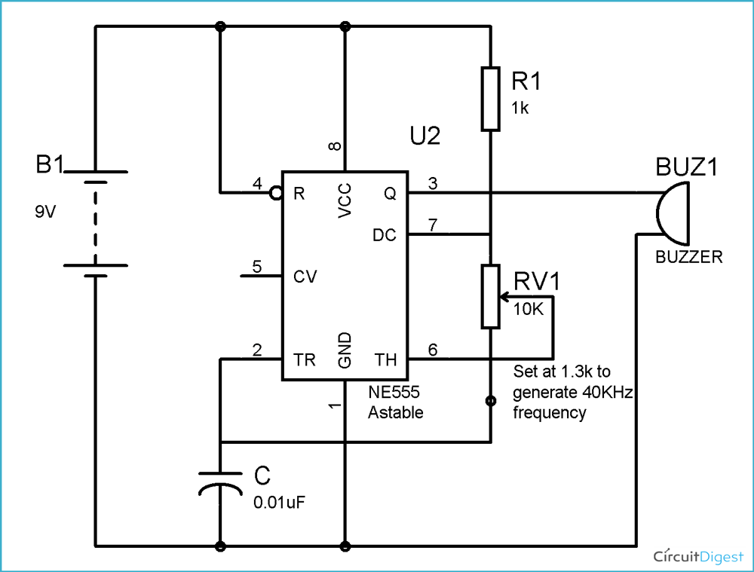

The most common form of Astable multivibrator is [**555 Timer IC**](https://www.electronicshub.org/how-555-timer-ic-testing-circuit-works/). It is basically an 8 pin IC with the following pin description:

* Pin1 – Ground pin, which is directly connected to the negative terminal of the battery.
* Pin2- Trigger Pin. It is an active low pin. For astable operation this pin is connected directly to pin no.6
* Pin 3 – It is the output pin.
* Pin 4 – It is the reset pin. It is usually connected to positive rail of the battery.
* Pin 5 – It is the control pin and is seldom used.
* Pin 6 – It is the threshold pin. For astable operation, this pin is shorted to pin 2 and connected to pin 7 using a resistor.
* Pin 7 – It is the discharge pin and provides the discharge path for the capacitor.

**COMPONENTS USED:**

* 555 timer
* A ceramic capacitor of 0.01 micro Farad
* A resistor of 760 Ohms
* Another resistor of 1.3 K
* piezo buzzer
* A 9V battery

**DESIGN APPROACH:**

* The basic idea behind developing the circuit is to use a buzzer to produce ultrasound. The buzzer is driven by an oscillator circuit.
* Here, we are using a **555 Timer based astable multivibrator circuit** as the oscillator circuit.
* Generally, frequency of output signal produced by a 555 astable multivibrator is given by,

F= (1.44)/(Ra+2Rb)*C

where Ra = 1KΩ

Rb=1.3KΩ

C = 0.01µF

On substitution,

F= (1.44)/((1K + 2.6K)*(0.01*10^-6))

F= 40 KHz

**THEORY BEHIND THE CIRCUIT:**

* A **multivibrator** is an electronic circuit producing a **pulsed output signal**. Generally multivibrators are classified based on the nature of stability of output.
* A multivibrator with **one stable state** is known **as monostable multivibrator** and is used as a **pulse generator.**
* A multivibrator with **no stable state** is known as an **astable multivibrator** and is used as an **oscillator.**
* A multivibrator with **two stable states** is known as a **bistable multivibrator** and is used as a **Schmitt Trigger.**

Here we are mainly concerned about Astable multivibrator. Astable multivibrators do not require any external triggering and hence can be used as oscillators. They are realized using transistors, operational amplifiers or ICs.

**Mosquito Repellent Circuit Operation:**

Once the switch is closed, the 555 timer gets the power supply. As per the inner circuit, initially the capacitor voltage will be zero and hence voltage at threshold and trigger pin will be zero. As the capacitor charges through resistors Ra and Rb, at a certain point voltage at threshold pin is less than the capacitor voltage. This causes a change in timer output. The capacitor now starts discharging through resistor Rb, i.e. the discharge pin and continues so until the output voltage is back to the original. Thus the output signal is an oscillating signal with frequency 38 KHz.  The output from this astable multivibrator circuit drives a 38 KHz piezo buzzer, producing ultrasound at regular repetitions. On varying the value of potentiometer, the output frequency can also be varied.

**SIMULATION:**

It is initially simulated in Multisim software and the desired output is obtained.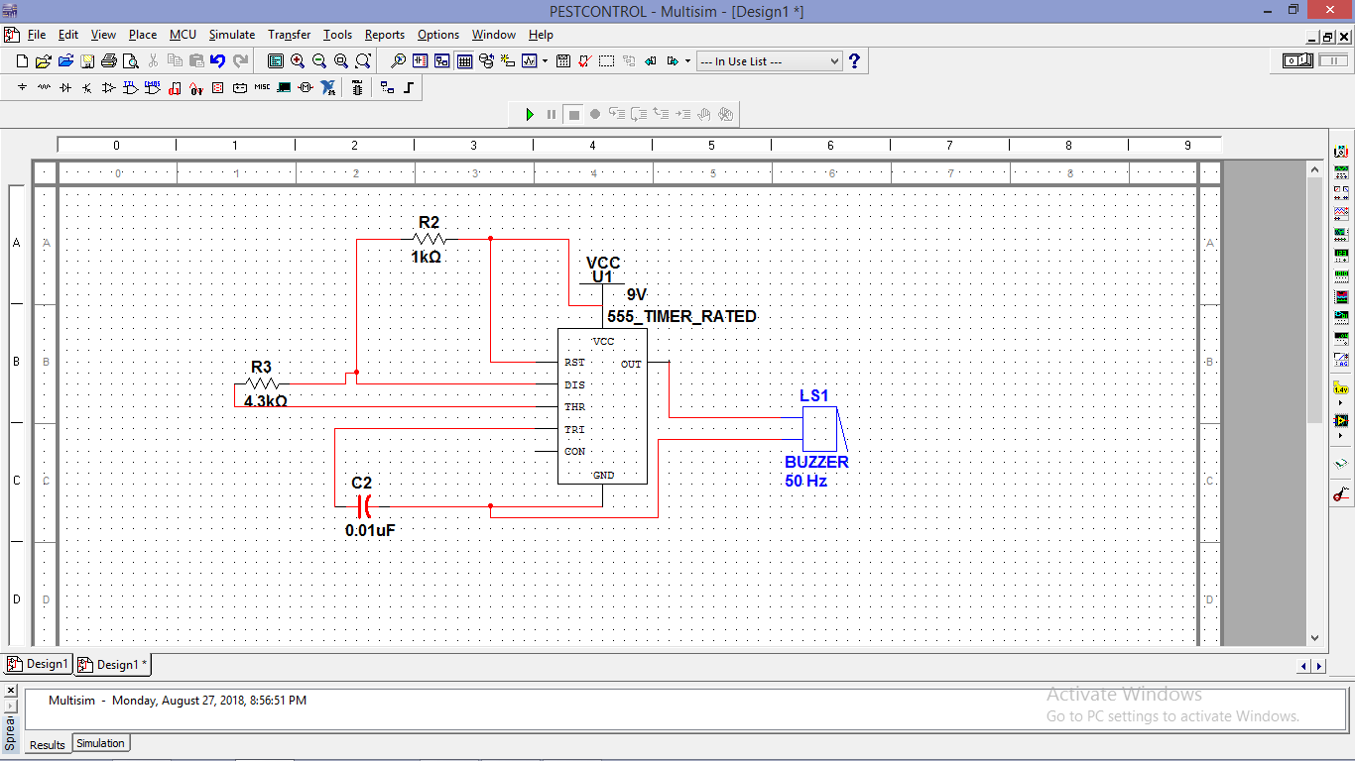

**BREADBOARD CONNECTION:**

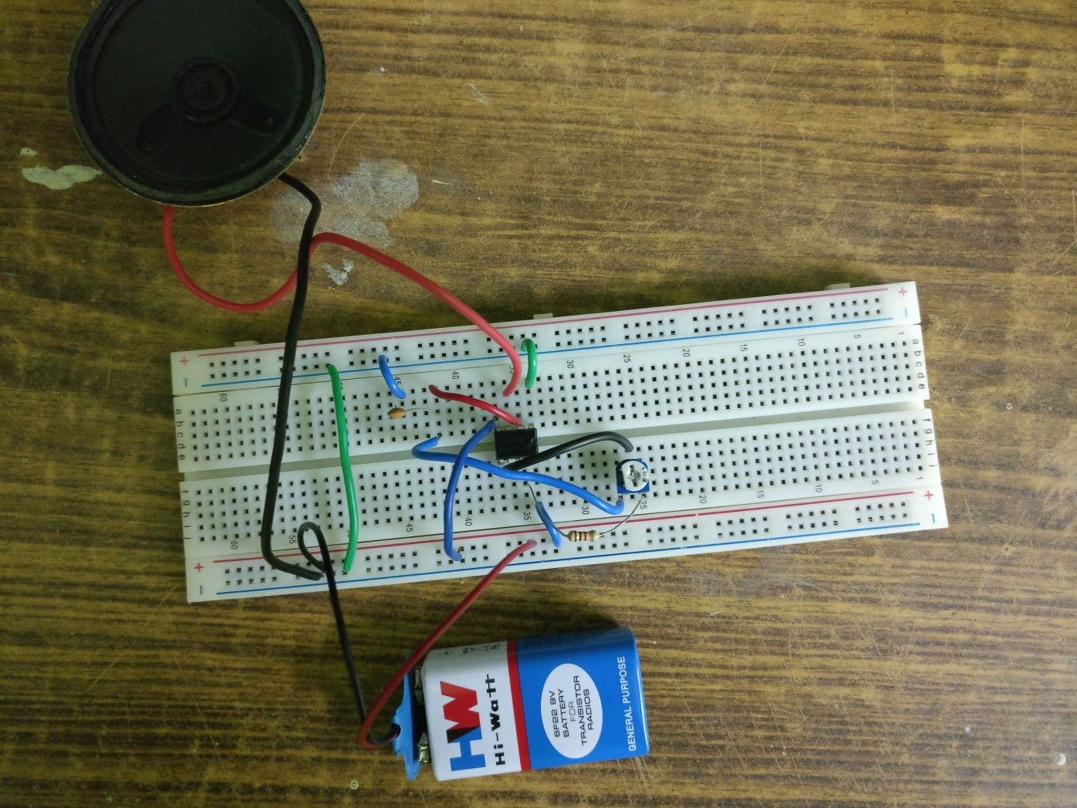

### PCB DESIGN:

### pic1.png

### pic2.png

### REAL-TIME APPLICATIONS:

As described, this circuit can be used as a mosquito repellent. By certain modifications and changes in the value of resistors and capacitor, the circuit can also be used as other insect repellent. Further, it can also be used as a simple buzzer alarm circuit.

### LIMITATIONS:

* It requires a lot of frequency setting.
* Ultrasound signals travel at an angle of 45 degrees from the source. In case of any obstacles in the path, the signals get reflected or diverted.
* It shows effect for lesser mosquito population.

**REFERENCES:**

* IIT Bombay Prof. Girish Kumar research paper, April 2009.
* http://www.ti.com/lit/ds/symlink/lm555.pdf
* <https://circuitdigest.com/electronic-circuits/mosquito-repellent-circuit>
* <https://www.electronicshub.org/electronic-mosquito-repellent-circuit/>
* <https://www.todayshomeowner.com/do-ultrasonic-electronic-pest-repellents-work/>
* <https://en.wikipedia.org/w/index.php?title=Electronic_pest_control&action=edit&section=3>
* <https://electronicsforu.com/resources/learn-electronics/555-timer-working-specifications>