Message Tracking Tool

Table of Contents

Purpose of the Tool 2

Key Feature 2

Benefits of the tool 2

Impact of the tool 3

Authentication 3

User Interface View 4

How to use the tool 4

# Purpose of the Tool

The purpose of the tool is to automate the message tracking in Biztalk hub remotely. All the transaction wise messages can be tracked through this tool End to End flow of Each PO’s

# Key Feature

1. Simple and Easy to use.

2. Ability to track transactional messages end to end transaction and correlate various flows and provide one single view for PO’s processed through Extranet and Corpnet hub with Header details, PO Line Details and PO history details.

3. Ability to different messages went through Extranet or Corpnet along with Confirm BOD status.

4. Ability to search based on Partners, PO number, LoadID, ASN, GR etc.. mainly all transaction based tracking.

5. Ability to view particular time period of transactions

6. Ability to view real time error Messages in UI and pre-seeded dashboard showing progress and exception in a color coded display.

# Benefits of the tool

1. Improvement in identifying gaps in present tracking and improvise the same.
2. Standard instrumentation and Tracking for BizTalk solution
3. B2B Transaction-wise tracking and mapping to HVBS
4. Effort Reduction in Ticket Cost (KTLO) as troubleshooting is manual

# Impact of the tool

* Real-Time visibility to track transactional messages.
* Reduce Customer calls and complaint once we enable this to business. The purpose of the tool is to automate the message tracking in Biztalk hub remotely. All the transaction wise messages can be tracked through this tool End to End flow of Each PO’s

# Authentication

This is authenticated with service account Redmond\btuuser1.

URL: <http://localhost/BPM/main.aspx>

# User Interface View

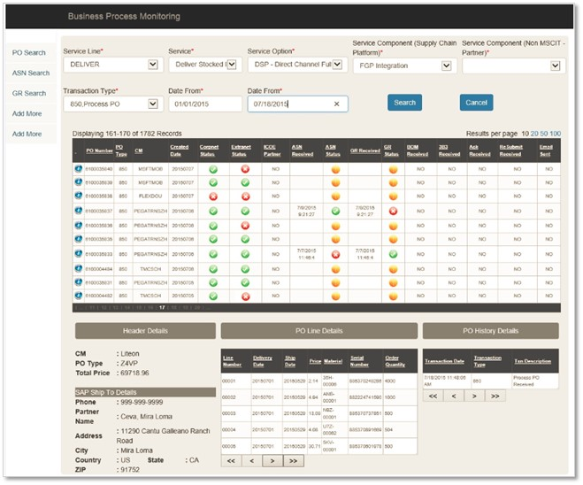

# How to use the tool

1. Go to the link

UAT: <http://localhost/BPM/main.aspx>

PROD: <http://localhost/BPM/main.aspx>

1. Select Transaction Type for full flow message



1. Click on the blue icon to get the PO Header details, PO line details and PO History

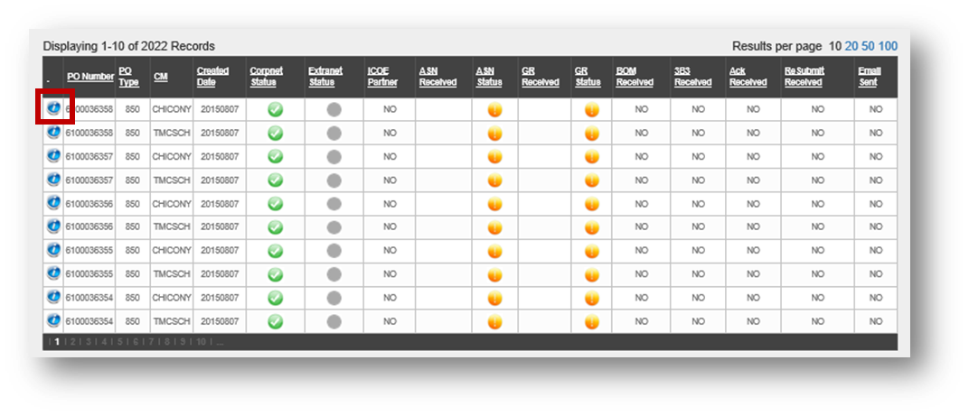

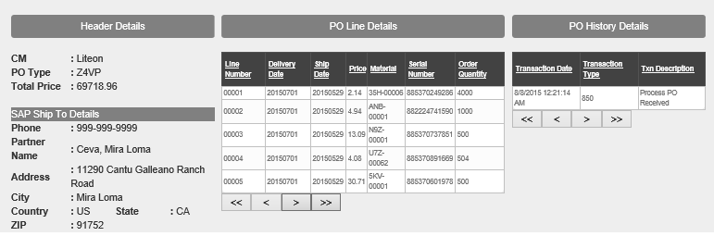

1. If you aware of only PO number, click on the left hand side PO search

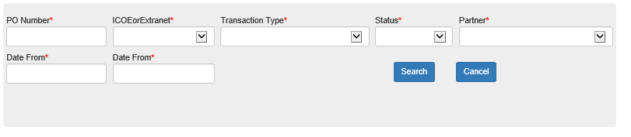

1. Place your PO number in PO number Text box and click search

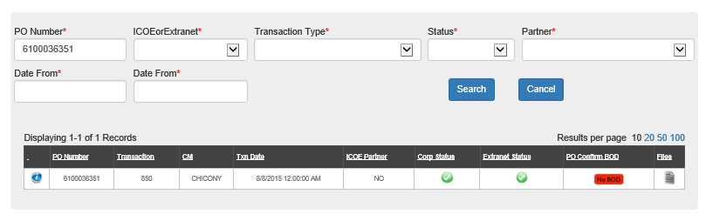

1. Click files icon to get the Archive file V02 & Oagais Files details

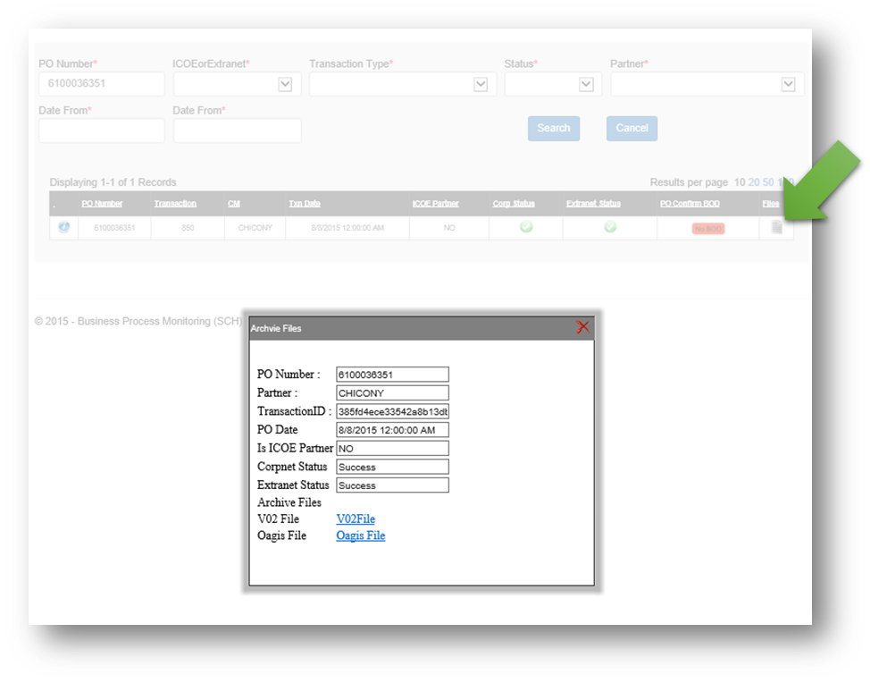

1. If you want to view only failed messages for specify transactions, Click on status failed and select transaction type. It will provide PO confirm BOD status and Failure status

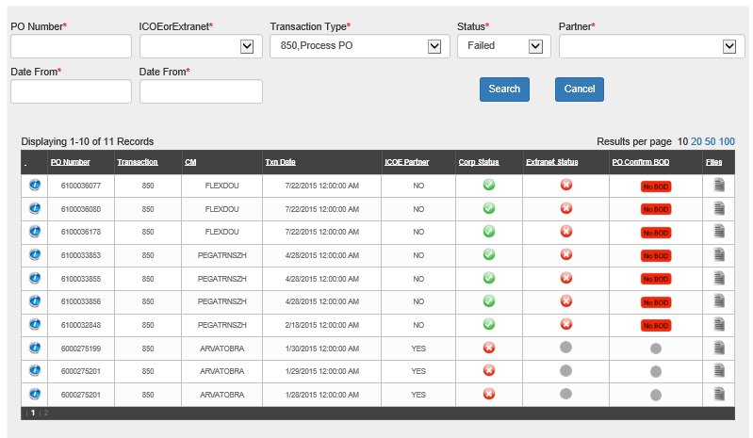

1. Partner Wise Search. Select the partner and click search

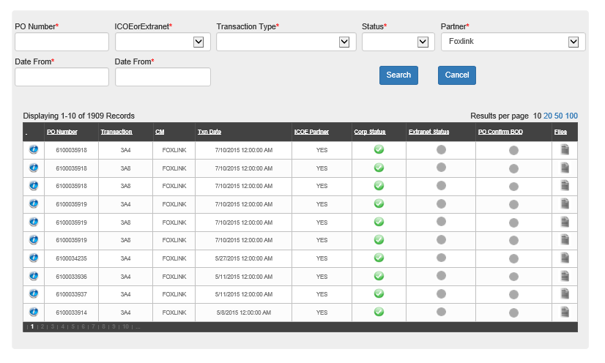

1. Date Wise Search for a specific partner. Provide the required “Date From” and “Date To “
2. **ASN Search**: LoadID or PO Number. Place your LoadID in Load ID test or PO Number in PO. Date as mandatory. Click search

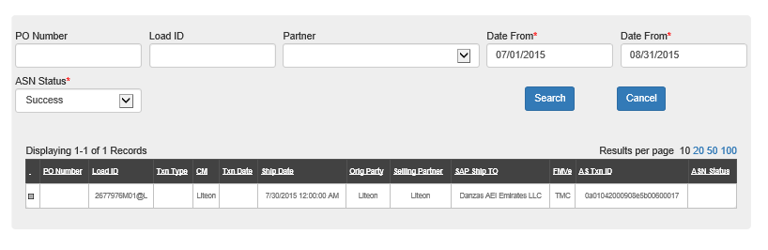

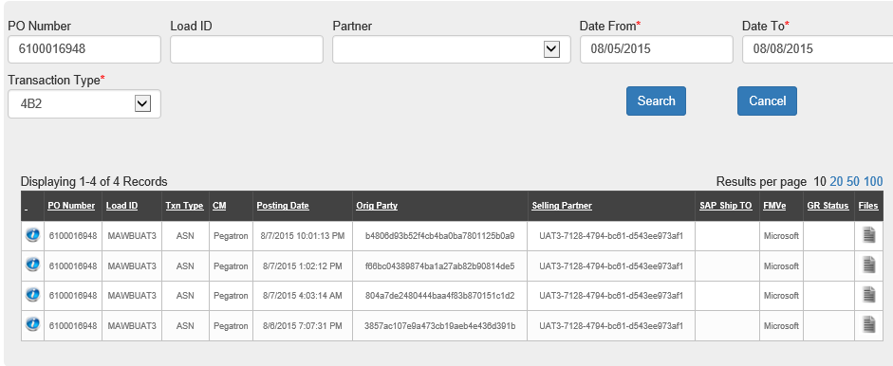

1. **GR Search:** LoadID or PO Number. Date as mandatory. Click search

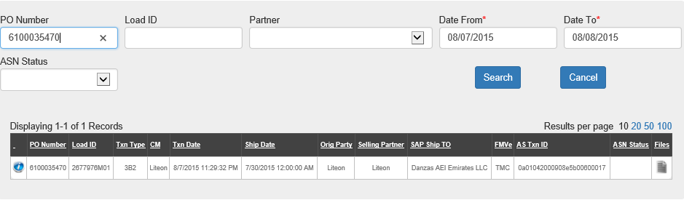

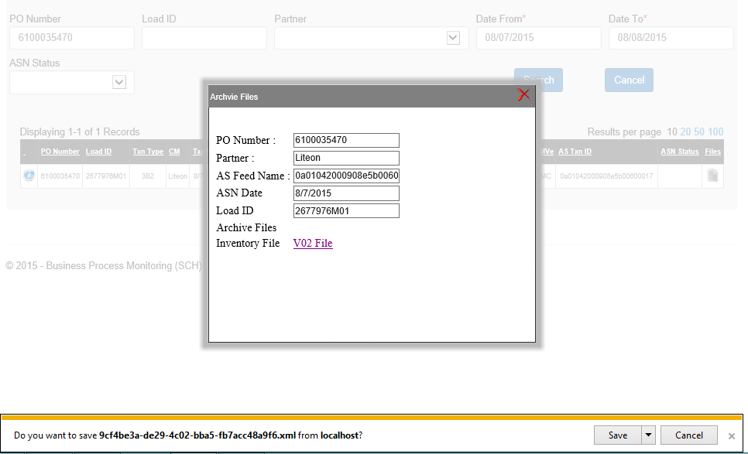

1. **841 Search:** Provide ControlNumber Number. Date as mandatory. Click search

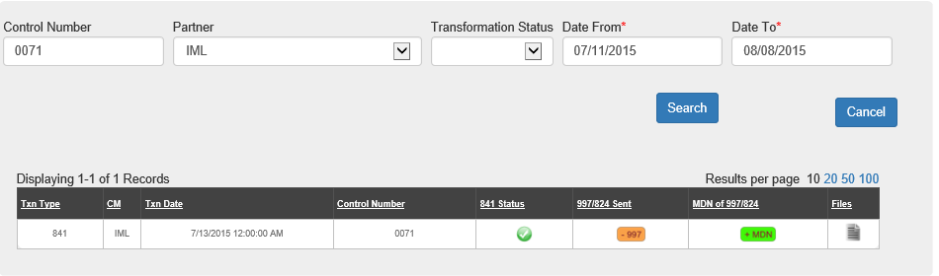

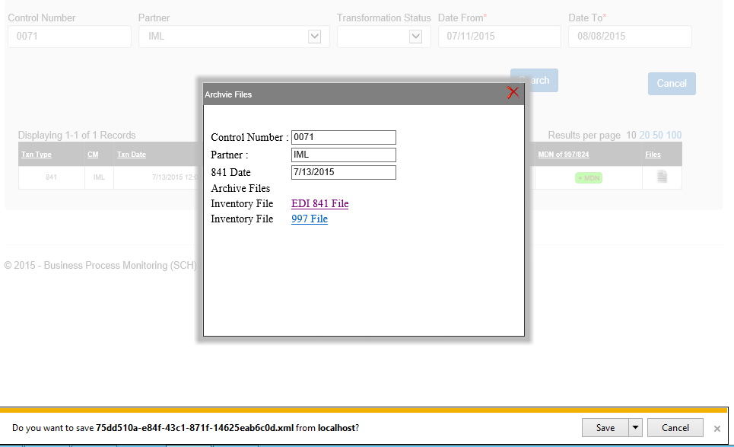

1. **945 DESADV Search:** Provide TransactionID. Date as mandatory. Click search

