LLM :

A large language model (LLM) is a type of artificial intelligence (AI) that's been trained on a massive amount of text data. This allows them to understand and generate human-like language in a variety of ways, making them incredibly versatile tools for a wide range of tasks.
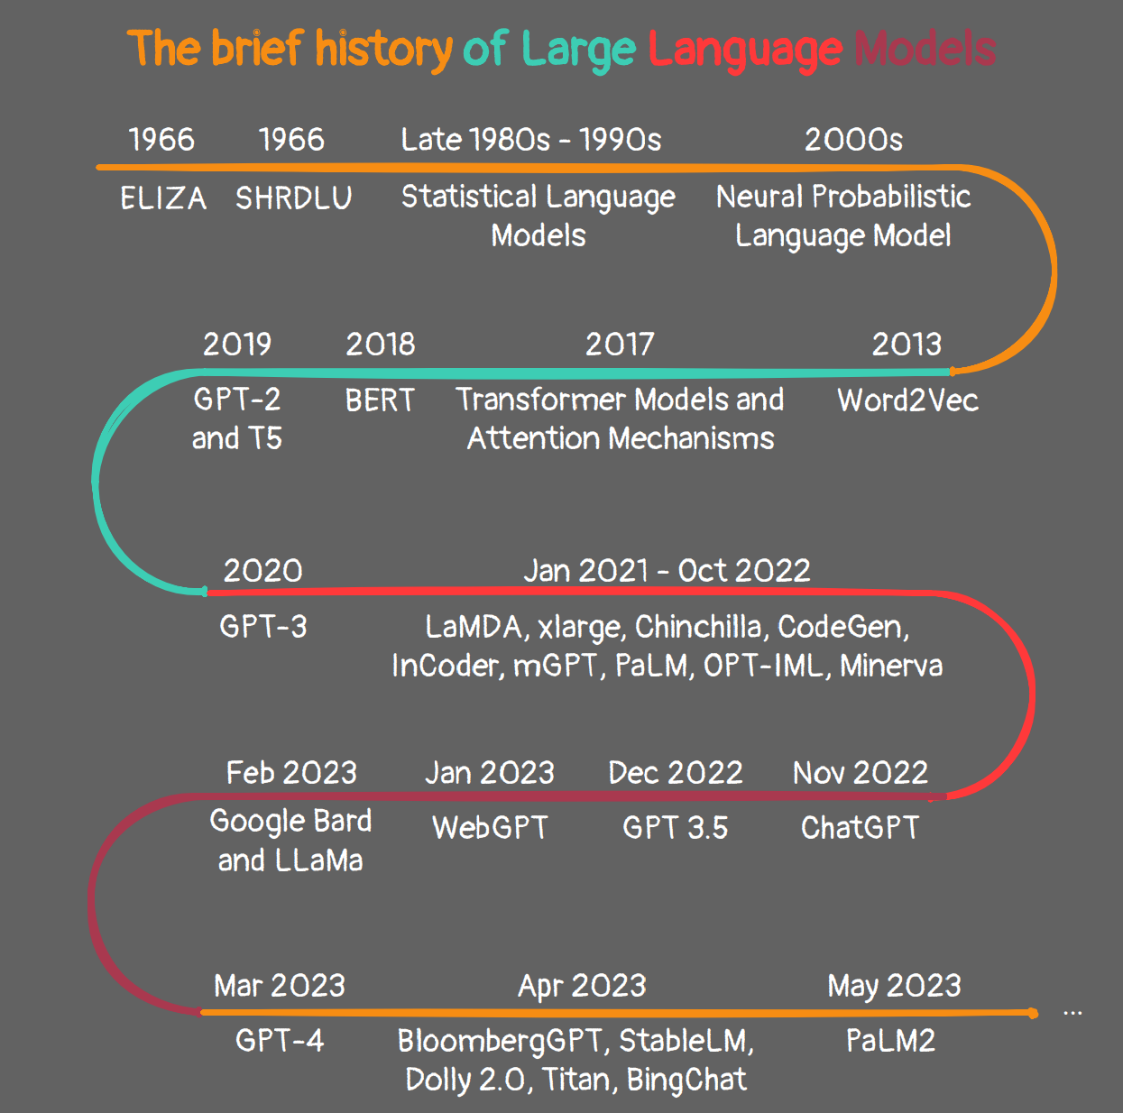
1) LLM Taks:
- Text Generation: Creating coherent and contextually relevant text passages.
- Text Summarization: Generating concise summaries of longer texts.
- Language Translation: Translating text from one language to another.
- Write different kinds of creative content: LLMs can be used to generate different creative text formats, like poems, code, scripts, musical pieces, email, letters, etc. They will try their best to fulfill all your requirements.
- Question Answering: Providing relevant answers to user queries.
- Sentiment Analysis: Analyzing and understanding the sentiment expressed in a piece of text.
- Chatbot Development: Building conversational agents capable of interacting with users in natural language.

2) How LLM Work:
- Think of them as superpowered language models. LLMs are essentially advanced versions of the language models you might be familiar with, like those used for autocorrect or chatbots. But instead of being trained on a limited dataset, LLMs are trained on massive amounts of text, often containing trillions of words. This includes books, articles, code, and even social media posts.
- They learn by crunching numbers. By analyzing these vast amounts of text, LLMs learn the statistical relationships between words and phrases. This allows them to understand the meaning of language, how it's used, and even generate new text that follows the same patterns.
- Transformer models are the key. The specific type of architecture used in most LLMs is called a transformer model. This allows them to process long sequences of text and understand the relationships between words, even if they're far apart in the sentence.

3) The future of LLMs:
- Developing new forms of creative expression: LLMs could be used to create new art forms, music, and even literature.
- Personalizing education and learning: LLMs could tailor educational materials to individual students' needs and learning styles.
- Improving healthcare: LLMs could be used to analyze medical data and help doctors make better diagnoses and automate the healthcare field.
- Scientific Research: By exploring vast datasets and generating hypotheses, LLMs could accelerate scientific discovery and technological breakthroughs.
- Global Communication and Understanding: Bridging language barriers and promoting cultural exchange, LLMs could foster a more connected and empathetic global community.

4) LLM Challenges:
- Bias and Fairness:
- LLMs are trained on massive amounts of text data, which can often reflect societal biases and stereotypes. These biases can then be amplified through the model's outputs, leading to unfair or discriminatory outcomes.
- Mitigating bias requires careful selection of training data, incorporating diverse perspectives, and developing methods for debiasing models. We need to ensure LLMs don't perpetuate social inequalities and instead promote fairness and inclusivity.

- Explainability and Trust:
- The inner workings of LLMs are often complex and opaque, making it difficult to understand how they arrive at their outputs. This lack of transparency can erode trust in these models and create ethical concerns.
- Explainable AI research aims to shed light on how LLMs make decisions, allowing users to understand the reasoning behind their responses. Building trust is crucial for responsible development and adoption of LLMs.

- Job displacement:
- LLMs' automation capabilities raise concerns about replacing human jobs, particularly in tasks involving language processing. This could lead to widespread unemployment and economic disruption.
- Adapting to this changing landscape requires reskilling and upskilling initiatives to equip workers with the skills needed to thrive in a future where LLMs are commonplace.

- Misinformation and Malicious Use:
- LLMs' ability to generate human-quality text can be exploited for malicious purposes, such as creating fake news, manipulating public opinion, or generating harmful content.
- Robust safeguards are needed to prevent misuse, including filters for detecting hateful content, fact-checking mechanisms, and user identification systems. Responsible development and ethical considerations are crucial in ensuring LLMs are used for good.

- Computational Resources: Discuss the significant computational resources required for training and fine-tuning large language models.

- Data Privacy: Explore concerns related to the use of personal data and the implications for privacy.

5) Applications of LLMs:
- Writing and translation: Creating content for websites, writing emails and reports, translating documents, and more.
- Customer service: Providing automated customer support through chatbots and virtual agents.
- Education: Tailoring educational materials to individual student needs, generating personalized feedback, and creating interactive learning experiences.
- Healthcare: Analyzing medical records, assisting with diagnoses, and providing patient education.
- Research and development: Generating hypotheses, designing experiments, and analyzing data.
- Creative expression: Writing poetry, music, and fiction.

6) Types of LLMs:
1. Autoregressive Models:
Process text sequentially, generating words one at a time, predicting the next word based on the previous ones.

Examples: GPT-3, Jurassic-1 Jumbo, Megatron-Turing NLG

Strengths: Produce fluent and coherent text, excel in open-ended generation tasks like writing stories or poems.

Limitations: May struggle with long-range dependencies and logical reasoning.

2. Autoencoding Models:
Learn to encode text into a compressed representation and then decode it back into its original form.
Examples: BERT, RoBERTa, T5

Strengths: Effective for tasks like text classification, question answering, and summarization.

Limitations: May not be as fluent in text generation as autoregressive models.

3. Encoder-Decoder Models:
Combine an encoder for understanding input text with a decoder for generating output text.

Examples: BARD, LaMDA, Bloom

Strengths: Versatile for various tasks, including translation, dialogue, and summarization.

Limitations: Can be computationally expensive to train and run.

4. Transformer-Based Models:
Utilize the transformer architecture, which excels at capturing long-range dependencies in text.

Examples: GPT-3, Megatron-Turing NLG, Gopher

Strengths: State-of-the-art performance in many language tasks.

Limitations: Can be very large and computationally demanding.

5. Pre-trained and Fine-Tuned Models:
Many LLMs are first pre-trained on massive text datasets to learn general language patterns.
Then, they can be fine-tuned on specific tasks or domains using smaller, task-specific datasets.

Examples: BERT, GPT-3, T5, GPT-3.5, GPT-4

Strengths: Effective transfer learning, saves computational resources, and time.

6. Hybrid Models:
Combine the strengths of different architectures to achieve improved performance.

Examples: Models incorporating both transformer-based and recurrent neural networks (RNNs).

Strengths: Potential for greater accuracy and versatility.

7. Few-Shot and Zero-Shot Learners:
Some LLMs can perform tasks with few or even zero examples, demonstrating rapid learning abilities.

Examples: GPT-3, LaMDA

Strengths: Adaptability to new tasks without extensive training data.

8. Generative Models:
Focus on generating new text, including different creative text formats, translation, and code generation.

Examples: GPT-3, Jurassic-1 Jumbo, BARD

Strengths: Creativity and flexibility in text generation.

9. Dense Retrieval Models:
Combine a dense vector storage of text with an LLM to retrieve relevant information from large text databases.

Examples: Retrieval-Enhanced Transformer (RETRO), REALM

Strengths: Access to vast amounts of knowledge and information, potential for more comprehensive and informative answers.

10. Foundation Models:
Large, adaptable models trained on diverse data modalities, capable of performing a wide range of tasks across different domains.
Potential to become a fundamental component of AI systems.

11. LLMs for Code:
Specialized in understanding and generating code, enabling applications such as code completion, debugging, and code generation.

Examples: Codex, GitHub Copilot

12. Multimodal LLMs:
Integrate different data modalities (text, images, audio) for more comprehensive understanding and generation.

Examples: DALL-E 2, Imagen

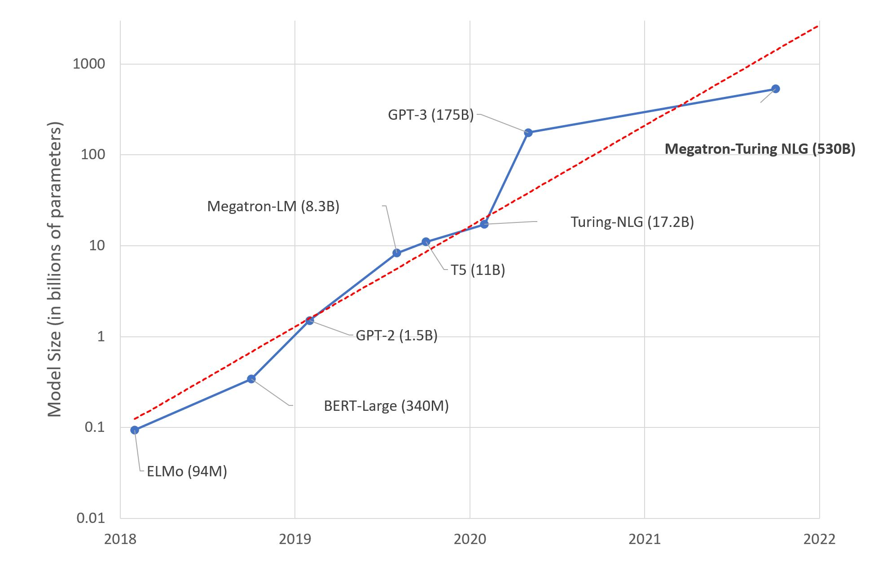

7) Types of Top LLMs:
1. GPT-3.5:
- Definition: A versatile, autoregressive LLM known for its impressive text generation abilities.
- Strengths: Creates fluent and creative text formats, excels in open-ended tasks like writing stories or poems.
- Limitations: May struggle with factual accuracy and fairness due to biases in its training data. Limited reasoning capabilities.
- Examples: Generating different creative text formats like poems, scripts, and code; completing prompts and creating stories; answering open-ended questions.
2. GPT-4:
- Definition: The anticipated successor to GPT-3.5, promising advancements in reasoning and factual accuracy.
- Strengths: Expected to improve upon GPT-3.5's strengths while offering better factual accuracy and reasoning capabilities.
- Limitations: Still under development, details about its features and limitations are yet to be revealed. Closed-source model, raising concerns about transparency and explainability.
- Examples: Not publicly available yet, potential applications include complex question answering, generating different creative text formats with improved factual accuracy.
3. BARD (Google AI):
- Definition: A factual language model from Google AI focusing on accurate knowledge and logical reasoning.
- Strengths: Provides insightful summaries of factual topics, excels at answering challenging questions with reliable information.
- Limitations: Limited creative text generation capabilities. May be overly cautious in responses to avoid potentially misleading information.
- Examples: Summarizing scientific articles or historical events, answering open-ended questions with factual evidence, providing comprehensive explanations for complex topics.
4. LlaMA (Meta AI):
- Definition: A specialized LLM focused on understanding and processing code, capable of translation and generation across programming languages.
- Strengths: Masterfully translates and generates code in various languages, offering efficient assistance to programmers.
- Limitations: Less versatile than some other LLMs, lacking capabilities in areas like text summarization or creative writing.
- Examples: Translating Python code to Java, generating different programming languages for specific tasks, understanding and debugging code snippets.
5) Falcon(Hugging Face):
- Primarily focuses on code generation and translation.
- Outputs are primarily code snippets in various programming languages.
- Can also analyze and debug code to some extent.
- Less suited for generating different creative text formats like poems or scripts.
6) PaLM(Google):
- Focuses on factual language understanding and reasoning.
- Can generate different creative text formats like poems, scripts, and summaries of factual topics.
- Outputs are primarily human-readable text, ranging from short answers to lengthy pieces of text.
- While proficient in code, its core functionalities lie in the realm of natural language processing.
7) Med-PaLM(Google Medical Research):
Med-PaLM is a large language model (LLM) developed by Google AI specifically for answering medical questions with high accuracy and quality. It has been trained on a massive dataset of medical texts and code, including academic papers, clinical reference books, and even patient charts.

