PyTorch is an open-source deep learning framework developed by Facebook's AI Research lab (FAIR). It is widely used for building and training deep neural networks. PyTorch provides a dynamic computational graph, making it easy to experiment with and iterate on models. Here's a brief definition of PyTorch.

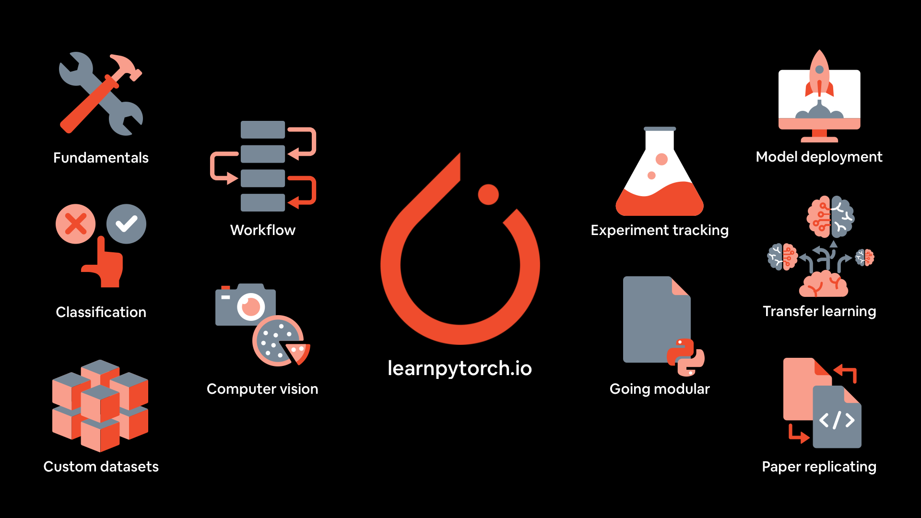

Advantages of PyTorch

It is easy to debug and understand the code.

It includes many layers as Torch.

It includes lot of loss functions.

It can be considered as NumPy extension to GPUs.

It allows building networks whose structure is dependent on computation itself.

Pytorch three levels of abstraction
- Tensor − Imperative n-dimensional array which runs on GPU.
- Variable − Node in computational graph. This stores data and gradient.
- Module − Neural network layer which will store state or learnable weights.
1) Key Features:
- Dynamic Computational Graph: PyTorch uses dynamic computation graphs, allowing the graph to be built and modified on-the-fly during runtime. This dynamic nature is beneficial for tasks that involve varying input sizes or changing architectures.
- Autograd: PyTorch includes an automatic differentiation library called "autograd," which automatically computes gradients of tensors with respect to a specified loss. This feature simplifies the implementation of backpropagation for training neural networks.
- Tensor Operations: PyTorch provides a multi-dimensional array, known as a tensor, as its fundamental data structure. It offers a comprehensive set of tensor operations and supports GPU acceleration for efficient numerical computations.
- Neural Network Module: PyTorch includes the torch.nn module, which provides pre-built layers, activation functions, loss functions, and optimization algorithms to facilitate the construction of neural network architectures.
- Dynamic Neural Networks: With PyTorch, models can be defined using a more imperative and Pythonic syntax. This allows for easy debugging and experimentation, as the model structure can be modified interactively.
- Libraries and Ecosystem: PyTorch has a growing ecosystem of libraries and tools, including torchvision for computer vision, torchtext for natural language processing, and torchaudio for audio processing. The community actively contributes to the development of various extensions and utilities.
- Research and Production: While PyTorch is often used in research settings for its flexibility and ease of use, it also provides tools like TorchScript for model deployment and productionization.

2) Top 2 package & high-level features:
- Tensor computation (like NumPy) with strong GPU acceleration
- Deep neural networks built on a tape-based autograd system
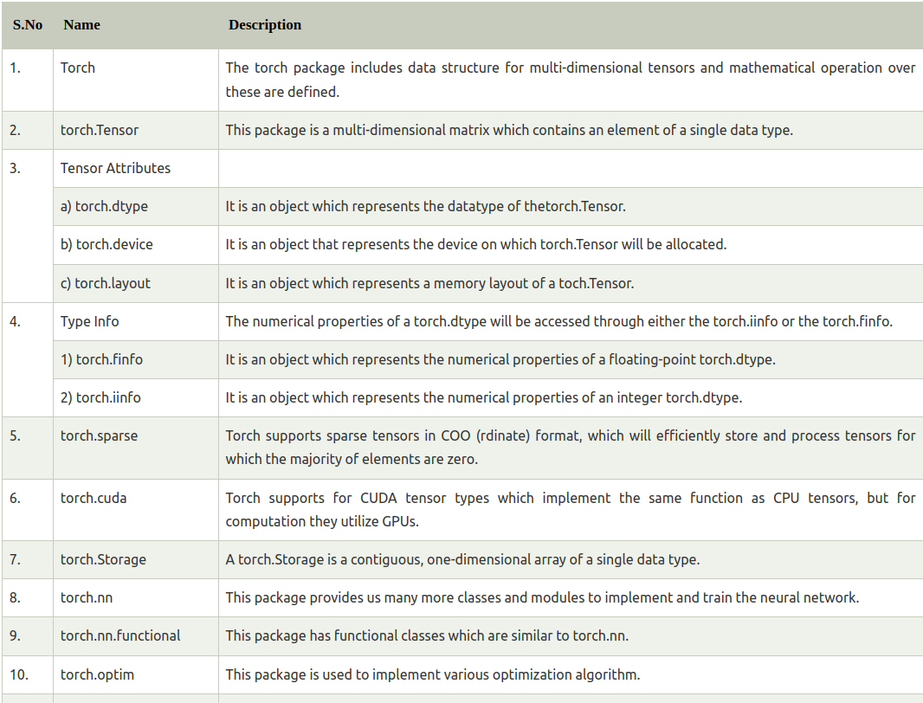
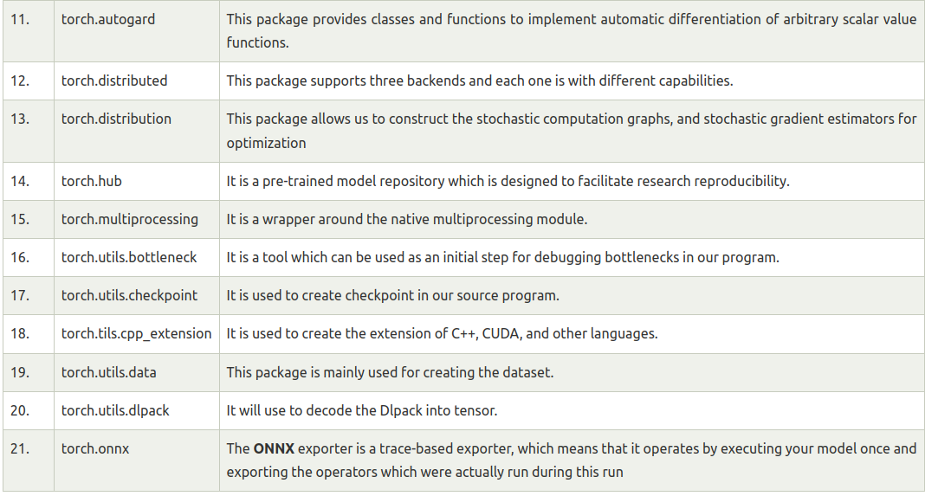
3) PyTorch Components & Descriptions:
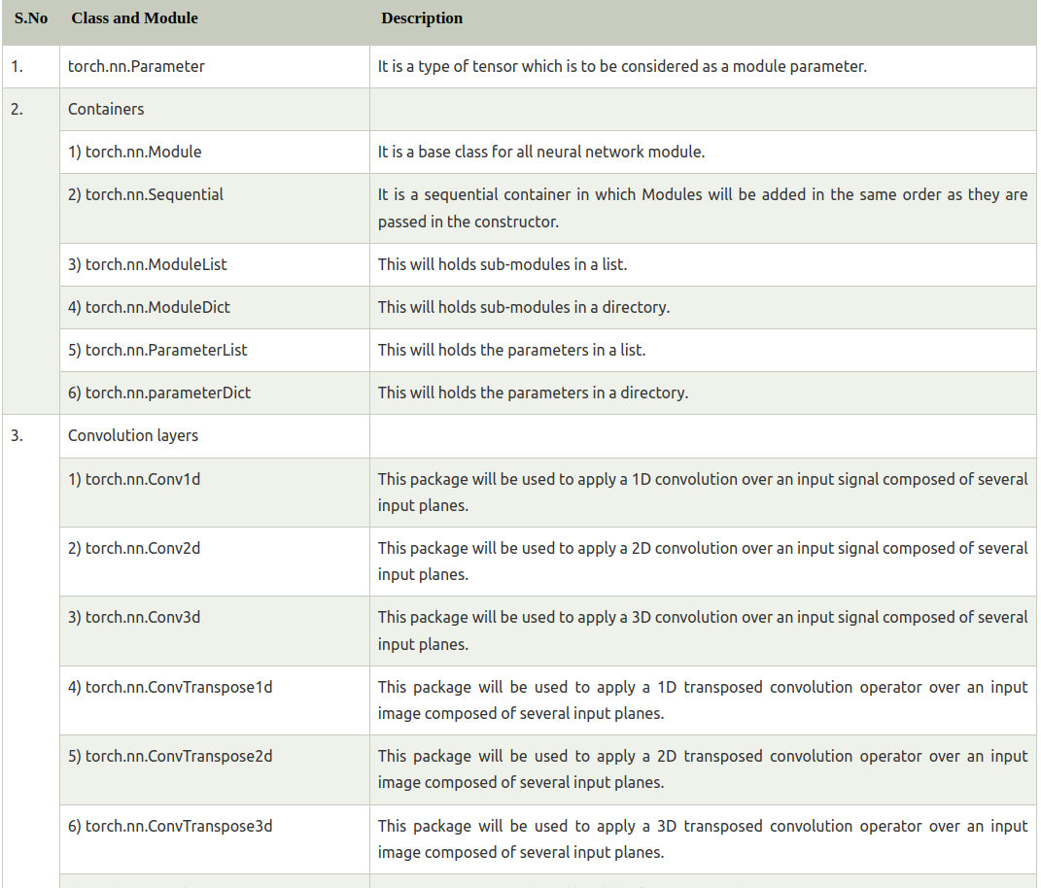
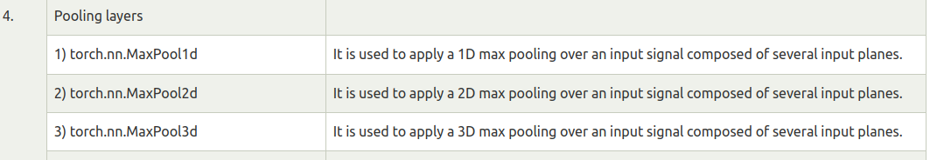
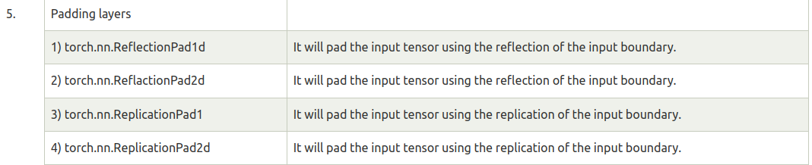
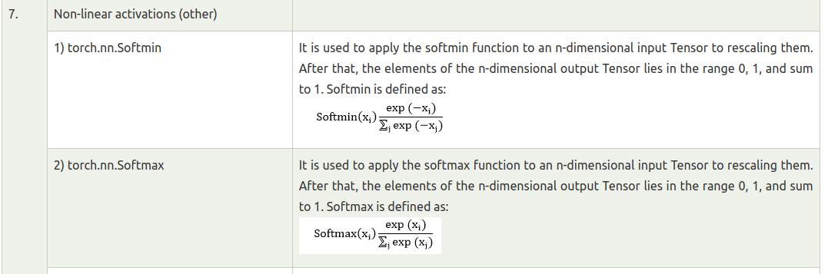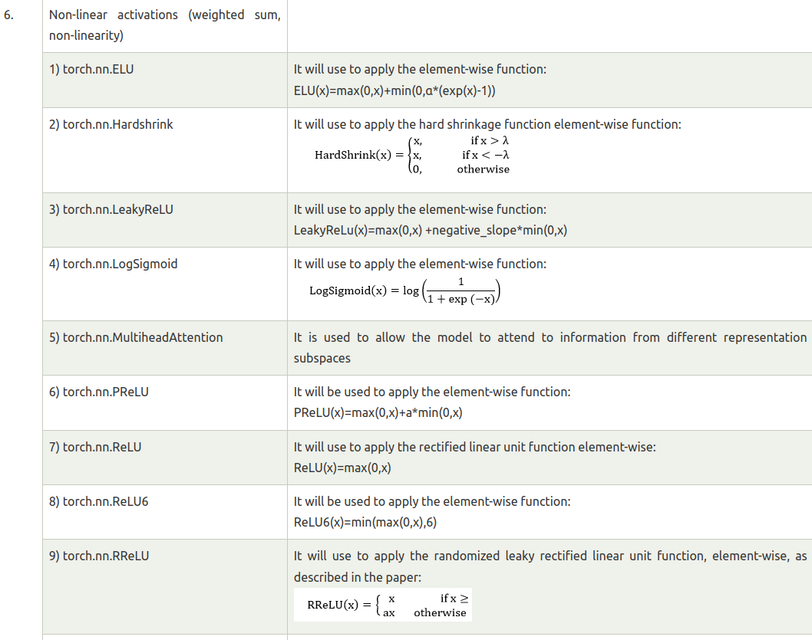

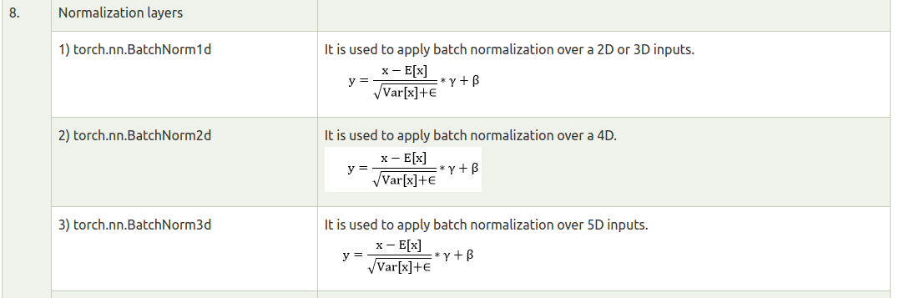
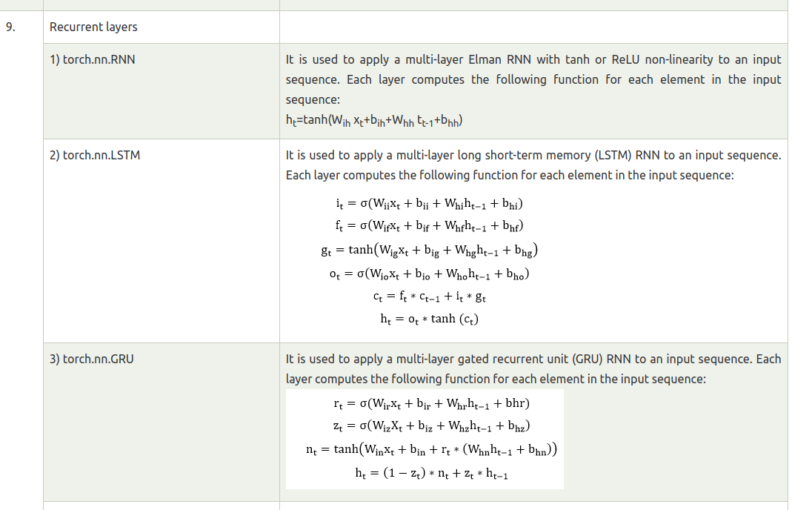
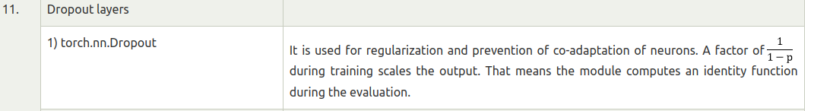
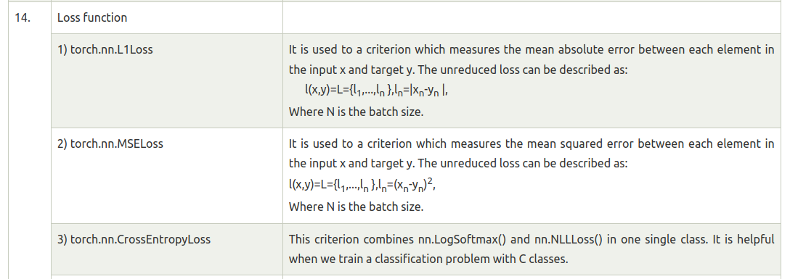
Usually, PyTorch is used either as:
- A replacement for NumPy to use the power of GPUs.
- A deep learning research platform that provides maximum flexibility and speed.

4) A GPU-Ready Tensor Library
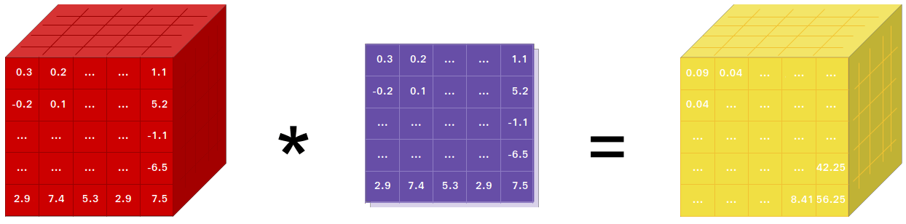

PyTorch provides Tensors that can live either on the CPU or the GPU and accelerates the computation by a huge amount.
We provide a wide variety of tensor routines to accelerate and fit your scientific computation needs such as slicing, indexing, mathematical operations, linear algebra, reductions. And they are fast!

5) Dynamic Neural Networks: Tape-Based Autograd
PyTorch has a unique way of building neural networks: using and replaying a tape recorder.
Most frameworks such as TensorFlow, Theano, Caffe, and CNTK have a static view of the world. One has to build a neural network and reuse the same structure again and again. Changing the way the network behaves means that one has to start from scratch.
With PyTorch, we use a technique called reverse-mode auto-differentiation, which allows you to change the way your network behaves arbitrarily with zero lag or overhead.
While this technique is not unique to PyTorch, it's one of the fastest implementations of it to date. You get the best of speed and flexibility for your crazy research.



6) PyTorch Coding:
Tensors: Tensors are the key components of Pytorch. We can say PyTorch is based on the Tensors and Torch provides tensor computation with strong GPU acceleration.

In mathematics, a rectangular array of number is called metrics.
In NumPy library, these metrics called ndaaray.
In PyTorch, it is known as Tensor. A tensor is an n-dimensional data container.
Tensor have different types of dimensions such as zero dimension, one dimension, and multi-dimensional. Vectors are a one-dimensional tensor, and to manipulate them several operations available.
Vector operations are of different types such as mathematical operation, dot product, and linspace. Vectors play a vital role in deep learning.

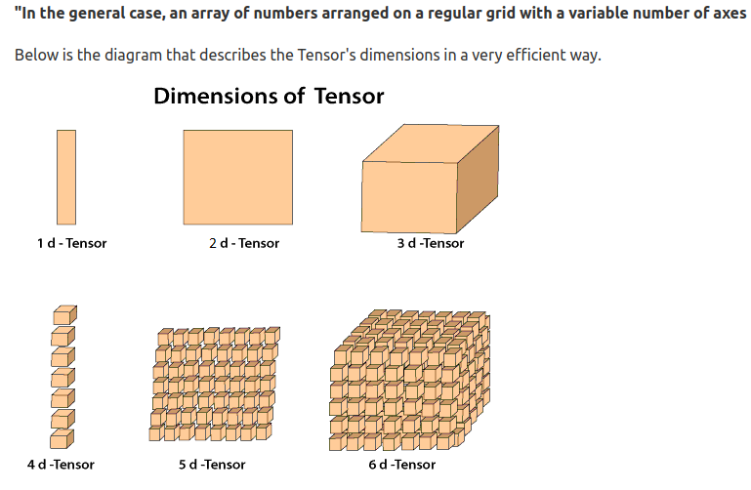

7) 3 Ways to create Tensor:
- Create PyTorch Tensor an array
For example
- import torch
- arr = [[3, 4], [8, 5]]
- pyTensor = torch.Tensor(arr)
- print(pyTensor)
Output:
tensor ([[3., 4.],[8., 5.]])
- Create a Tensor with all ones and random number
For example
- import torch
- ones_t = torch.ones((2, 2))
- torch.manual_seed(0) //to have same values for random generation
- rand_t = torch.rand((2, 2))
- print(ones_t)
- print(rand_t)
Output:
Tensor ([[1., 1.],[1., 1.]])
tensor ([[0.4963, 0.7682],[0.0885, 0.1320]])
- Create Tensor from numpy array
For example
- numpy_arr = np1.ones((2, 2))
- pyTensor = torch.from_numpy(numpy_arr)
- np1_arr_from_Tensor = pyTensor.numpy()
- print(np1_arr_from_Tensor)
Output:
[[1. 1.] [1. 1.]]

8) Tensors Operations

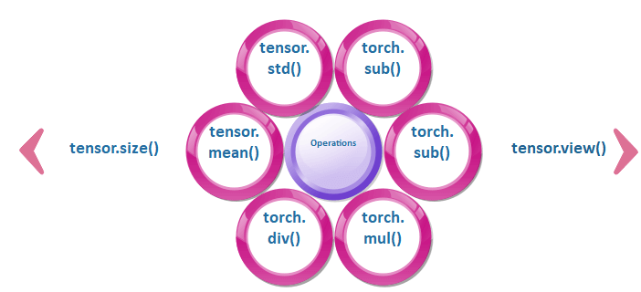

9) Tensors Operations Explanation:

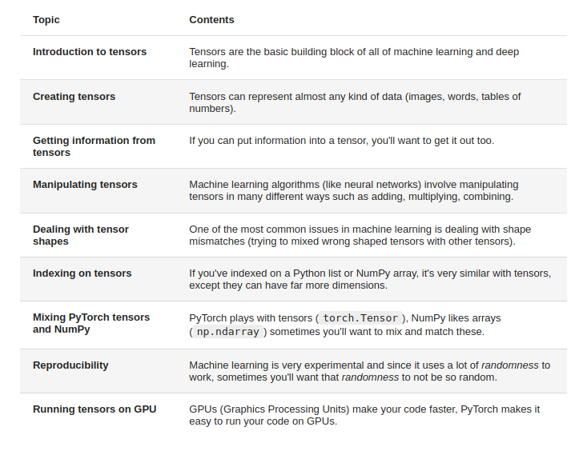

10 ) Vectors
Vector is considered to be array of numbers which is either continuous or discrete and the space which consists of vectors is called as vector space. The space dimensions of vectors can be either finite or infinite but it has been observed that machine learning and data science problems deal with fixed length vectors.
temp = torch.FloatTensor([23,24,24.5,26,27.2,23.0])
temp.size()
Output - torch.Size([6])

11) Scalars
Scalars are termed to have zero dimensions containing only one value. When it comes to PyTorch, it does not include a special tensor with zero dimensions; hence the declaration will be made as follows −
x = torch.rand(10)
x.size()
Output - torch.Size([10])

12) Matrices
Most of the structured data is usually represented in the form of tables or a specific matrix. We will use a dataset called Boston House Prices, which is readily available in the Python scikit-learn machine learning library.

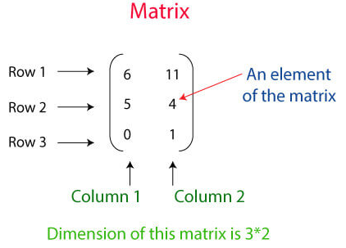

boston_tensor = torch.from_numpy(boston.data)
boston_tensor.size()
Output: torch.Size([506, 13])
boston_tensor[:2]
Output:
Columns 0 to 7
0.0063 18.0000 2.3100 0.0000 0.5380 6.5750 65.2000 4.0900
0.0273 0.0000 7.0700 0.0000 0.4690 6.4210 78.9000 4.9671
Columns 8 to 12
1.0000 296.0000 15.3000 396.9000 4.9800
2.0000 242.0000 17.8000 396.9000 9.1400
Note:
In mathematical term, a rectangular array of number is called a metrics.
In the Numpy library, these metrics called ndaaray.
In PyTorch, it is known as Tensor.
A Tensor is an n-dimensional data container.
example In PyTorch,
1d-Tensor is a vector,
2d-Tensor is a metrics,
3d- Tensor is a cube,
4d-Tensor is a cube vector.

13) One Dimensional Tensors
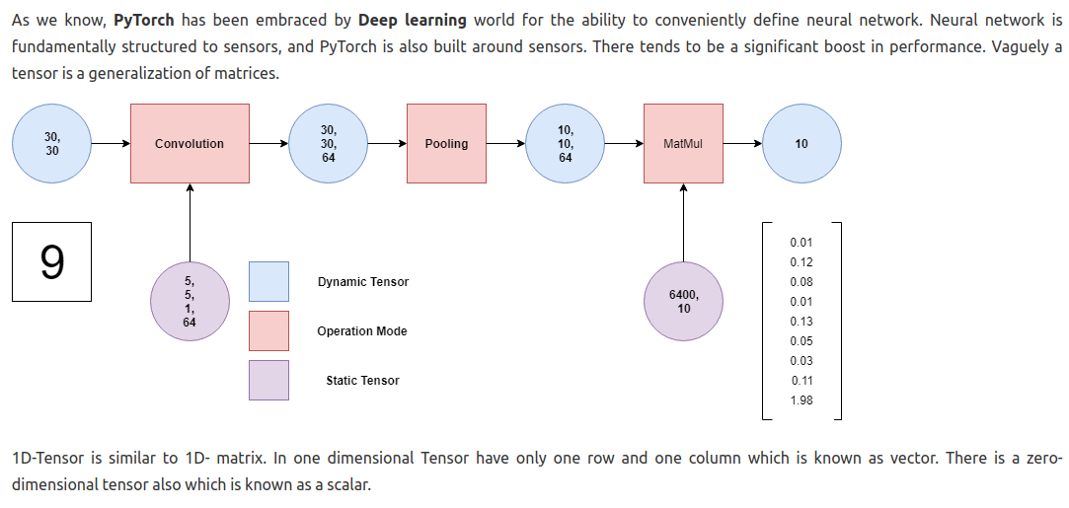

14) Creating one-dimensional Tensor
n=torch.tensor([1,2,3,4])
print(n)
Output:
tensor([1, 2, 3, 4])

15) Creating of Floating Point Tensor

We can create a floating point Tensor using integer element. In this, we use FloatTensor property of torch is used.

Example
- n=torch.FloatTensor([1,2,3,4,5,6,7])
- print(n)
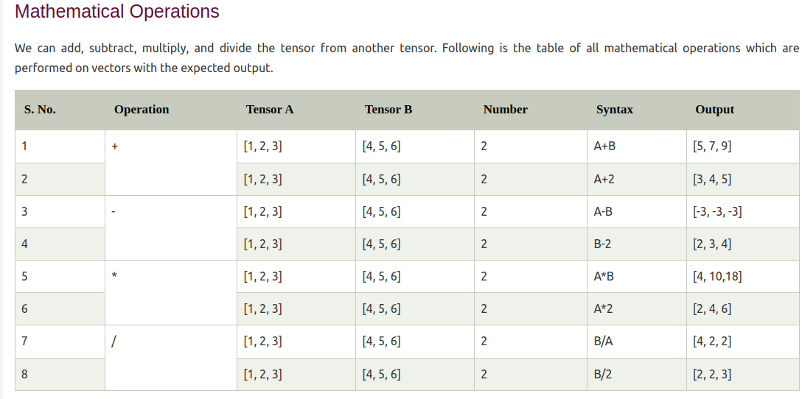

16) Creating two-dimensional tensor
For creating a two-dimensional tensor, you have first to create a one-dimensional tensor using arrange () method of the torch. This method contains two parameters of integer type. This method arranges the elements in tensor as per the given parameters. Once your one-dimensional tensor is created, then our next step is to change its view in two-dimensional form and store this view in the two-dimensional type of variable.
- import torch
- x=torch.arange(0,9)
- x
- y=x.view(3,3)
- y
Output:
tensor([0, 1, 2, 3, 4, 5, 6, 7, 8])
tensor([[0, 1, 2],
[3, 4, 5],
[6, 7, 8]])

17) Tensors Multiplication
The multiplication is done in the same manner as metrics multiplication. Tensor multiplication is done with multiplying corresponding row with the corresponding column. Tensor multiplication plays a vital role in the deep learning model. Tensors can be one dimensional, two dimensional, three dimensional, and so on. Multiplication of tensor is done only with compatible size.
Let see an example of Tensor Multiplication
- mat_a=torch.tensor([1,3,5,7,9,2,4,6,8])
- mat_a=mat_a.view(3,3)
- mat_b=torch.tensor([1,3,5,7,9,2,4,6,8])
- mat_b=mat_b.view(3,3)
- mat_a
- mat_b
- torch.matmul(mat_a,mat_b)# We can also usemat_a @ mat_b
Output:
tensor([[1, 3, 5],
[7, 9, 2],
[4, 6, 8]])
tensor([[1, 3, 5],
[7, 9, 2],
[4, 6, 8]])
tensor([[ 42, 60, 51],
[ 78, 114, 69],
[ 78, 114, 96]])

19) Three Dimensional Tensor

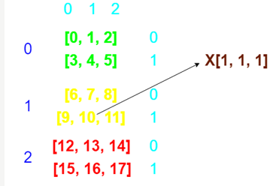

- x=torch.arange(18)
- y=x.view(3, 2, 3)
- y[1,1,1]

Output : tensor(10)

20) Gradient with PyTorch
The gradient is used to find the derivatives of the function. In mathematical terms, derivatives mean differentiation of a function partially and finding the value.
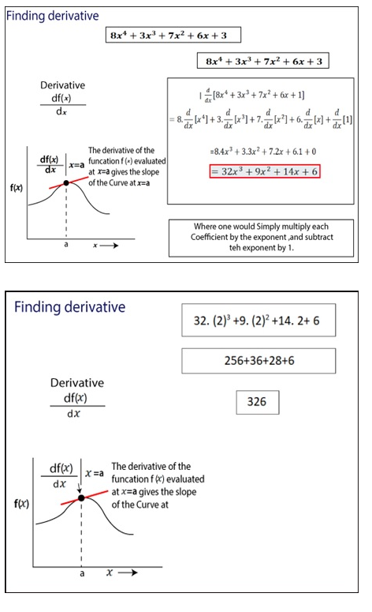
1. We have first to initialize the function (y=3x³ +5x²+7x+1) for which we will calculate the derivatives.
2. Next step is to set the value of the variable used in the function. The value of x is set in the following manner.
- X= torch.tensor (2.0, requires_grad=True)
We typically require a gradient to find the derivative of the function.
3. Next is to compute the derivative of the function simply by using backward () method.
4. The last step is to access or print the value of the derivative using grad.
Let see an example of finding derivative
- x=torch.tensor(2.0, requires_grad=True)
- y=8*x**4+3*x**3+7*x**2+6*x+3
- y.backward()
- x.grad

21) PyTorch - Loading Data
PyTorch includes a package called torchvision which is used to load and prepare the dataset. It includes two basic functions namely Dataset and DataLoader which helps in transformation and loading of dataset.

Dataset
Dataset is used to read and transform a datapoint from the given dataset. The basic syntax to implement is mentioned below −
trainset = torchvision.datasets.CIFAR10(root = './data', train = True,
download = True, transform = transform)
DataLoader is used to shuffle and batch data. It can be used to load the data in parallel with multiprocessing workers.
trainloader = torch.utils.data.DataLoader(trainset, batch_size = 4,
shuffle = True, num_workers = 2)

