

MITTAL SCHOOL OF BUSSINESS

BIG DATA ANALYTICS
(INTM590)

PROJECT

SUBMITTED TO: SUBMITTED BY:
ROBIN TYAGI RAKESH MAHATO
REG NO. 12500123
ROLL NO. 27

Big Data Analytics Using Apache Pig and HDFS Commands

Introduction
Apache Hadoop is an open-source framework designed for the distributed storage and processing of large datasets through the Hadoop Distributed File System (HDFS). It provides key features such as fault tolerance, scalability, and efficient data management across multiple clusters.
Apache Pig is a high-level platform used for analysing large volumes of data. It offers a scripting language called Pig Latin, which makes data transformation tasks easier compared to writing complex MapReduce programs.
This assignment emphasizes the practical application of Big Data concepts using:
• Apache Pig for executing data processing tasks (Word Count Case Study)
• HDFS commands for managing files and directories in a distributed system
The primary objective is to gain an understanding of how large datasets can be efficiently processed, stored, and managed using Big Data technologies.

Objective
- To understand the fundamentals of Big Data processing using Apache Pig and HDFS
- To gain practical experience in writing and executing Pig Latin scripts
- To perform data transformation, grouping, and aggregation using a word count case study
- To analyze and identify patterns such as the most frequently occurring elements in data
- To learn file management operations in Hadoop Distributed File System (HDFS)
- To execute various HDFS commands for storing, retrieving, and managing data
- To develop hands-on skills in handling large-scale data in a distributed computing environment

Apache Pig – Word Count Case Study

The word count program is implemented using Apache Pig. The process includes the following steps:

Step 1: Creation of Input File
In this step, a text file named input.txt was created in the local system. The file contains sample textual data consisting of multiple words and lines. This data acts as the input dataset for performing the word count analysis in Apache Pig.

Step 2: Uploading File to HDFS
The input file was uploaded from the local system to the Hadoop Distributed File System (HDFS) by making a directory naming CA2 and checking the content of file input.txt. This step ensures that the data is available in the distributed storage environment so that it can be processed using Pig.
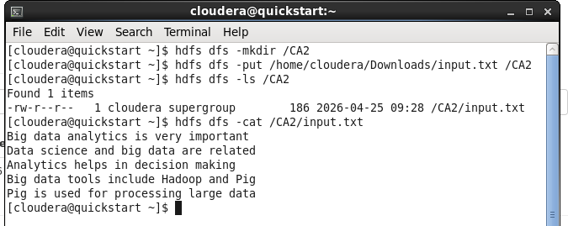

Step 3: Loading Data into Pig
The data stored in HDFS was loaded into Pig using a relation named lines. Each line of the text file was stored as a separate record in the form of a bag. This step initializes the dataset for further processing.

Command:
$ grunt> lines = LOAD '/CA2/input.txt' AS (line:chararray);

Input command:
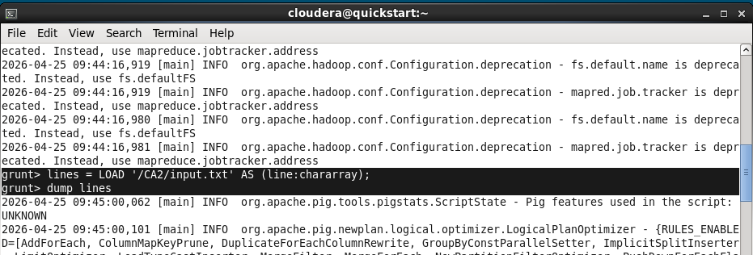

Output:
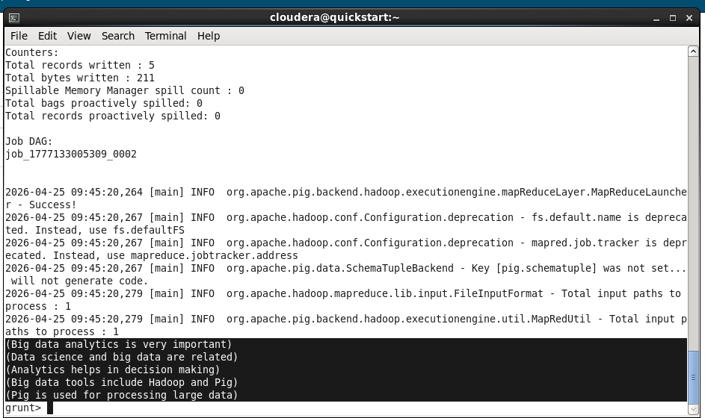

Step 4: Tokenization of Data
In this step, each line of text was split into individual words (tokens). The tokenization process converts unstructured text into a structured format where each word can be processed independently.

Command:
$ grunt> words = FOREACH lines GENERATE FLATTEN(TOKENIZE(line) AS word;

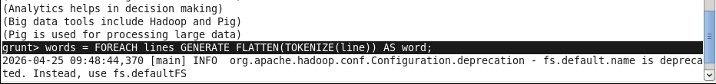
INPUT COMMAND:

OUTPUT

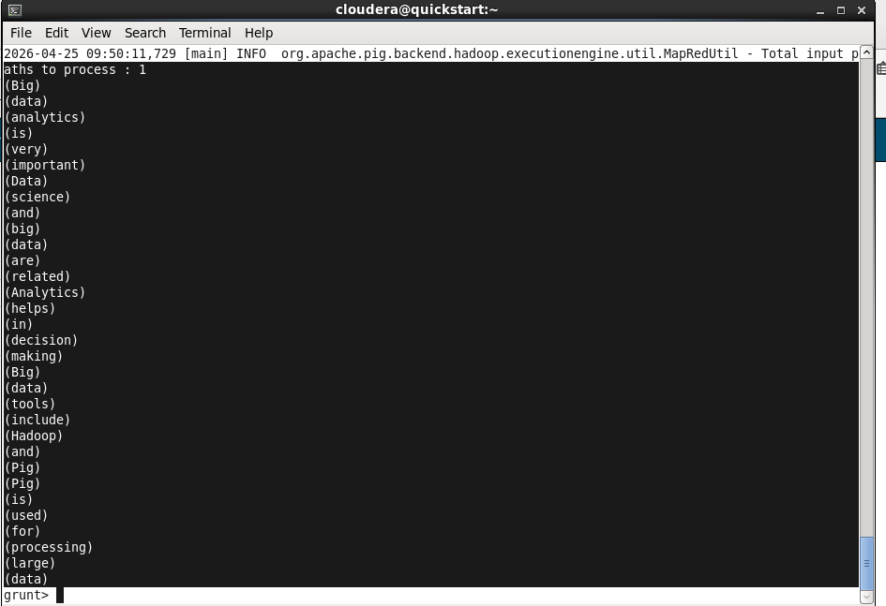

Step 5: Data Standardization
All words were converted into lowercase format to ensure uniformity. This step is important to avoid duplication of words due to case differences (e.g., “Apple” and “apple” being treated as different words).

Command:
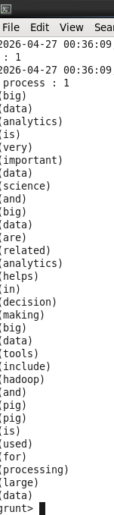
$ grunt> lower_words = FOREACH lines GENERATE LOWER(word) AS word;
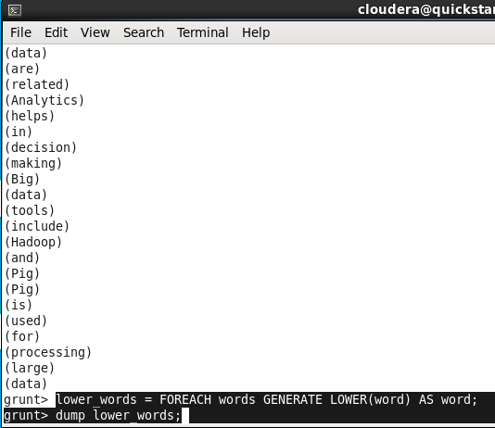
Input Command

Output

Step 6: Extraction of First Letter
From each word, only the first letter was extracted. This transformation helps in grouping words based on their starting character, which is essential for the analysis.
Command:
$ grunt> letters = FOREACH lines GENERATE SUBSTRING(word, 0, 1) AS letter;

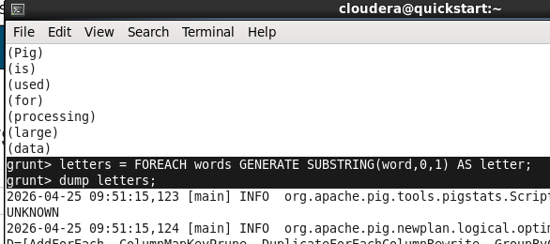
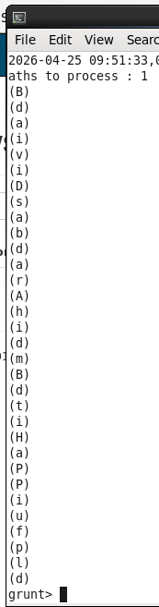
Input Command

Output

Step 7: Grouping of Data
The extracted letters were grouped together based on their value. This means all words starting with the same letter were placed in one group. Grouping is a key step for performing aggregation operations.

Command:
$ grunt> words = FOREACH lines GENERATE SUBSTING(word, 0, 1) AS word;
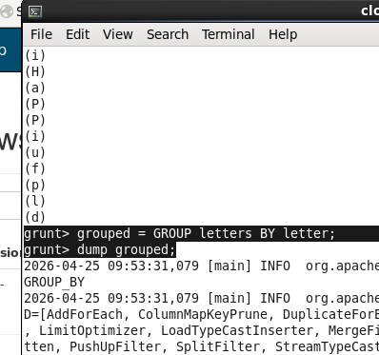
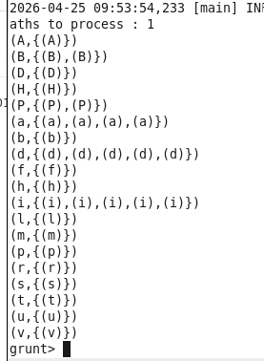

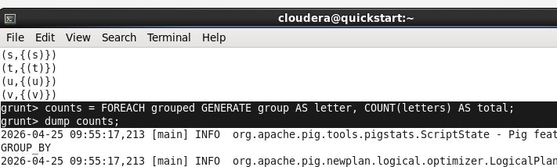
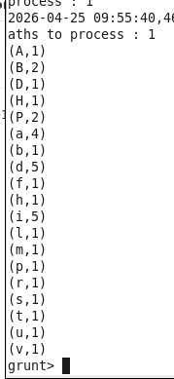
Step 8: Counting Occurrences
Output
Input Command
The number of occurrences of each grouped letter was calculated. This step determines how many times each letter appears as the starting character in the dataset.
Command:
$ grunt> counts = FOREACH grouped GENERATE group AS letter, COUNT(letters) AS total;

Step 9: Sorting the Results
The grouped data was sorted in descending order based on the count of occurrences. This helps in identifying the most frequently occurring letters easily.

Command:
$ grunt> sorted = ORDER Counts BY count DESC;

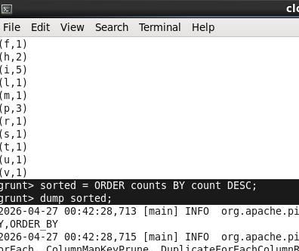
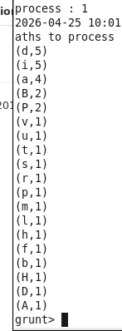
Input Command
Output

Step 10: Identifying Most Frequent Letter
The top result was selected from the sorted data, representing the letter with the highest frequency. This step highlights the most dominant starting letter in the dataset.
Command:
$ grunt> top = LIMIT sorted 1;

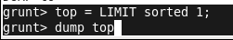
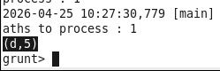
Input Command
Output

Step 11: Storing Output in HDFS
The final processed output was stored back into HDFS. This ensures that the results are saved in a distributed storage system for future use or analysis.

Step 12: Viewing the Output
The stored output file was accessed and displayed from HDFS. This step verifies the successful execution of the program and allows analysis of the results.

HDFS Commands Implementation

Step 1: Creating Directory in HDFS
In this step, a new directory was created in the Hadoop Distributed File System (HDFS). This directory serves as a storage location for files and helps in organizing data within the distributed environment.

Command:

$ hdfs dfs -mkdir /Assignment;
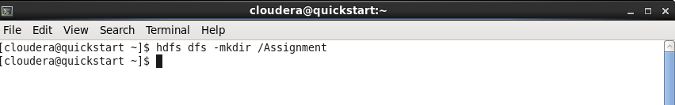

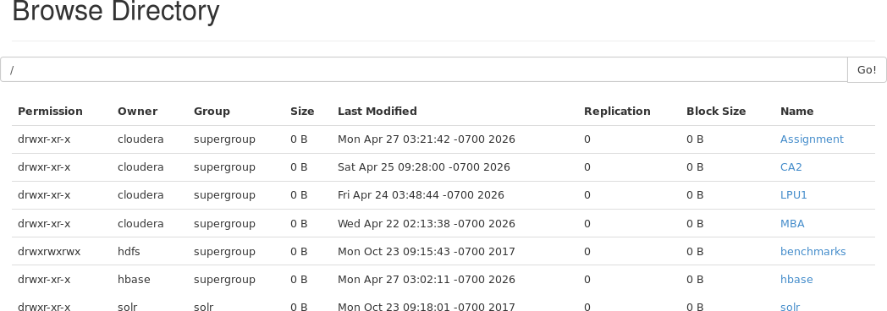
Assignment Directory Created

Step 2: Uploading File to HDFS
A file from the local system was uploaded into HDFS. This step is important as data must be present in HDFS before it can be processed using Big Data tools like Pig.
Command:
$ hdfs dfs -put /home/cloudera/Downloads/input.txt /Assignment;
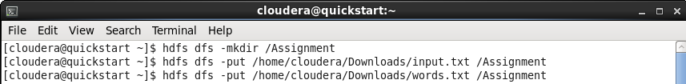

Step 3: Listing Files and Directories
The contents of both the local file system and HDFS were listed. This step helps in verifying the presence of files and directories and ensures that operations like upload or deletion are performed on the correct paths.

Command:
$ hdfs dfs -ls /Assignment;

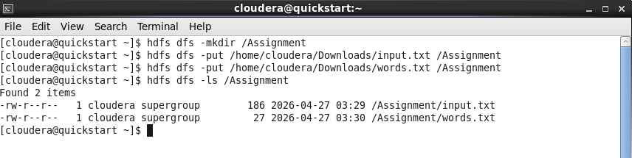
List of Files

Step 4: Viewing File Content in HDFS
The content of the uploaded file was displayed directly from HDFS. This step confirms that the file has been successfully uploaded and stored without any corruption.

Command:
$ hdfs dfs -cat /Assignment/input.txt;

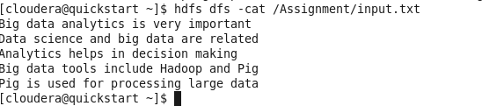
File Content

Step 5: Downloading File from HDFS
The file stored in HDFS was downloaded back to the local system. This demonstrates how data can be retrieved from the distributed storage when needed.
Command:
$ hdfs dfs -get /Assignment/input.txt;
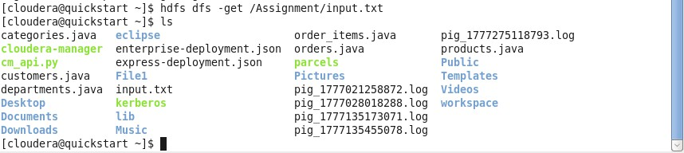

File downloaded on local system

Step 6: Copying File within HDFS
A copy of the file was created within HDFS. This step shows how duplication of data can be performed without affecting the original file.

Command:
$ hdfs dfs -cp /MBA/file.txt /Assignment;

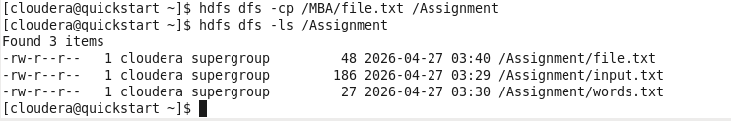
file.txt copy from MBA directory to Assignment directory

Step 7: Moving/Renaming File in HDFS
The file was either moved to another directory or renamed within HDFS. This helps in managing files efficiently and maintaining proper organization.

Command:
$ hdfs dfs -mv /Assignment/words.txt /MBA;
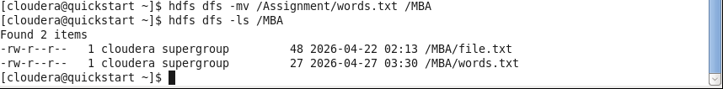
Moving word.txt file Assignment directory to MBA

Step 8: Deleting File from HDFS
The file was deleted from HDFS. This step is useful for removing unnecessary or outdated data and freeing up storage space.

Command:
$ hdfs dfs -mv /Assignment/words.txt /MBA;

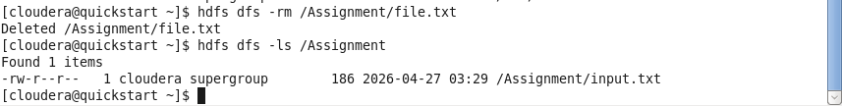

Step 9: Checking Disk Usage
The disk usage of a directory in HDFS was checked. This provides information about the storage space occupied by files and helps in monitoring resource utilization.

Command:
$ hdfs dfs -df -h /Assignment;

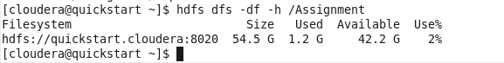

Step 10: Merging Multiple Files
Multiple files stored in HDFS were merged into a single file using the getmerge operation. This step is useful for combining distributed output files into one consolidated file for easier access and analysis.

Command:
$ hdfs dfs -getmerge /Assignment file.txt;

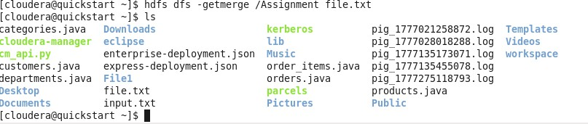

Conclusion
This assignment provided comprehensive hands-on experience with two essential components of the Hadoop Big Data ecosystem: Apache Pig and HDFS.
In Task 1, the Apache Pig word count program demonstrated the power and simplicity of Pig Latin for text analytics. By chaining together data processing operations such as LOAD, FOREACH, TOKENIZE, GROUP BY, FOREACH..COUNT, ORDER BY,
LIMIT, and STORE, a complete data processing pipeline was implemented with

minimal code. The pipeline successfully identified the most frequently occurring first letter in a text corpus and persisted the result to HDFS. This exercise highlighted Pig's strength as a high-level abstraction layer over MapReduce, eliminating the need to write verbose Java code.
In Task 2, the ten HDFS shell commands covered the complete lifecycle of file management in a distributed file system: from creating directories and uploading files, to viewing, copying, moving, deleting, and merging data. These operations are fundamental to any Big Data workflow and form the building blocks of data ingestion and output management in the Hadoop ecosystem.

