**B TASK-2(VPN Gateway connection)**

1.Created **Resource Group** with name **AnnuRG**

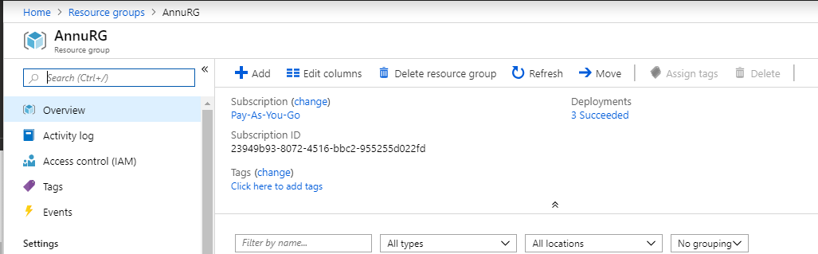

2. Inside **AnnuRG** resource group 3 Virtual Network created with name **AnnuVnet1**, **AnnuVnet2** and **AnnuVnet3**

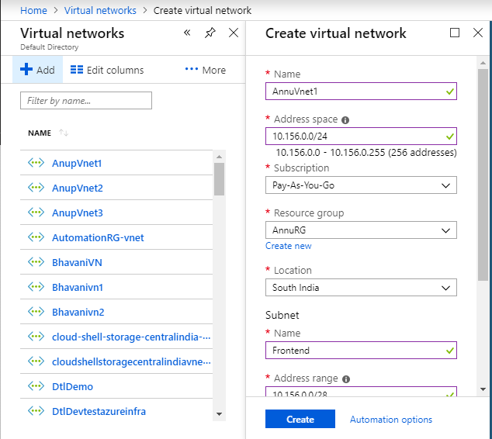

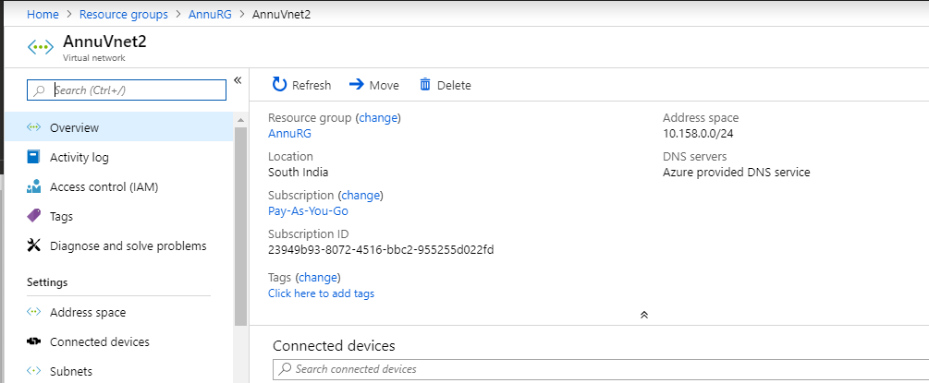

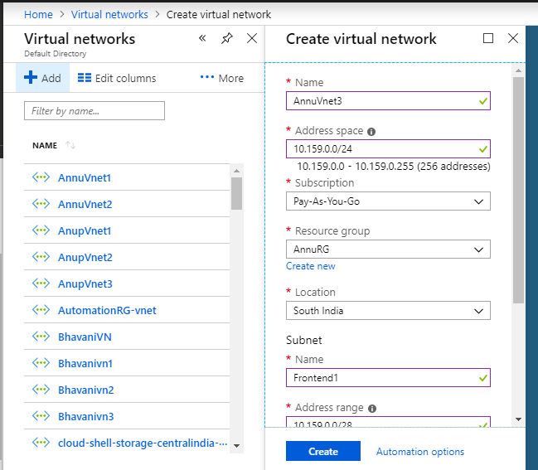

3. Inside AnnuVnet1 3 subnet created with name **Fontend1**, **Backend1** and **Gateway subnet**

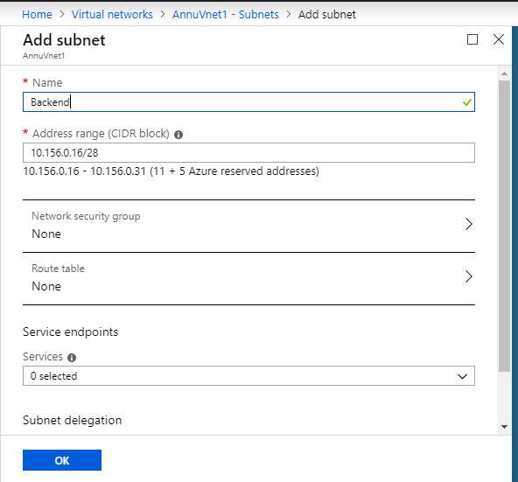

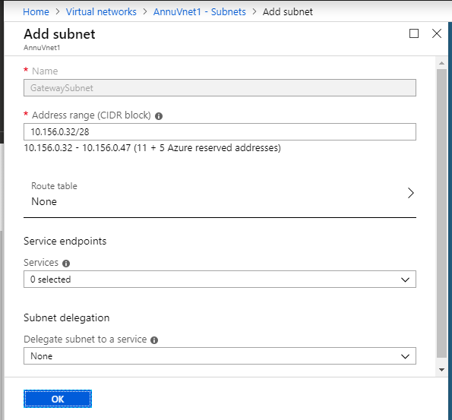

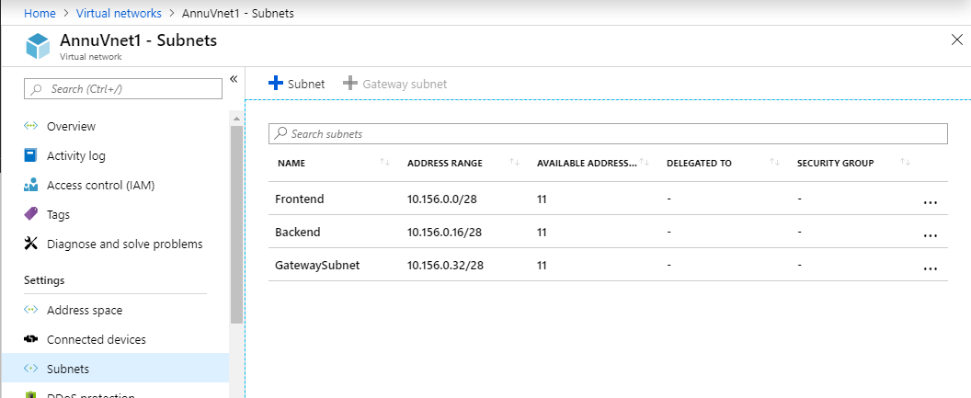

4. Inside **AnnuVnet2**, 3 subnet created with name **Fontend2**, **Backend2** and **Gateway subnet**

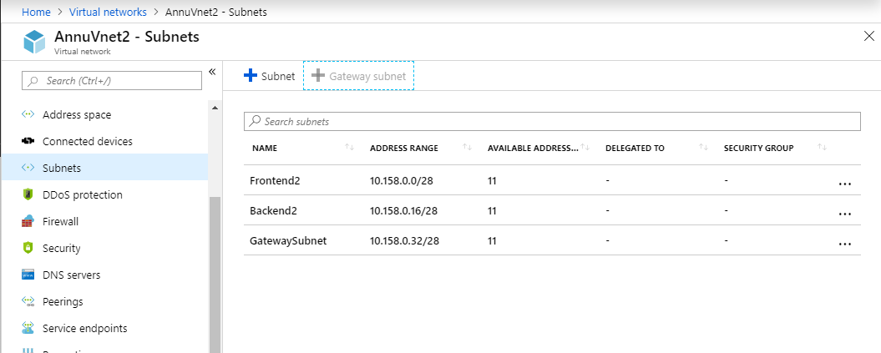

**5.** Inside **AnnuVnet3**, 3 subnet created with name **Fontend2**, **Backend2** and **Gateway subnet**

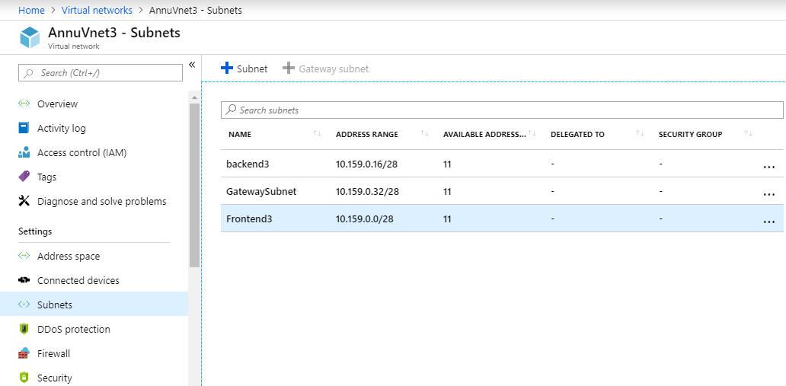

6.In virtual network **AnnuVnet1** VPN Gateway created with name [**VPNGateway1**](https://portal.azure.com/)

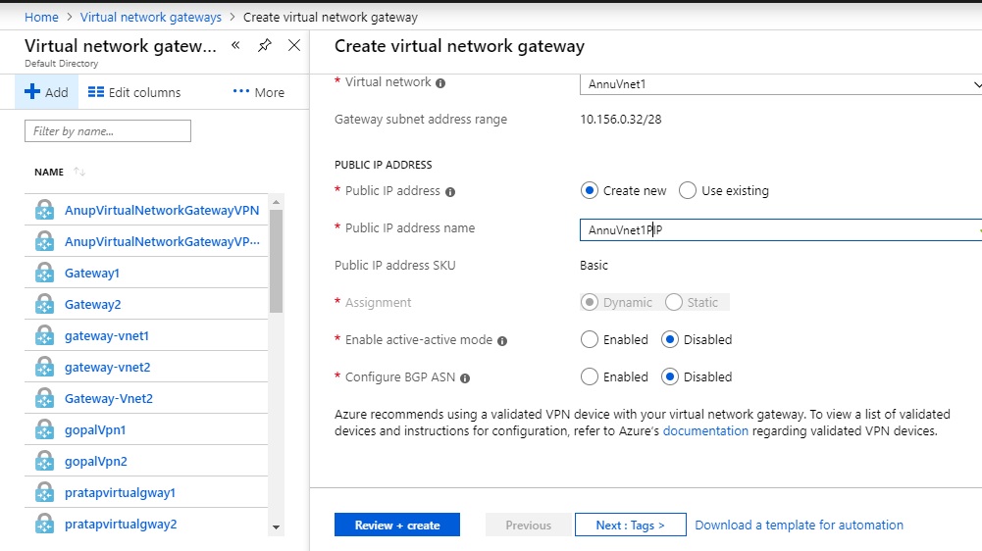

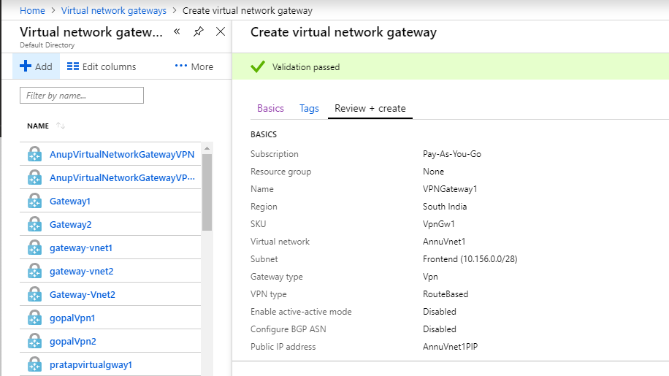

7.In virtual network **AnnuVnet2** VPN Gateway created with name **VPNgateway2**

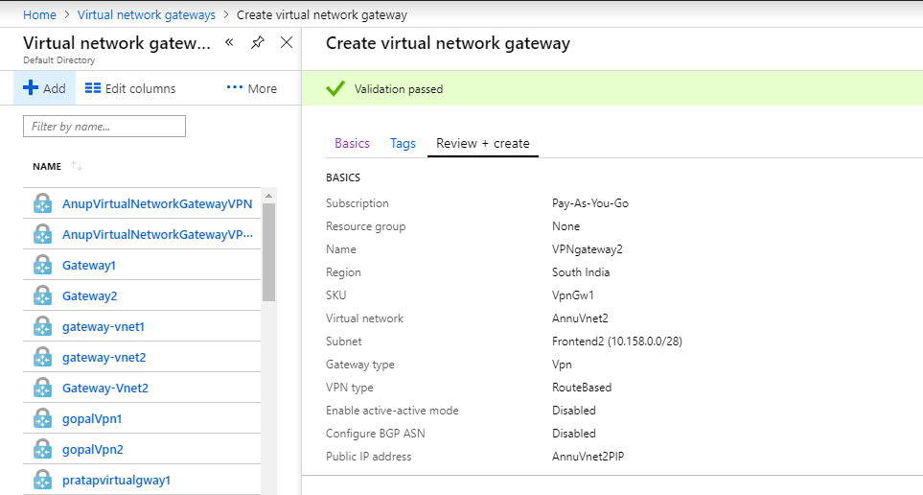

8.Inside **VPNgateway1,** created connection with name **VPNcon1, VPNcon2**

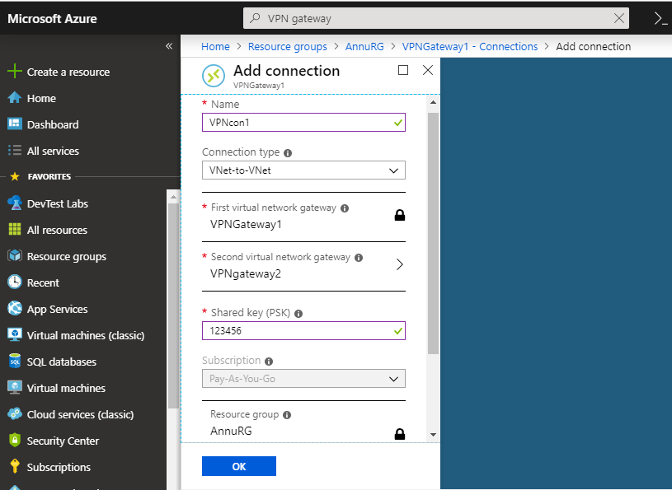

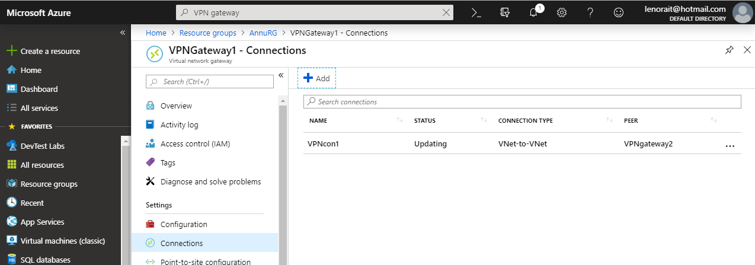

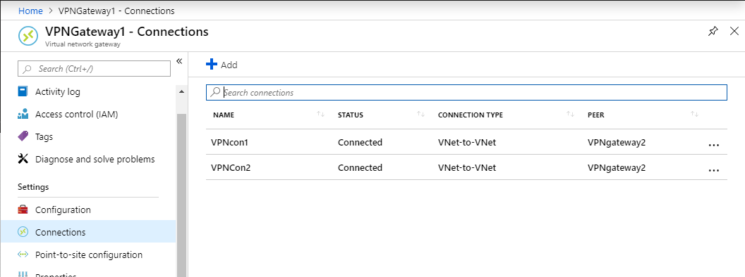

9.Inside **VPNgateway2,** created connection with name **VPNcon1**, **VPNcon2**

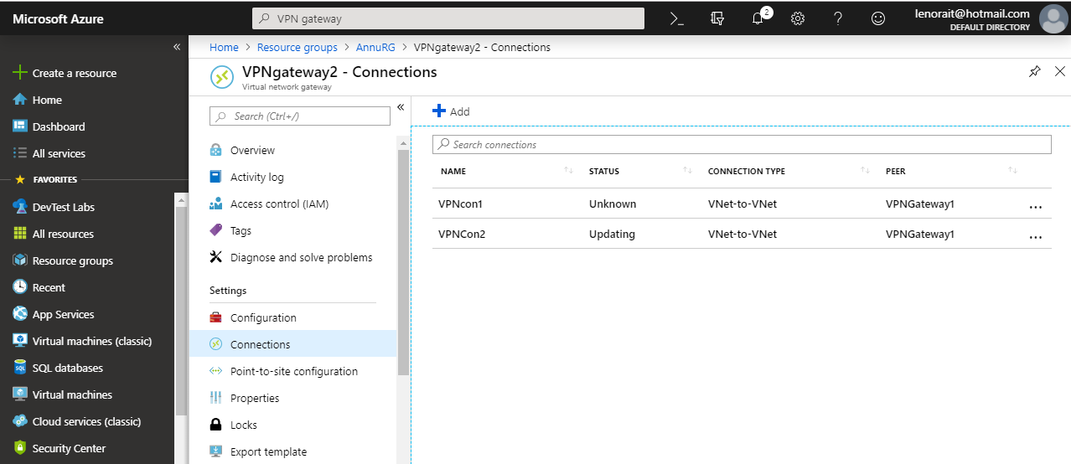

10.In Resource group **AnnuRG** inside virtual network **AnnuVnet2** added peering From **AnnuVnet2** to **AnnuVnet3,** here enable Virtual network to access from AnnuVnet2 to AnnuVnet3 to allow gateway transits.

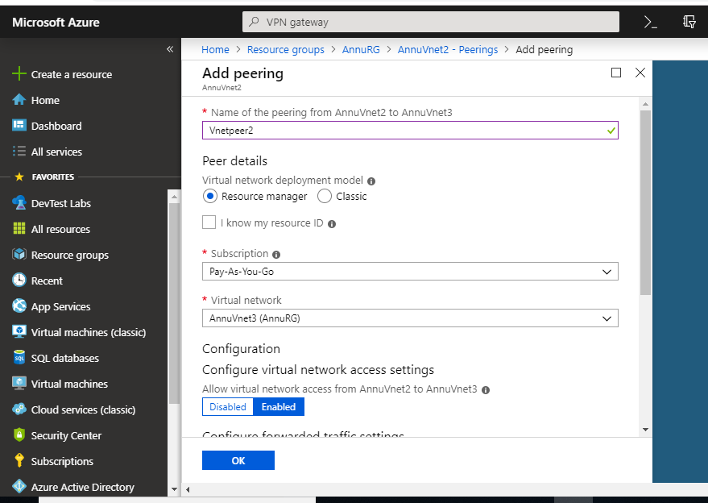

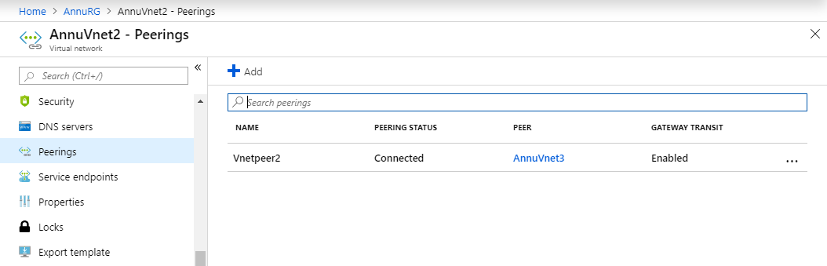

11. In Resource group **AnnuRG** inside virtual network **AnnuVnet3** added peering From **AnnuVnet3** to **AnnuVnet2,** here enable Virtual network to access from AnnuVnet3 to AnnuVnet2 to use remote gateway

