**Creation of Azure SQL Database**

1. Created Sql Database with name **AnnuDB** in Resource Group **AnnuRG**

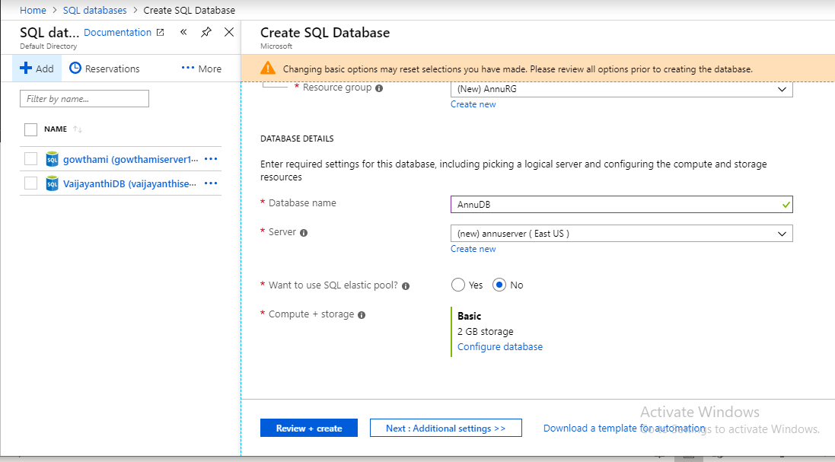

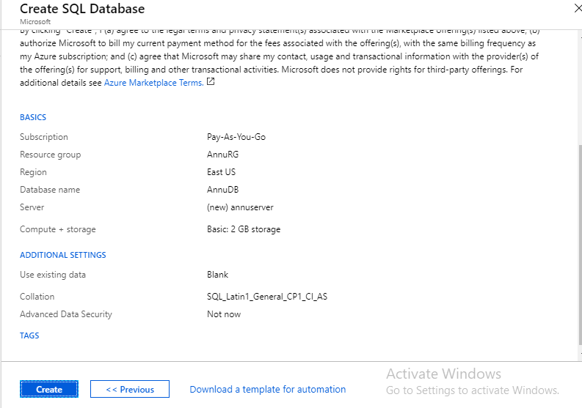

1. Added firewall setting having starting and ending IP.

