1. Created two repository with name Devops and Developer.
2. Clone Developer to local with Url.

$ Git clone “https://github.com/AnnuCh/Developer.git”

1. In Developer repository, create one branch with name Testbranch1.

$ git checkout -b Testbranch1

1. Added one text file with name Testfile.txt

$ git add .

$ git commit -m “Adding file”

$ git push origin Testbranch1

1. Created sub-modules with name DevOsubMod having default branch name master

git submodule add -f -b master https://github.com/AnnuCh/Devops.git DevOsubMod

git add .

git commit -m "Linking Submodule"

git push origin Testbranch1

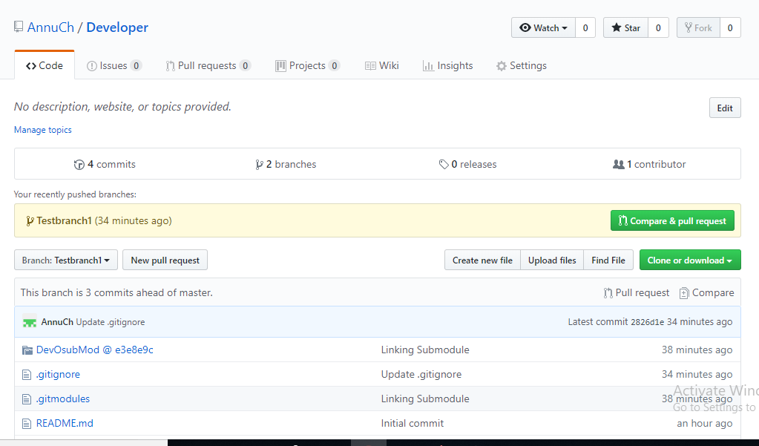

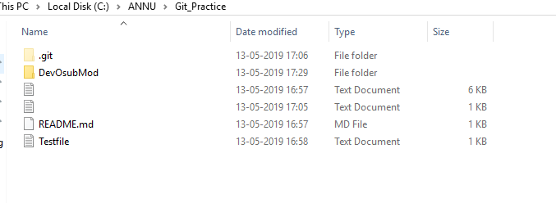

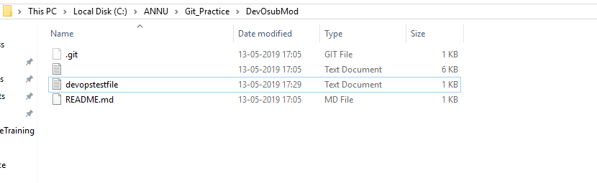

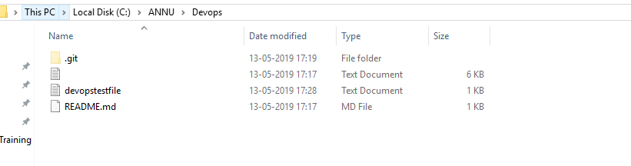

1. Creating a text file in **Devops** repository with name **devopstestfile** and add some text.

$ git clone “url .”

$ git add .

$ git commit -m “Adding file”

$ git push

1. Update the changes whatever we did in devops, it will reflect in developer

git submodule update --recursive –init

git submodule foreach git pull origin master

**GitBash command in Developer**

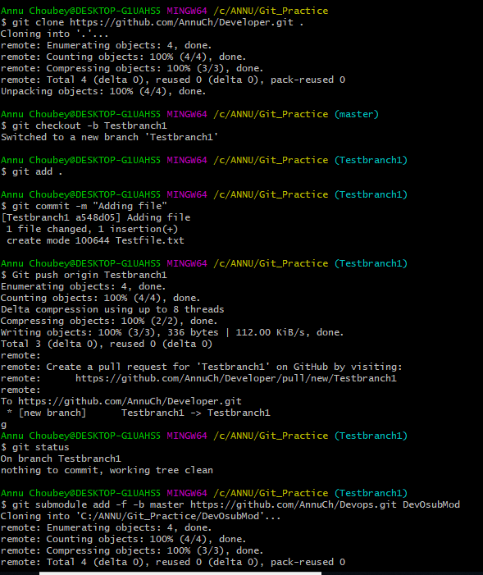

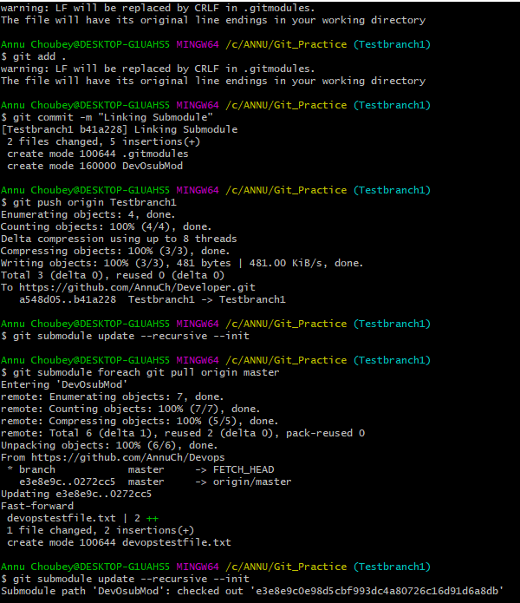

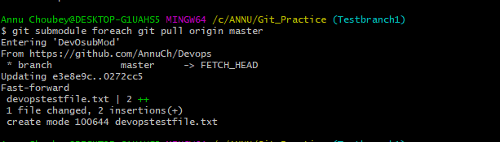

**GitBash command in DevOps**

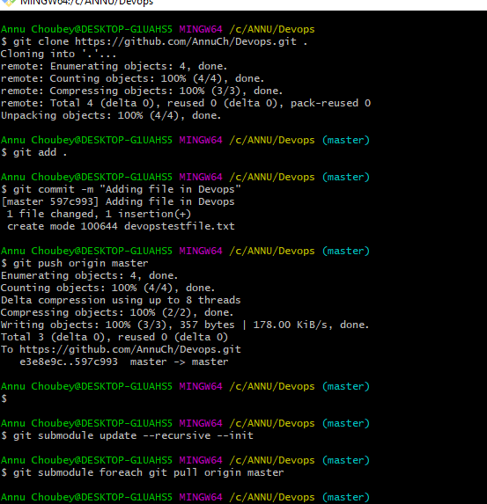

**Getting Updated Changes**

