**Created Storage Account, Blob, Container, Uploading and Downloading Images**

1. **Login to Azure Portal**

Login-AzureRmAccount

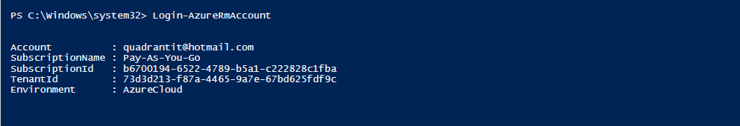

1. **Created Resource Group with name AnnuRG**

New-AzureRmResourcegroup -Name AnnuRG -Location “East US”

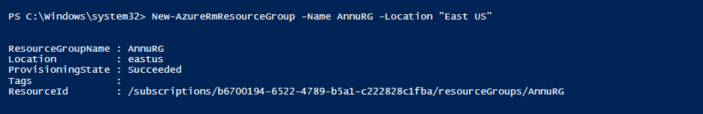

1. **Created Azure Storage Account**

New-AzureRmStorageAccount -ResourceGroupName AnnuRG

-Name annustoracc -SkuName Standard_LRS -Location "EastUS” -AccessTier Hot -Kind BlobStorage

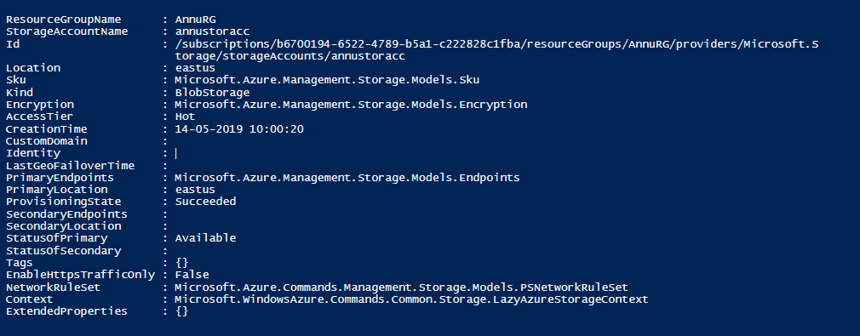

**4.Created StorageContainer with name “annucontainer”**

$ctx=$storageAcc.Context

New-AzureStorageContainer -Name ”annucontainer” -Context $ctx -Permission Off

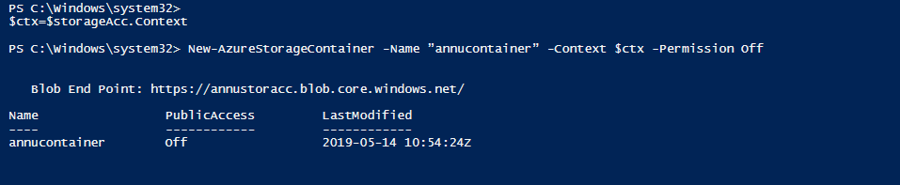

**5.Upload blob with Image file into the container.**

Set-AzureStorageBlobContent -Container ”annucontainer”

-File "C:\Users\Annu Choubey\Downloads\2019-04-27-17-27-26-267.jpg" -Context $ctx

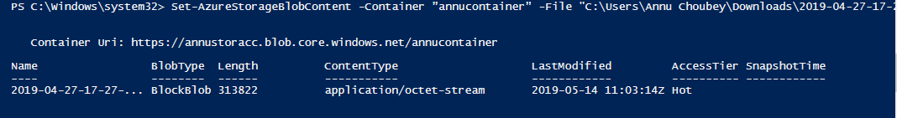

Image uploaded in Portal

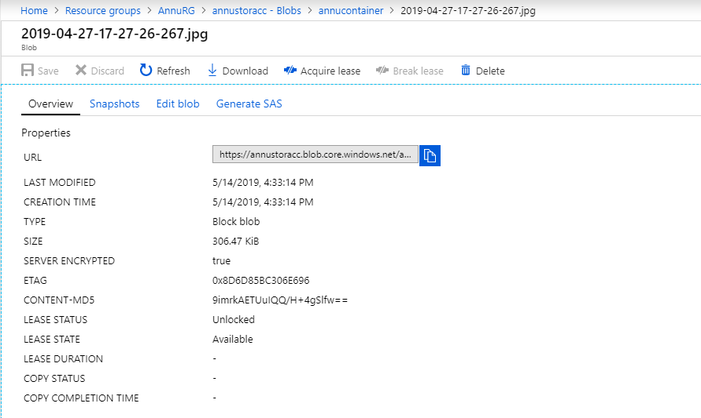

**6. Download the Blob from the Container**

We are downloading Blob from the container and storing it in a specific path.  
  
Hence, first we will get reference to a list of blobs in a container by using the below script.  
  
$blobs = Get-AzureStorageBlob -Container ”annucontainer” -Context $ctx

Create the destination Directory,

New-Item -Path ”C:\ANNU\Azure Offshore Training”

-Name Image -ItemType Directory -Force

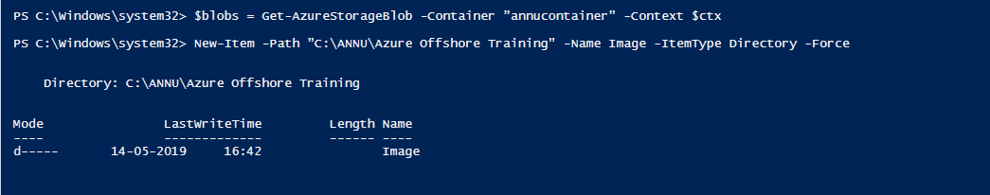

 We can see we have created the local directory.  
  
Finally, here we are downloading the blob into the local destination directory.

