Assignment 2: Create 3 virtual networks Vnet1, Vnet2 and Vnet3. Assign IP 10.0.0.0/24, 10.0.1.0/24 and 10.0.2.0/24. Create 2 subnets for each – FrontEnd Subnet(16) and BackEnd Subnet(16) and Gateway Subnet(16). Create a VPN gateway between Vnet1 and Vnet2. Create a VPN peering between Vnet2 and Vnet3. Set Vnet2 as Hub and Vnet3 as spoke. Setup VPN connection.

Note: VPN gateway is used for a connection between cloud and on-premise. Since we do not have an on-premise setup, we have used Vnets.

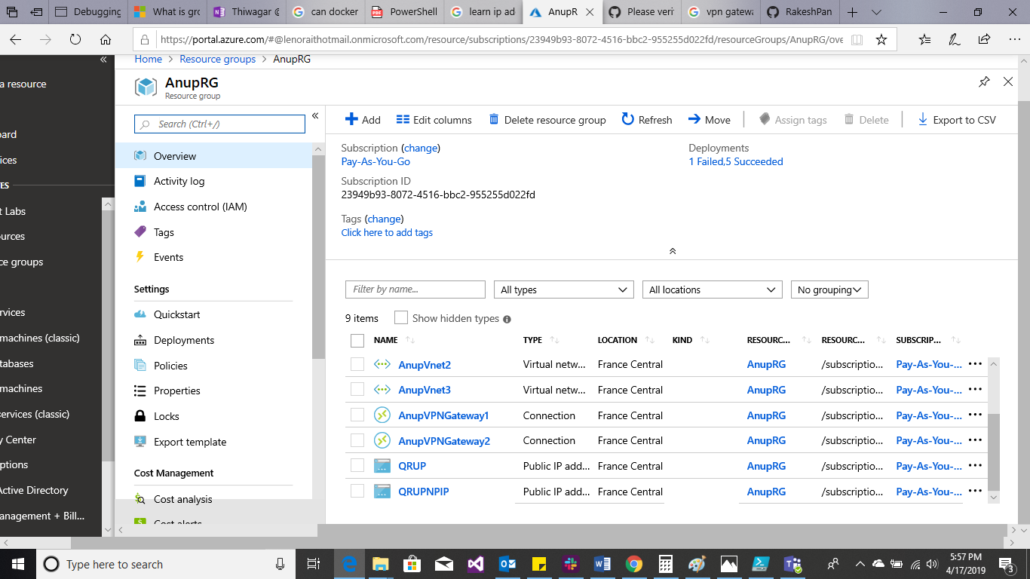

All the resources in a resource group.

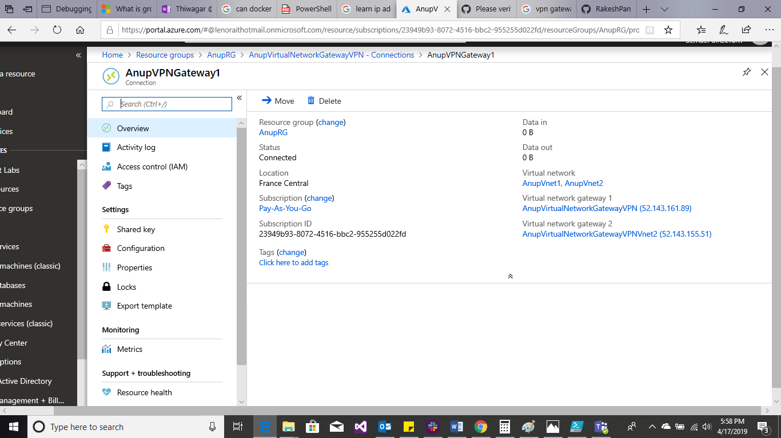

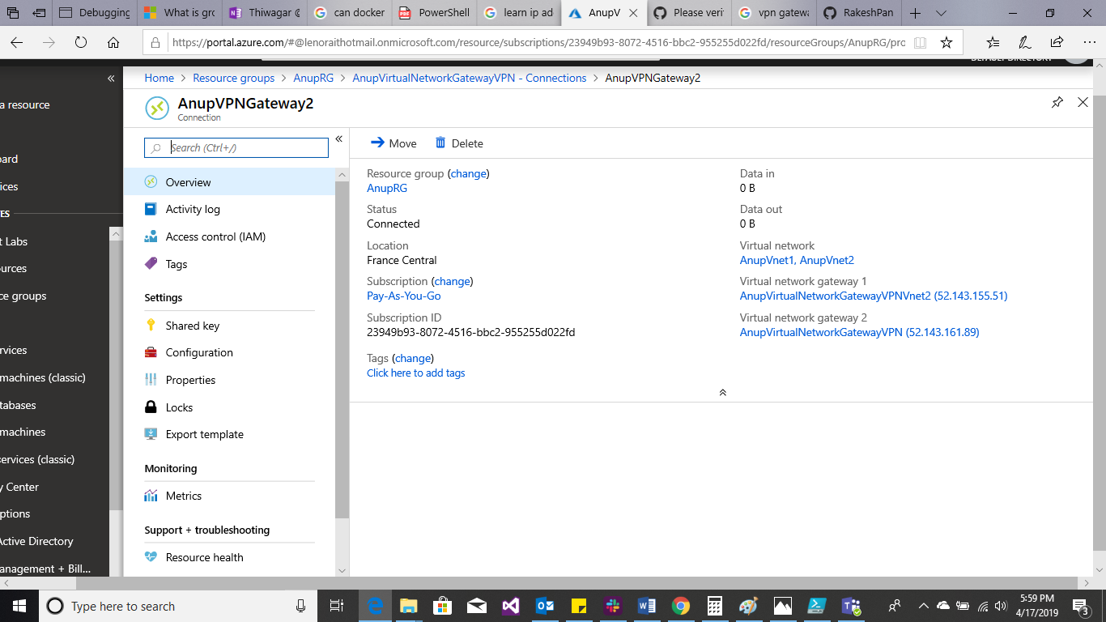

VPN Gateway connection between virtual network Vnet1 and Vnet2.

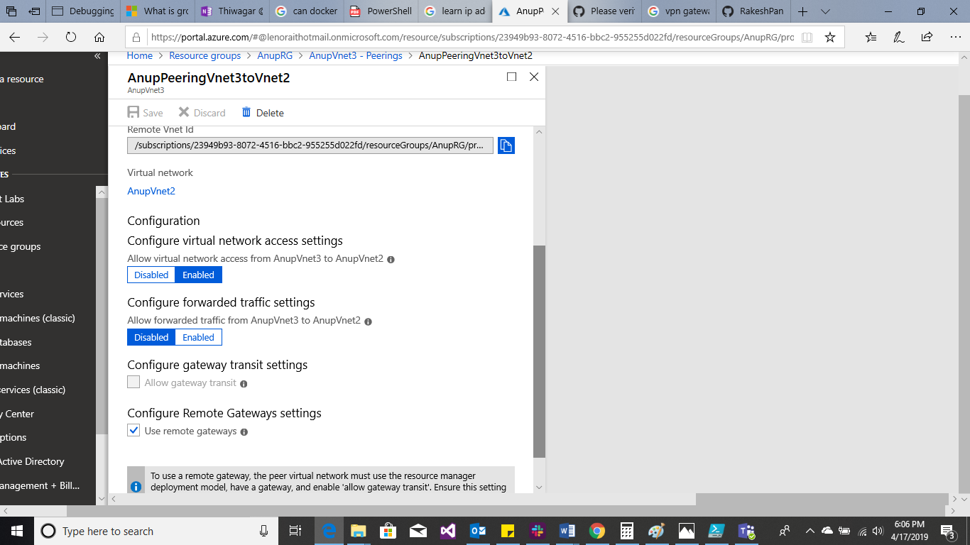

Peering connection between Vnet2 and Vnet3.

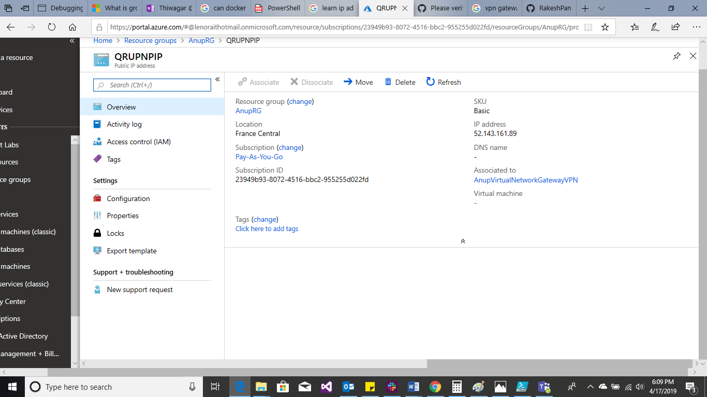

Public IP “QRUPNPIP”.