**TASK-1**

1.Created a Resource Group with Name **AnnuRG.**

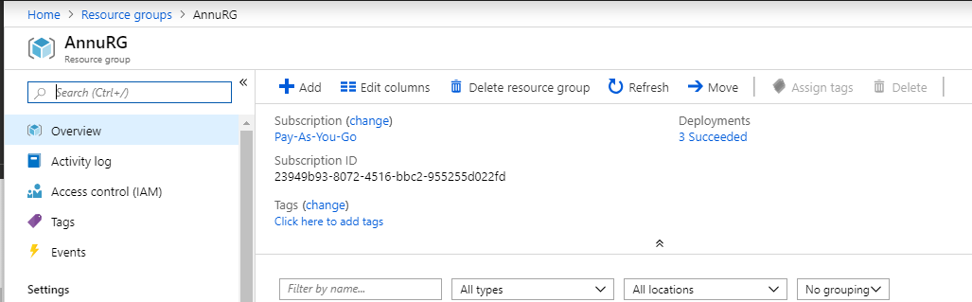

2.Added two network Security Group with name **FrontendNSG** and **BackendNSG** in **AnnuRG** resource group

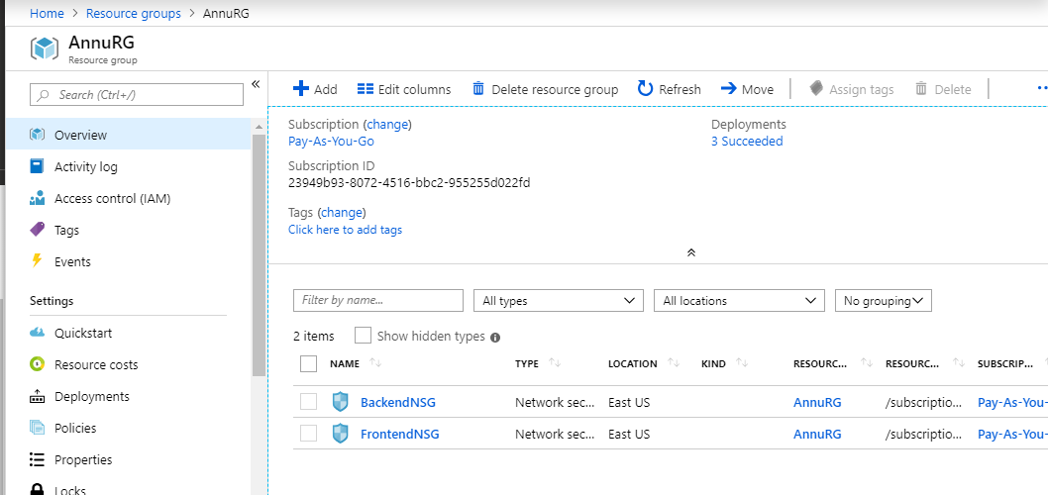

3.In **FrontendNSG** Network Security Group adding **Inbound Security rules.**

4.Adding RDP

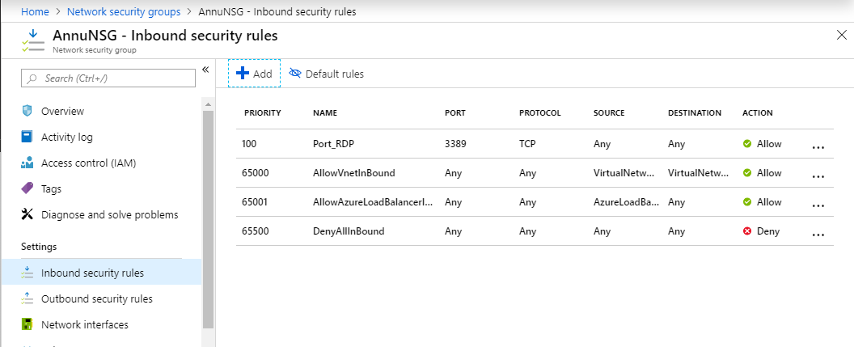

5. Adding HTTP

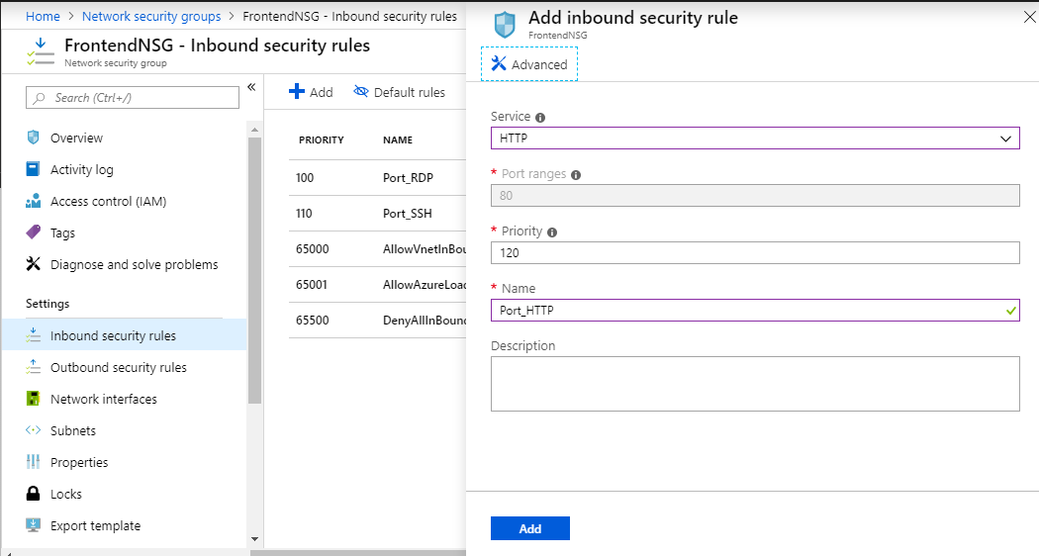

6. Adding MSSQL

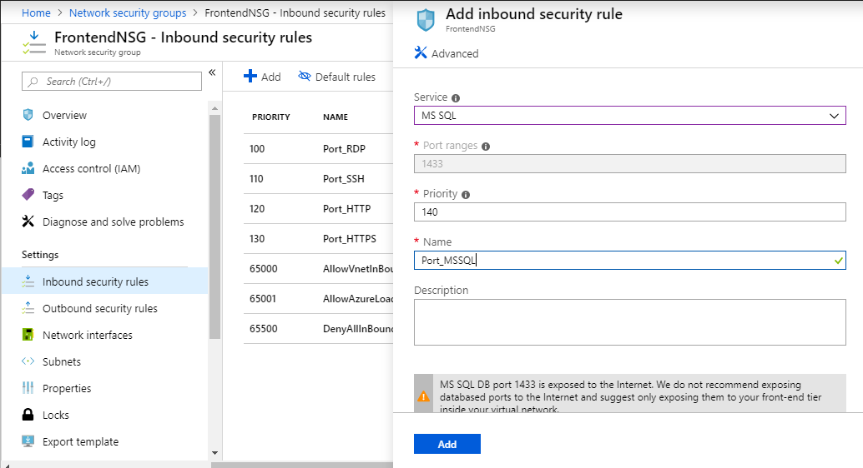

7. Adding HTTPS

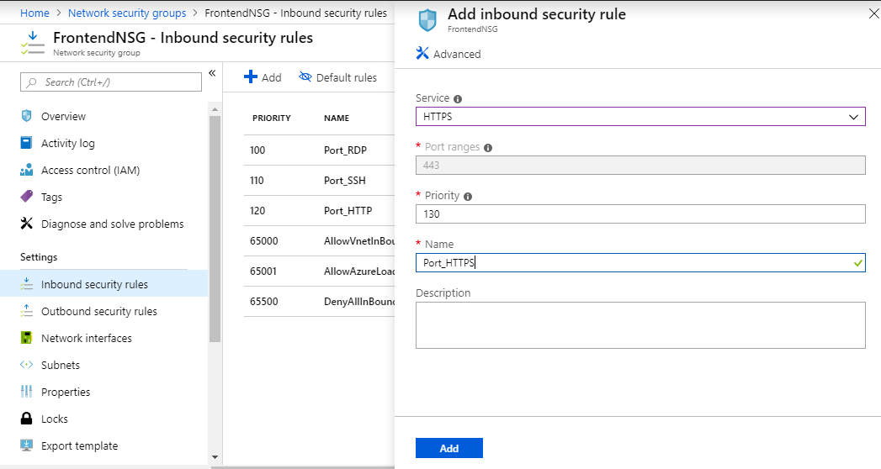

8.Adding SSH

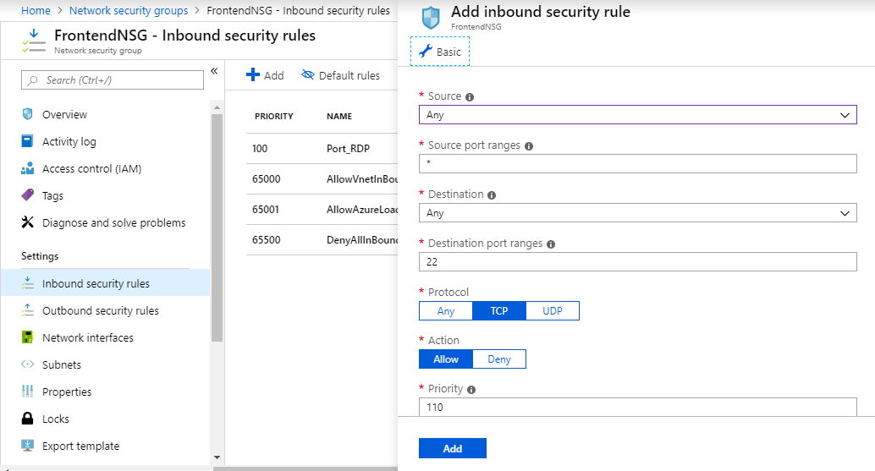

9.FrontendNSG-Inbound security rules

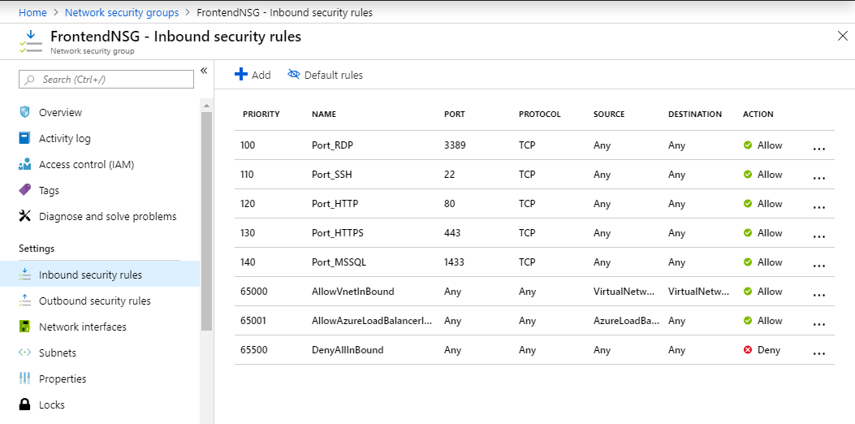

11. In **BackendNSG** Network Security Group adding **Outbound Security rules.**

12.Adding MSSQL

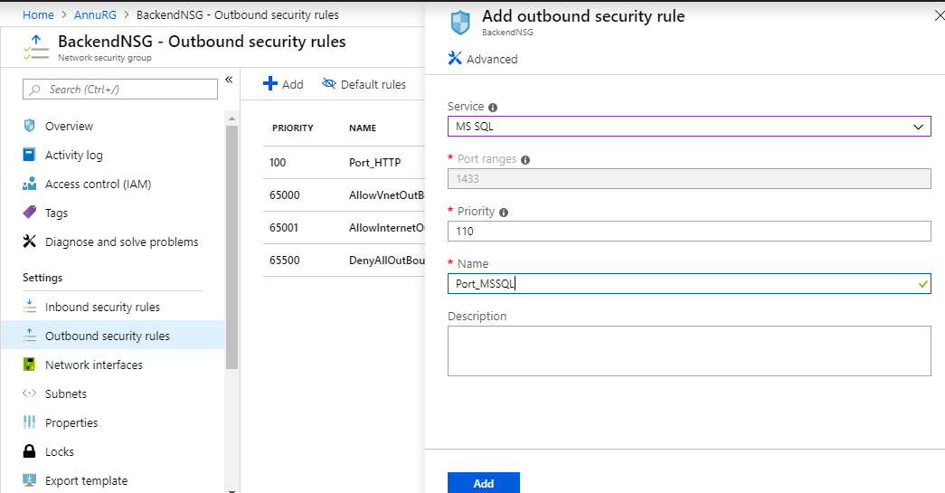

13.Adding HTTP

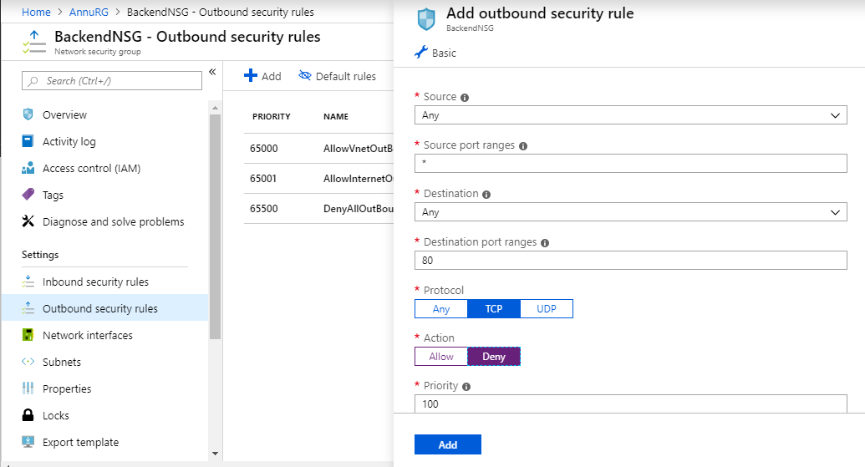

14.BackendNSG-Outbound security rules

