Creating a Resource Group

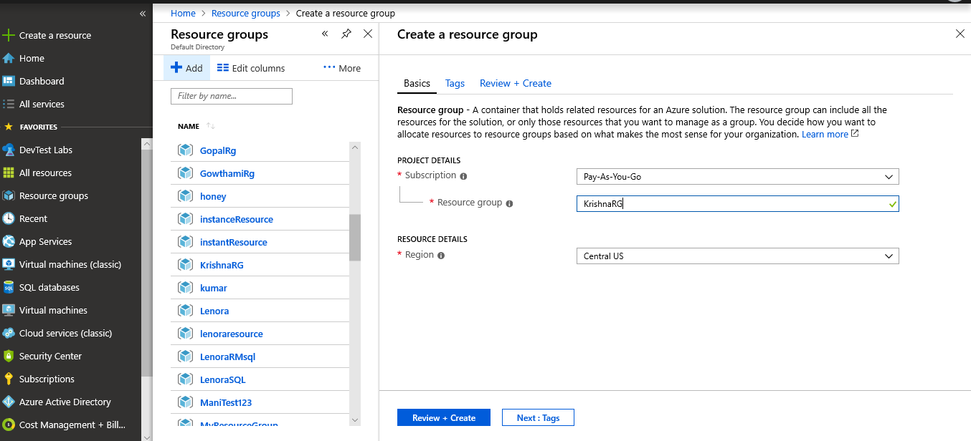

Creating VNet

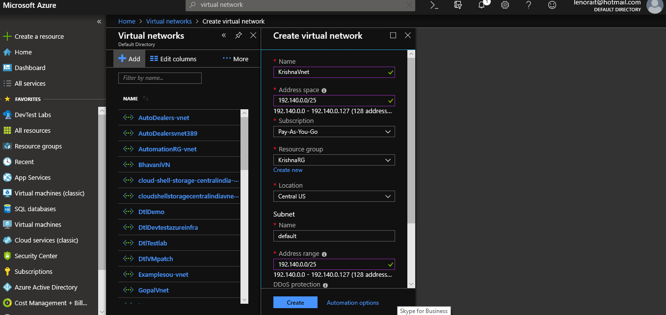

Creating Network Security Group(FrontEnd)

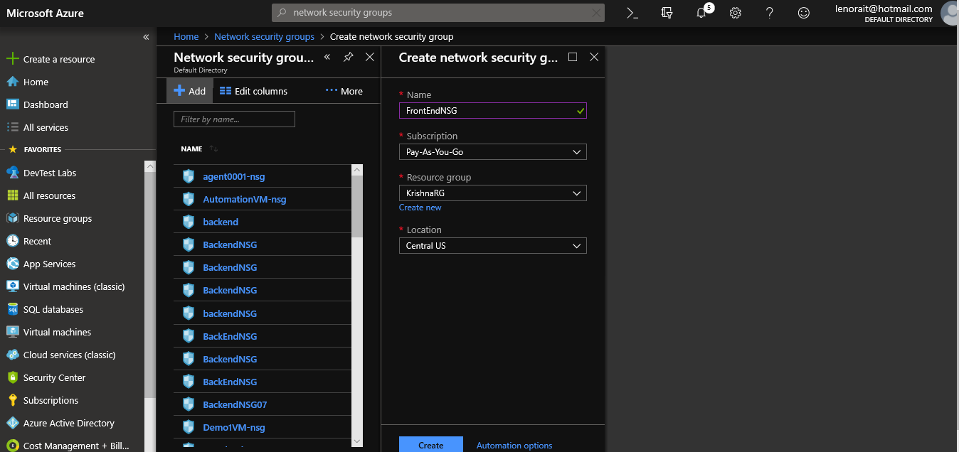

Creating Network Security Group(BackEnd)

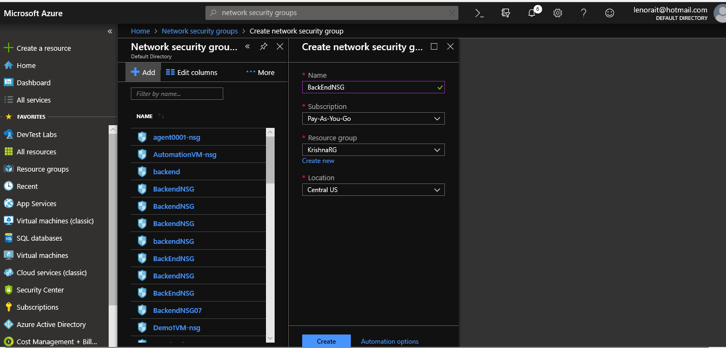

Creating Inbound Security Rules for FrontEndNSG(HTTPS)

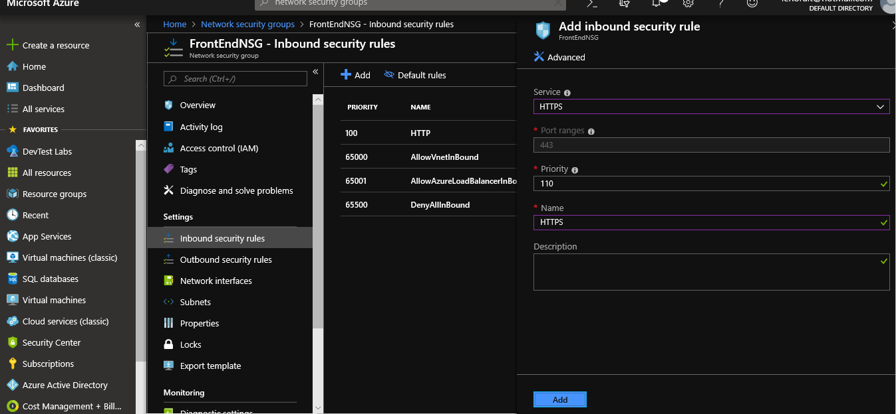

Creating Inbound Security Rules for FrontEndNSG (SSH)

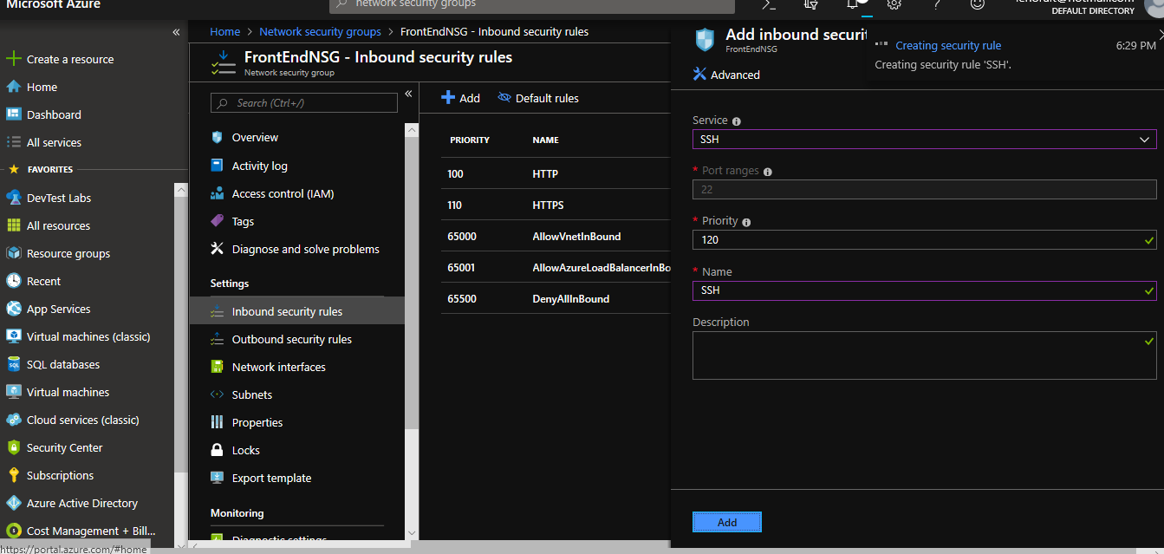

Creating Inbound Security Rules for FrontEndNSG (RDP)

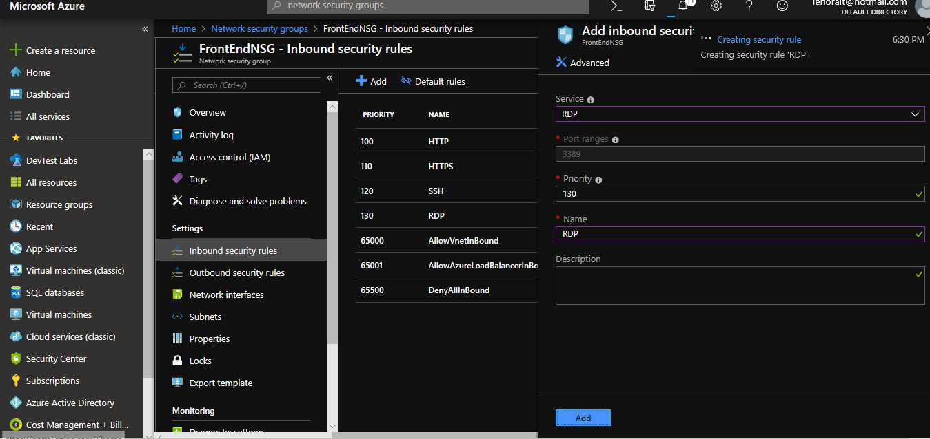

Creating Outbound Rules for BackEndNSG(HTTP)

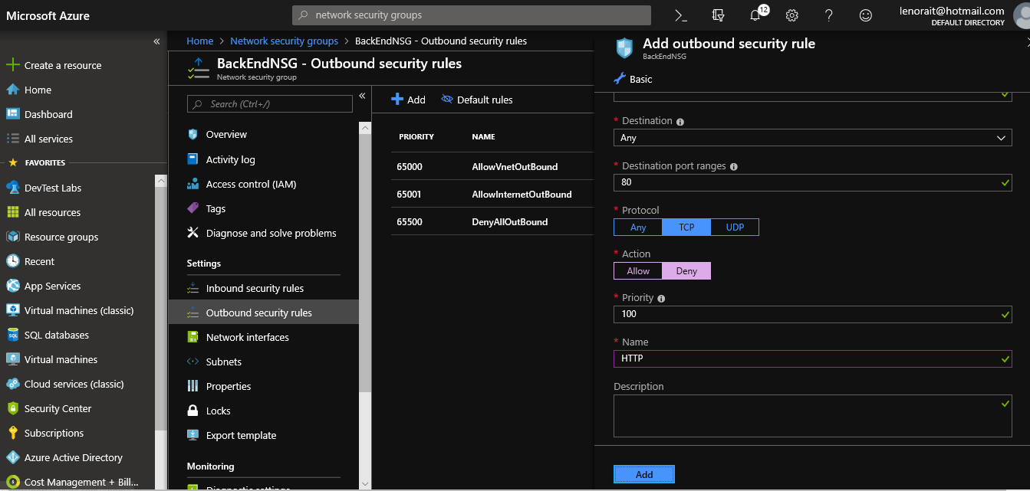

Creating Outbound Rules for BackEndNSG(HTTP)

