**VNet**

Inorder to create a VNet we need to choose a resource group to store all the resources under that Vnet. Below is the screen shot for creating Resorce Group in Azure portal.

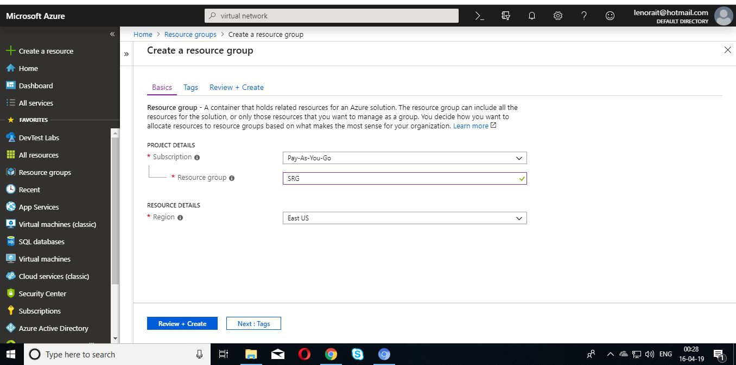

VNet Creation through Azure portal.

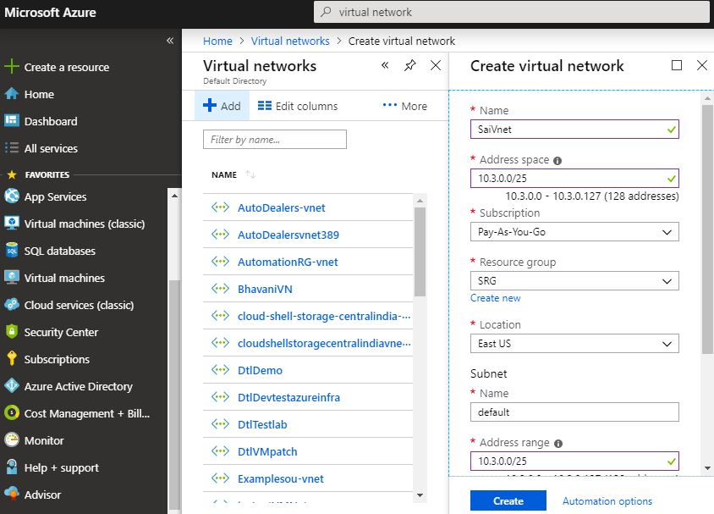

Adding FrontEndSubnet to the Vnet.

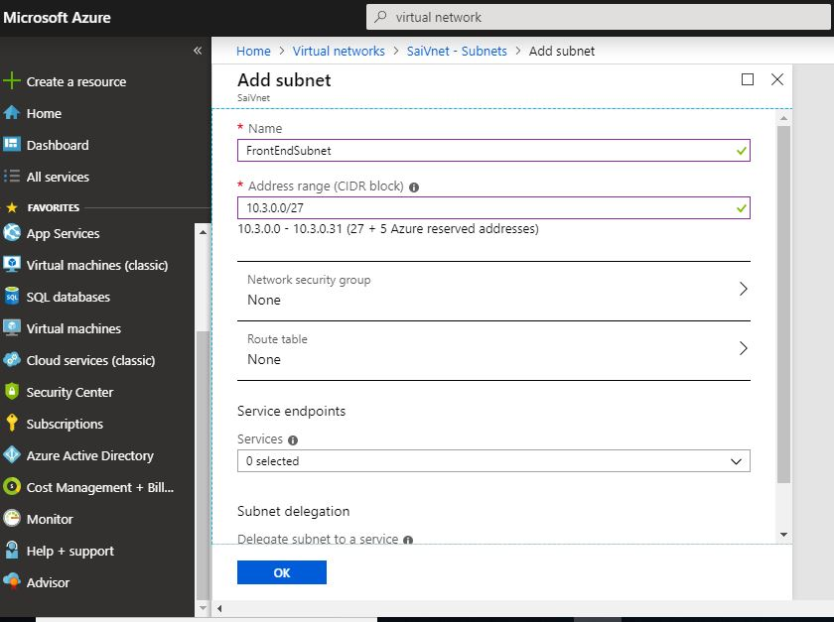

Adding FrontEndSubnet to the Vnet.

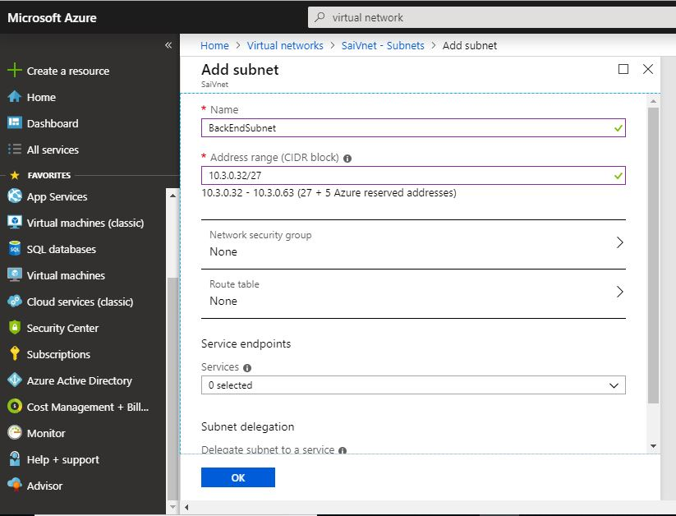

Creating a FrontEndNSG in Network Security Group

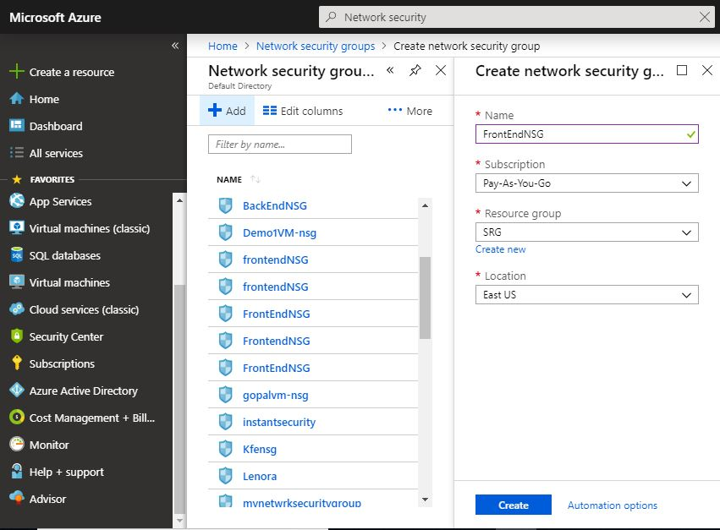

Adding Inbound security rules to FrontEndNSG

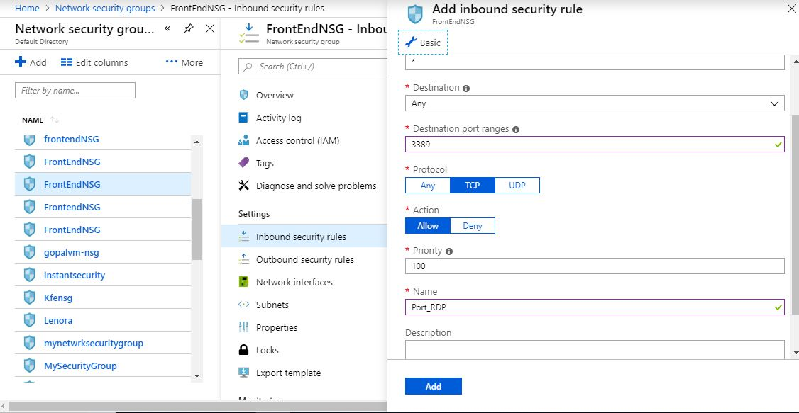

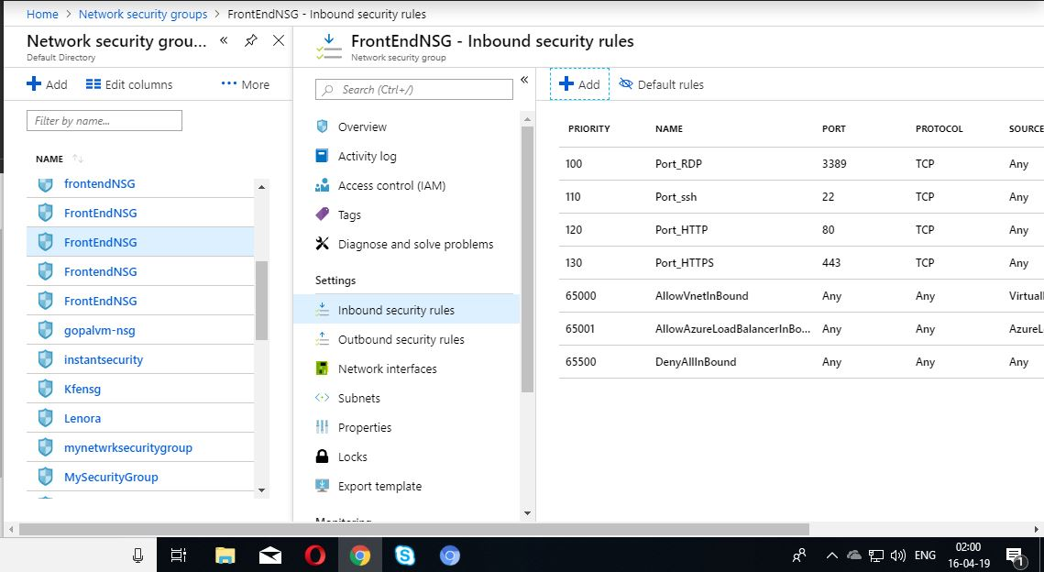

Creating a BackEndNSG in Network Security Group

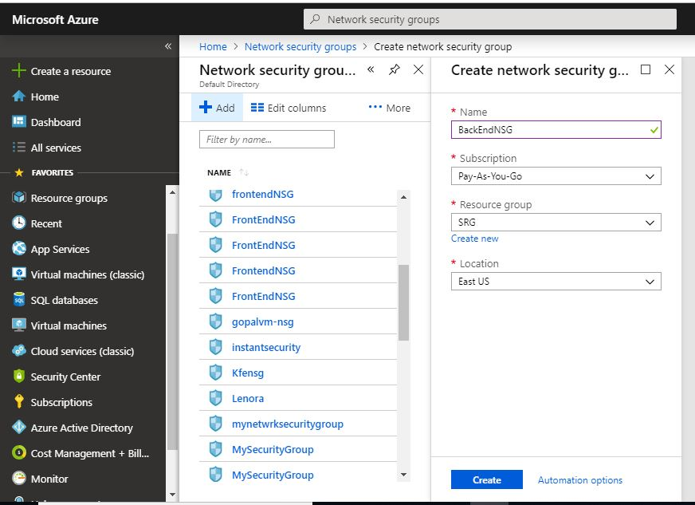

Adding Inbound security rules to BackEndNSG

