1.Created Resource Group RakeshRG

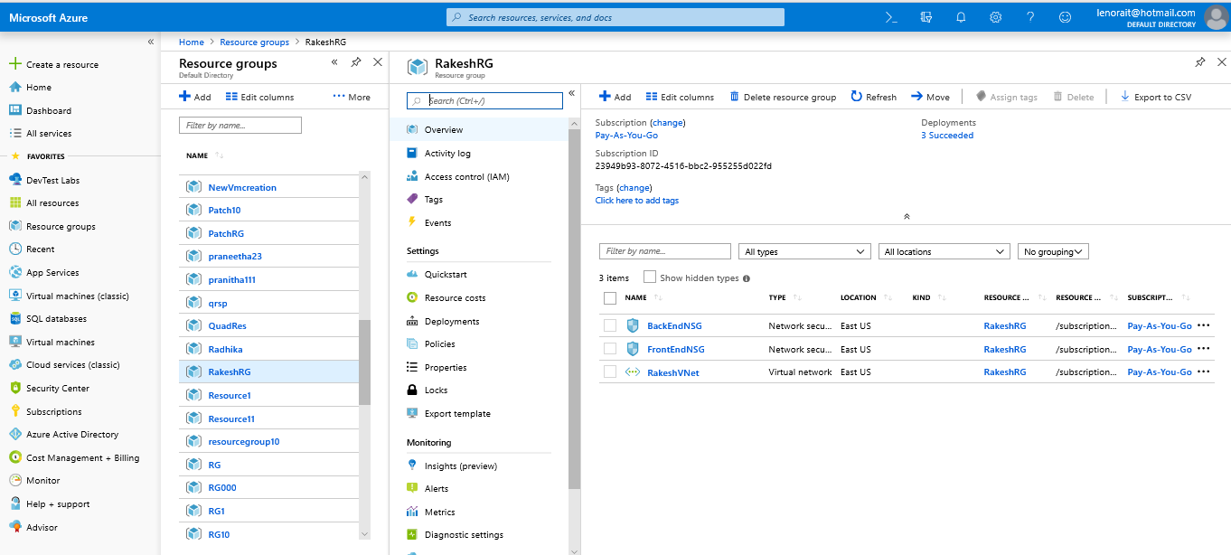

2.Created Vnet named RakeshVNet

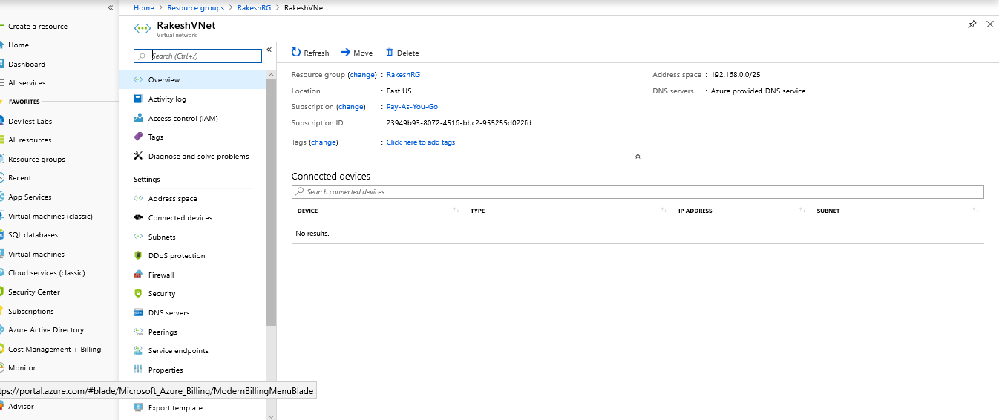

3.Created subnet named FrontEndSubnet

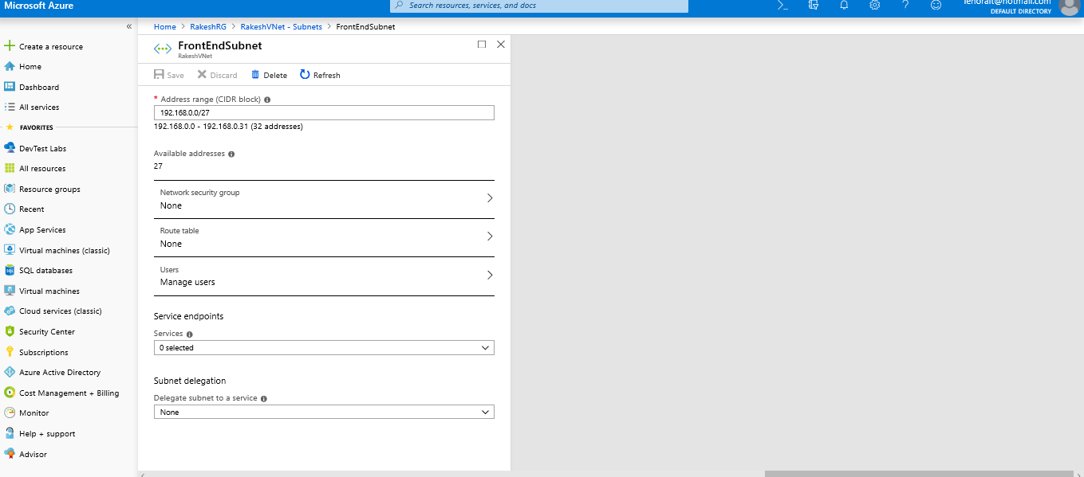

4. Created another subnet named BackEndSubnet

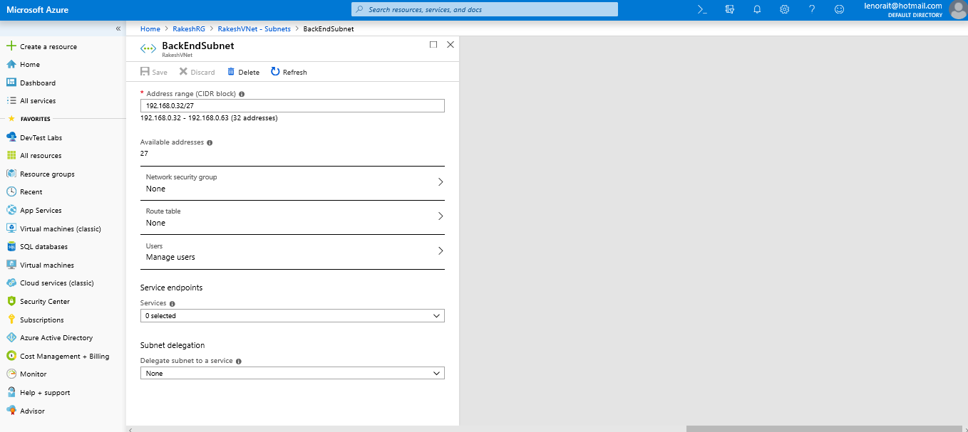

5.Created NSG named FrontEndNSG

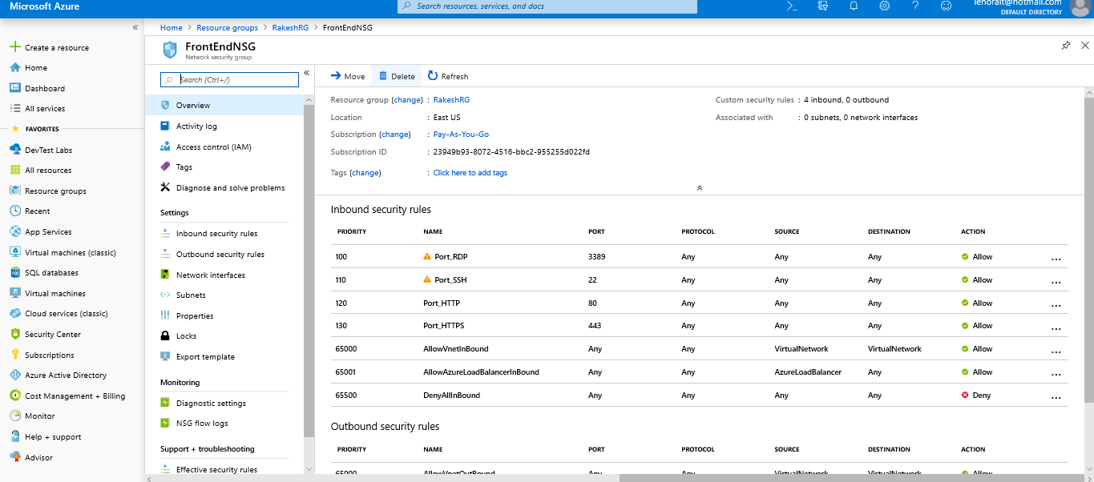

6.Created NSG named BackEndNSG

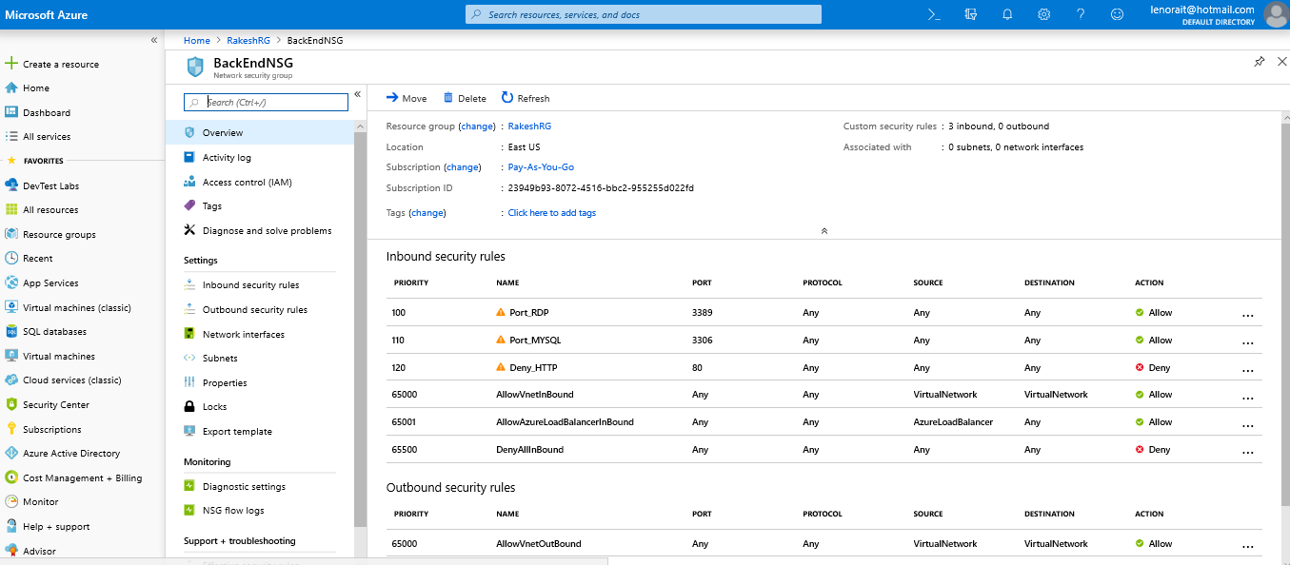

7.Created Inbound Security Rule to Allow RDP

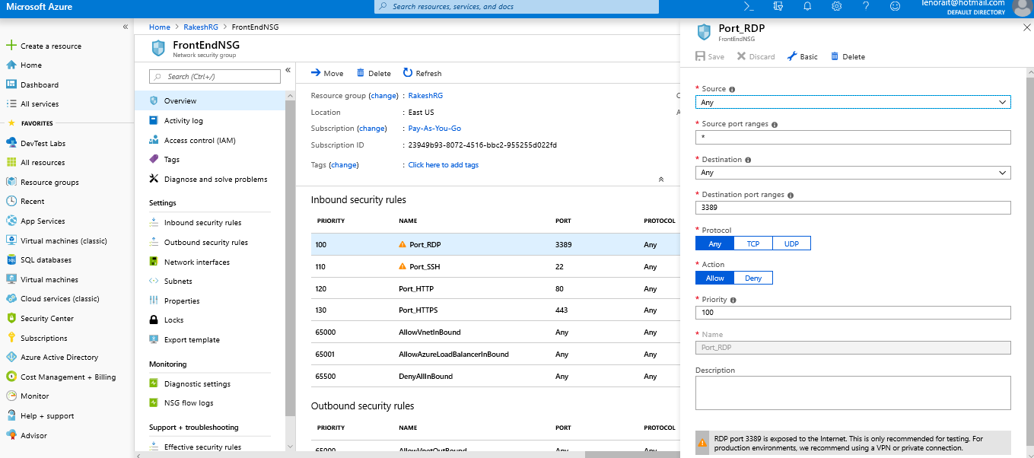

8.Created Inbound Security Rule to Allow SSH

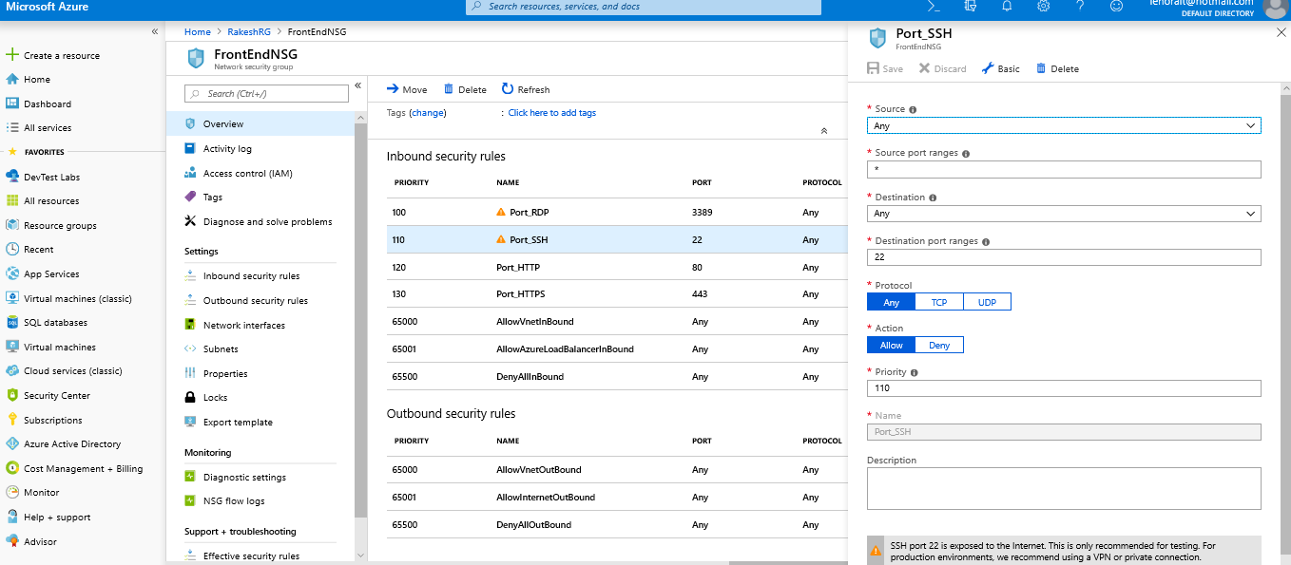

9.Created Inbound Security Rule to Allow HTTP

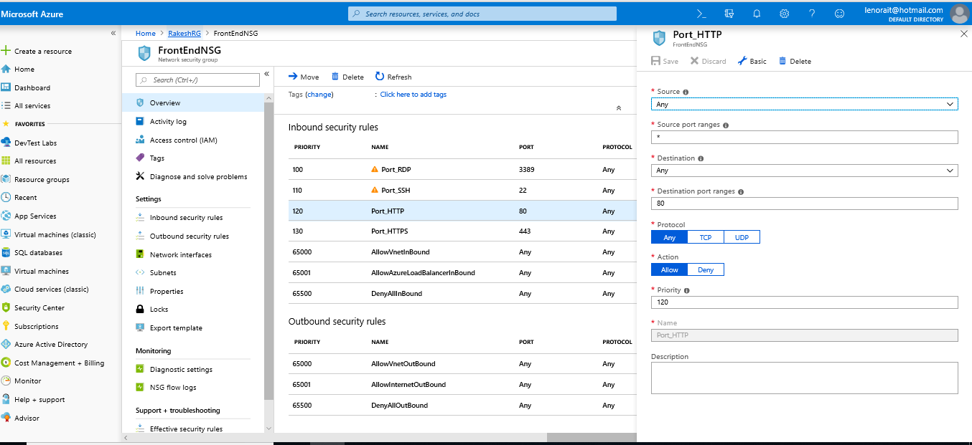

10.Created Inbound Security Rule to Allow HTTPS

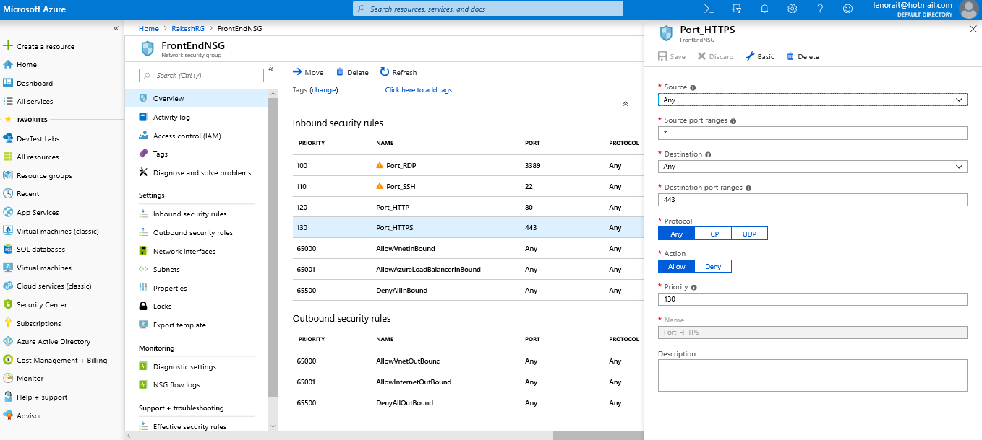

11.Created Inbound Security Rule to Allow MYSQL

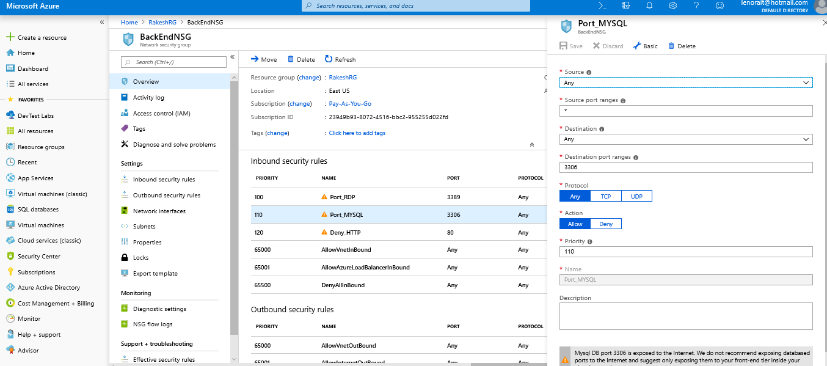

12.Created Inbound Security Rule to Deny HTTP

