* Created **Resource** **Group** with name **VaijayanthiRG**.

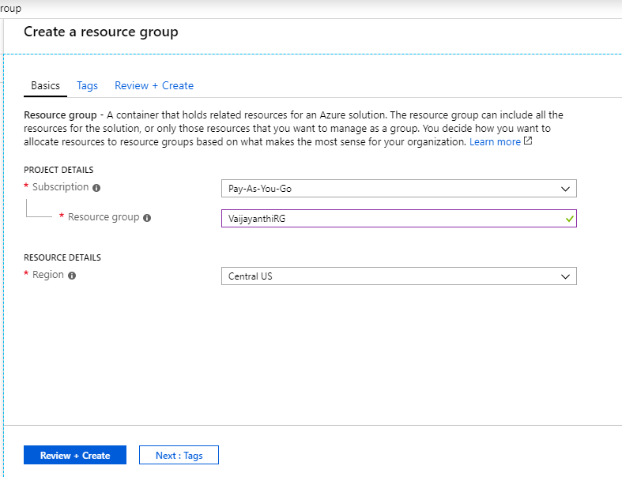

* Created **Vnet** with name **LenoraVnet**:

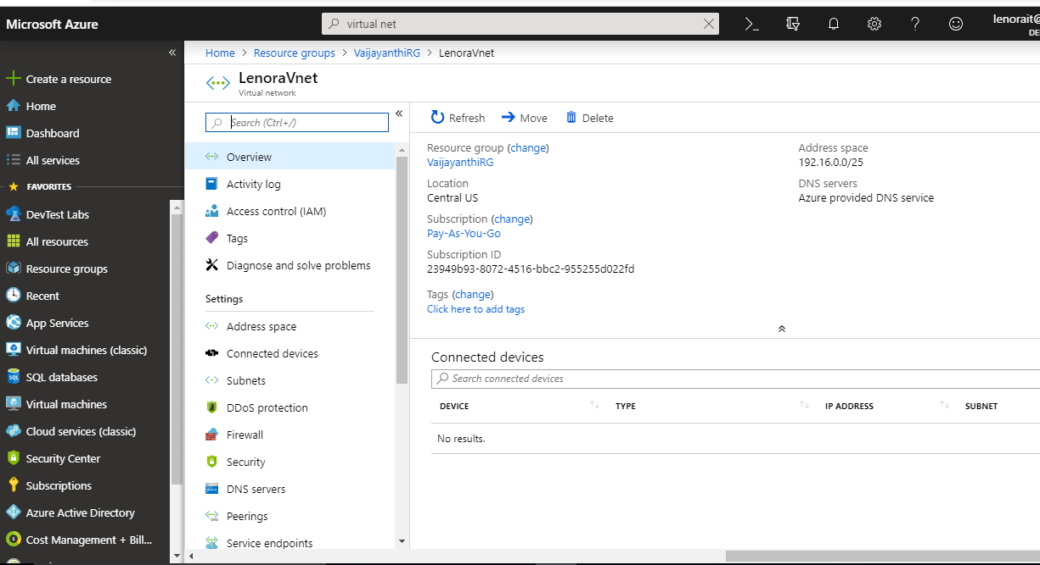

* Created **Subnet** with name “**frontendsubnet**” and “**backendsubnet**”.

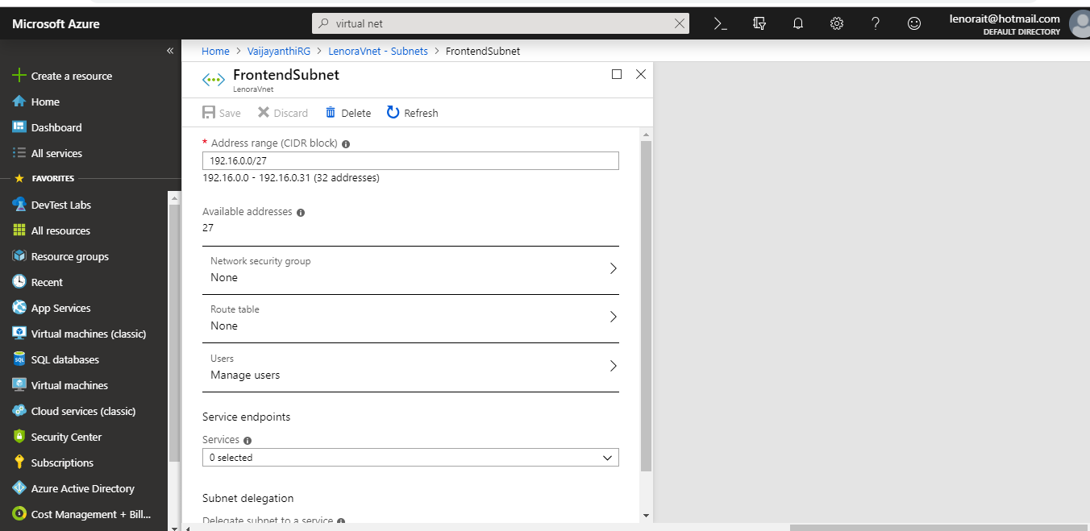

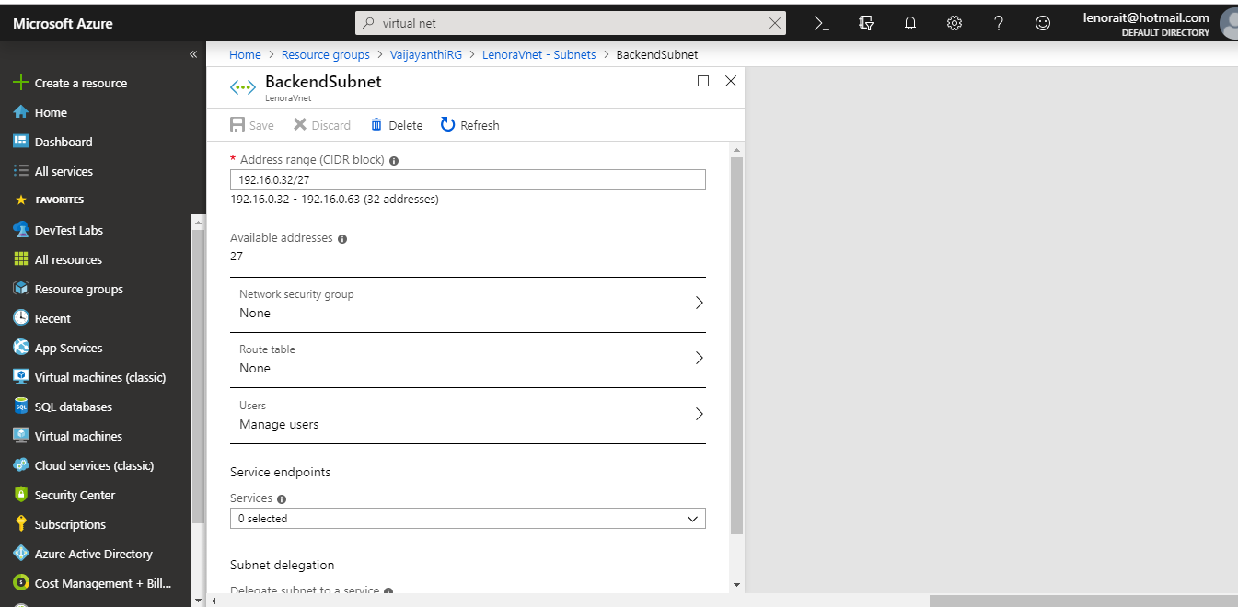

* Created Inbound Security Rules for Frontend:

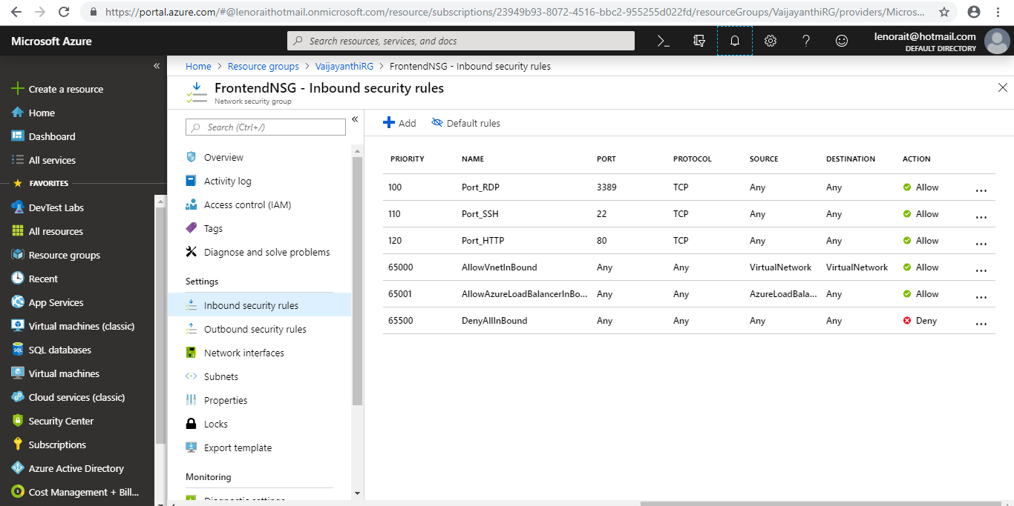

* Created Inbound Security Rules for Backend:

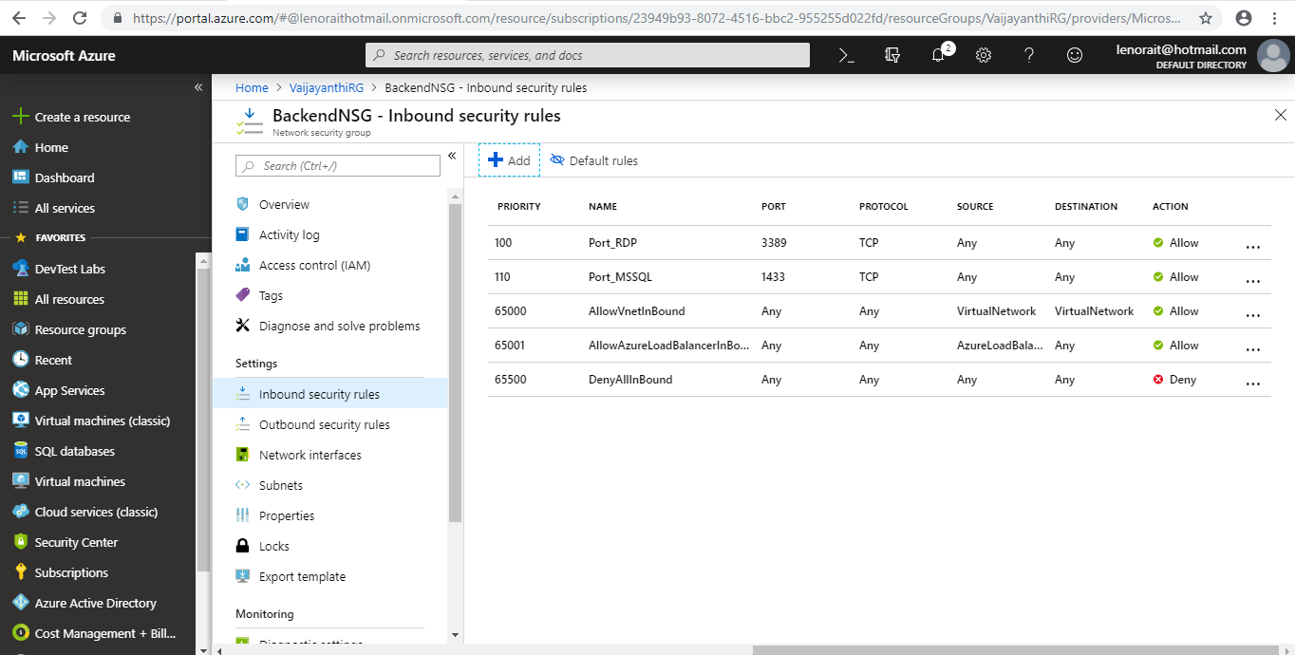

* Created Outbound Security Rules to Backend:

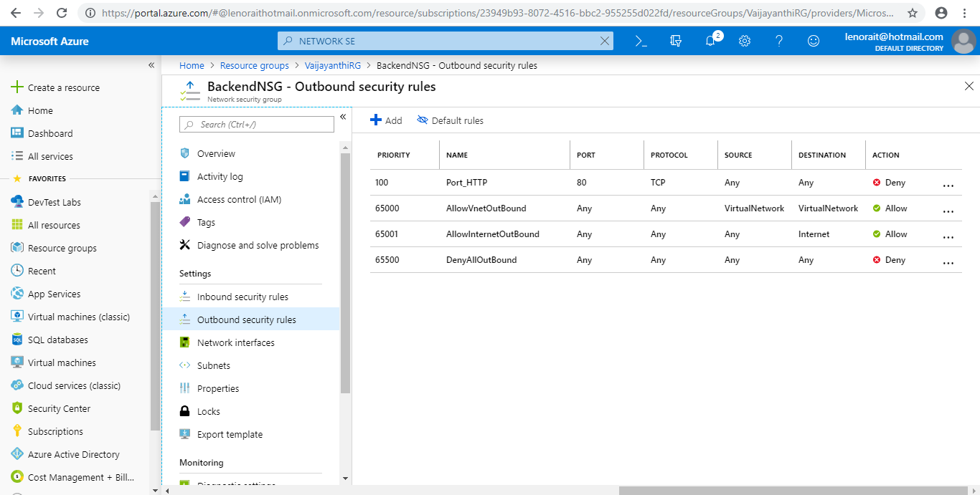

* Placed into Git using following commands:

