Task-2: Create 3 virtual networks Vnet1, Vnet2 and Vnet3. Assign IPs. Create 2 subnets for each – FrontEnd Subnet(16) and BackEnd Subnet(16) and Gateway Subnet(16). Create a VPN gateway between Vnet1 and Vnet2. Create a VPN peering between Vnet2 and Vnet3. Set Vnet2 as Hub and Vnet3 as spoke. Setup VPN connection.

**Creating Vnet1:**

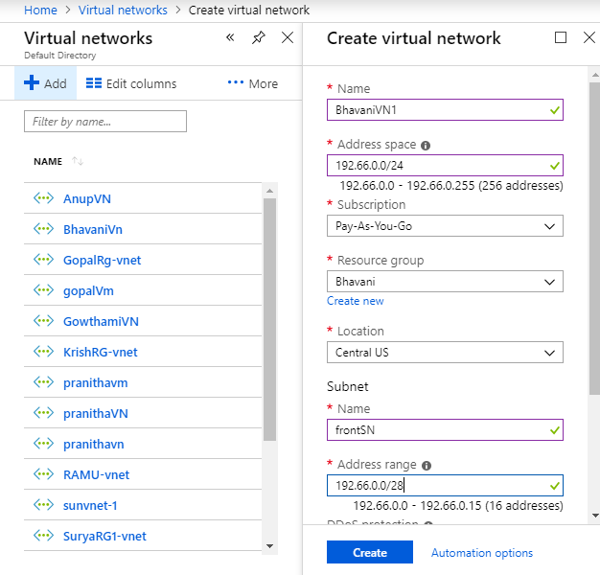

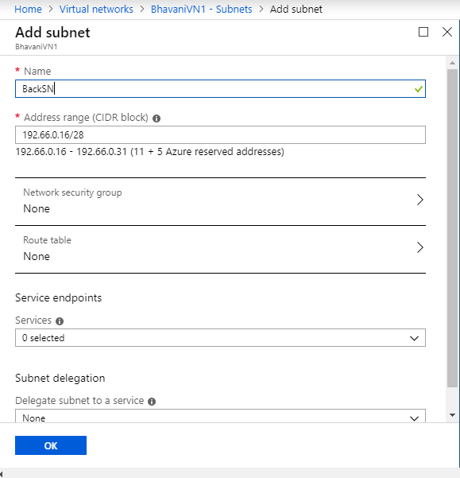

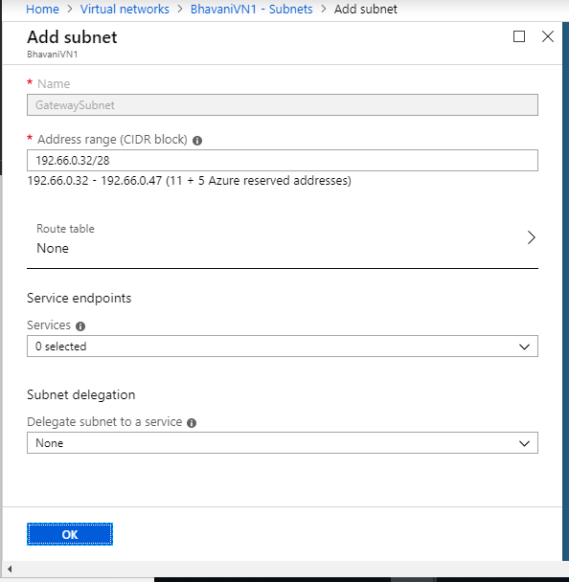

Front end subnet,Back end subnet and Gateway subnet for Vnet1:

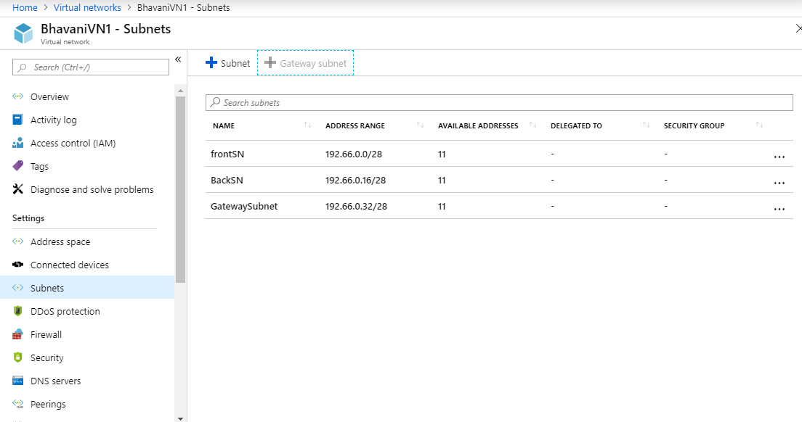

Creating Vnet2:

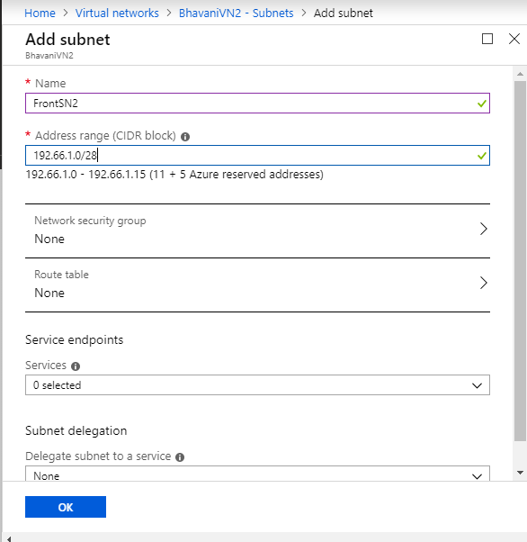

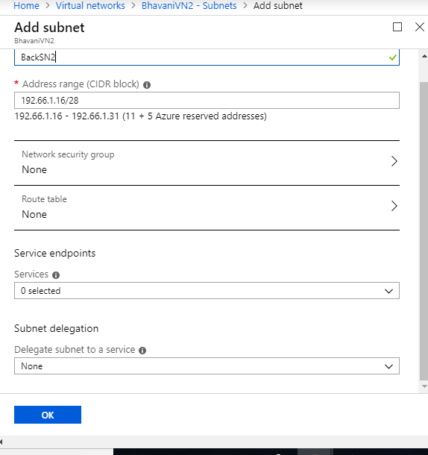

Frontend Subnet, Backend subnet,Gateway Subnet for Vnet3:

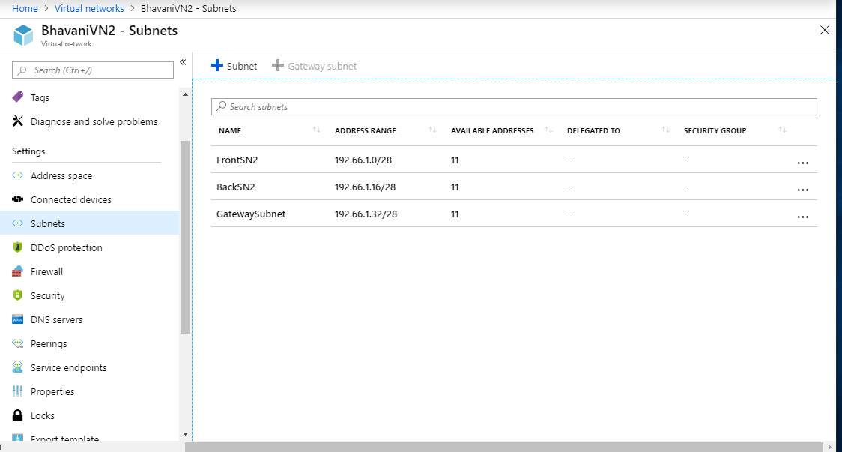

Creating Vnet3:

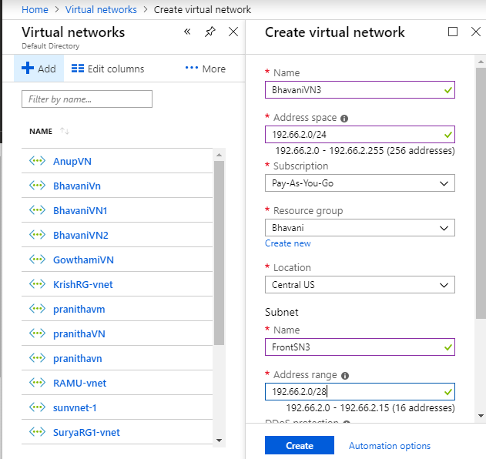

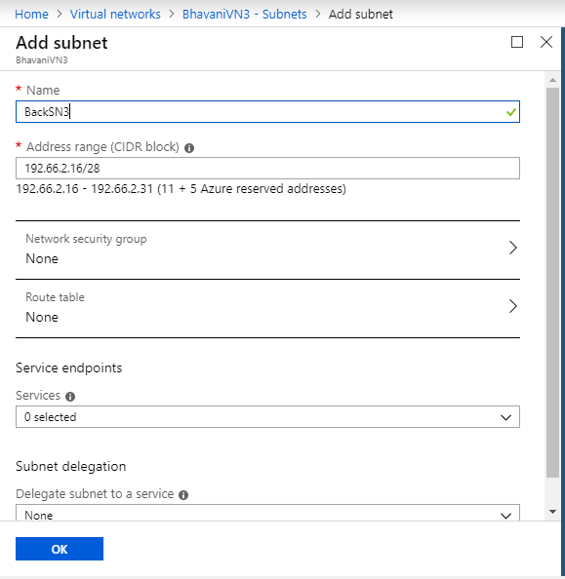

Front end subnet, Backend Subnet, Gateway subnet for Vnet3:

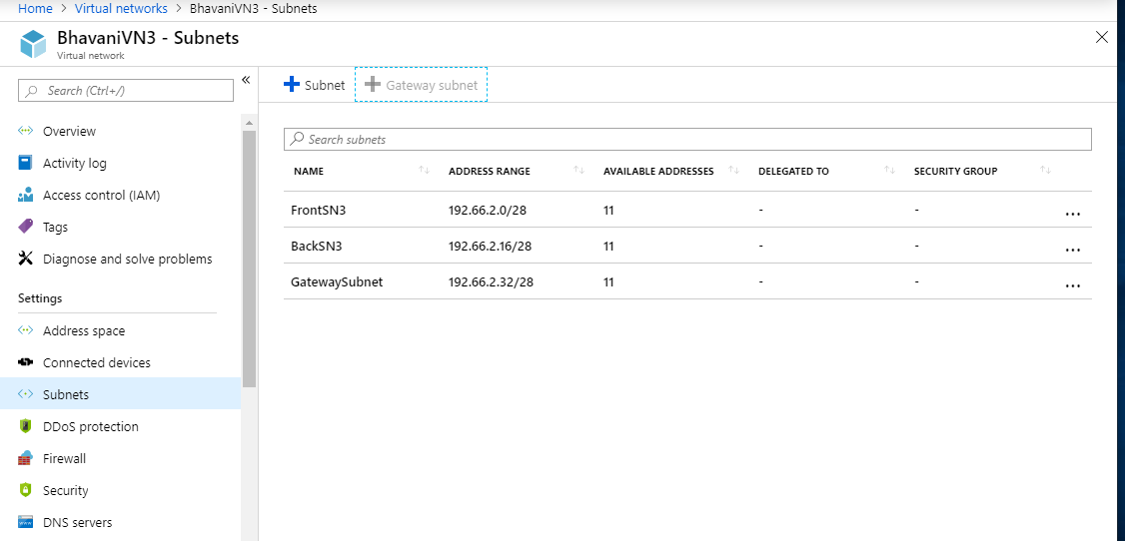

Creating VPN gateway1:

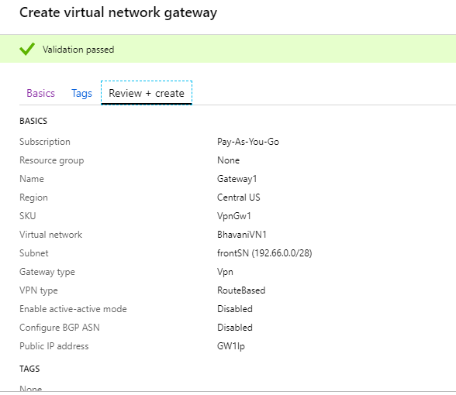

Creating VPN Gateway2:

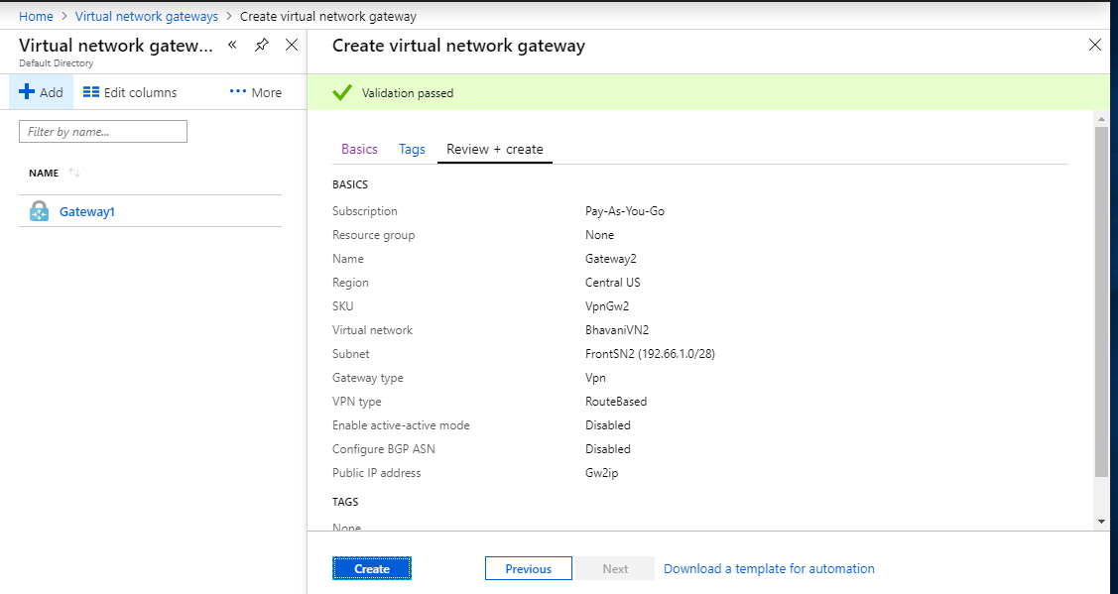

Connection Between Gateway1 and Gateway2:

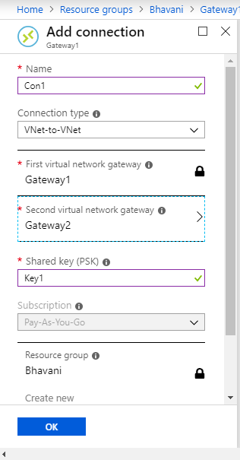

Connection Between Gateway2 and Gateway1:

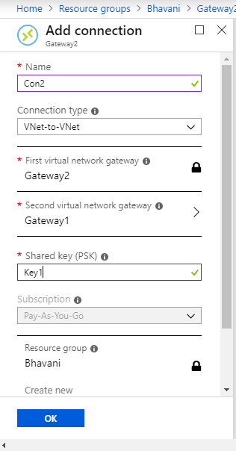

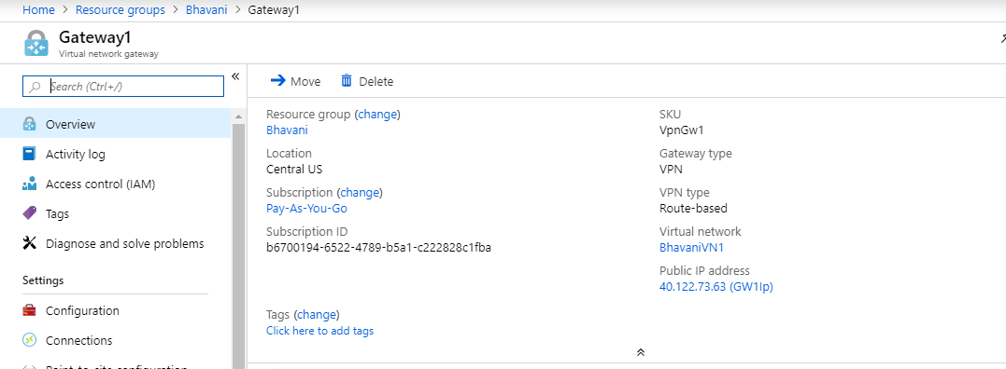

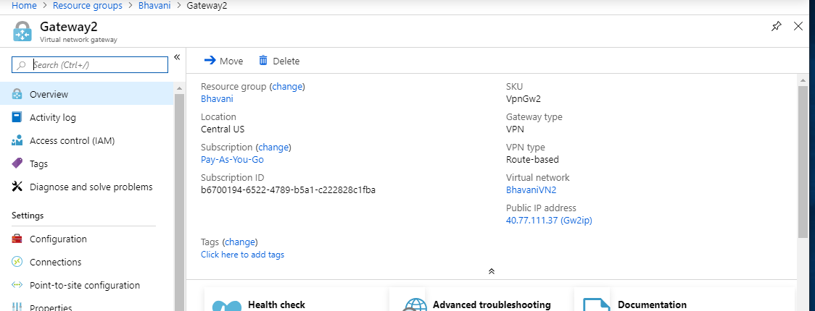

Peering Between Vnet2 and Vnet3 and make Vnet2 As HUB:

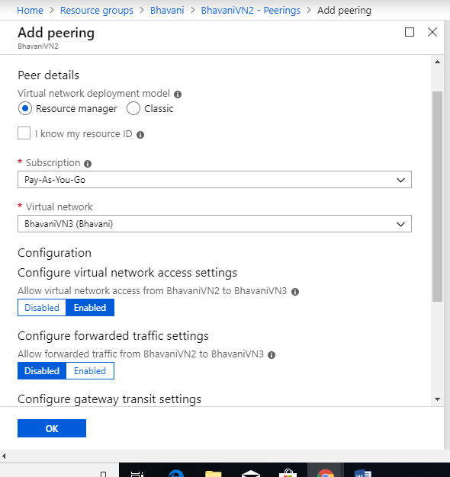

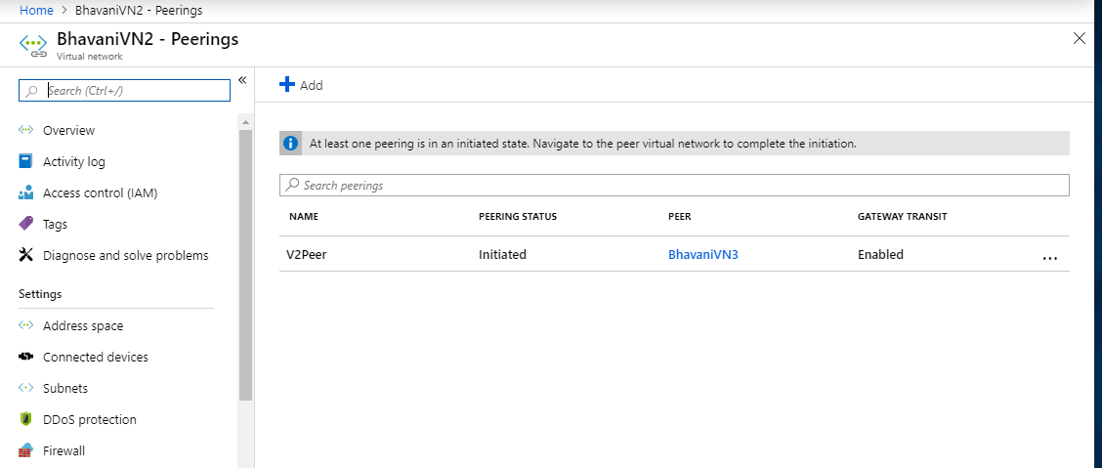

Peering between Vnet3 and Vnet2 and make VNet3 As Spoke:

