1. Creating Storage Account with name **annustoreacc**

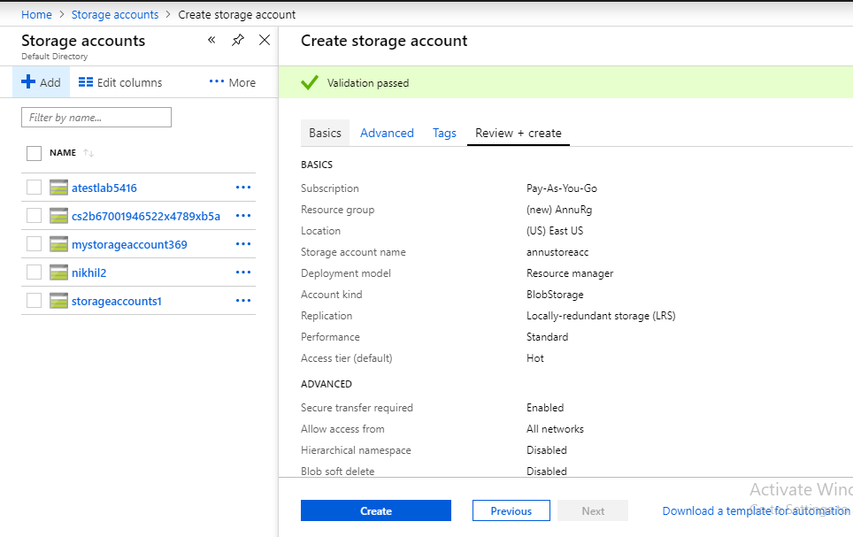

1. In storage Account(annustoreacc) select blobs

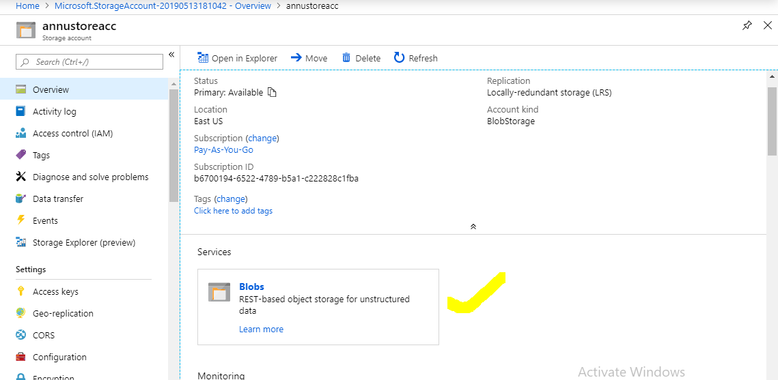

1. Inside blobs Created container with name **annucontainer**

