**Assignment3: Create V-net, Subnet, NSG and with help of this**

**1.How to Create VM**

1.Created Virtual network.(Resource Group🡪Created Virtual Network)

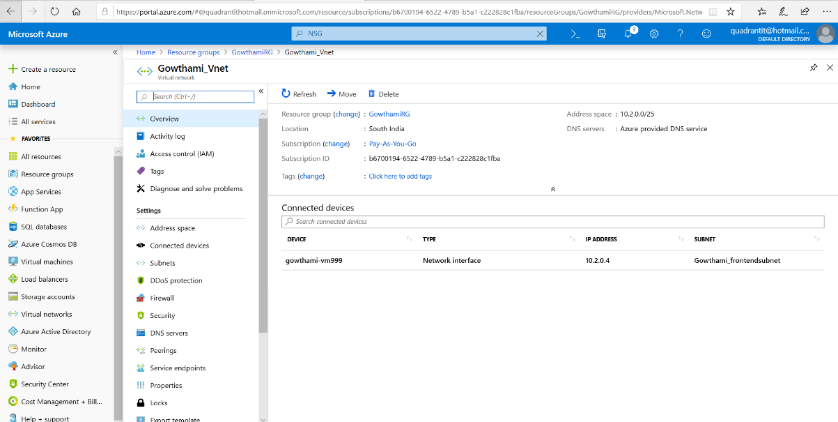

2.Added out-bound rules in NSG. (First Create Resource Group🡪Created Virtual Network🡪Created Network Security group in that added Virtual network and added outbound rules).

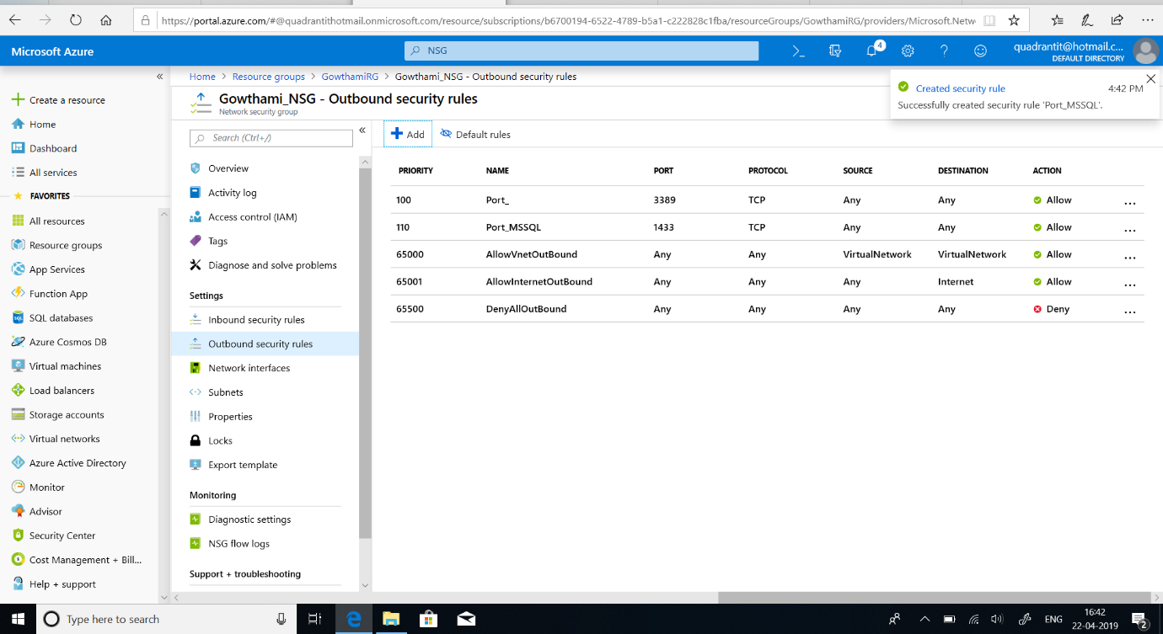

3.Steps to create Virtual Machine.(Created Virtual Network)

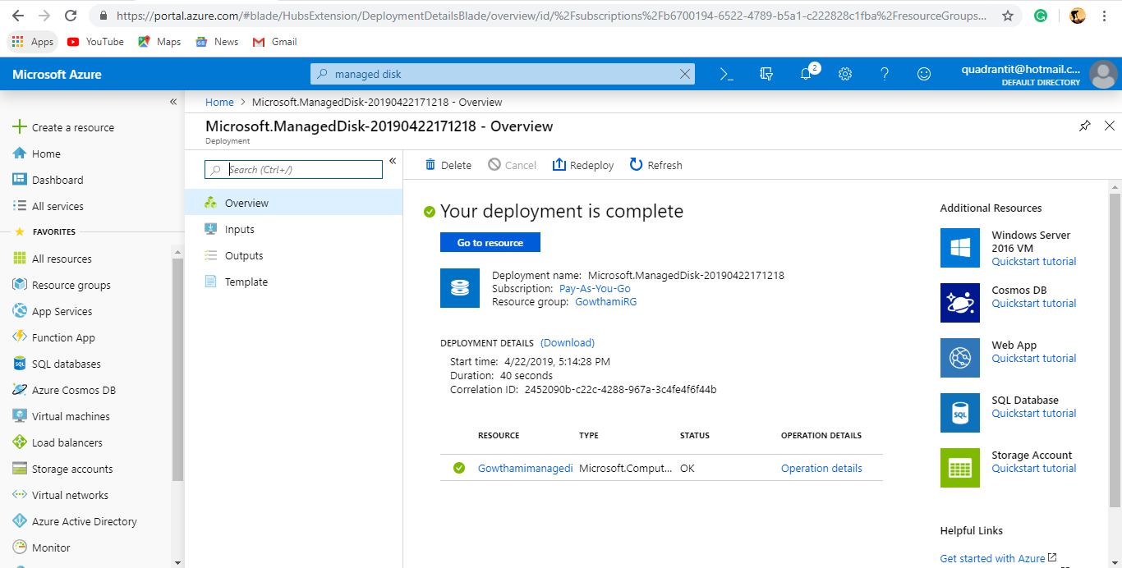

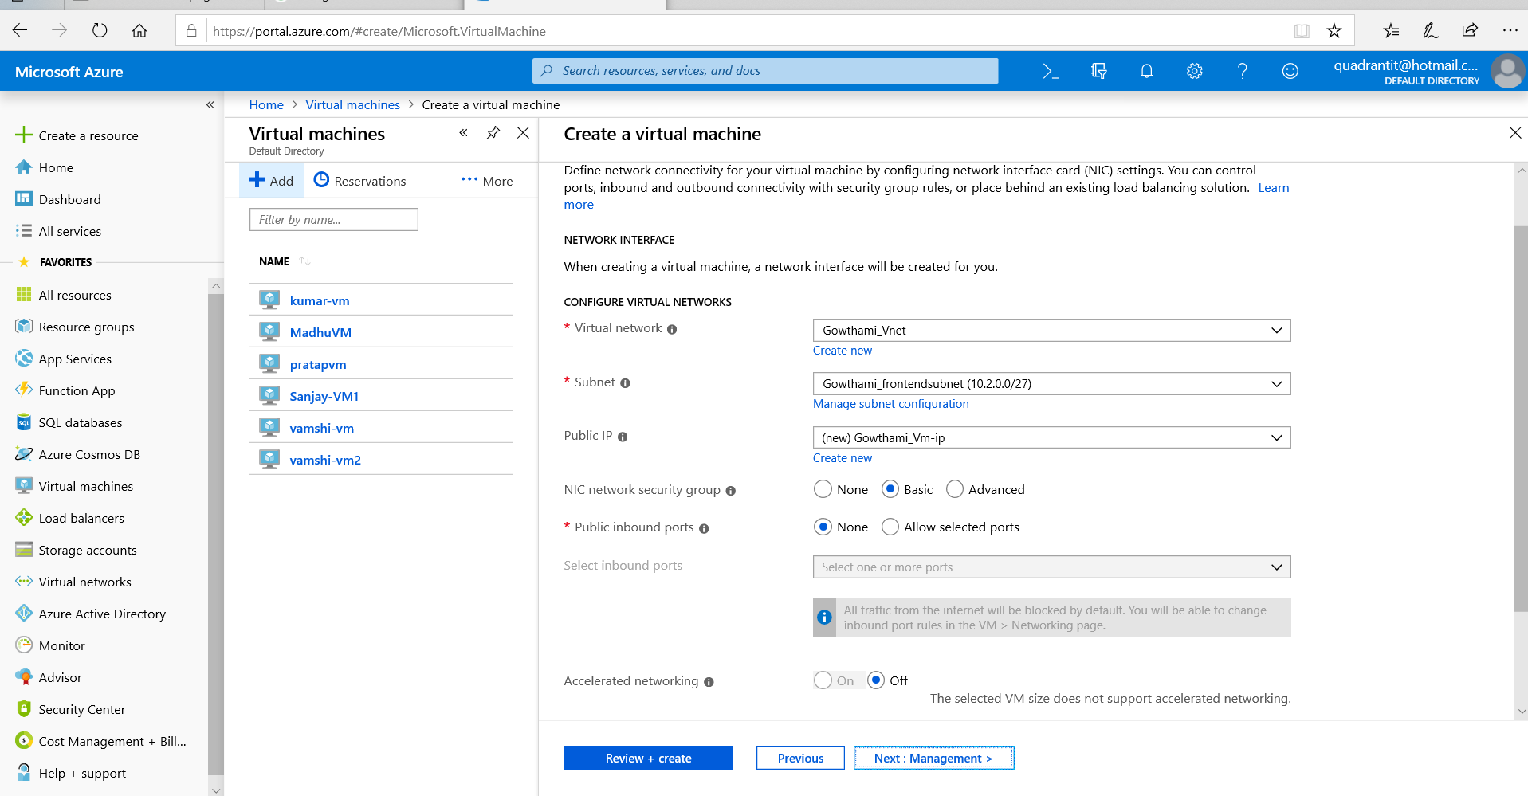

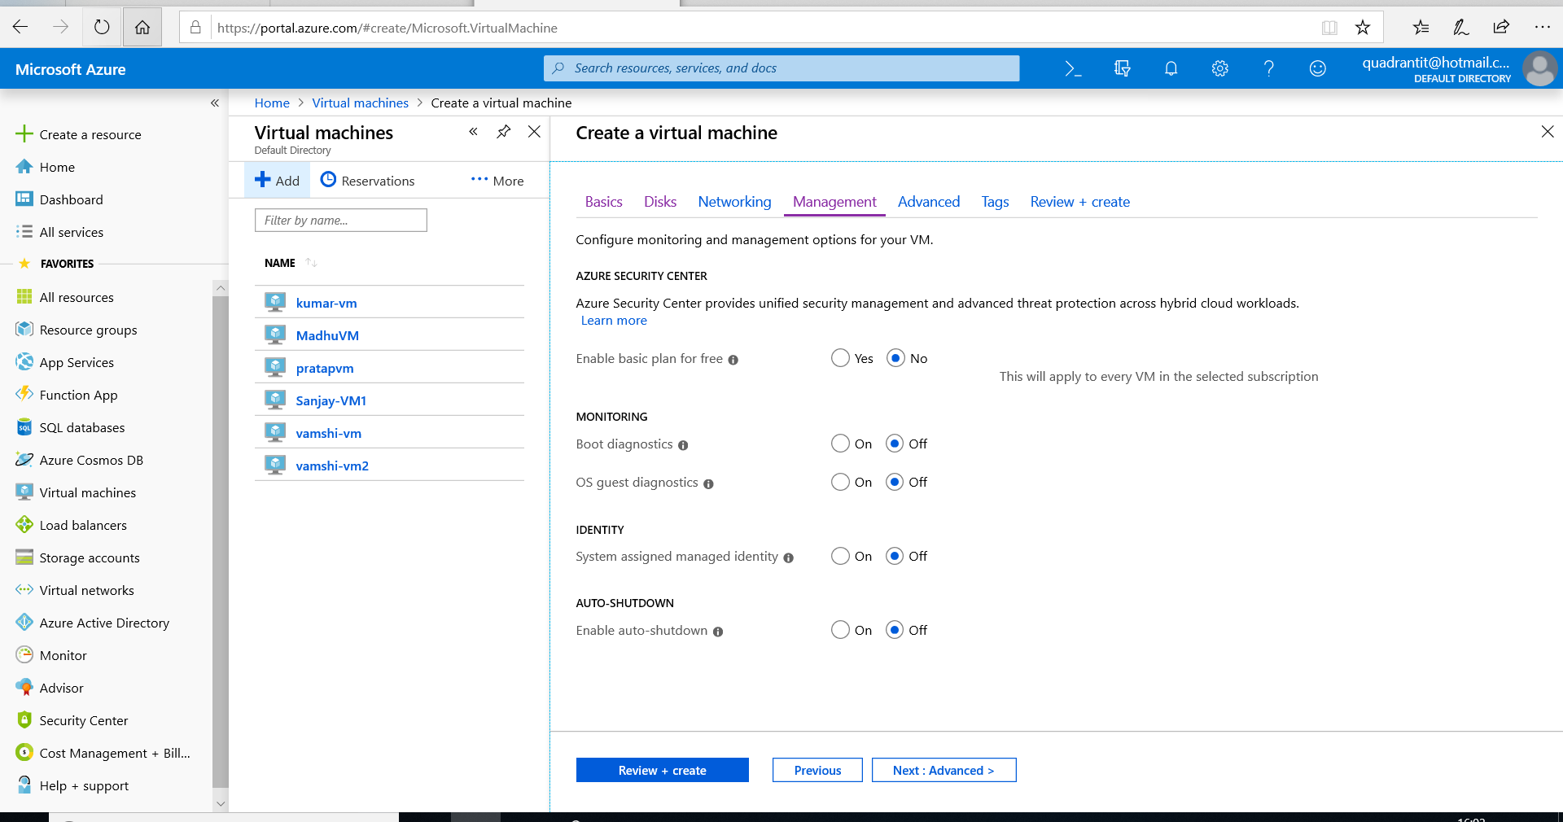

4.In VM created Snapshot.(After Creation of Virtual Network 🡪Disk🡪Create Snap-shot).

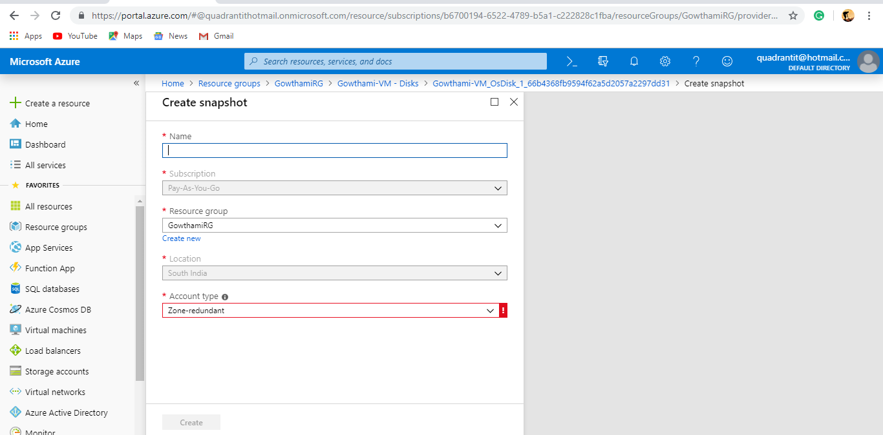

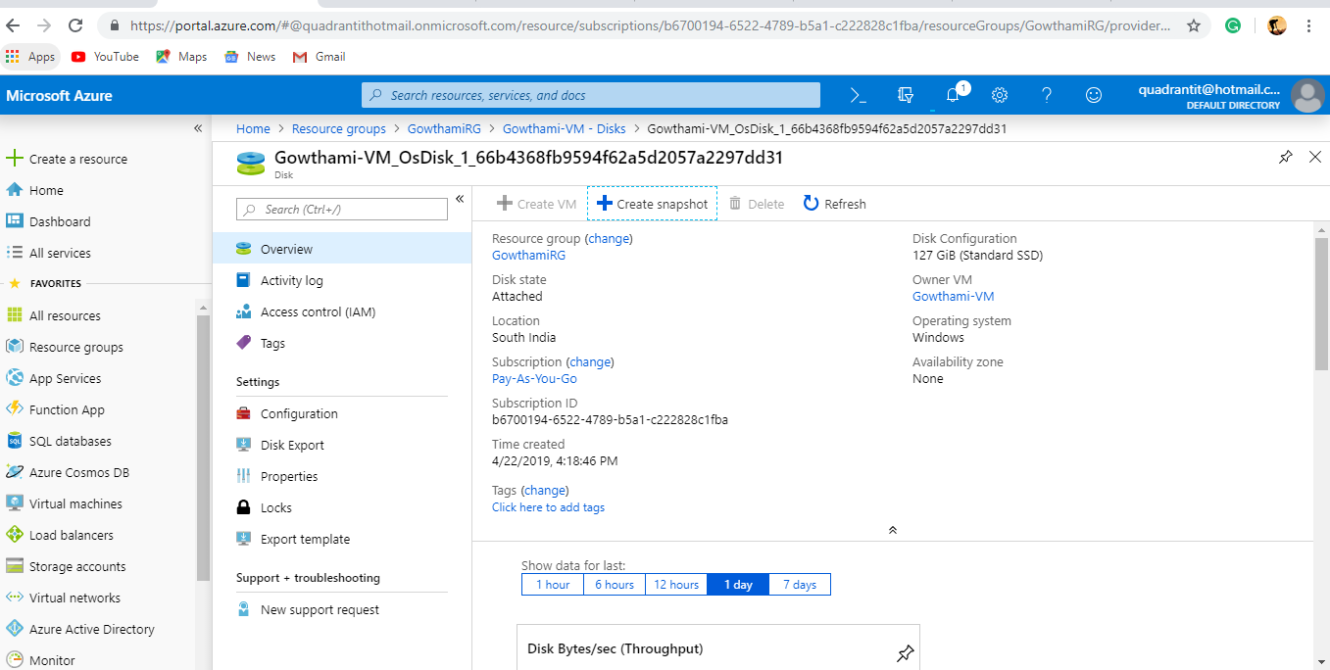

5.Created managed disk.(In Azure Type Manged Disk🡪Created managed disk).



6.Created VM1 with Snapshot.(While Creating the VM Added that managed disk).

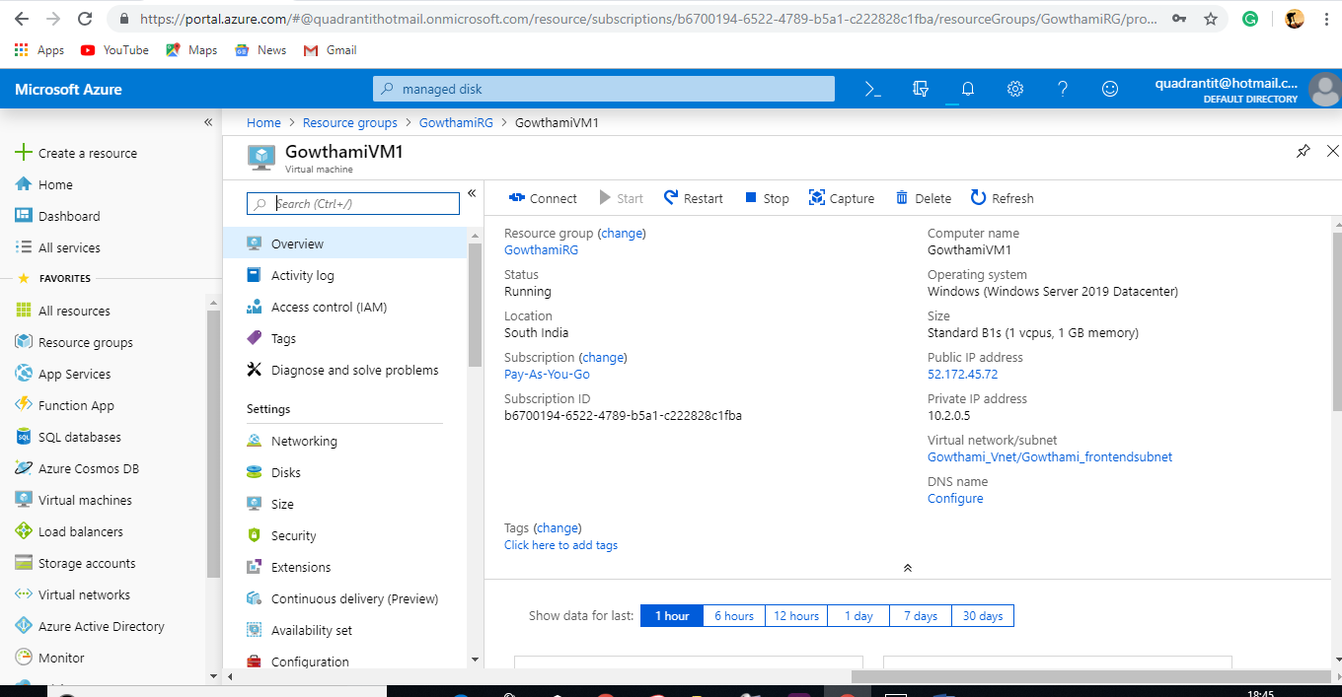

**3.How to Create image-VM**

7. VM Connected to the local machine with help of RDP and generalized thing taken from that Virtual network for Creation of image.

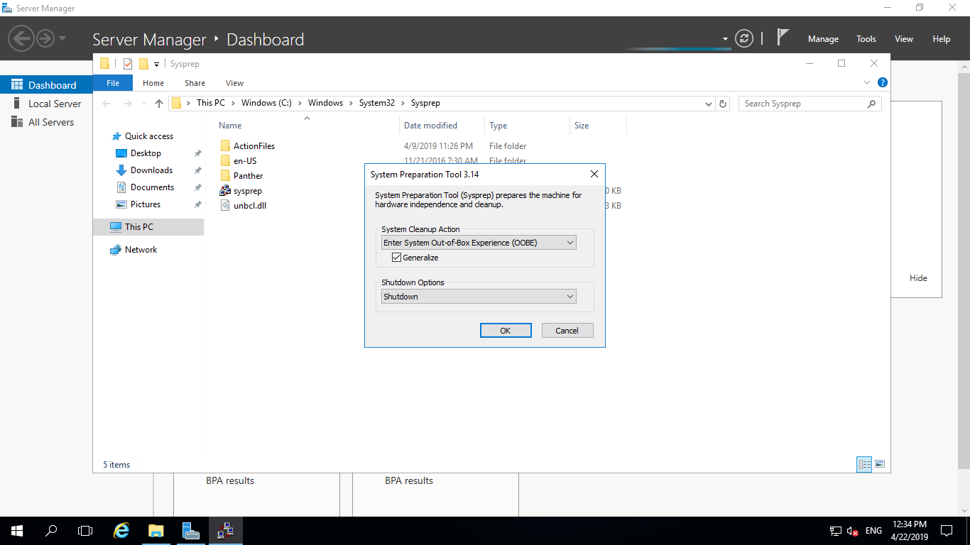

8.In VM Created Imaging.(Open VM in that Created Capture and deleted the existing VM ).

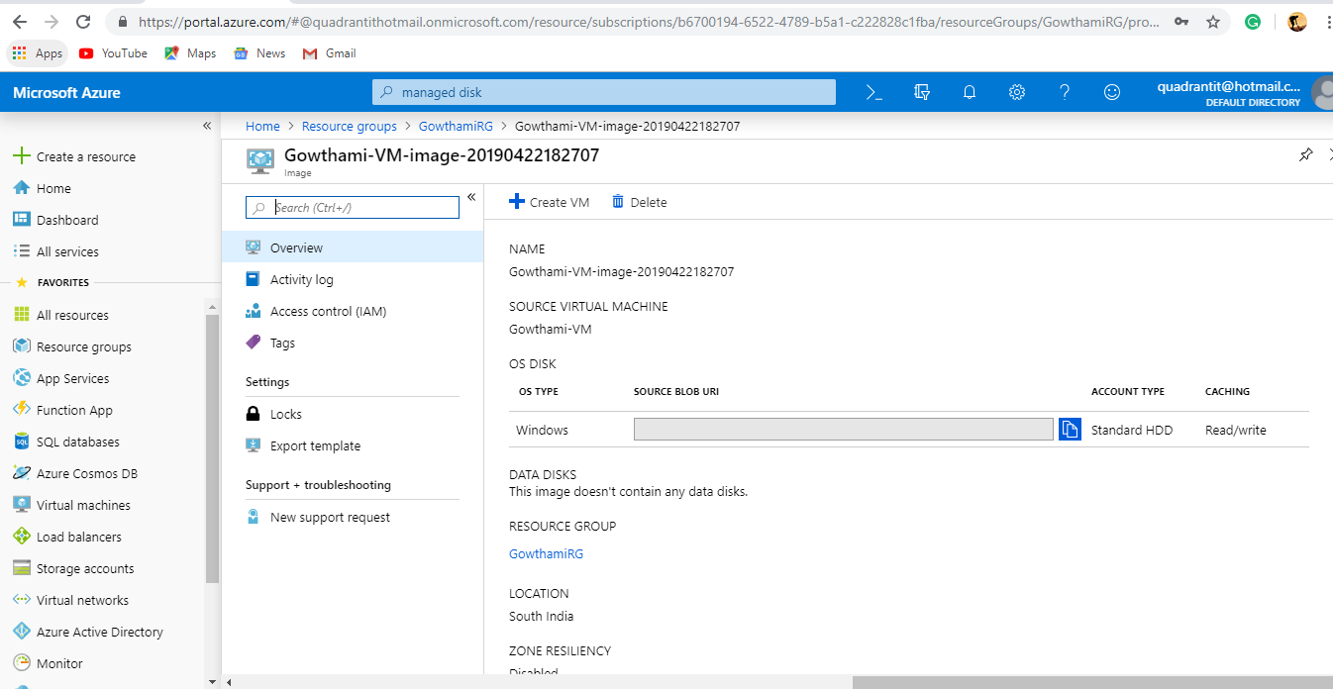

9.Created VM with Imaging.(Created Virtual Machine in that added image ).

