**Assignment-4:**

**Task1:**

Create One Resource Group in that create Scale-set.

1.Created Resource Group.

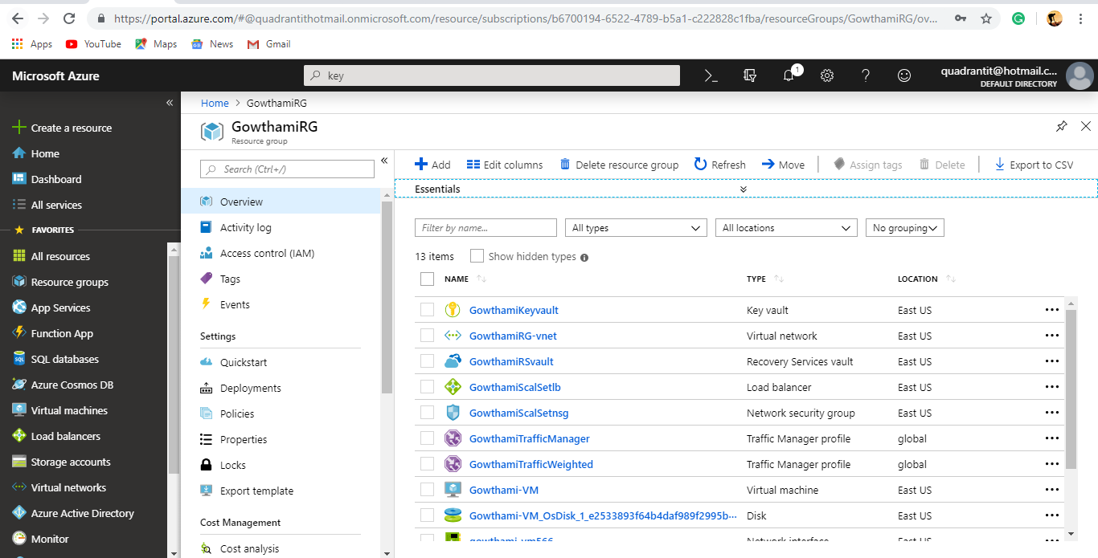

2.In the Resource Group Created Scale-Set.

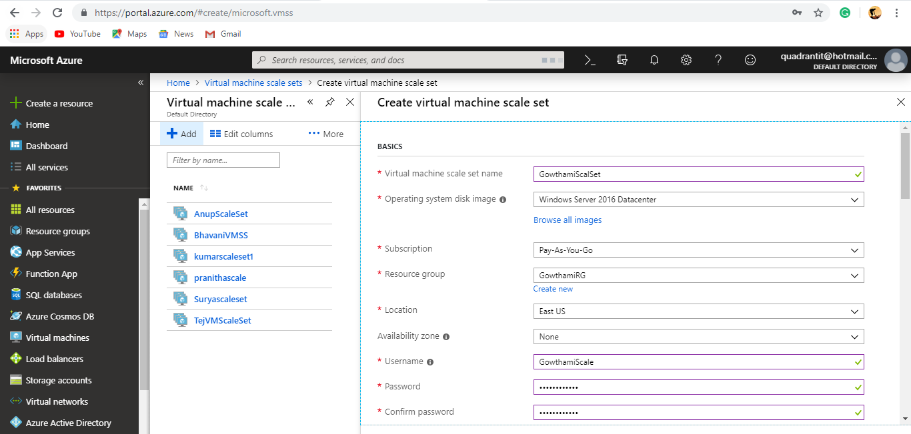

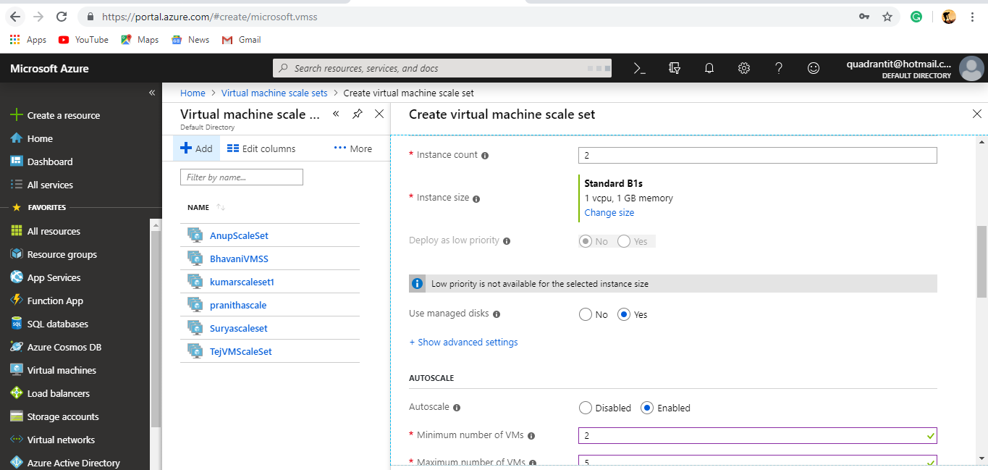

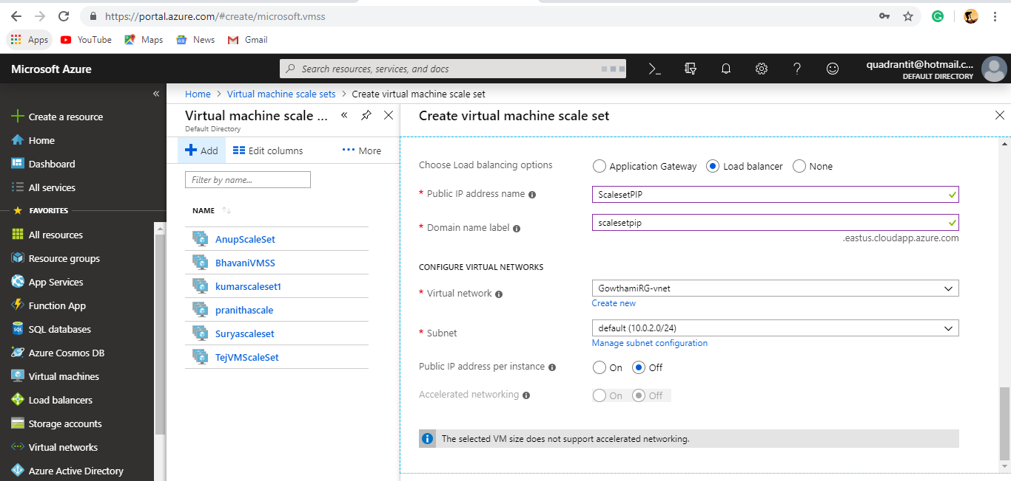

**Task2:**

Create one Resource Group int that create Recovery service vault in that added Backup Policies.

2.After Creating Resource Group in that Created a Recovery Service Vault.

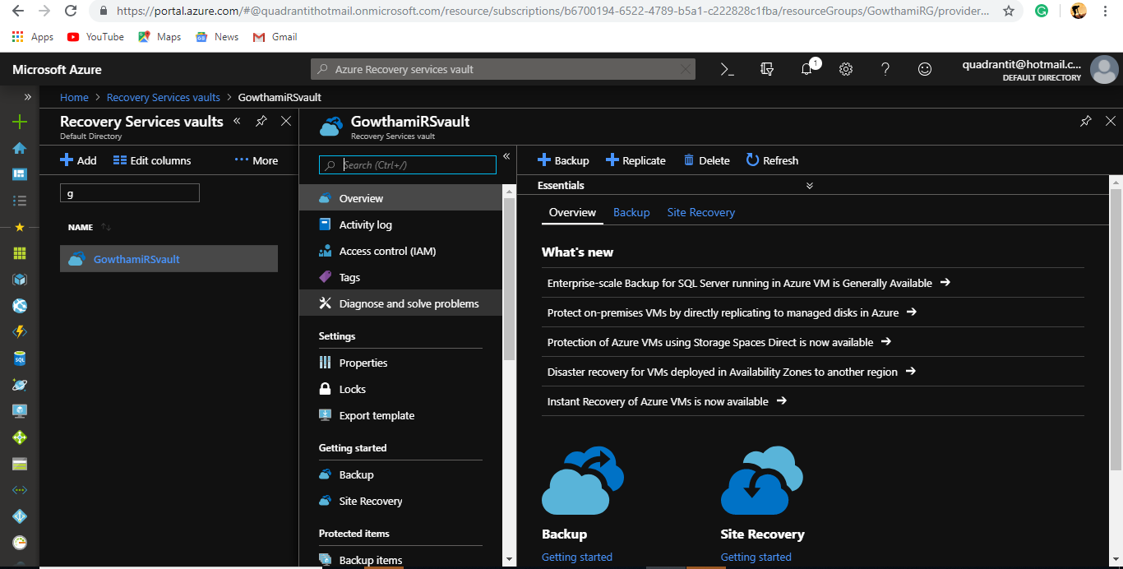

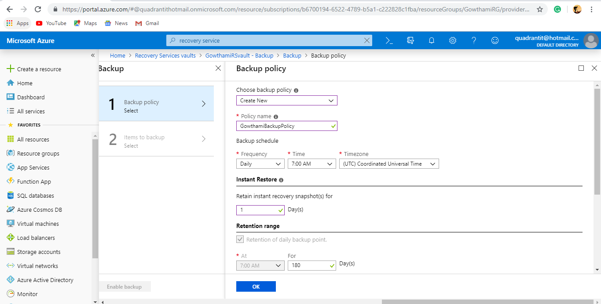

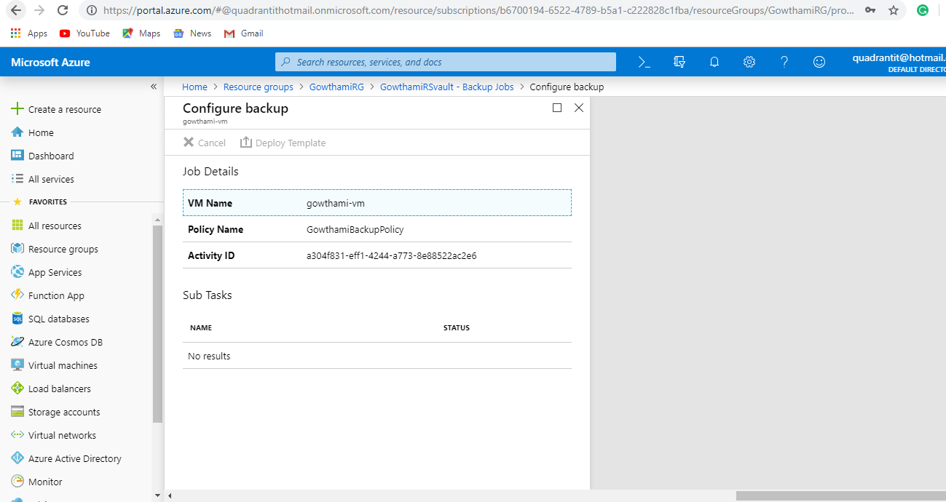

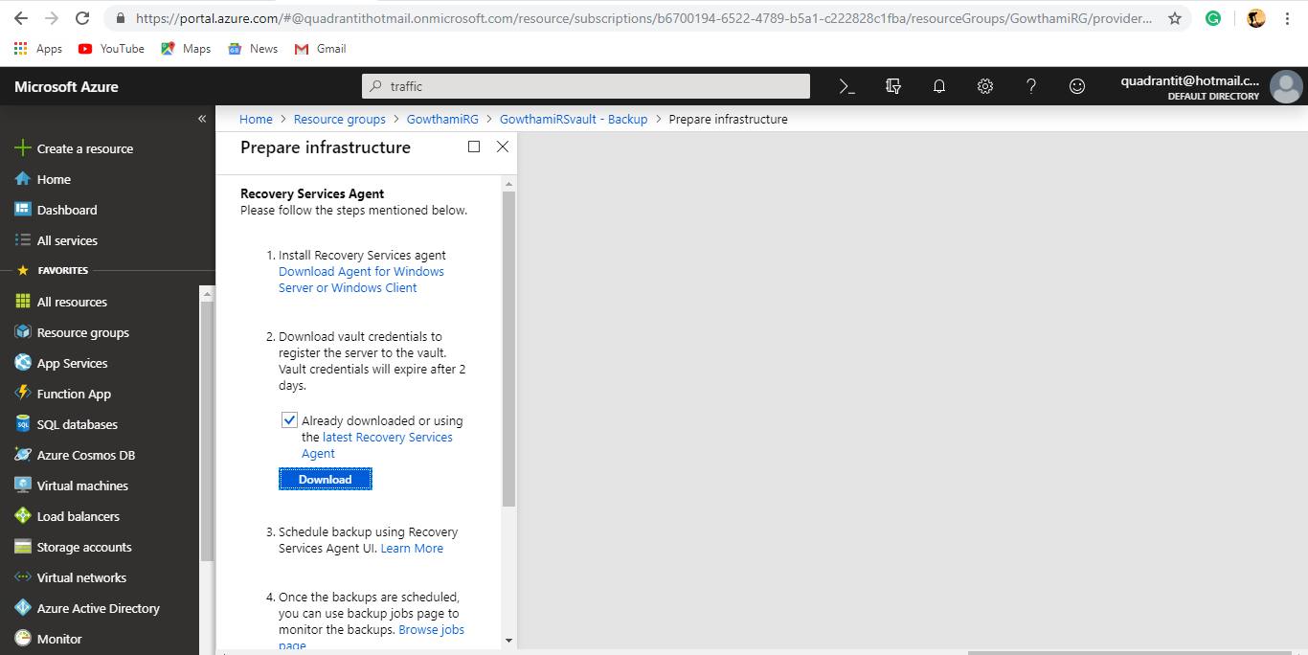

**Task3:**

Create one Resource Group in that Create Application Register(Azure Active directory🡪Application Register) open Application Register go to the Settings where go to the Keys and Create a key and save it and copy that key somewhere after create a keyvault in that add Application Register which name you created after completing that open key-vault add access policies give permissions and save it, In Google type (201-running-window---) in that select dev Deploy next fill the form with help of key and application id.

3.Created Encryption for Disk in Virtual Machine for that Created one Application Register, One Key-Vault and one VM.

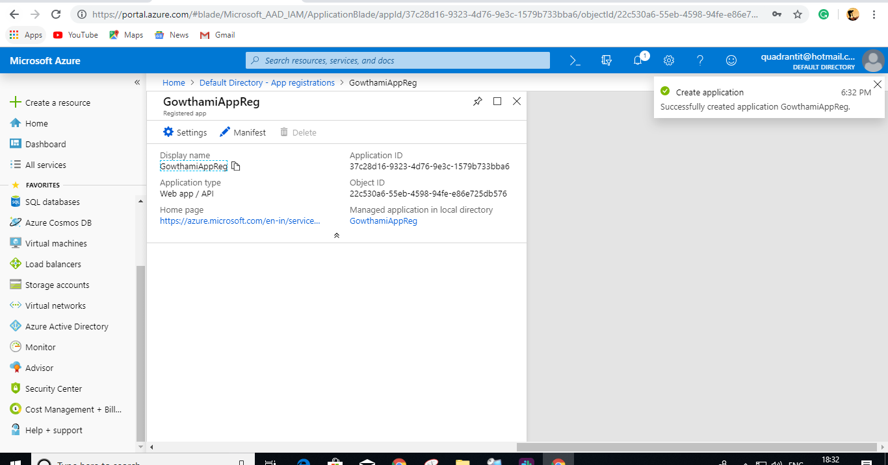

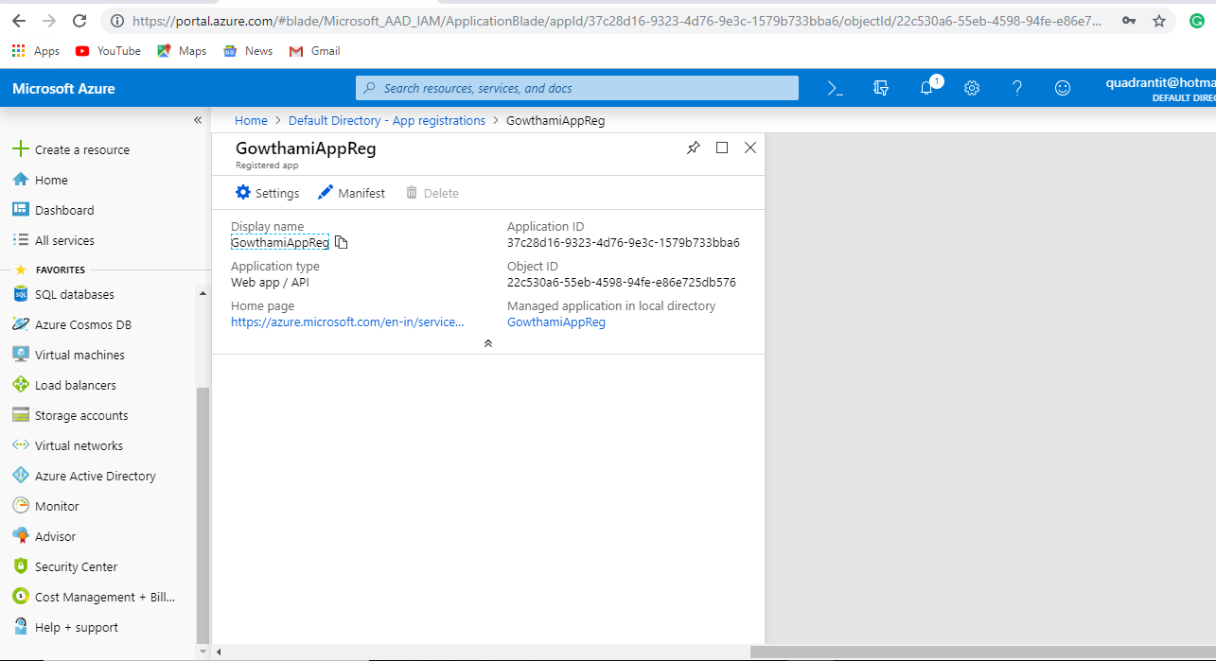

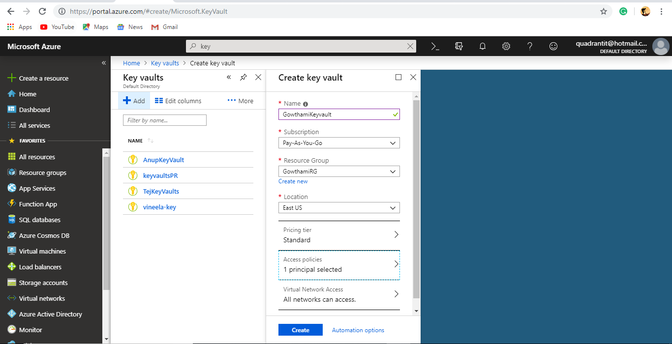

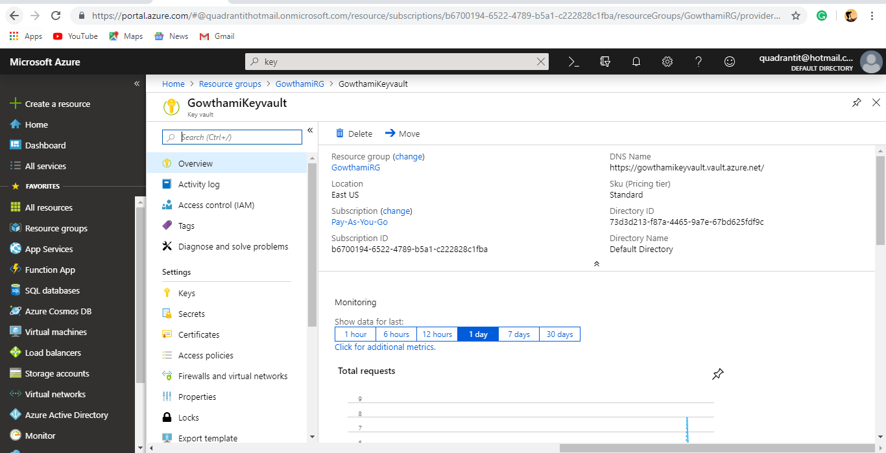

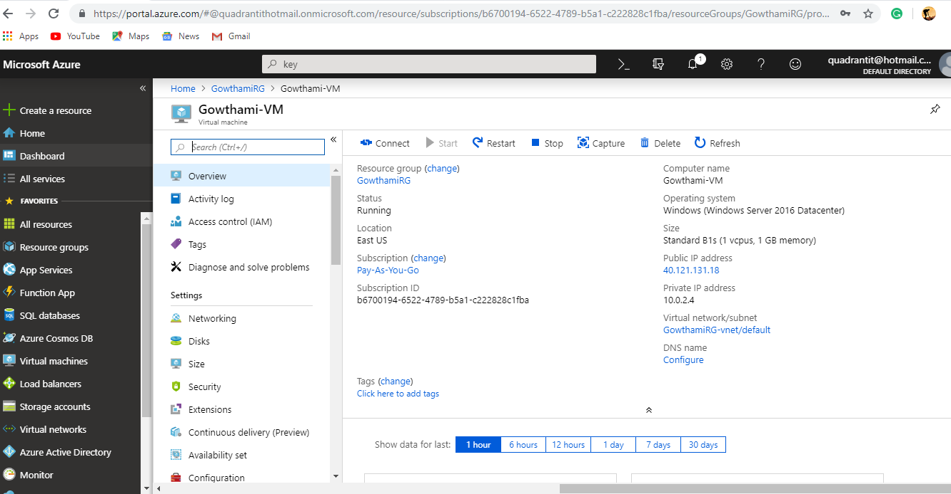

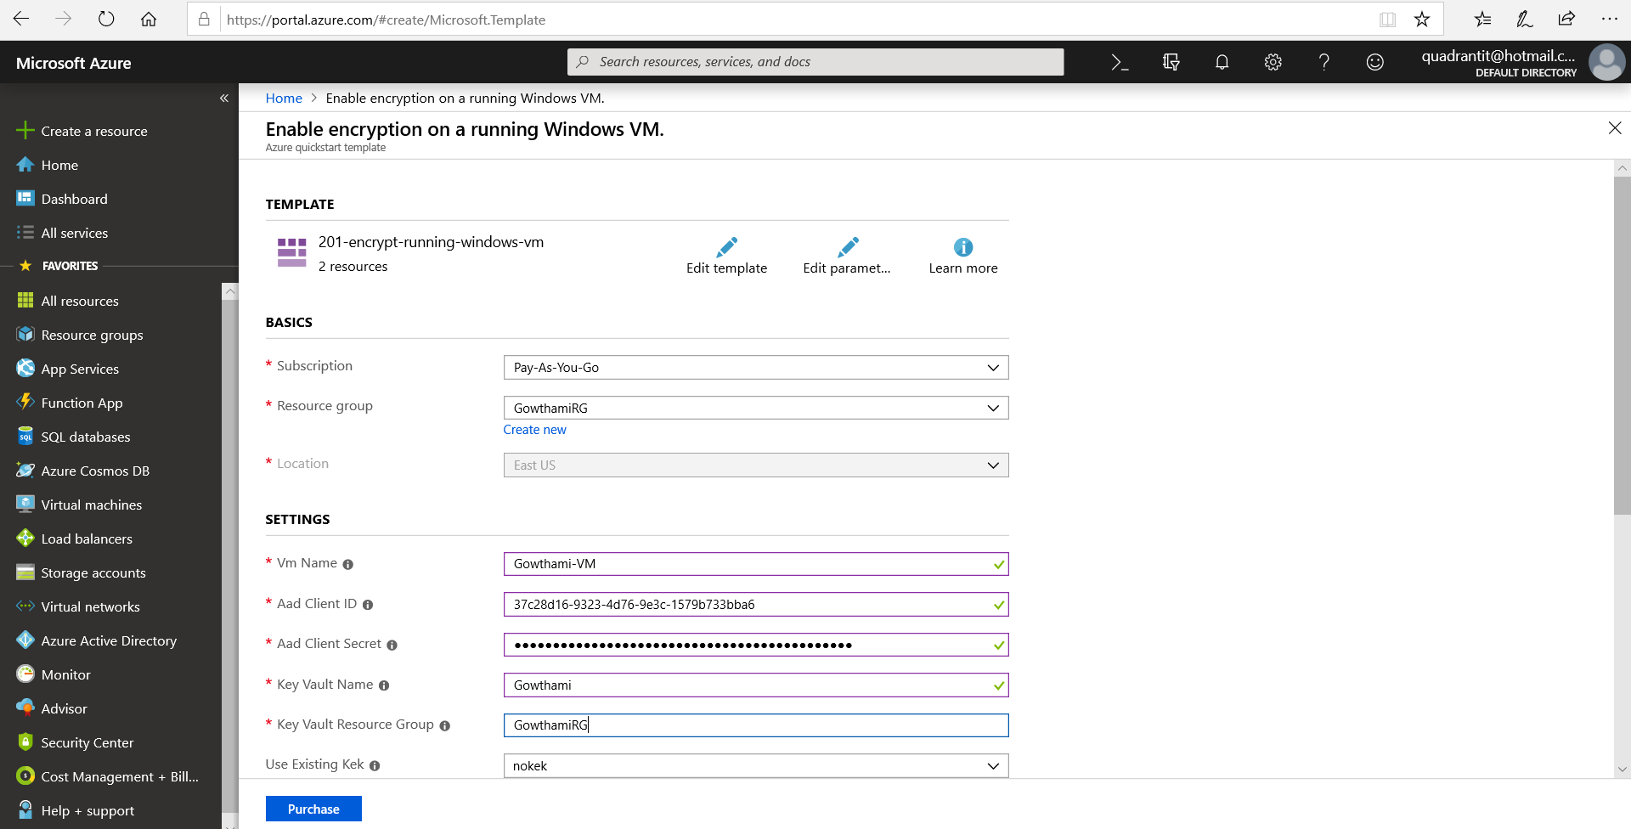

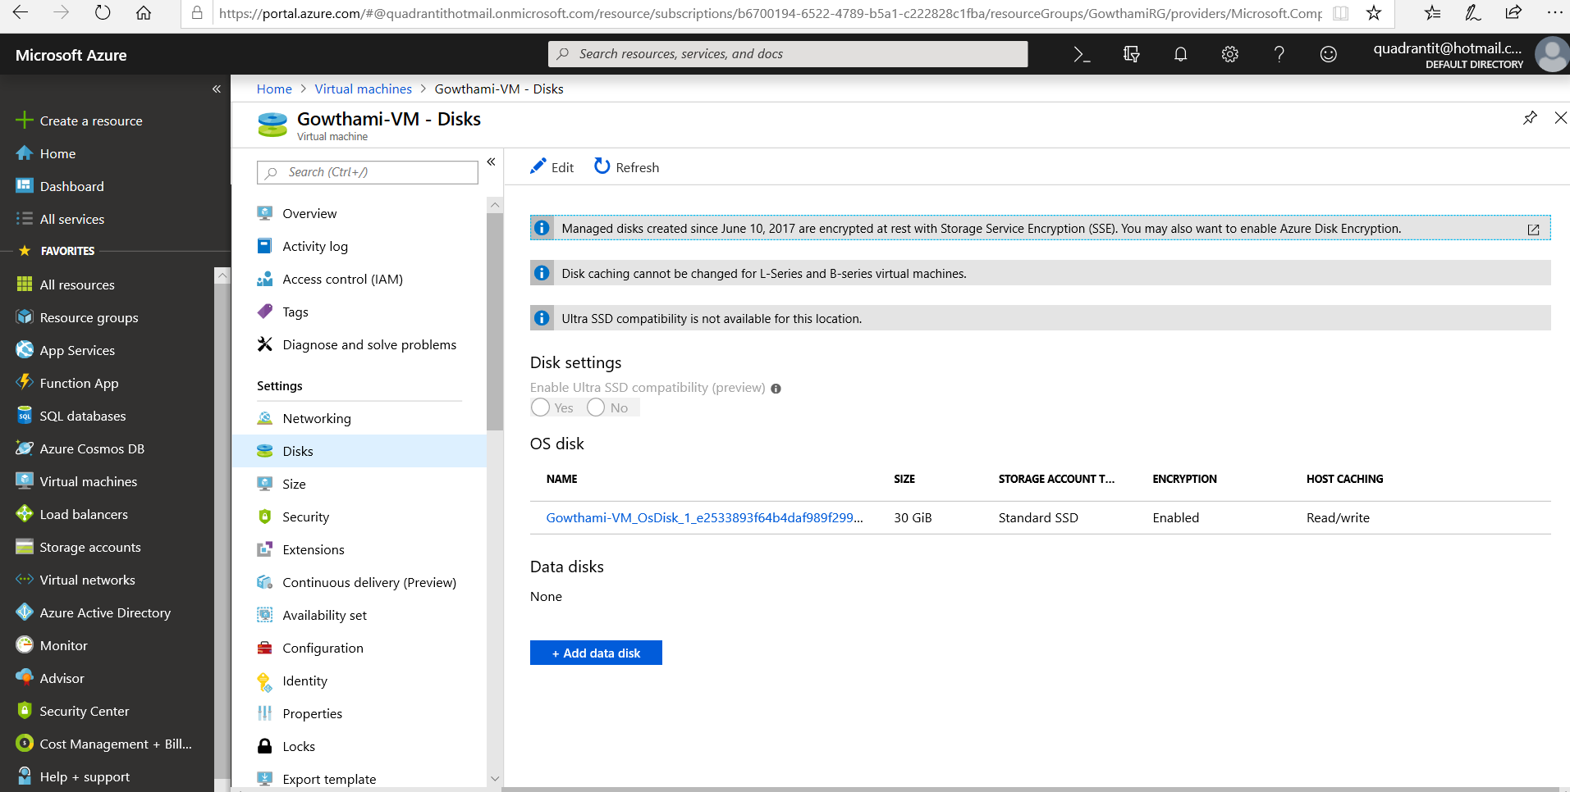

**Task4:**

Create 3 Types of Traffic manager (Performanced, Weighted, Priority) in that add end-points(Load-balancer)

4.Created 3-Types of Traffic Manager in that added end points.

