**Merging**

Task:

1.Merge the whatever files we have in the branch to the master.

2. Merge the whatever files we have in the master to the branch.

Task 1:

1.Created account in github in that created one repository.

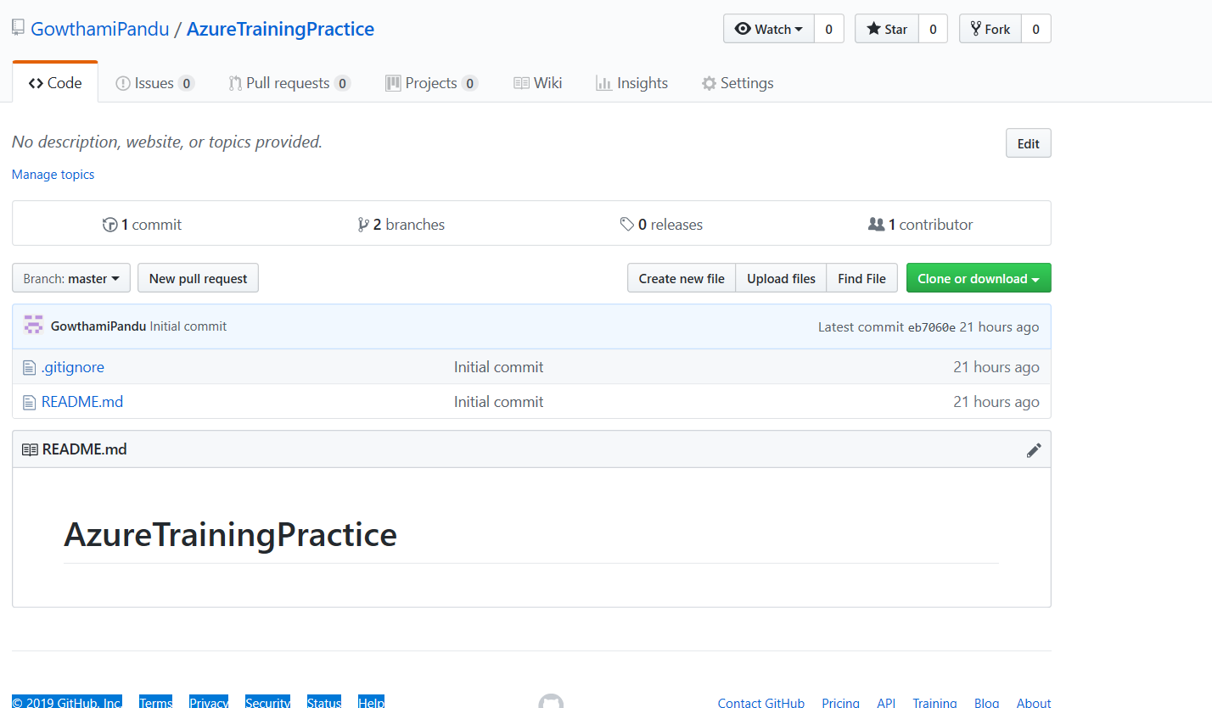

2.After Creation of repository cloned the entire history of the repository into specified path of the local machine.

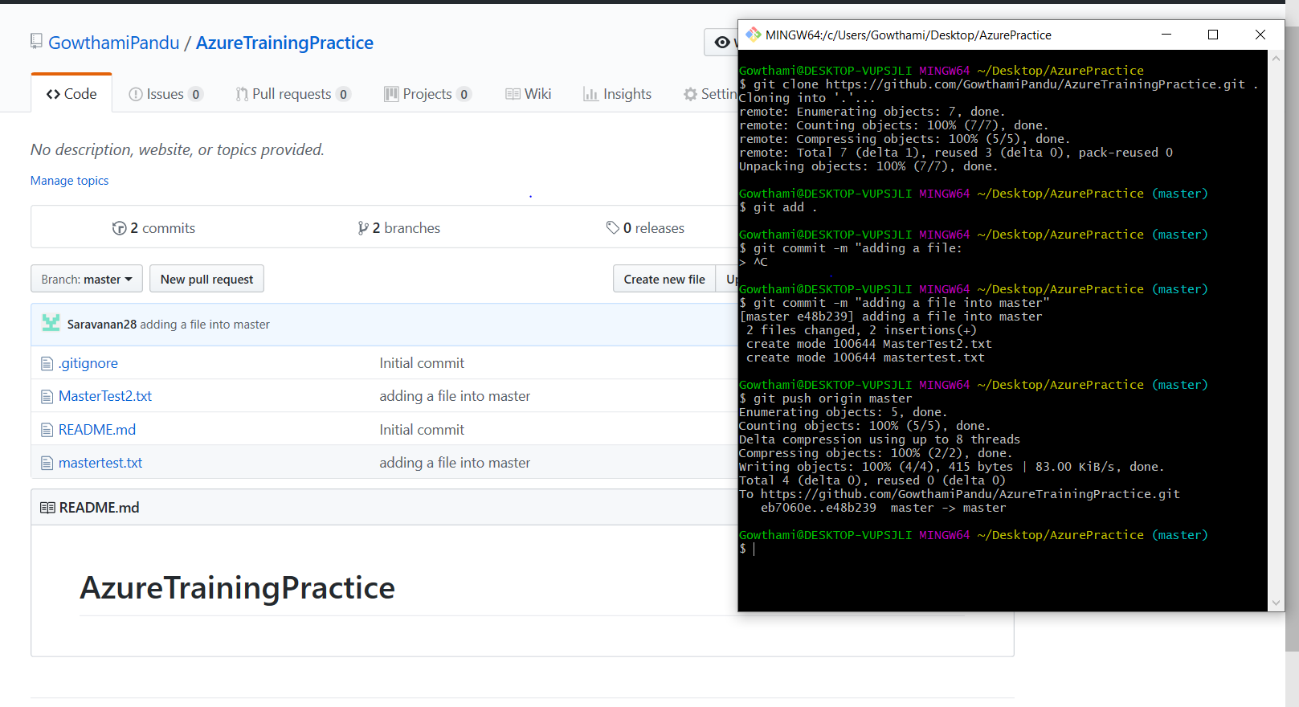

3.In that repository Created Branch name like MergeBranch.

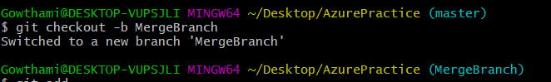

4.Added some files into branch and whatever I changed in branch those are merging into the master.

Adding a files into branch

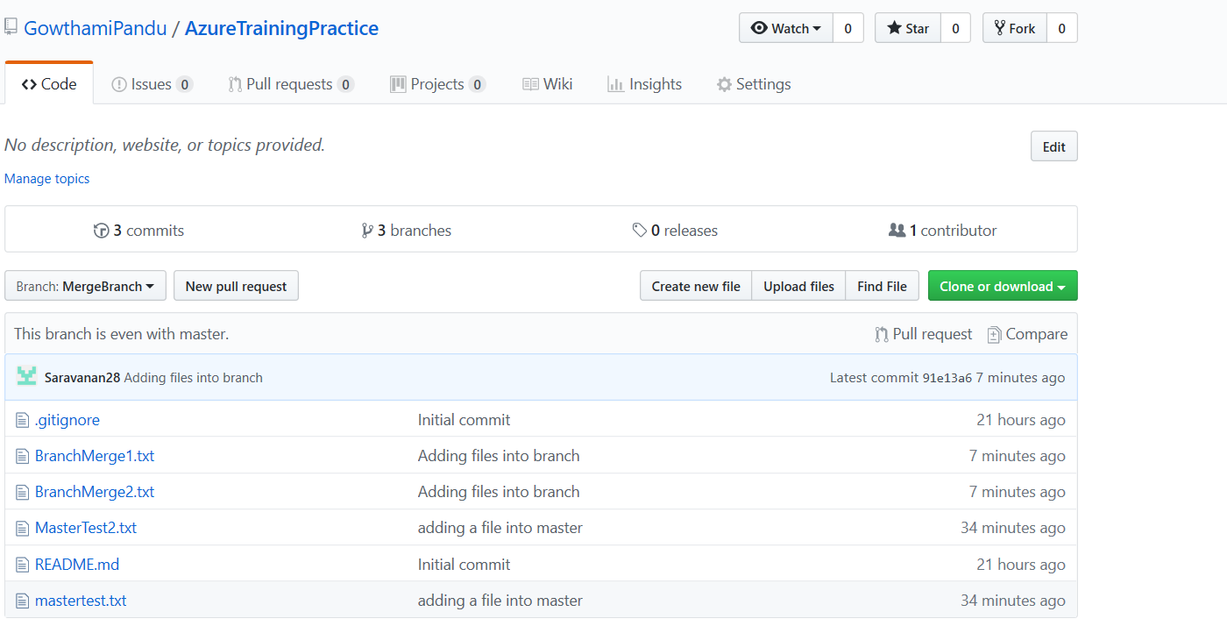

Git commands to add a file.

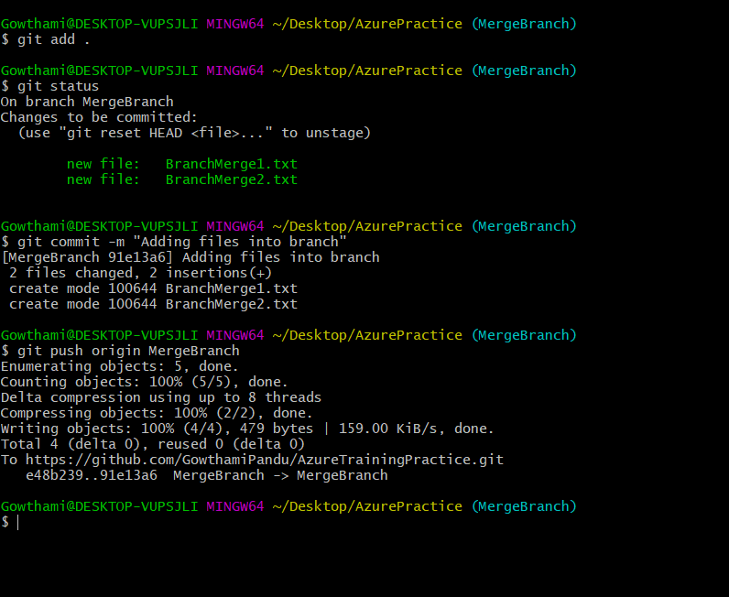

After merging files into master

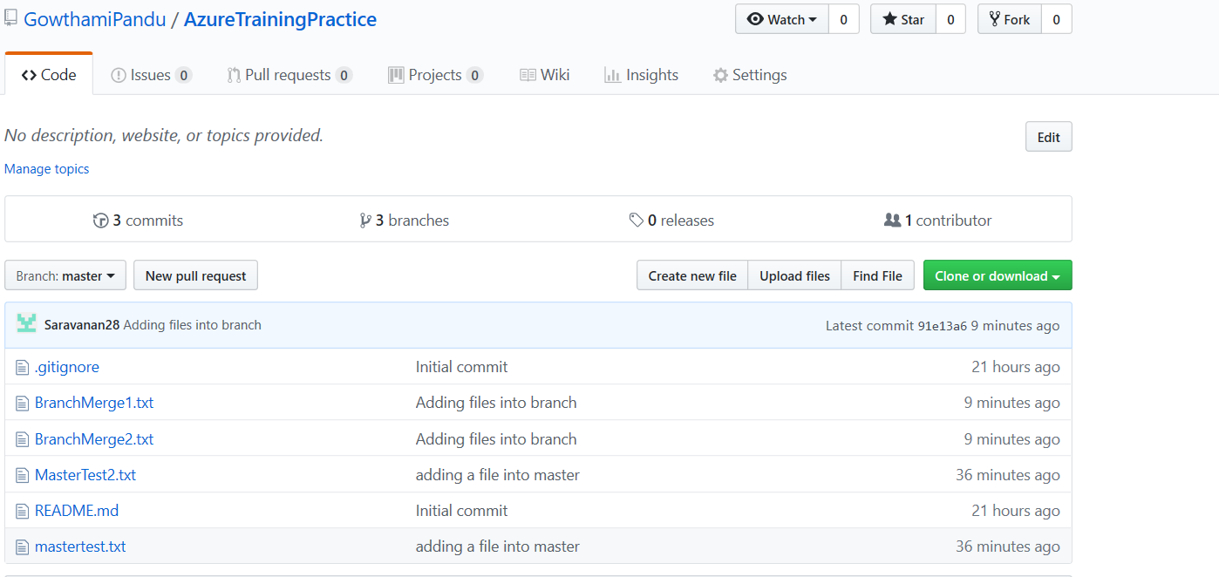

Git commands for merging.

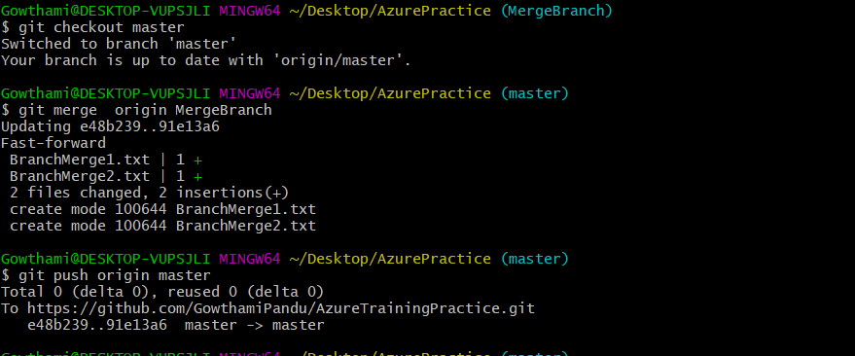

Task 2:

1.Adding some files into master.

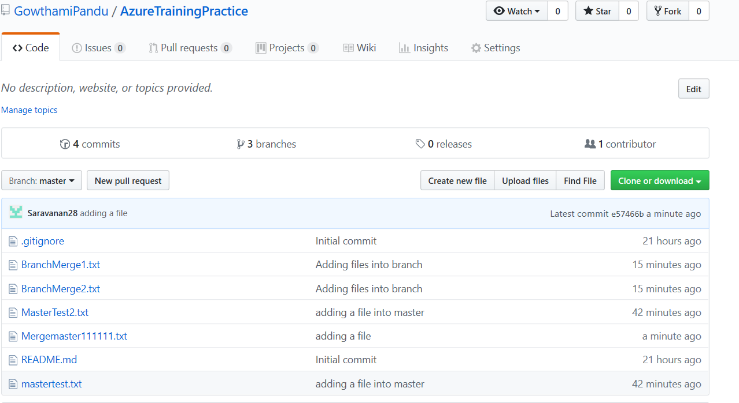

Git commands for adding files into master.

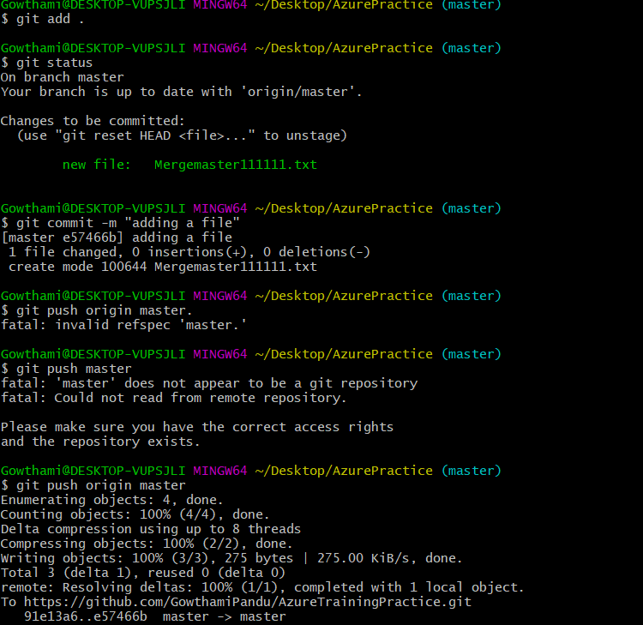

2.After merging a files from master to MergeBranch.

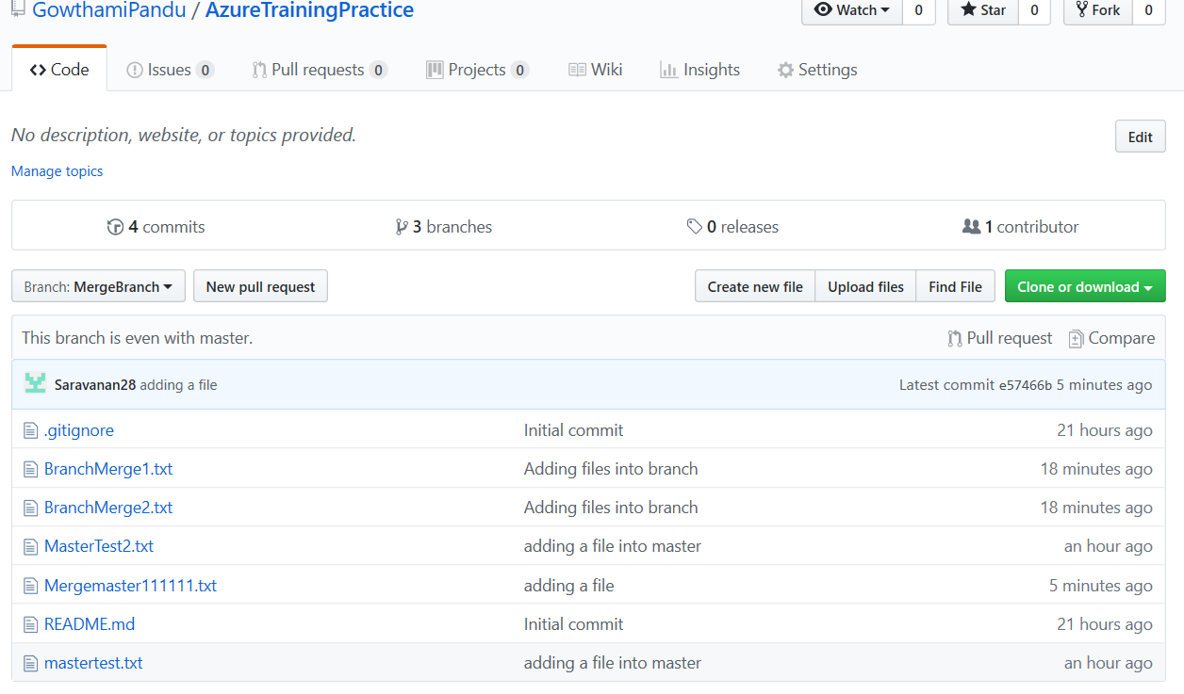

Git commands for merging master to MergeBranch.

